Can't Stop After One

“Betcha can't eat just one”
- Lay’s slogan

This slogan precisely describes the most satisfying, delicate, crunchy, natural, and light taste of any Lay's chips. The taste is simply divine, a tsunami of flavors! And now, let's look at the packaging, which adds even more desire to take that first bite of these great snacks. Colors attract attention and can be recognized everywhere. There are six different packaging colors: gold, yellow, black, green, orange, and red. The classic logo sits in the middle of these six beautiful packages. I chose this logo because I wanted to discover what is hidden in the history and design of these delightful can't stop eating just one chip.
Lay's company focuses on the taste and quality of the product, which affects the positive customer reviews and high ratings. The whole story began with a salesman Herman Warden Lay who, during the Great Depression, sold chips from the trunk of his Ford Model A car and thus earned his living.
Mr. Lay established himself as a super salesman from early childhood, selling snacks and drinks at his stand from the age of 10 near a baseball stadium in Greenville, South Carolina. H.W. Lay's business became so profitable that he opened a bank account, bought a bicycle, and hired workers to look after the stand. After two years of studying at the institute, Furman University in Greenville on an athletic scholarship, he dropped out and worked various jobs.
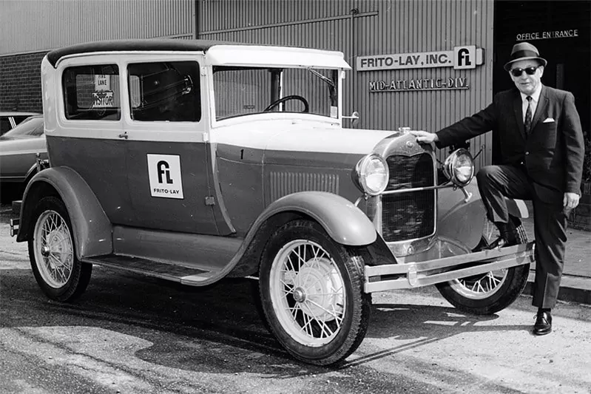
He then resumed his business career in 1932 as an independent snack food distributor in Nashville. In 1939, Herman Warden Lay bought a financially troubled Atlanta snack food manufacturer Barrett Food Company and turned it into the nationally known H.W. Lay & Company brand.
In 1961, two opposing companies, the Frito Company and H.W. Lay & Company merged, which people thought was impossible, but it did happen. Mr. Lay became chairman of the board of directors. And in 1965, he negotiated a merger with Pepsi-Cola to form PepsiCo, which now operates in 200 countries with a turnover of 14 billion dollars.
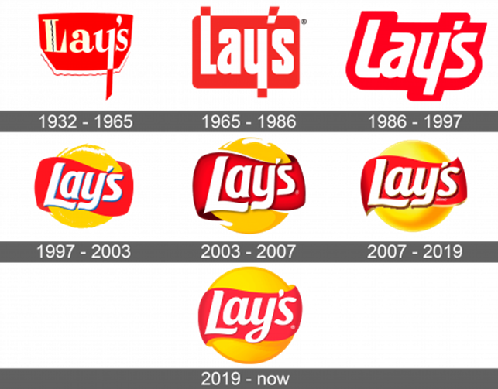
We can now see that the company has changed the design several times, but one part of the company has remained unchanged, the name of the company, which is also the name of the founder, Lays. The company and management considered modernity and relevance when choosing a design and luring buyers, which is important for the sales market.
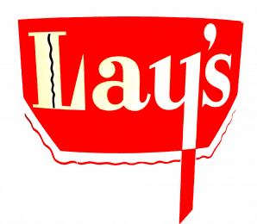
The first Lay's logo was created in 1932. The logo consisted of a red horizontal polygon with rounded corners, white bold type text, and two wavy lines, black inside the letter L and red at the bottom of the main shape. The letter Y going beyond the polygon is red. The polygon is like the shape of a saucepan. The wavy lines are like steam or fire. This is how it is recognized as a food brand. It existed from 1932 to 1965.
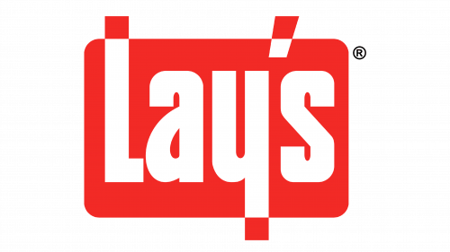
The second logo, created for Lays in 1965, has become more modern. As in the previous form, there was a white inscription on a red background, but now it is not a polygon but a rectangle with rounded corners. The font became Extrabold, and, like the previous version, letters or an apostrophe that went beyond the rectangle changed from white to red. It existed from 1965 to 1986.
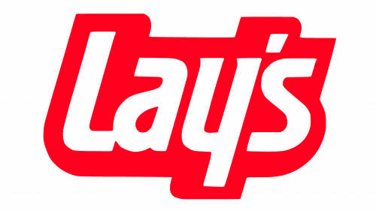
In 1986, the logo's color palette remained the same, but the forms were updated. The red rectangle has been removed, the text has become more italic, and now instead of a rectangle, the red outline surrounds the white text. The logo existed from 1986 to 1997.
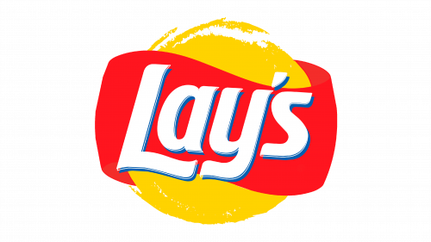
In 1997 Lay's logo was designed by the San Francisco-based Landor Associates bureau. Designers added yellow to the logo, contrasting nicely with the red stripe, and symbolizing the sun and potato. The white letters have subtle blue shadows that give the text a three-dimensional effect. The logo existed from 1997 to 2003.
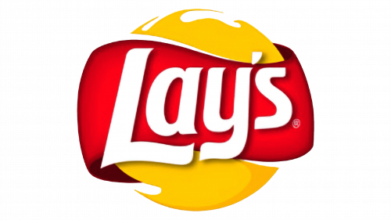
At the end of 2003, the designers rotated the logo. Because of this, the text has moved up a bit. The red stripe now has a gradient of red and dark red. The shadow under the white letters is no longer blue but dark red. The "Brand" sign is shown in small print. The logo existed from 2003 to 2007.
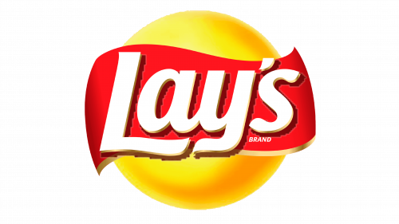
In 2007, the designers changed the solar ball using a 3D effect. After adding gold outlines, the colors became softer, and the shadows became larger. The changes have occurred in the font as well, we can see that in connection between A and Y letters. The word "brand" has become more visible but still small. The logo existed from 2007 to 2019.
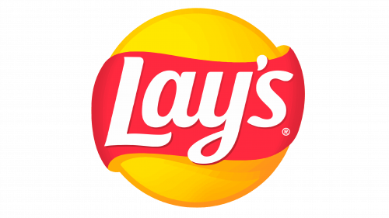
The last redesign happened in 2019 and is still in use today. The Lay's logo is flat again. There are some gradients in colors. The color palette stayed the same. Some shadows and outlines have disappeared. The word "brand" has become an icon again. The Y letter in "Lay's" ends with a loop at the end. I want to note that Lay's company created unique fonts for the logo from the beginning, and exact information about them is not specified. The font of the 2019 logo, like the previous ones, was created exclusively for the brand; however, you can trace the similarity with the Makozin Heavy Italic and Bluestar Medium Italic fonts.

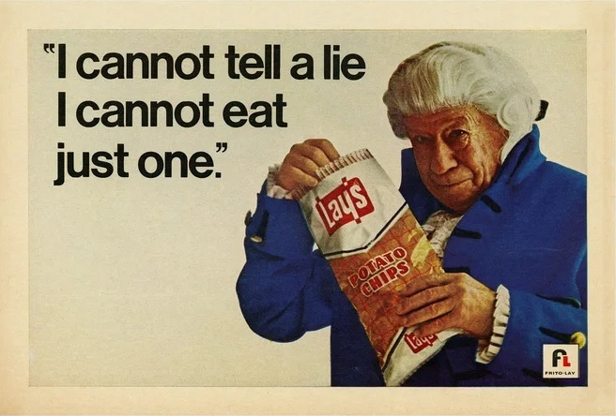
I can't help but talk about the publicity made by Lay’s after the merger with PepsiCo after two years in business. At that time, the Helvetica font became very popular among designers in the United States. Helvetica Halbfett and Neue Haas Grotesk, display 65 Medium font can be seen in the lettering. You can see a unique inverted quotation mark in the advertising poster, also called sign artist quotation marks.
Based on the information above, I can confidently say that stability, uniqueness, and respect for the company's roots are traced in the corporate style of the Lay’s logo.
As a result of writing this paper, I can see that Lay’s has gone through a fascinating history since the very opening of the company business. Indeed, for each brand, whether it be snacks, drinks, electronics, or clothing, the goal is to gain popularity and improve the product, focusing on relevance and modernity. All these changes in the design and history of the famous chips worldwide confirm that Lay’s has always tried to be at the forefront in sales and modernity. The company has always been in tune with its target market and has been making the best product for consumers since 1932. The Lays logo gamma embodies energy, power, and drive. When combined with the pure white color, it evokes a sense of craftsmanship and reliability of a brand that focuses on the quality and taste of its product.

Bibliography
Francis, c Enjoli and Eric Noll., The story and pride behind one of America's favorite snacks: Lay's potato chips. ABC News.,29 Aug 2018. https://abcnews.go.com/Business/story-pride-americas-favorite-snacks-lays-potato-chips/story?id=57486116

Thomas Jr. Robert Mcg.,SUCCESS TIED TO POTATO CHIPS. 7 Dec 1982. The New York Times. https://www.nytimes.com/1982/12/07/obituaries/herman-w-lay-73-is-dead-success-tied-to-potato-chips.html

Lay’s Logo. LogoLook. https://logolook.net/lays-logo/

Lay’s Logo. Logos-world.net.,17 Feb 2022. https://logos-world.net/lays-logo/

1000Logos. 9 Nov 2021. Lays Logo. 1000 Logos The Famous Brands and Company Logos. https://1000logos.net/lays-logo/ Date accessed 6 Mar 2022.

Lay's Debuts Four Global Flavors. CSP Daily News., 25 July 2016. https://web.archive.org/web/20190502233701/https://www.cspdailynews.com/snacks-candy/lays-debuts-four-global-flavors

Lay’s Potato Chips ad. Fonts in Use., 8 Nov 2019. https://fontsinuse.com/uses/29276/lays-potato-chips-ad#:~:text=The%20specific%20cut%20in%20use,as%20sign%20painters'%20quotes

