Briana Burton
CDMG 1111
11/26/17

Folder, trees, 1960

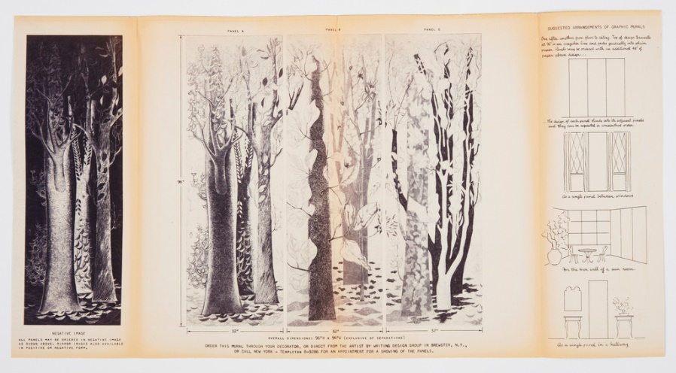

This folder was designed by llonka karasz and manufactured by design group inc in 1960. Both the promotional brochure and the full size mural are printed in the same technique. The outer layer shows detail of the mural in color and size. The inner layer displays the full mural. The medium for this piece is Luxograph print on paper. This piece stood out to me because it shows that whether the piece is small or big you can get the same effect. This is a part of the wallcoverings department

Book cover, Jazz Cleopatra, 1989
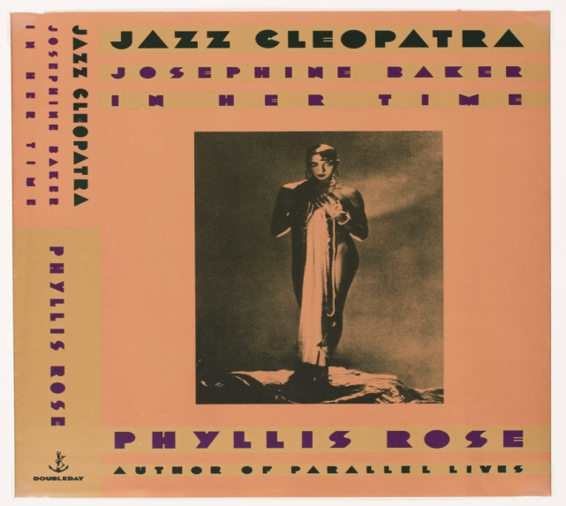
The book Jazz Cleopatra was written by Phyllis Rose and the cover was design by Carin Goldberg in 1989. This cover was created for the first edition of Jazz Cleopatra. The medium for this piece is lithograph on paper. This piece stood out to me because it shows that the simplest of detail can make a big difference. This is part of the Drawings, Prints and Graphic Design department.

