Sahriar Islam
ENG- 2575 OL-51
Summer-2020

Individual Final Work

- Explanation of the research: Since I started working on the final project, I have been researching on COVID-19 and prevention from next probable outbreak.

COVID -19 as Pandemic: The world is facing a deadly pandemic that have not ever seen before. COVID-19 spread all over the in a short period, and it has shaken the human civilization. The experts opine that the world will not go back to its normal atmosphere.

COVID-19 in NYC: New York city also has been facing this pandemic since March,2020. This pandemic hit NYC very hard that brings a huge number death as well as misery of countless family. The situation becomes worsen because we had no preparation to face this kind of outbreak. As a result, it took a heavy toll on everyone. The recent study shows that New York city had the highest rate of coronavirus death and confirmed cases in this pandemic. The city has been lockdown for almost four months. The normal life is disturbed. This pandemic effect all New Yorkers physically, mentally and financially.

Preparation and Prevention from next outbreak: New York City is one of the most densely populated cities in the world. The study says the any infectious disease spread rapidly in densely populated area. Therefore, NYC is in high risk for any infectious disease. Government as well as the New Yorkers should be more conscious to prevent probable outbreak. First of all, we must have a well-planned health system. Current health system needs structural and non-structural development. Government should increase budget to the health sector in order to train health workers, more researches on detecting contagious diseases, and increase ability to treat large number of patients during any pandemic. Government labs and private pharmaceutical companies should keep trying to find COVID-19 vaccine in order to prevent next attack, and also government should make a law for automotive companies, every company must make specific numbers of ventilators every year for confronting future outbreak. For preventing next outbreak, we must raise health awareness among the people and people must take precaution in their daily life. The WHO’s policies should be changed and hold it more accountable because we noticed that beginning of this pandemic WHO was very irresponsible and careless. All the passengers of international flights must go through a health screening procedure in airport. Public transportation should be sanitized every 12 hours. People must maintain social distance everywhere and avoid public gathering as much as possible; moreover, authority should be vigilant to make sure it.

- Explanation of My Participation: Beginning of the semester my first and foremost tasks were to introduce myself to others in this class and describe my neighbor’s lifestyle in this pandemic and what was their main concern at that time. I finished these tasks individually. In the third task I was paired with Rajeen Khadka and thus completed that task with him. That task was about finding similarities and dissimilarities between his and my neighborhood. In the fourth task the professor added two more person, Anna and Lutfar to our group. We jointly completed our fourth task that was about finding similarities and dissimilarities among us. Then we jointly started working on our final project and we created a project proposal for our final project. We submitted it as task-5. In that project proposal, I was assigned to complete project goal. Thus, we finished our final project that is a website with many resources. In the final project I was assigned to research current situation of New York city during the pandemic and how to prevent next outbreak. First, I did a research on COVID-19 and got to know how it spread all the world in a few months. Also, I got to know why New York city became the epicenter of this pandemic. I described in the project how New Yorkers suffered by this pandemic and what’s were the reason New York city got the hardest hit by COVID-19. Furthermore, I shared my suggestions in the website how we can prevent and prepare ourselves for any probable outbreak.

Journal Entry

- Date: 06/01/2020
The semester began. I posted Task 1 and Task 2 on OpenLab according to the professor’s instructions.
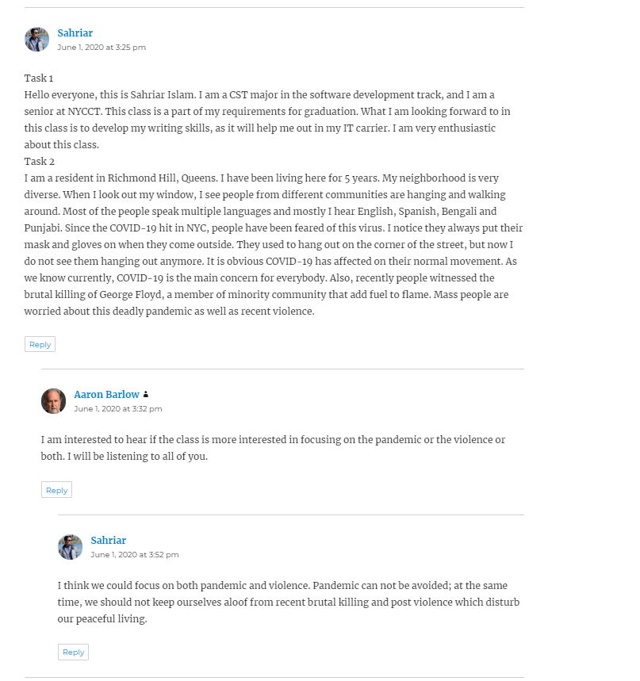

- Date: 06/02/2020
The professor added me with Rajeen Khadka in a group, and he assigned us to do Task-3 together.

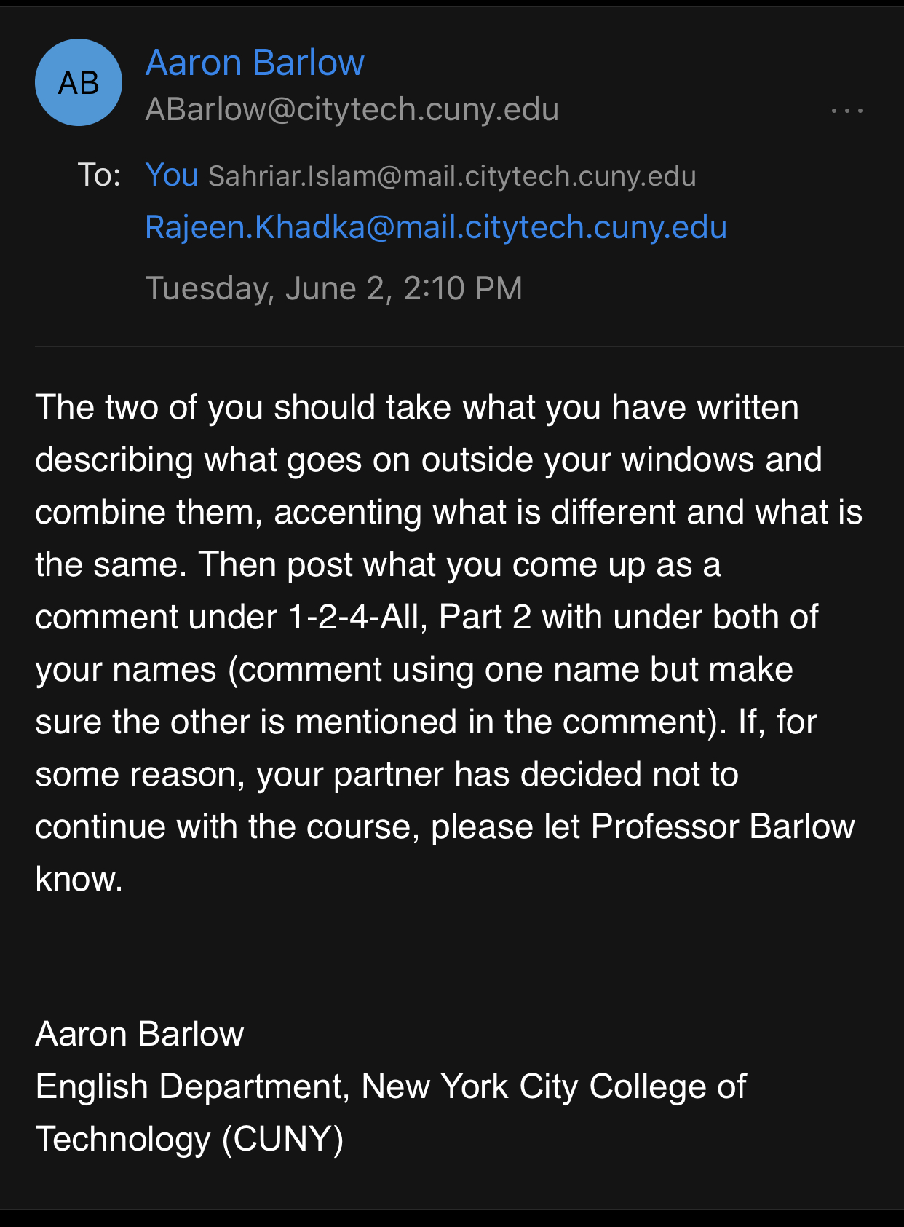

- Date: 06/03/2020
I and Rajeen completed Task-3 and posted it on OpenLab. On that task we wrote about similarities and dissimilarities of our Task-2.
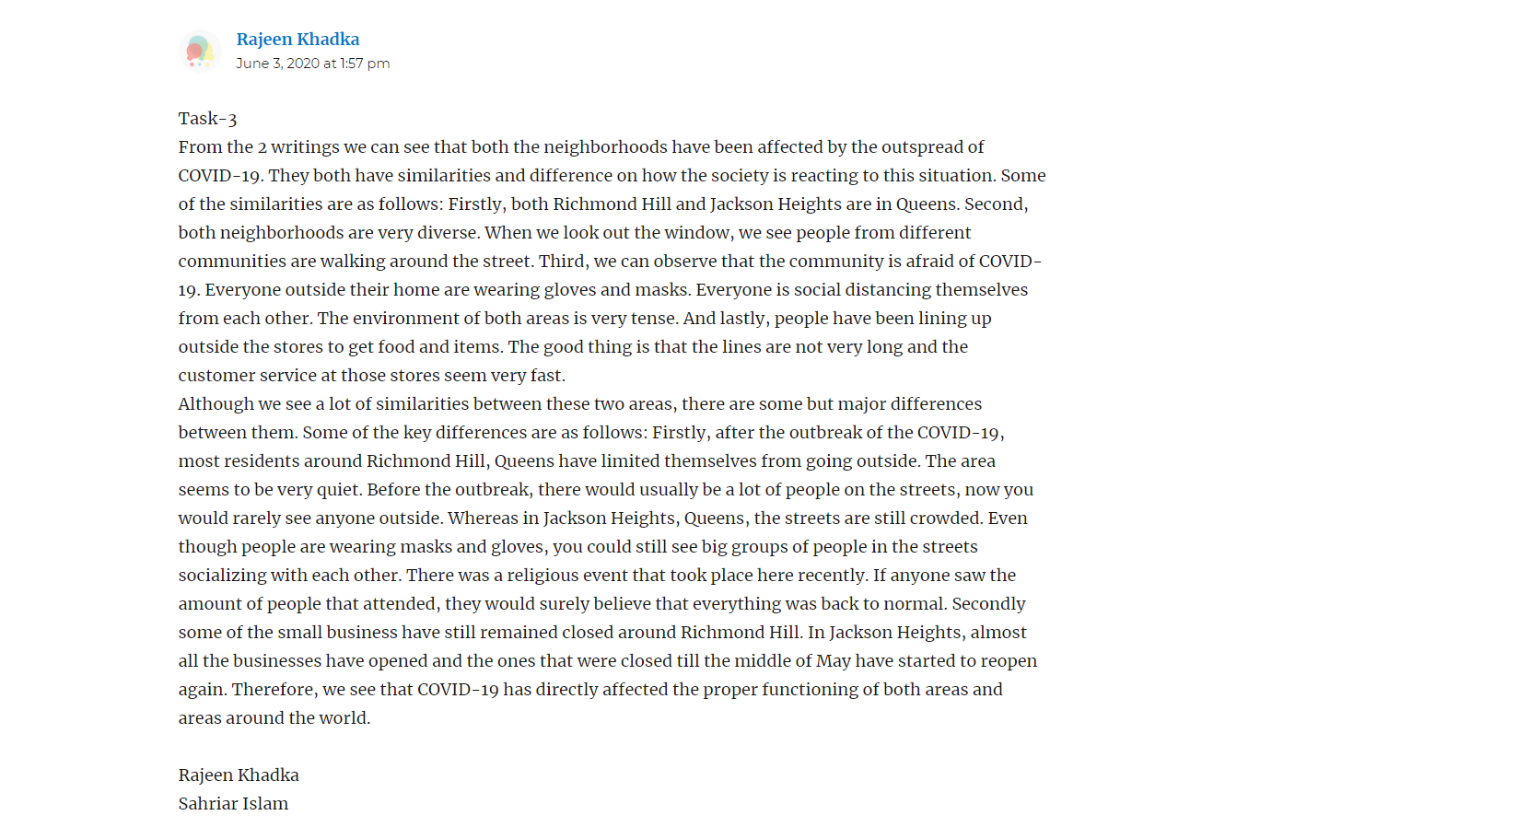

- Date: 06/04/2020
The professor added Ana Panameno and Luftar Nahar to our group, and he assigned us to complete Task-4 together. We contacted each other and decided to create a group on skype for group discussion.
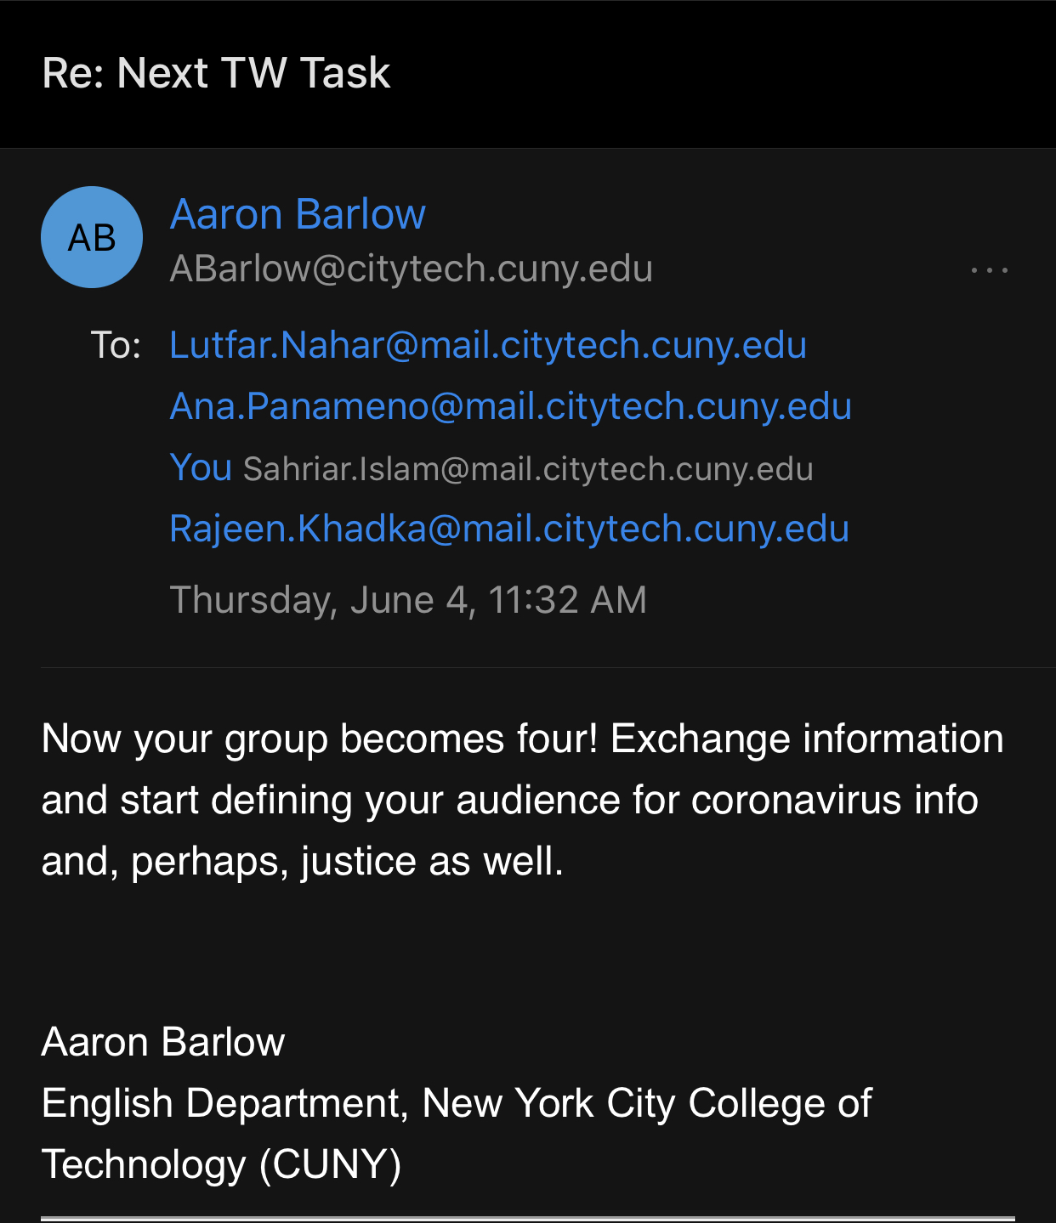
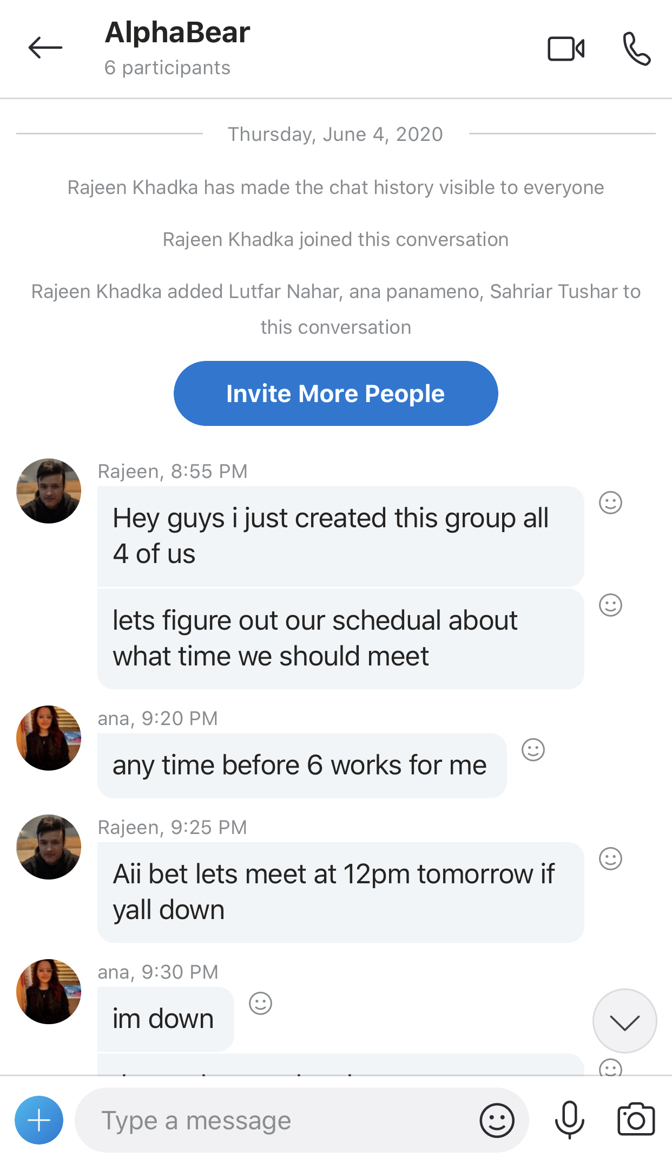
- Date: 06/06/2020
We completed the Task-4 and posted it on OpenLab. It was about comparing our neighborhood’s scenario during the pandemic.
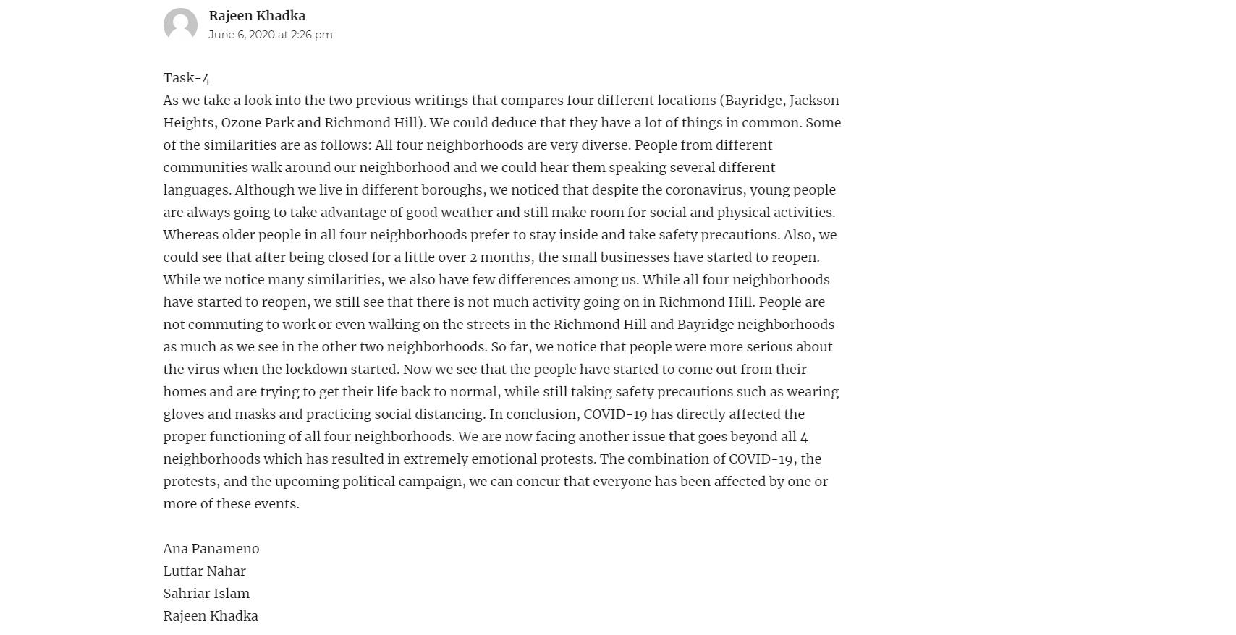

- Date: 06/10/2020
After a long discussion over the skype call we picked our topic for the final project, and we informed other groups about our topic.
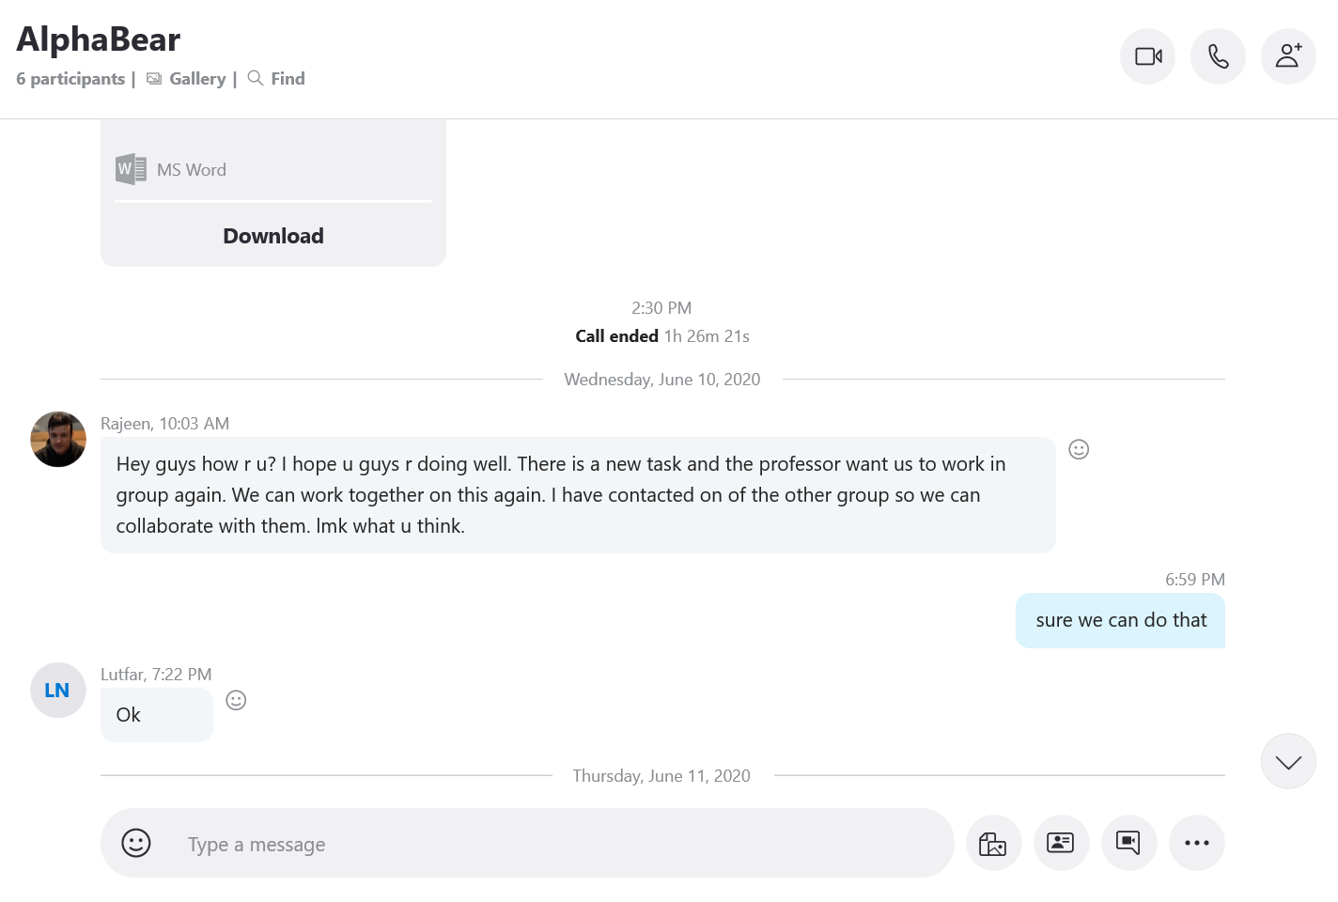
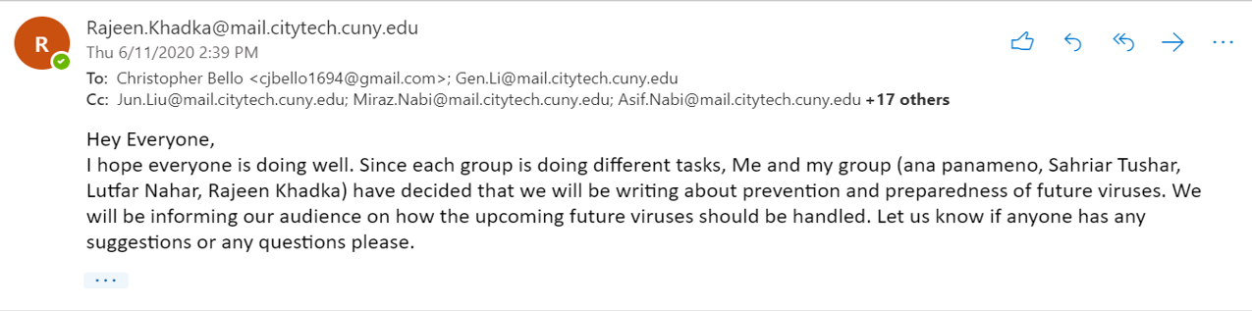

- Date: 06/12/2020
We started working on our final project.

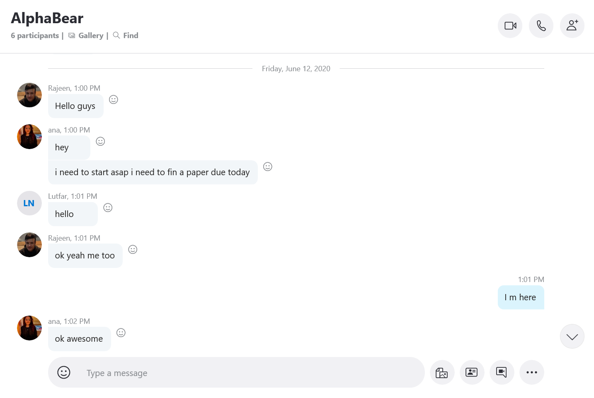

- Date: 06/16/2020
We created a project proposal regarding our final project and posted it on OpenLab as Task-5.
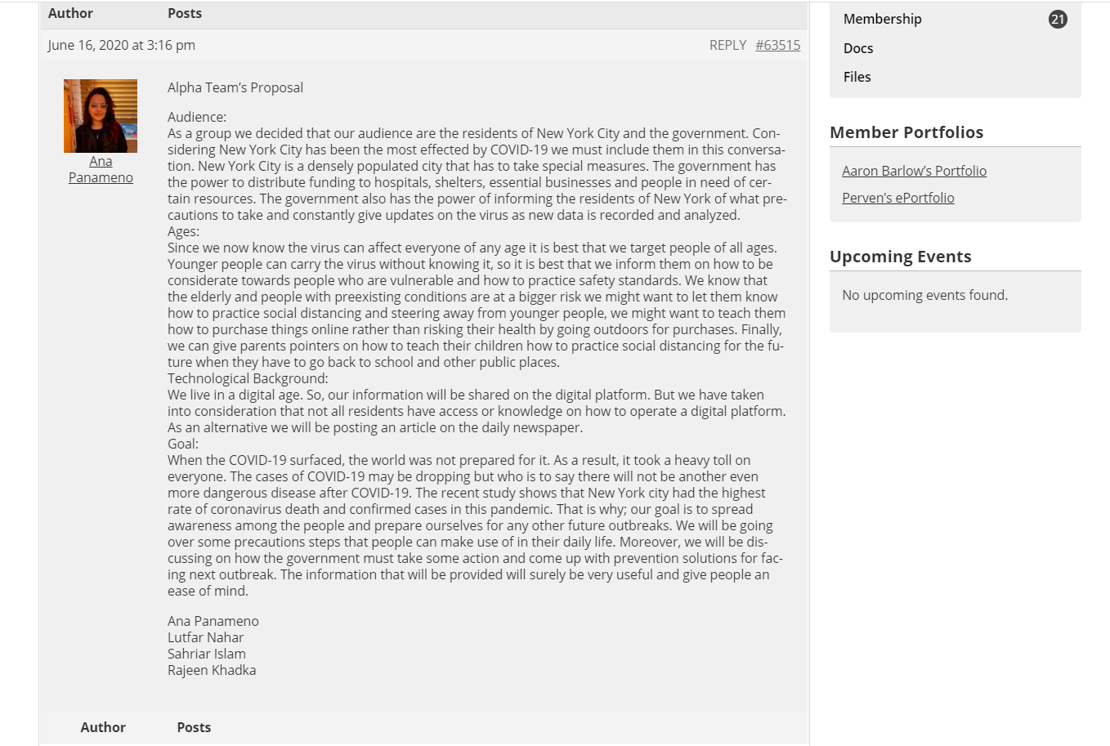

- Date: 06/20/2020
We started working individually on different parts of our project in order to create a resourceful website.

- Date: 06/25/2020
We created our first initial website with four webpages.
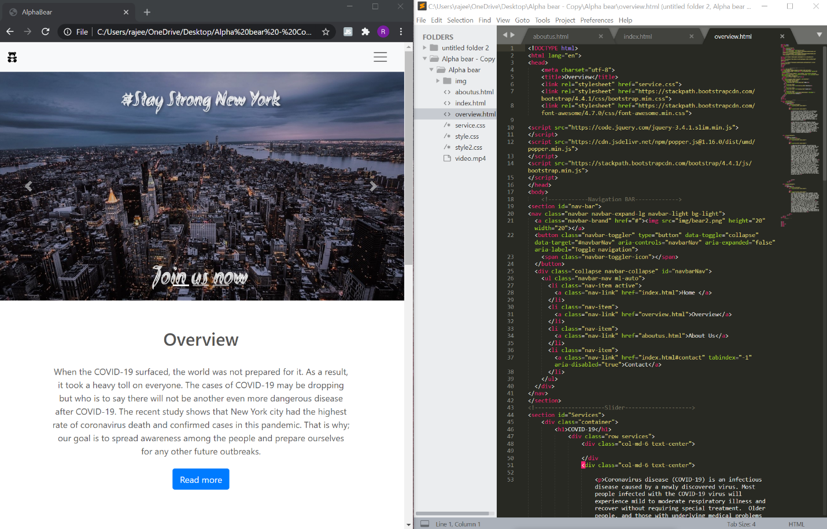

- Date: 06/29/2020
We updated and designed our website with all resources.
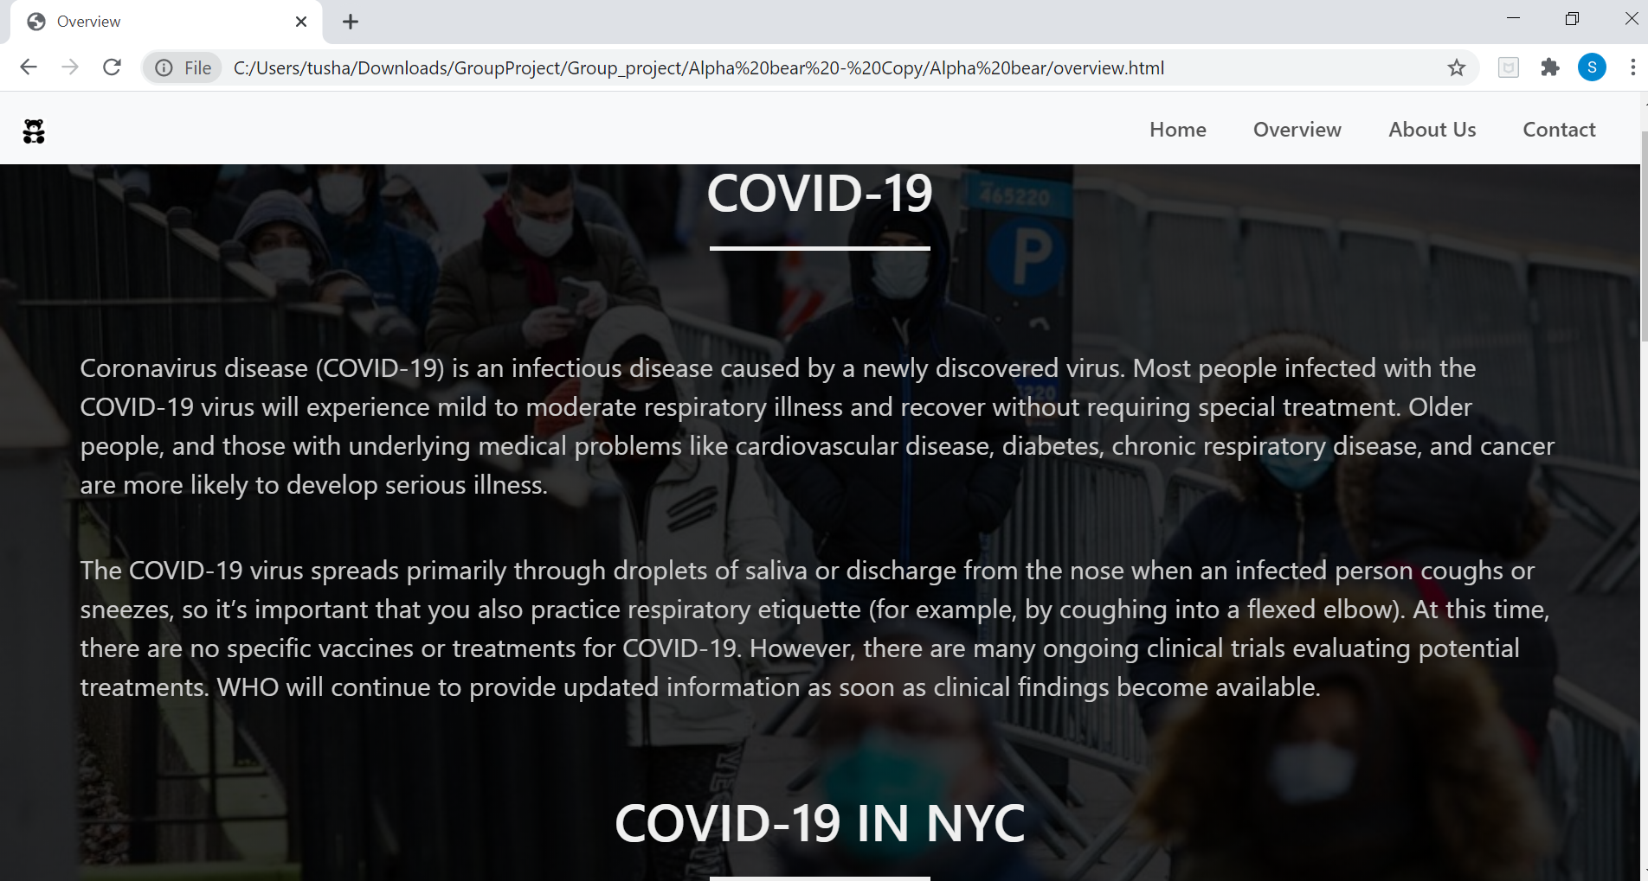

- Date: 06/30/2020
Two more people (Asif Nabi & Miraz Nabi) joined our group with their resources and ideas.

- Date: 07/01/2020
We wrote an overview to submit our final project.

- Date: 07/02/2020
We updated and designed our website for final submission.

LETTER

Dear Professor, Leston,
This is my first fully online writing class, and I was very enthusiastic about it. I would like to thank you for taking over this class in absence of Prof. Barlow.
I found this class very interesting because I had an opportunity to work on current world issue. From the beginning of the class I worked in a group and I came to learn so many strategies and techniques. I had not worked with any group for long time, but in this class, I spent whole semester working with a group. It is completely a different experience for me. From this experience, I realized the spirit of teamwork, and I came to know that how a successful team can achieve their goal easily.
In this class, my first and second tasks were to observe my neighbor and neighborhood scenario, but as a matter of fact I had never experienced to observe my neighbor so closely. When I worked with other persons in a group, I came to know situation of their neighborhood during the pandemic and their point of views. When I started working on our final project, I had to research on COVID-19 effects, and I learnt so many unknown information which enriched me with experience. I also studied on prevention method of probable outbreak which is a challenge for us to face. If I did not take this class, I would be deprived of this opportunity.
Overall, this class was very amusing to me. I learnt how to form a group and get team spirit to work together. I do believe that help me in my future IT career because most of job places required to work with team. I am very much optimistic to use my experience in my real life and thank you for your kind effort.
Best regards,
Sahriar Islam

