Rajeen Khadka
ENG2575
Summer 2020
1. Research:
During the semester, I along with my group did multiple researches on the current state of our neighborhood. Looking at our posts, we researched about COVID-19: how it has affected our neighborhood and the world and what must we do to protect ourselves from it. Another research we did was for our final group project. We included information on the impact and handling of COVID-19 and any future diseases.
2. Participation:
During this semester, communication was key to complete all the tasks for this course. My group included Ana Panameno, Sahriar Islam, Lutfar Nahar, Asif Nabi and Miraz Nabi. I mostly worked within my group, but I also exchanged several emails with members outside our group to figure out the topic and information of my group’s final project. For more details, conversation pictures can be found on the Journal Entry section. As for the final project, I was tasked with designing and updating the website along with conducting several researches.

3. Journal Entry:
Entry #1: 06/01/2020
Posted the first part of the assignment. The first part was an individual assignment.
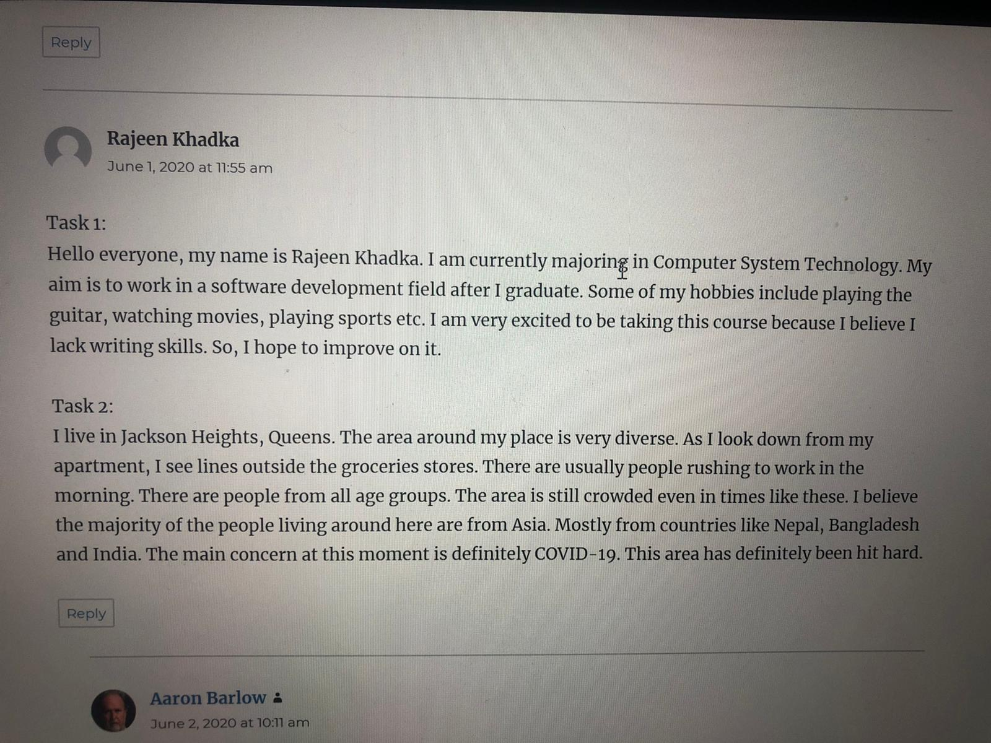

Entry #2: 06/02/2020
Professor paired me and Sahriar Islam together for the second part of the assignment. The communication was done via WhatsApp.
Entry #3: 06/03/2020
Posted the third part of the assignment. The third part included the similarities and the differences between mine and Sahriar’s neighborhood.
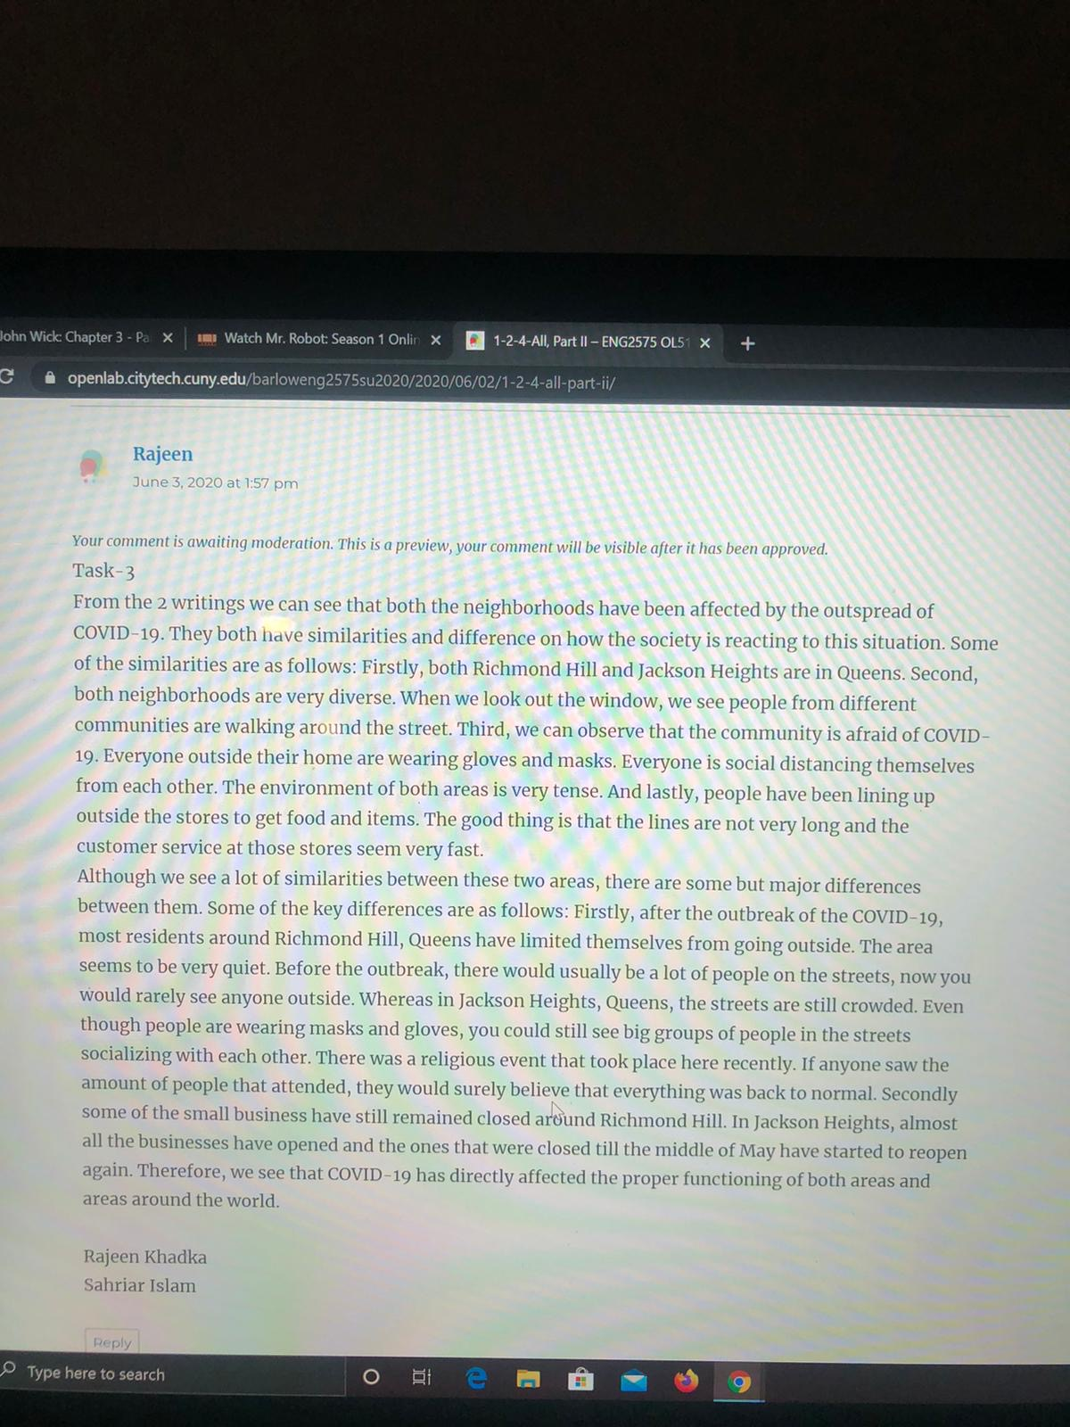
Entry #4: 06/04/2020
Professor paired me and Sahriar Islam together with Ana Panameno and Luftar Nahar for the next task. The communication between all four of us was done via Skype. Our group task was to compare all our neighborhoods with each other’s. The professor also selected me at random to be the point person on my group. My job according to my knowledge was to communicate with other groups and work on the final task.

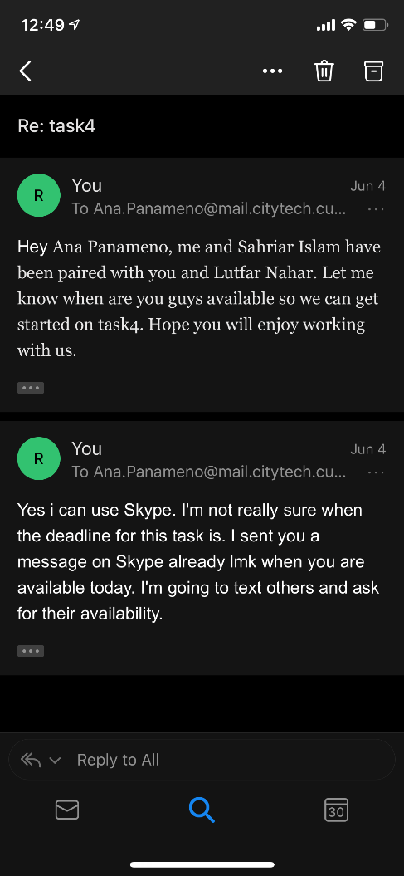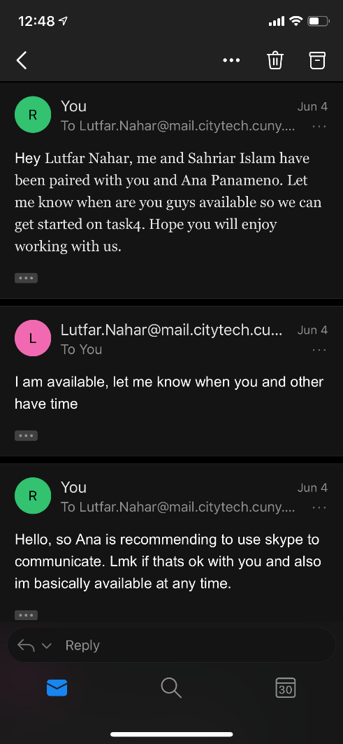
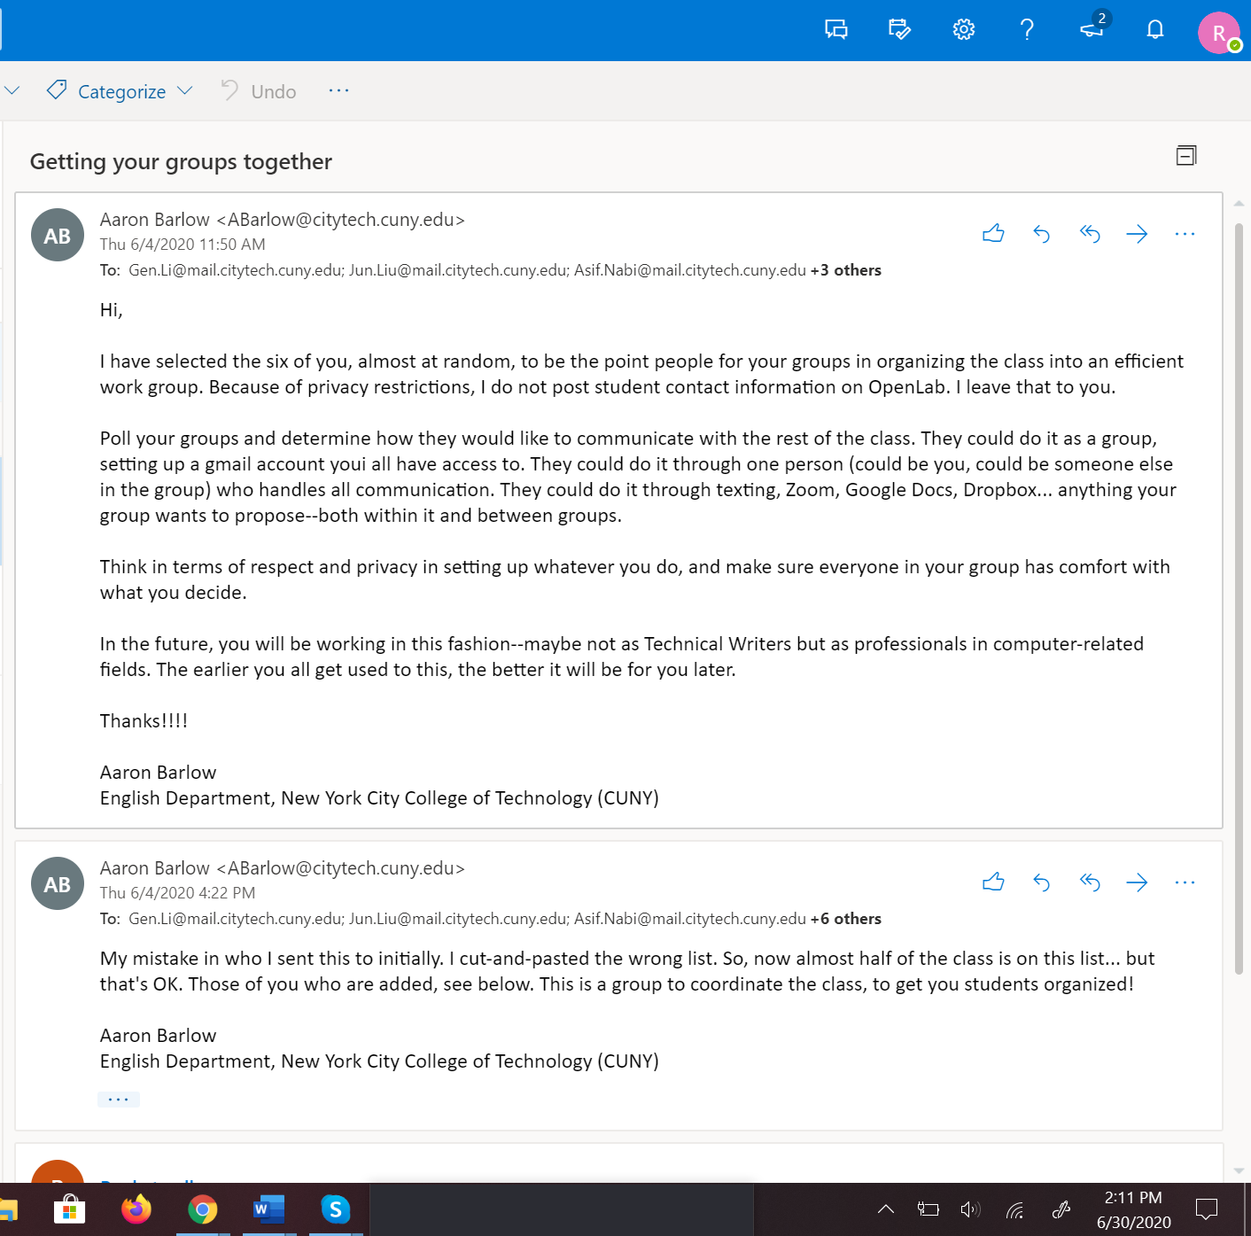

Entry #5: 06/10/2020
Exchanged emails between the class to get started.
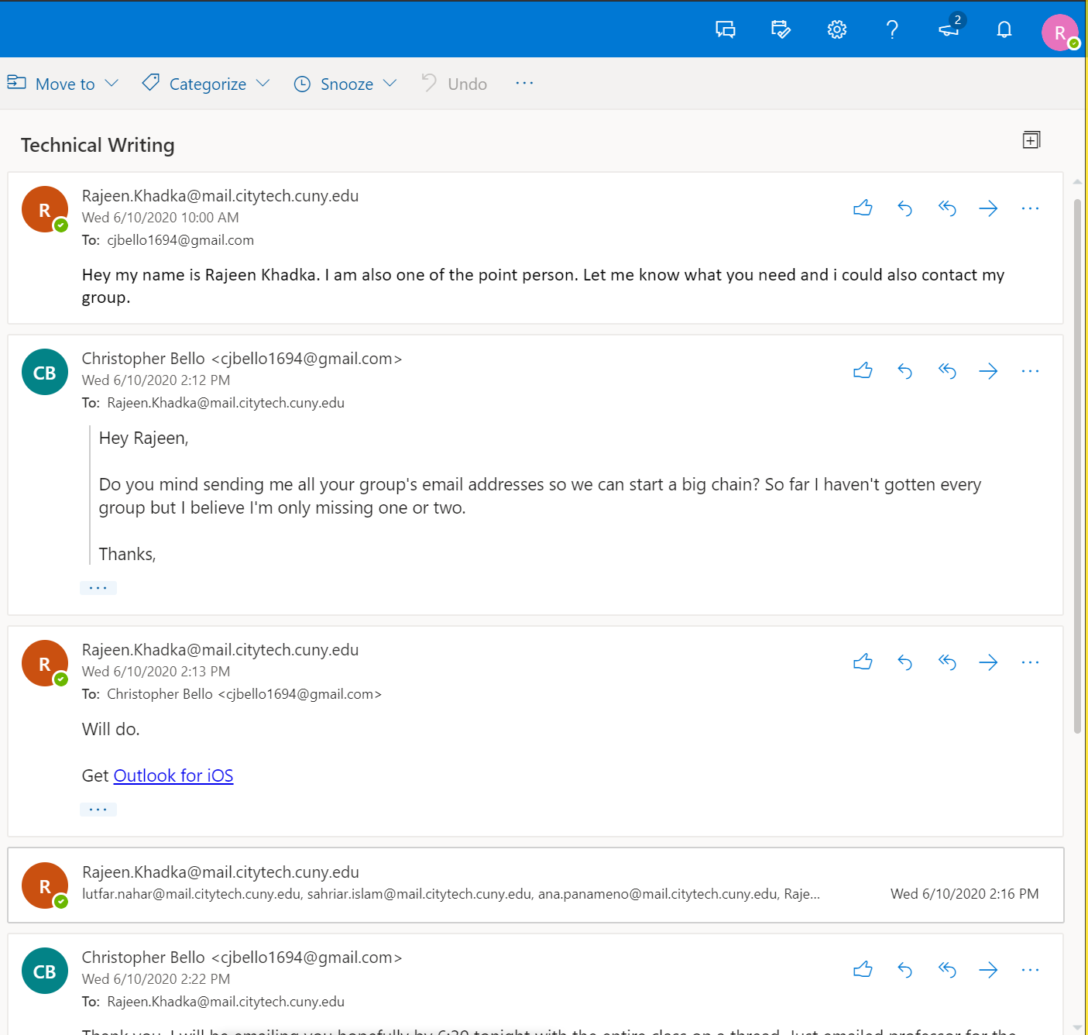

Entry #6: 06/11/2020
After discussing with the group. We decided on our topic of the final project and I emailed the class of what our group was going to do.
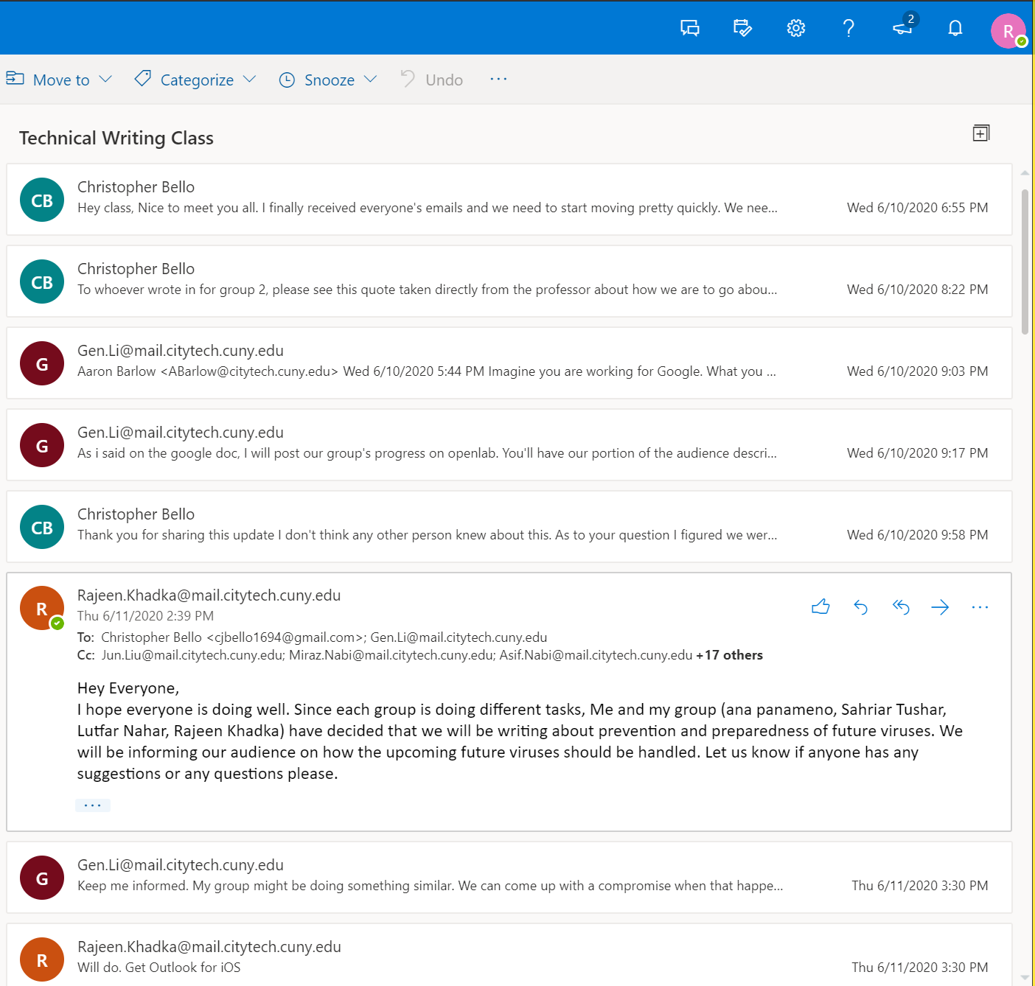

Entry #7: 06/12/2020
One of my fellow classmates emailed me that both of our group’s topic was kind of similar. So, we had to sort that out. We exchanged in depth details on our part of the final project and got it sorted out.
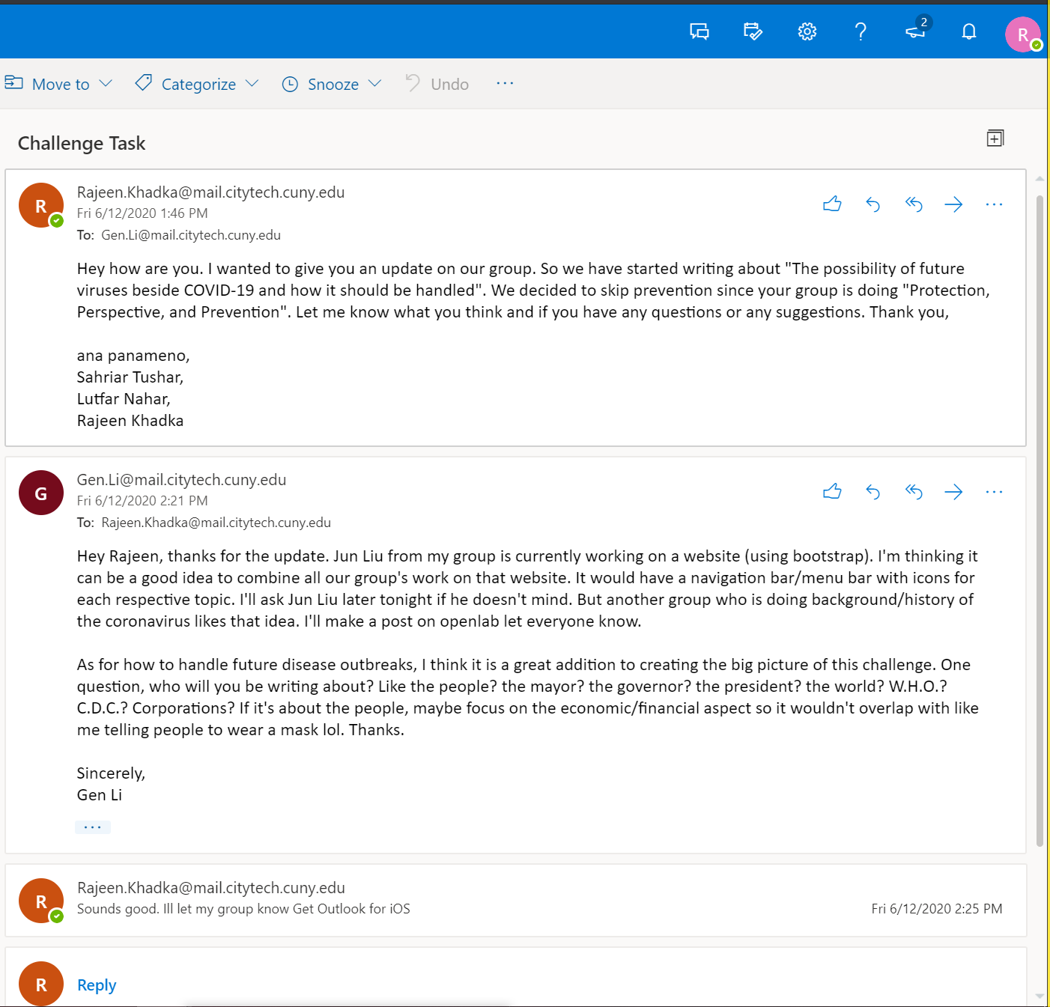

Entry #8: 06/16/2020
Me and the group met a couple days in a row to work on the proposal of our final project. We posted our proposal on the discussion section on openlab.
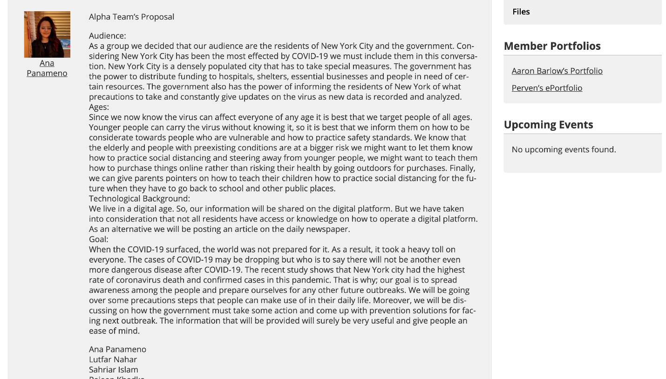

Entry #9: 06/20/2020
Today the group assigned individual tasks for our final project. My task was to design and update the website. Sahriar Islam, Ana Panameno and Luftar Nahar had the task of researchers.

Entry #10: 06/25/2020
I created a website with 4 webpages using HTML and CSS. The group met every day at around 1:30 to finish the final assignment.

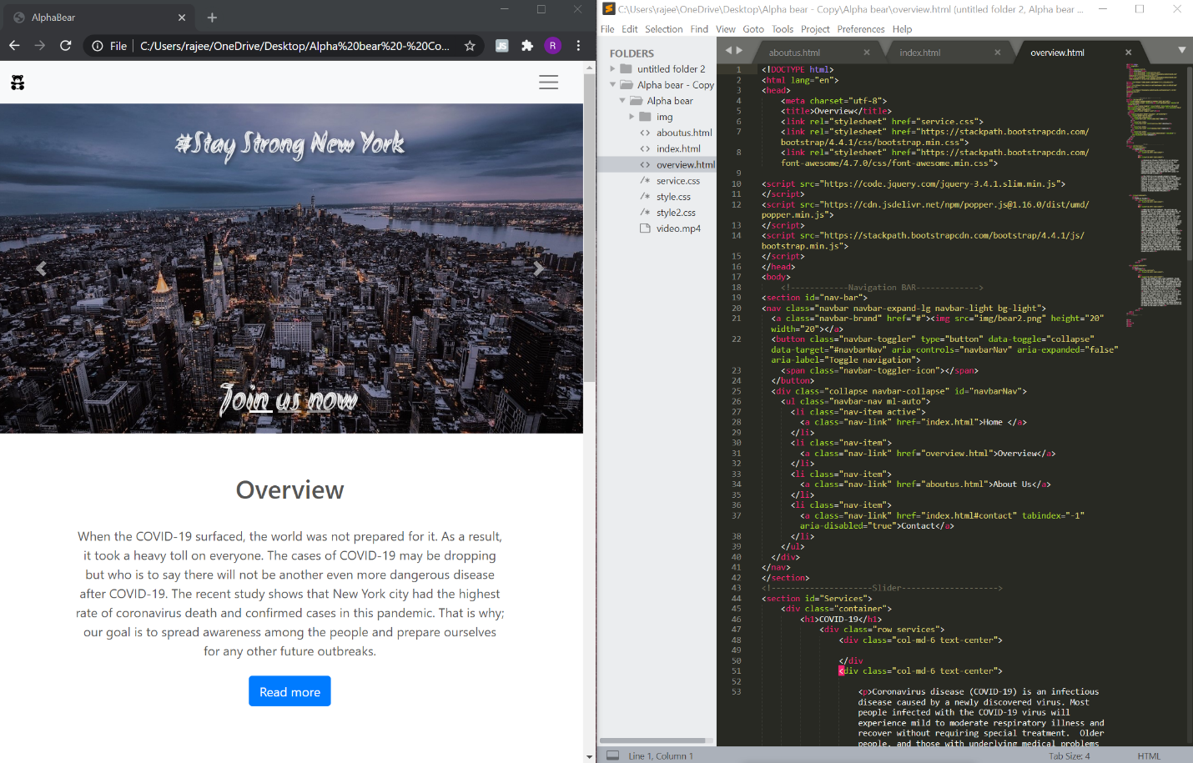

Entry #11: 06/29/2020
We combined all our ideas and finalized our project.

Entry #12: 06/30/2020
One of our classmates emailed me saying they had a falling out on their group and asked me if they could come join our group. They said they had asked the professor and the professor told them it was ok to do it. I told them I had to discuss with my group since all the assignment was already done.

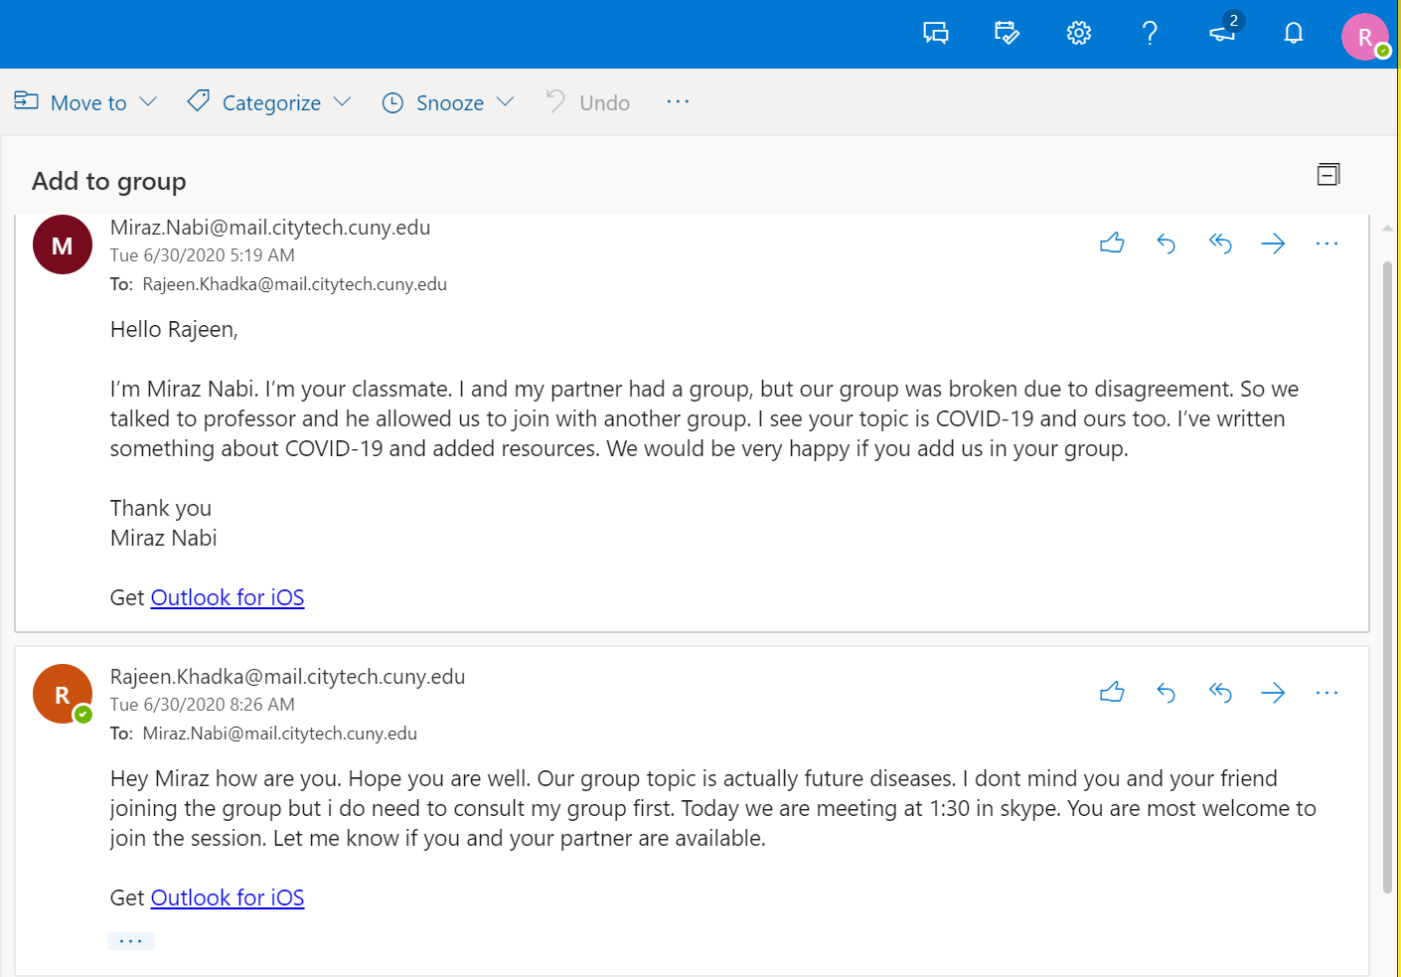

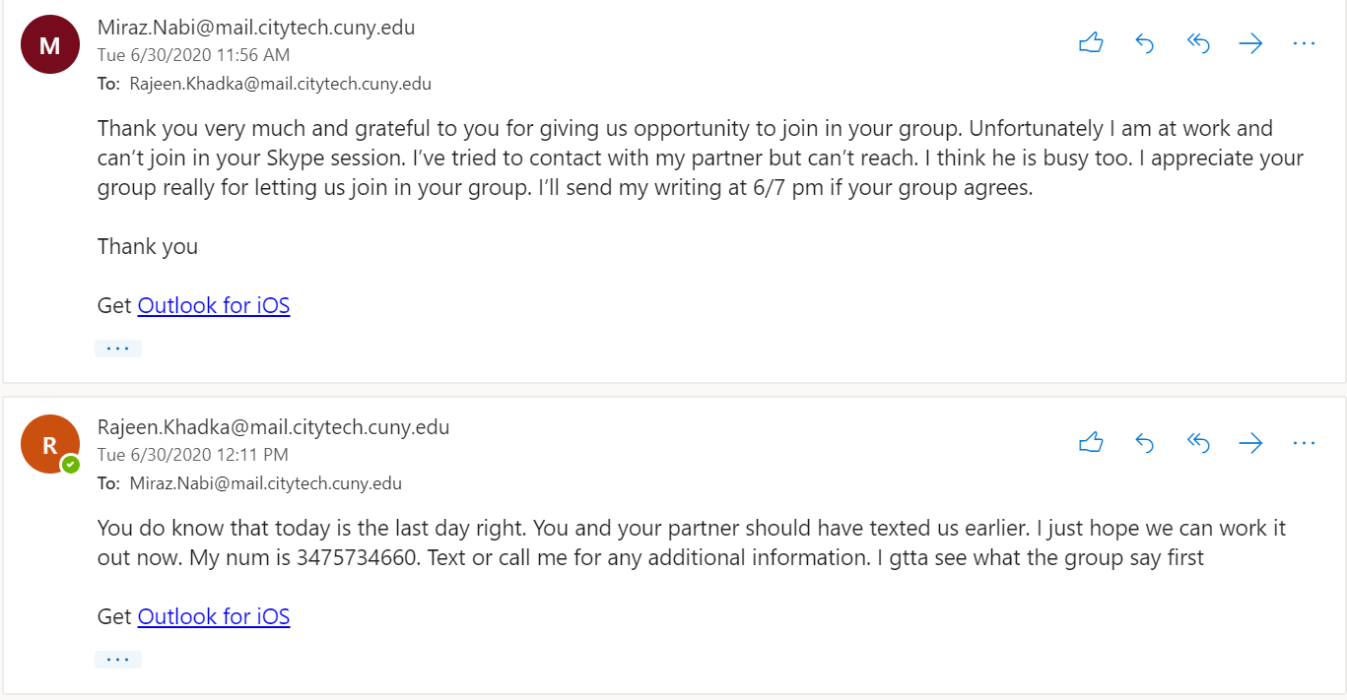
Entry #13: 06/30/2020
After discussing with Ana Panameno, Sahriar Islam and Lutfar Nahar and since they had the permission from the professor, we decided to let them join our group. We assigned them the group task that the professor posted today.

Entry #14: 07/02/2020
We finalized everything today. We finished writing out post and finished with the website. Only the individual task remained.
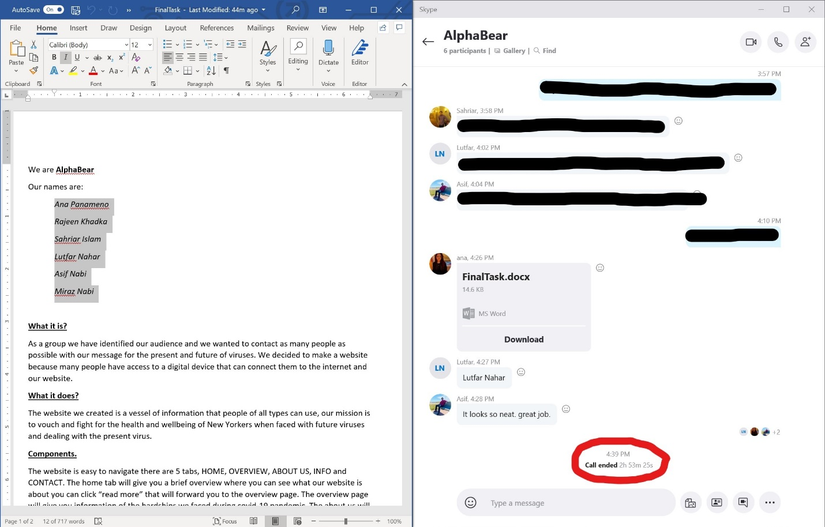

4. Letter:
Dear Professor, Lestón,
Firstly, I would like to thank you for taking over this class in its time of need and I wish Professor Barlow a speedy recovery.
This class was definitely very interesting for me. I had worked in groups before, but I had never worked with the entire class. I got to know different people and see how they operate. Everyone had their own skill set which they brought to the table and tasks had to be assigned to them according to it. Almost all the assignment for this course had to be done as a group. When doing the group work, proper communication was very important.
During the middle of the semester, I was picked at random as a point person for my group. My job was to communicate with the point persons from another group and come to a decision on each of our group’s final project. This experience was very new to me. I tried to keep my group organized and consistent as possible. Me and the group met almost every day beside the weekends to work on the final project. We exchanged a lot of ideas. Everyone was very friendly and very cooperative.
In conclusion, this semester was very interesting and useful. I understood why proper communication is very important when working with a group. During the semester, I learned how to communicate better, distribute tasks, and manage people. These skills are very important to me because I am pursuing a software development career so I will be working in teams mostly in the future. I am very glad, I had the opportunity to take this course and thank you again so much for your hard work.

Sincerely,
Rajeen Khadka

