Md Sakib
ENG-2575 OL-51
July 3rd, 2020
Individual Final Work

Explanation of Research
During the semester, we did two research as a group. In the beginning of the semester, we have researched on COVID-19 in our neighborhoods. How people react to that in different neighborhoods. We also posted our work in the comment section on OpenLab. For the final project, Professor Barlow gave us an option to research on either COVID-19 or Justice in America. Our group decided to research on justice and racial equality in America.

Explanation of Participation
Professor Barlow told us to work with groups so we learn how to share our thoughts with other and increase our communications skill. In the beginning, I was working with Mohamed Sawadogo and shared our similarities and differences in our neighborhoods. Even though we were supposed to have four members in our group for the final project, one of the group member decided to drop the course in a last minute. Thus, Me and Mohamed worked with Chris Gyasi for the Final proposal and the project. We also had contacted with other group members and shared with each other what we are doing for the final paper. Each member in our group has put efforts and shared ideas. Although, we all put informations, my job was to create the websites for the final research project and put the informations there.

Log/journal with dates
Dates | Tasks | Groups  Members | Accomplishments | Comments
5/31/2020 | The 1-2-4-All Challenge and… oh, yes, Hello!  Part I | It was an Individual task. | After I introduced myself in the comment section, I have described my neighborhood according to the second task. How people in my neighbor react towards  COVID-19.  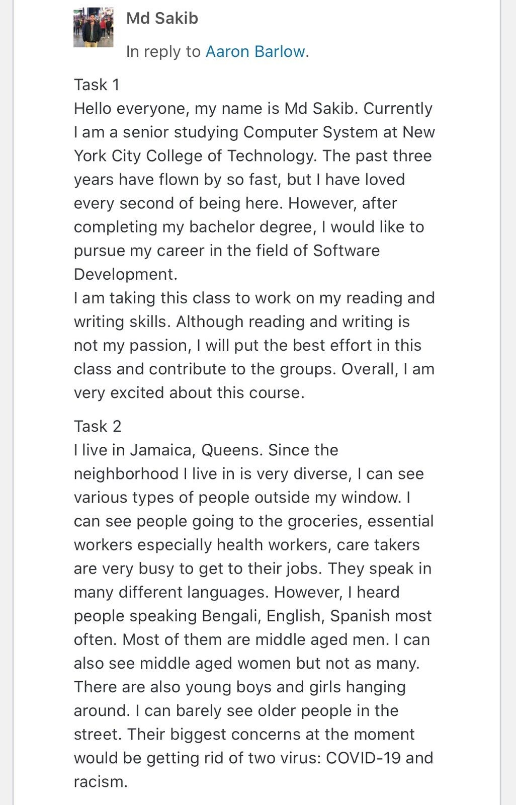 | I really like the way professor started this class. Since we can not interact with each other in person it is describing ourselves and hobbies does help getting to know each other.
6/02/2020 | The 1-2-4 All  Part II | For this task, I was assigned to work with  Mohamed  Sawadogo | We emailed each  other and exchanged our numbers. We created a google document in order  to prepare ourselves for the next task.
6/03/2020 | The 1-2-4 All  Part II |  | We both shared the similarities and the differences in our neighborhoods. | It was a pretty easy task.

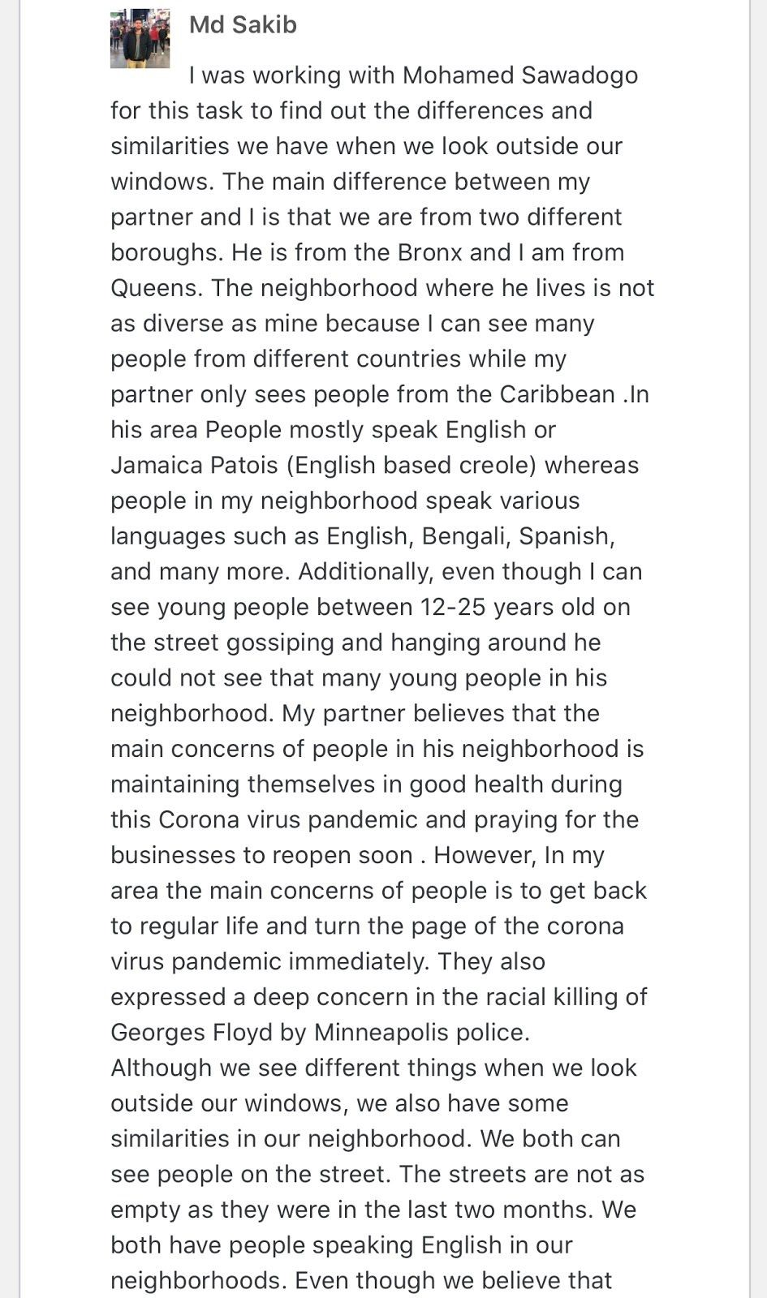
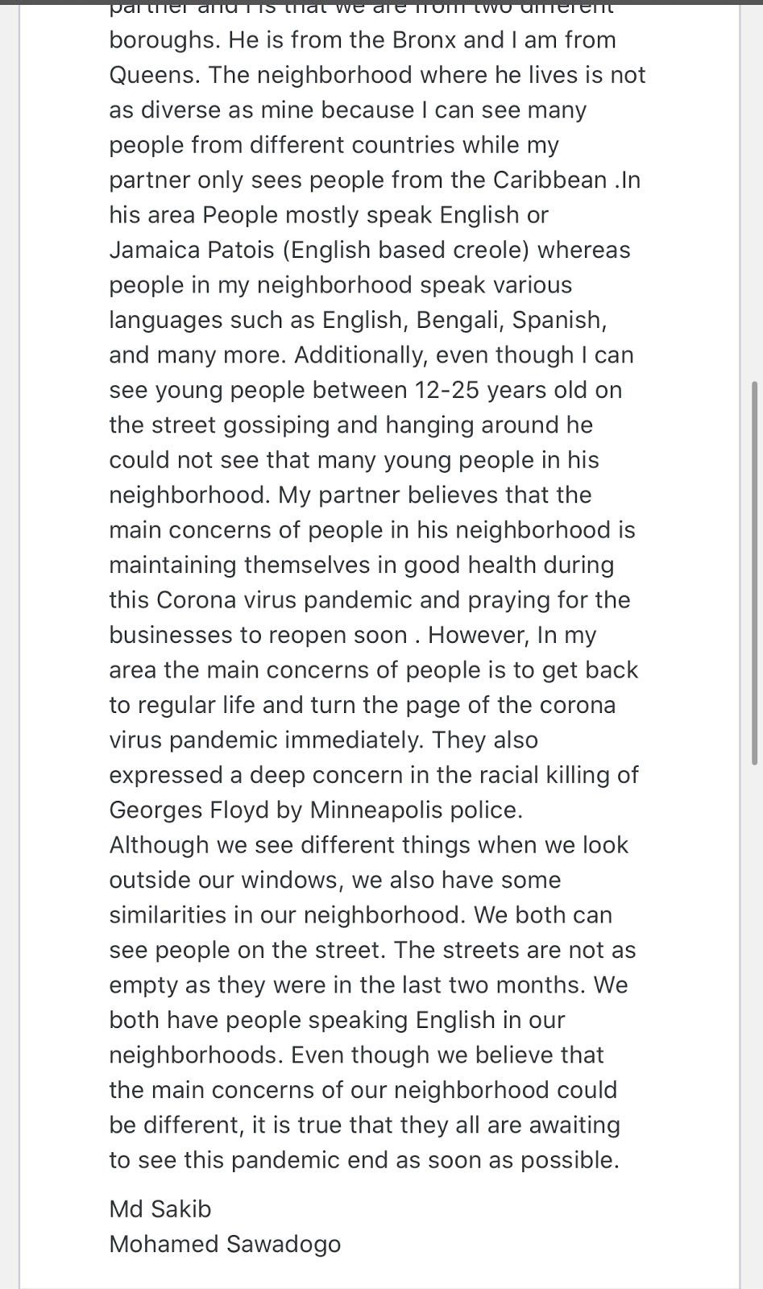
6/04/2020 | The 1-2-4 All  Part III | Professor paired me and  Mohamed Sawadogo with Chris Gyasi and another student. On the same day, he dropped the course. So only three of us ended up working for this project. | For this task, we had to compare and  contrast our neighboorhoods with each other. I created the document with other two members and we all shared our thoughts equally.  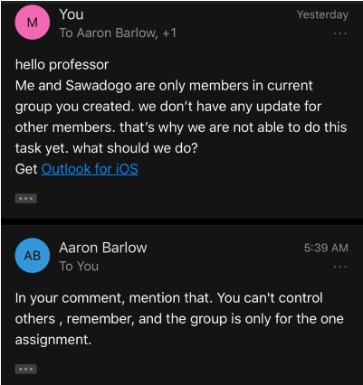 | Both of them were very  friendly so it was comfortable to work work with each other.

6/10/2020 | Getting started for the proposal of the  Final Project | Me,  Mohamed,  Chris | We all were required to share our emails with whole class and  create a documents
6/11/2020 | Proposal of the  Final Research  Paper | Me,  Mohamed,  Chris | We, as a group had to decide which topic we would be doing research on and share the outlines on the same document. Although most of the groups picked COVID-19, we have decided to research on Justice in America. We also let the other groups know via email. | It was pretty difficult to choose the research topic and finally we get to decide.
6/13/2020 | Proposal of the  Final Research Paper on Justice and Racial Equality | Me,  Mohamed,  Chris | We shared our thoughts what to put for the final paper vis texts.
6/14/2020 | Proposal of the  Final Research Paper on Justice and Racial Equality | Me,  Mohamed,  Chris | We worked on our proposal for the research paper. | Everyone was very active.
6/16/2020 | Proposal of the  Final Research Paper on Justice and Racial Equality | Me,  Mohamed,  Chris | We were debating on who our audiences will be, the age groups, the goals and the | Everyone was participating

 |  |  | challenge for our final project. Each members put thoughts on a document.
6/17/2020 | Proposal of the  Final Research Paper on Justice and Racial Equality | Me,  Mohamed,  Chris | We came up with our proposal, goals, and challenge. We have decided to revise our work then post it on the OpenLab.
6/18/2020 | Proposal of the  Final Research Paper on Justice and Racial Equality | Me,  Mohamed,  Chris | We finally posted our work in a individual blog titled as Justice and Racial Equality Foundation. | Everyone put their best effort.
6/20/2020 | Getting started to work on the Final Research Paper on  Justice and Racial  Equality | Me,  Mohamed,  Chris | We all were working together for the websites we need to create.
6/28/2020 | Final Research Paper on Justice and Racial  Equality | Me,  Mohamed,  Chris | We gathered all the informations. | Everyone put their effort equally
7/01/2020 | Final Research Paper on Justice and Racial  Equality | Me,  Mohamed,  Chris | We all were researching to put more informations. After we put all our thoughts and informations, we decided to crated few headers so that way it would be easier for our audiences to | Everybody was involved equally.
 |  |  | understand our point of views.
7/03/2020 | Submission day of the Final Research Paper on Justice and Racial  Equality | Me,  Mohamed,  Chris | We were finishing up our final project by putting all the informations into the websites. Getting ready to submit our final research paper of the course.  My role was to create the Website for this project and put all the informations there also at the end I edited all of our works. | I think everybody has done a great job and super kind to each other.

Reflection on the semester letter

Dear Professor Leston,
I would like to start this letter with appreciation. I would like to Thank You for taking over this class otherwise we might not have completed this course successfully. I really hope Professor Barlow will get better soon.

The journey of this semester went pretty smooth. This was actually my second course with Professor Barlow. I took another English course with him during the Spring semester. I was never a fan of online classes but he made online classes super easy which is way I have decided to take this class in the summer although it was online. One thing I have learned in this course was how to communicate as a whole as with each other virtually. I worked with groups for many of my classes but never worked in a group for online classes. So, it was a different experience for me.

The class was not as difficult as I thought it would be. Most importantly, everyone was very kind and supportive to each other which made the class very easy and interesting. Time management was the key for online classes. Since I was taking two classes at the same time in the summer, it was kind of difficult for me to put myself ahead of everyone but I managed it successfully. My group members were very responsible and they took the initiative whenever they needed.

Nevertheless, the lack of in person interaction with both instructors and classmates was the most​ challenging part for me. We were all confused about some tasks during the semester but we communicate with other and figured it put. Although this semester had ups and downs, I have​ learned so much during this summer session. I did not let any negative thoughts impact me in my academic journal. I have maintained time management as much as possible in order to make sure I do not fall behind.

In conclusion, this semester also taught me to have patience in order to gain big achievements.
Thus, I chose not to give up when I had the option to do so while many students did give up.
Overall, it was an excellent journey and experience for me.

Sincerely,
Md Sakib.

