Miraz Nabi

Prof. Robert Leston

ENG 2575

Summer 2020

**1.Explanation of The Research**

My research is to provide information of government (federal and state) support and services because of coronavirus. Most people in New York City are affected by coronavirus directly or indirectly. People have lost their job, businesses, health insurance, had a lack of food and the internet and fear of losing their rent and house. So, I have added all the information to get the resources that are needed most. I have also included some video links to see how to apply to them. In the second group, I worked on blog post and helped final editing of the website.

**2.Explanation of Participation**

I participated with Gen Li who oversaw writing and editing, Jun Liu who oversaw designing website and Asif Nabi who oversaw visual organizer. I worked in a second group with Rajeen Khadka who was in the position of designing and editing website, Shahriar Tushar who was in the position of research of future outbreak, Lutfar Nahar who was in the position of research of task writing and Ana Panemano who was in the position of writing and editing. My participation in the final group project are the impact of our project will have upon people and some ideas on our proposal.

**3.My Journal**

**Entry #1: 05/31/2020**

I posted the first individual assignment. It is the first part of the assignment.

**Entry #2: 06/02/2020**

The professor paired me with Asif Nabi together for the second part of the assignment. The communication was done via phone call.

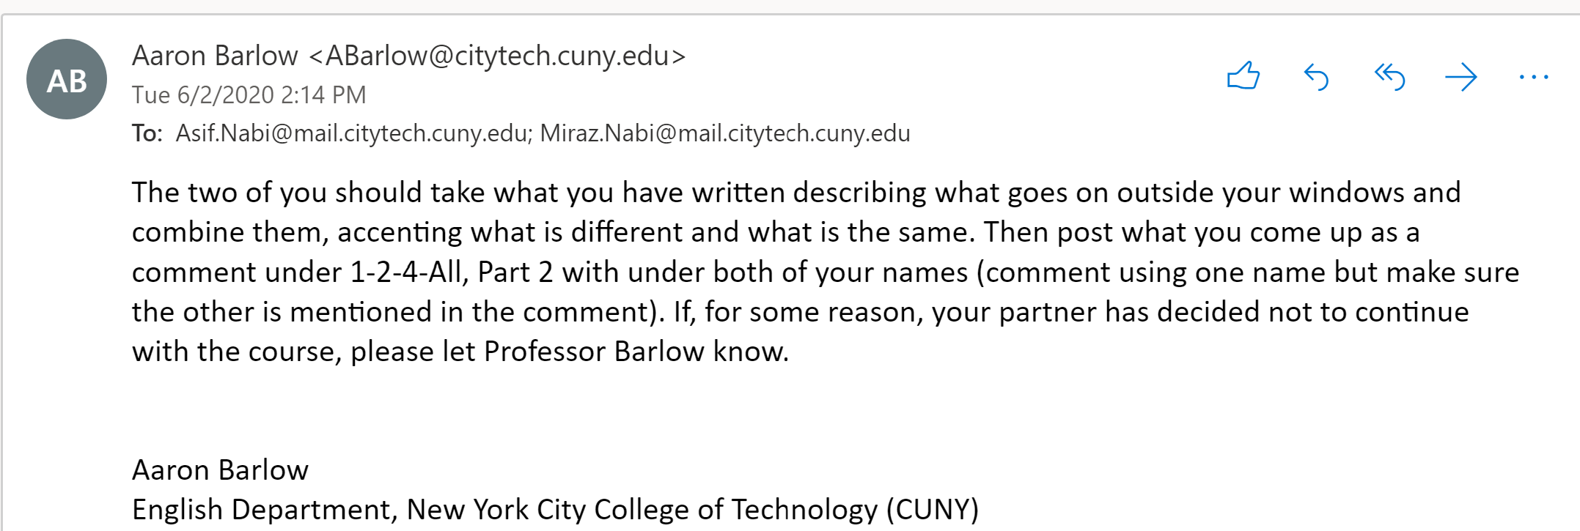

**Entry #3: 06/03/2020**

Posted the third part of the assignment. The third part included the similarities and the differences between mine and Asif’s neighborhood.

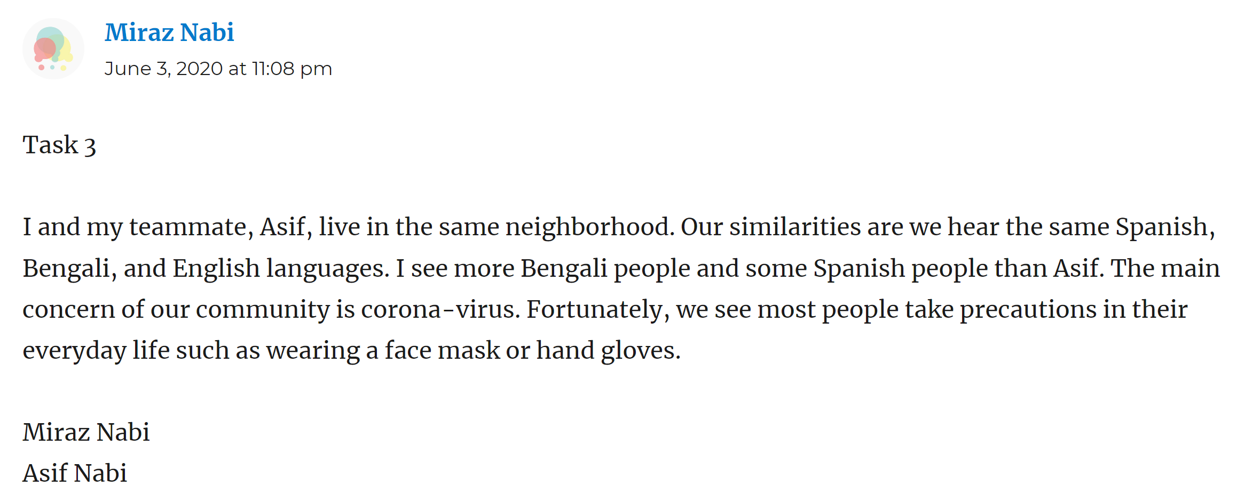

**Entry #4: 06/04/2020**

Professor made a group of four. He paired me, Asif, Gen Li, and Juan Liu for the next task. The communication between all four of us was done via WhatsApp message. Our group task was to compare all our neighborhoods.

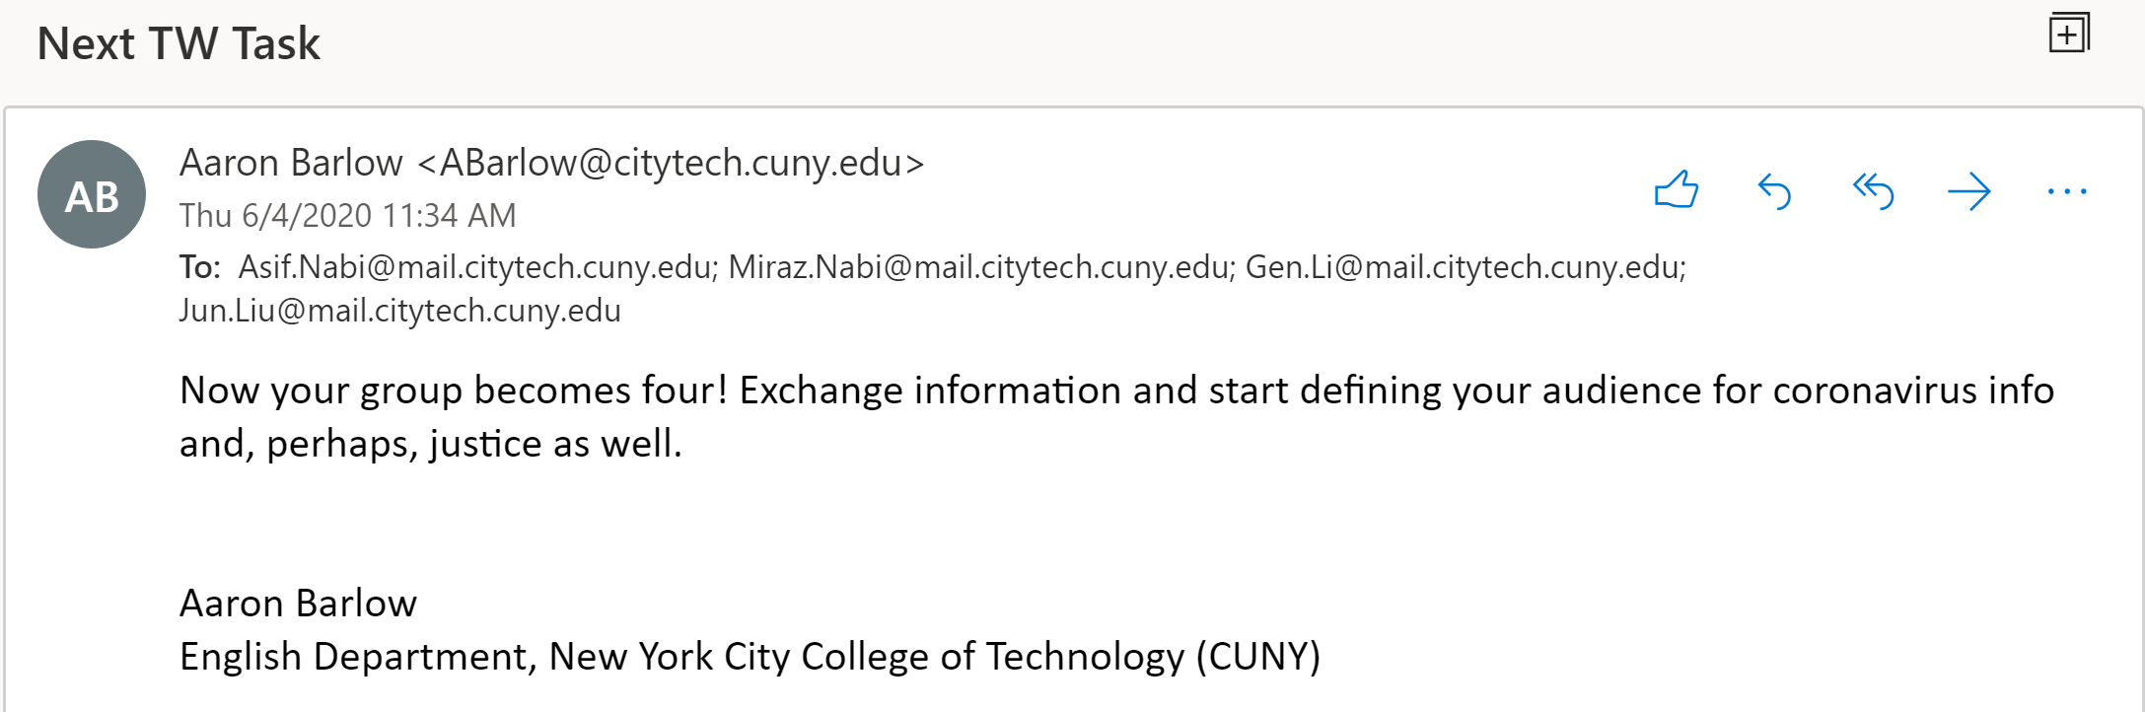

**Entry #5: 06/04/2020**

Exchanged emails between the class to get started.

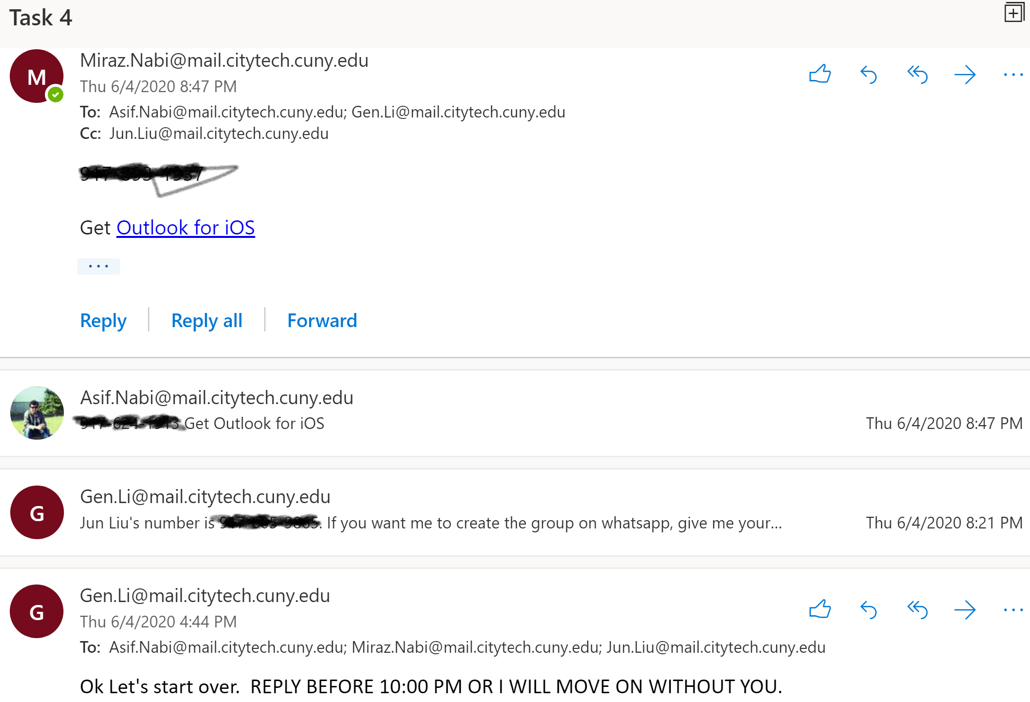

**Entry #6: 06/05/2020**

We posted our fourth part of the assignment. The task was finding similarities and differences among our neighborhoods.

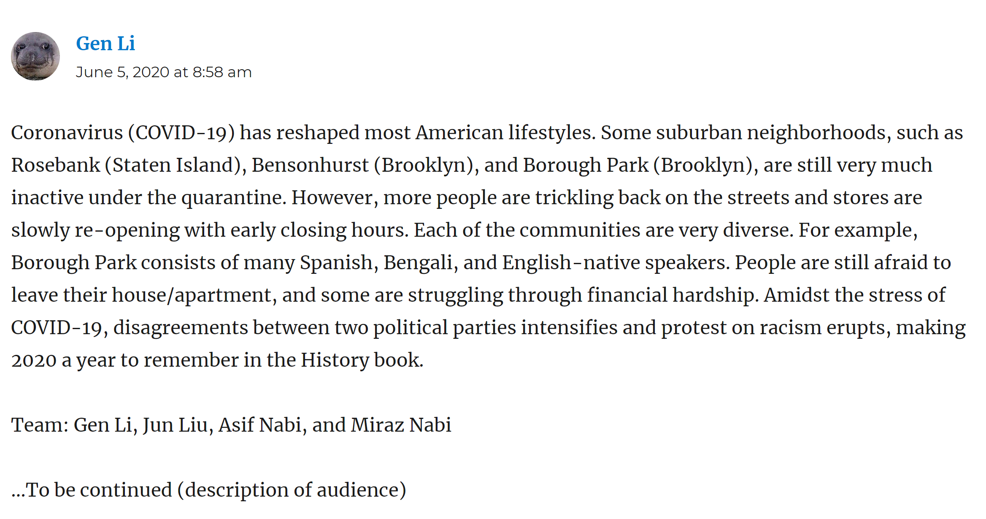

**Entry #7: 06/10/2020**

After discussing with the group. We decided on our topic of the final project and posted a blog on Openlab of what our group was going to do.

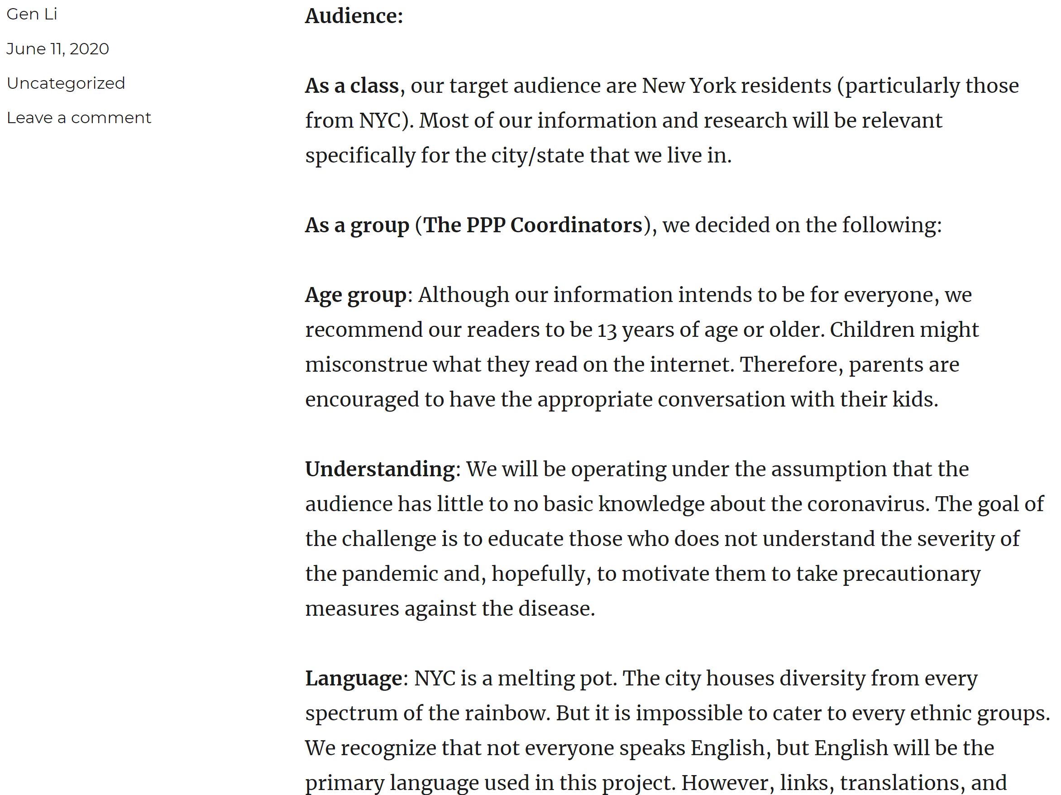

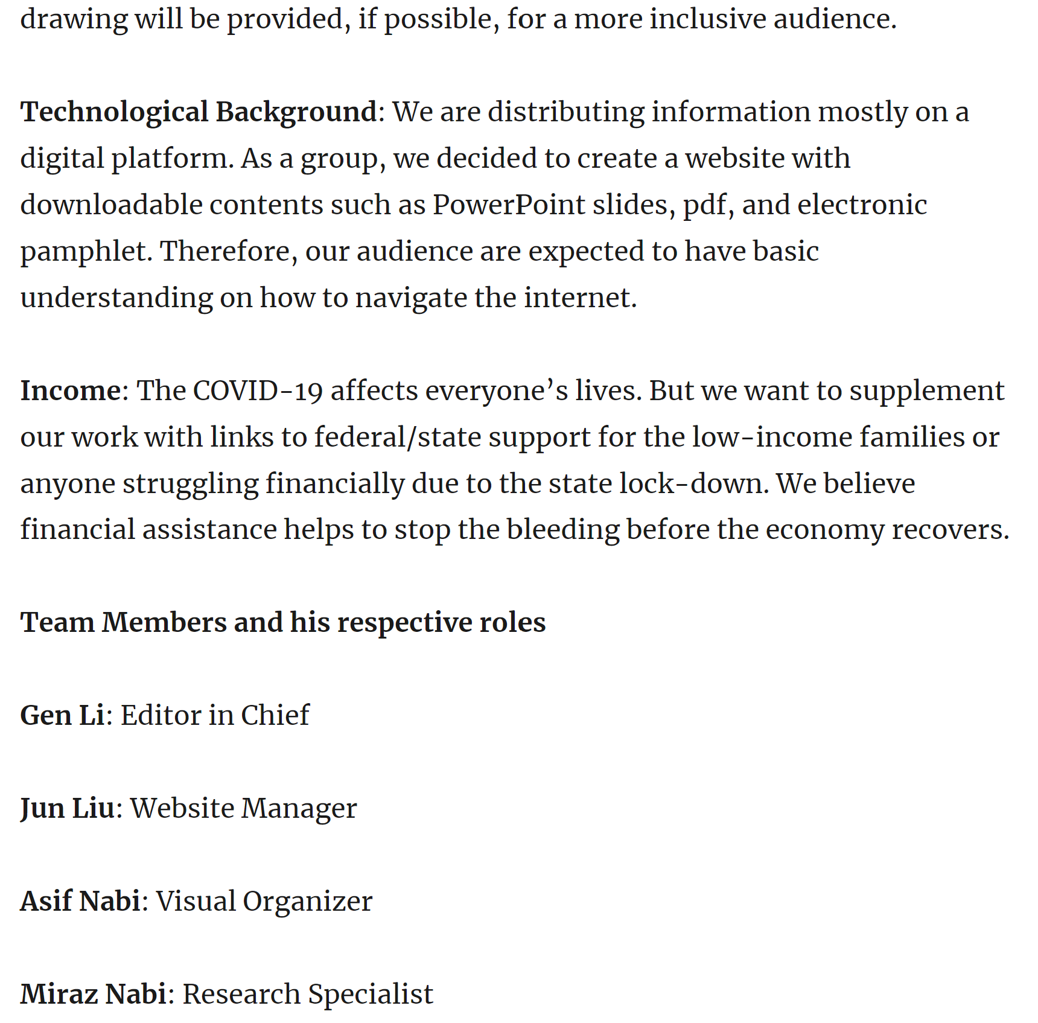

**Entry #8: 06/11/2020**

I talked to my group members about the types of research I am going to conduct.

**Entry #9: 06/12/2020**

Gen Li, a group member, had trouble with Asif. He removed Asif and me because I am a cousin of Asif, though I was not between in them and did not do anything. We reported to the professor; he said to work on your part and he will see later.

**Entry #10: 06/20/2020**

Today I started my part of the project. I conducted some research.

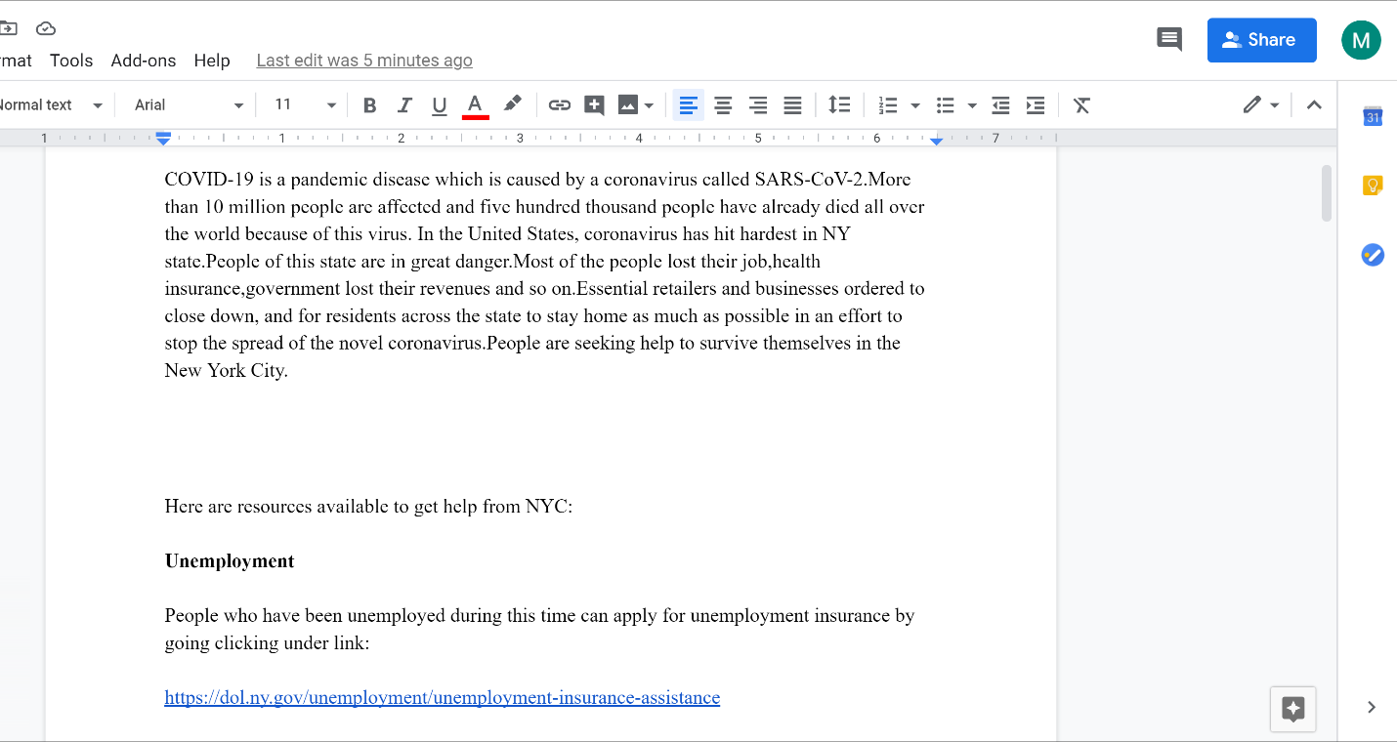

**Entry #11: 06/25/2020**

I and Asif tried to contact with another guy, so we can submit our part of the project. But we did not receive any response.

**Entry #12: 06/30/2020**

Since we did not get any response from our group, we feel like we are lost, and we did not even get a response from a professor. So, I and Asif decided to join another group. I mailed to a group name “AlphaBear”. Rajeen, the team leader, said he would talk with his group.

**Entry #13: 07/01/2020**

The group AlphaBear accepted me and Asif and gave us writing to contribute to their project. We wrote and submitted that.

**Entry #14: 07/02/2020**

Today I talked with group members through skype. I gave some ideas about our future proposals.

**4.Letter to Professor**

I have learned many things this semester. When I was paired with other people, I see everyone is not the same. Someone wants to be bossy, dominant, sticks to the rules and I also see someone does not want to be bossy and to be dominated by others, they want to be flexible. Someone likes to express their ideas all time. Someone always makes questions to find answers. The important thing I learned is to adapt to a group of people. Feeling inferior to the group, fear of expressing opinions, whether opinions will be the matter or not, etc. overcoming these types of obstacles was challenged to me. Now I have confidence about that because I completed a task that was given and expressed ideas about the project. Besides that, I think communication is the most important thing. People can sort things out with others, understand others and their position, and so on. By communicating, you can get ideas, explanations of ideas, answers to questions, and so on. Be kind, respectful, and listen to others is the key point. Everyone is not the same. I would not have been outside of the group if two members of my first group were respectful and listened to each other carefully. I have also experienced to be open-minded and accept everyone. When I requested to the second group to include me and my partner, the leader understood us and accepted us. The biggest advantage of a group project is that you can get help from your partners immensely and do not have to worry about the whole project. For example, if you are a writing editor, you will not think of designing a website, but you may give ideas to others to design a website. Participation in a group builds friends, creates networks, brings positiveness about you in front of others. That is all thing I have experienced throughout the semester.