Asif Nabi
Individual Final Work
ENG2575 (Summer 2020)

Research Explanation

I was the Visual Manager for the team called PPP Coordinators. My role was to make leaflets and flyers so that our audience can have a better understanding of the project which was titles “COVID-19 myths”. I also made these flyers available in different languages targeting those who speak in a language other than English in order to ensure accessibility to everyone.

Participation Explanation

For the group AlphaBear, I helped write how our project would impact our audience. I did this by analyzing which group of people had no awareness on the importance of wearing appropriate PPE during the current pandemic. Once I was able to highlight the groups who were least likely to wear the PPE, I actively worked with my group AlphaBear to help design and build a website that would target such groups to provide awareness of the importance of wearing PPE. This website included important figures, facts and research from scientific journals to further emphasize the importance of wearing masks.

Journal Entry
Journal Entry: 1 (06/01/2020)
Posted my first and second parts of the assignment. The first assignment was an individual task.
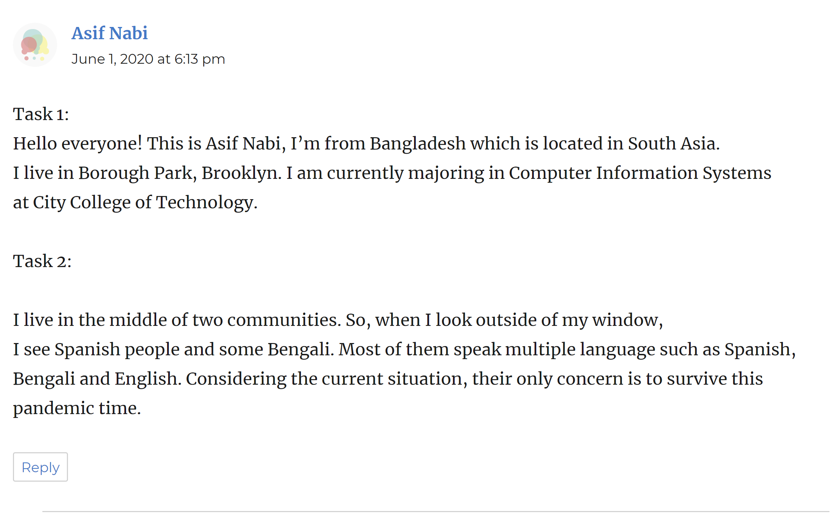

Journal Entry: 2 06/02/2020
My Professor had paired me with Miraz Nabi for the second part of the assignment as we were related to each other it was easier for us to start working on the assignment right away.
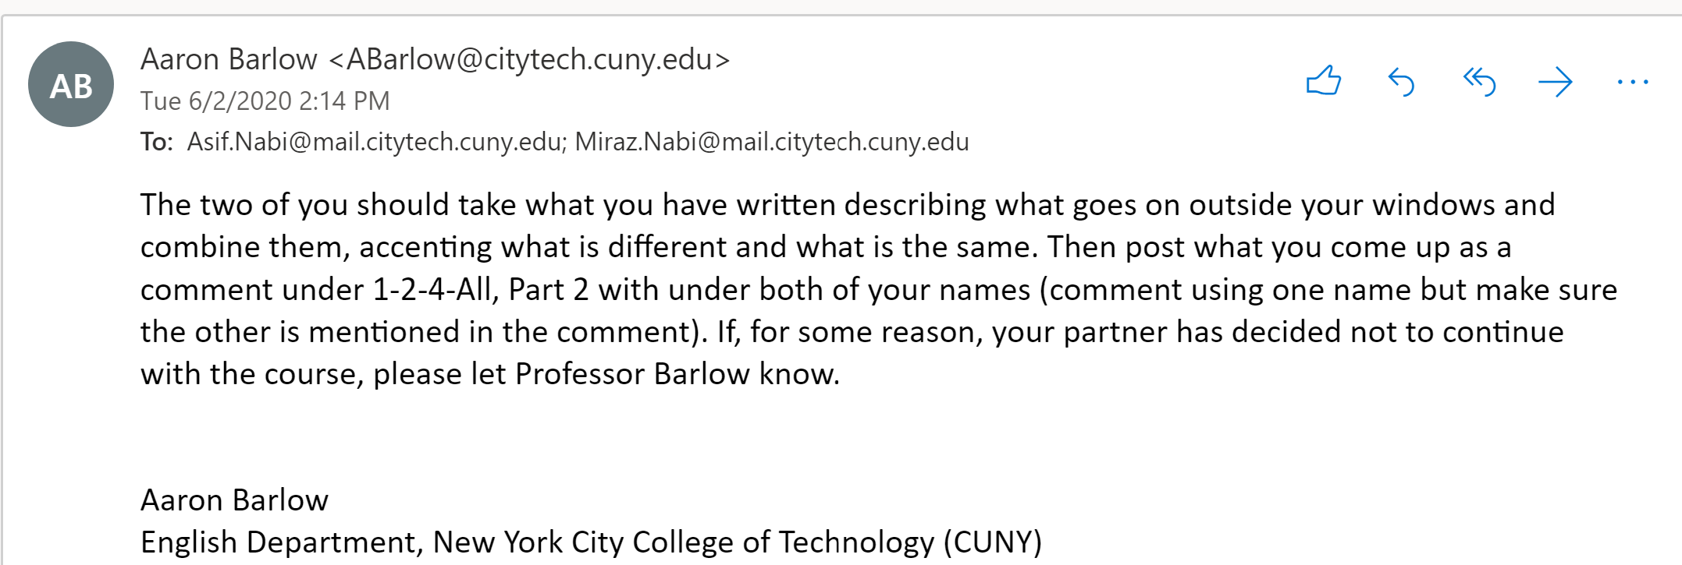

Journal Entry: 3 06/03/2020
Posted our third part of the assignment. This part was directed to find similarities and differences between mine and Miraz’s neighborhood. Miraz posted the assignment on the OpenLab on behalf of our group.
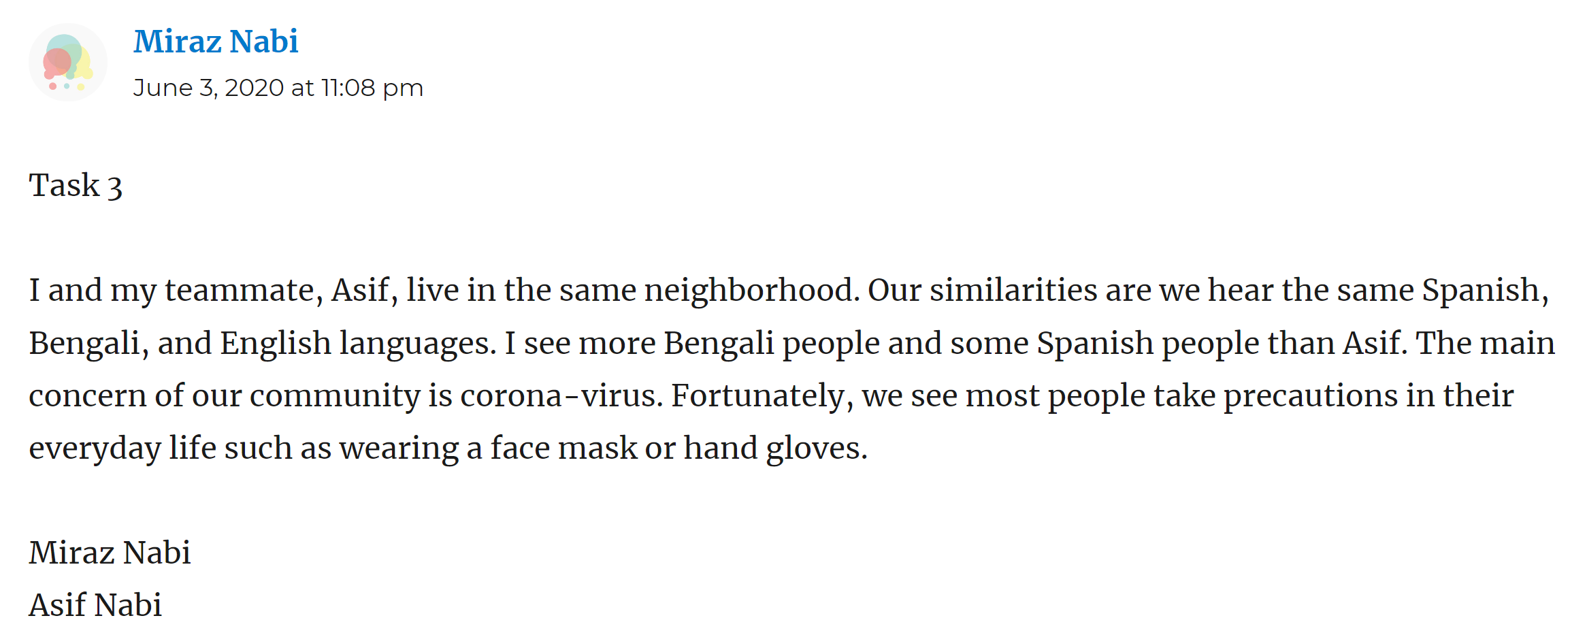

Journal Entry: 4 06/04/2020
For the next task, Professor Barlow had added two more members Gen Li and Jun Liu to our group. We created a WhatsApp group for the communication between all four of us. Our group task was to compare all our neighborhoods.
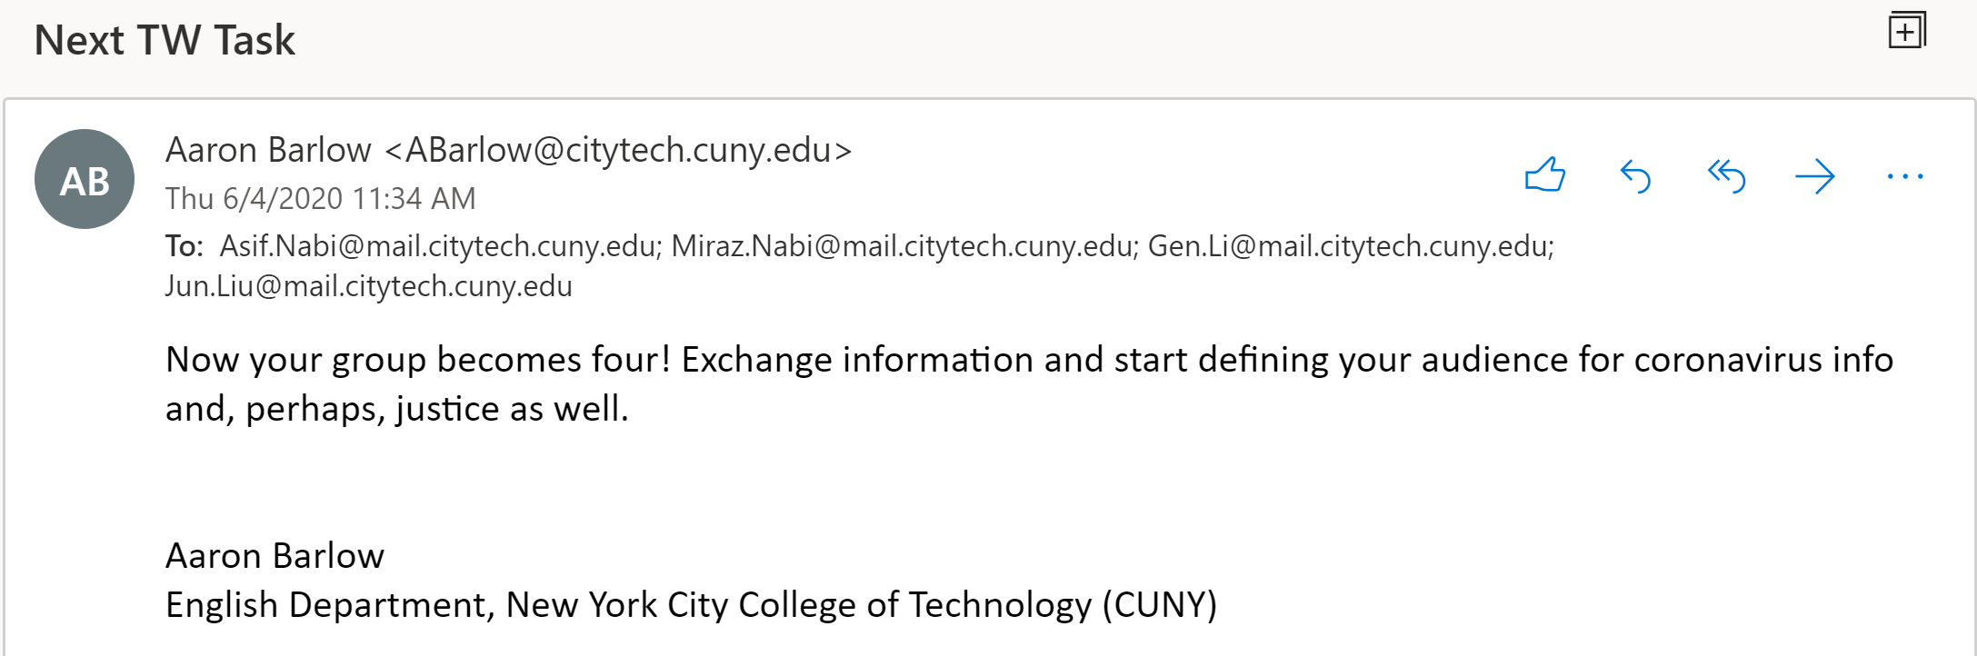

Journal Entry: 5 06/04/2020
We initiated our first conversation on WhatsApp group where we introduced to each other.

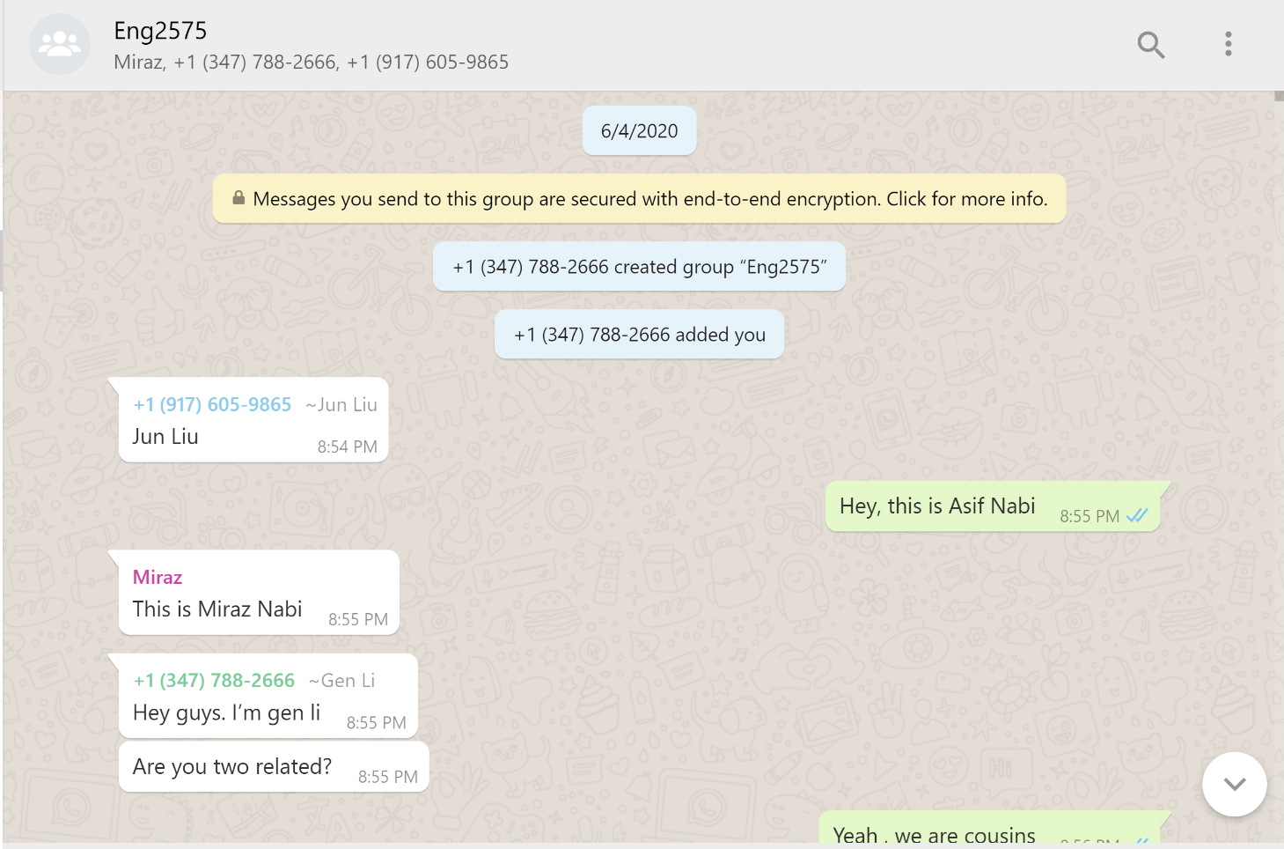

Journal Entry: 6 06/05/2020
We posted our fourth part of the assignment. We worked on finding similarities and differences between our neighborhoods, and we also spoke about setting our topic for this project. Gen Li had posted the assignment on behalf of us all.

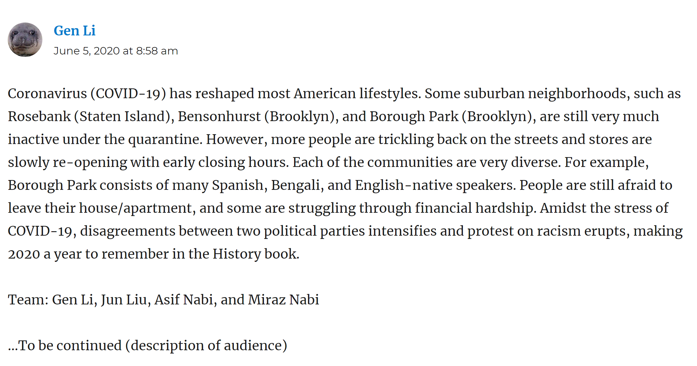

Journal Entry: 7 06/10/2020
After discussing with all the group members, we decided that our topic of this project will be on the current Coronavirus. We also set our audience and roles for this project. I was assigned as a Visual Organizer.
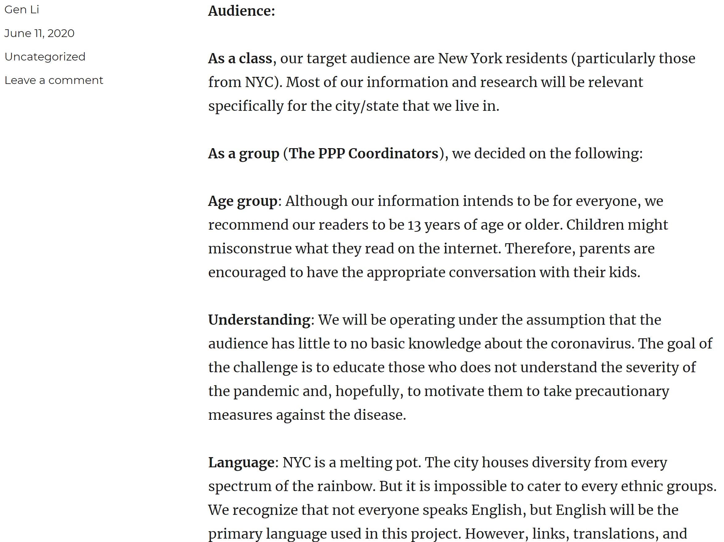

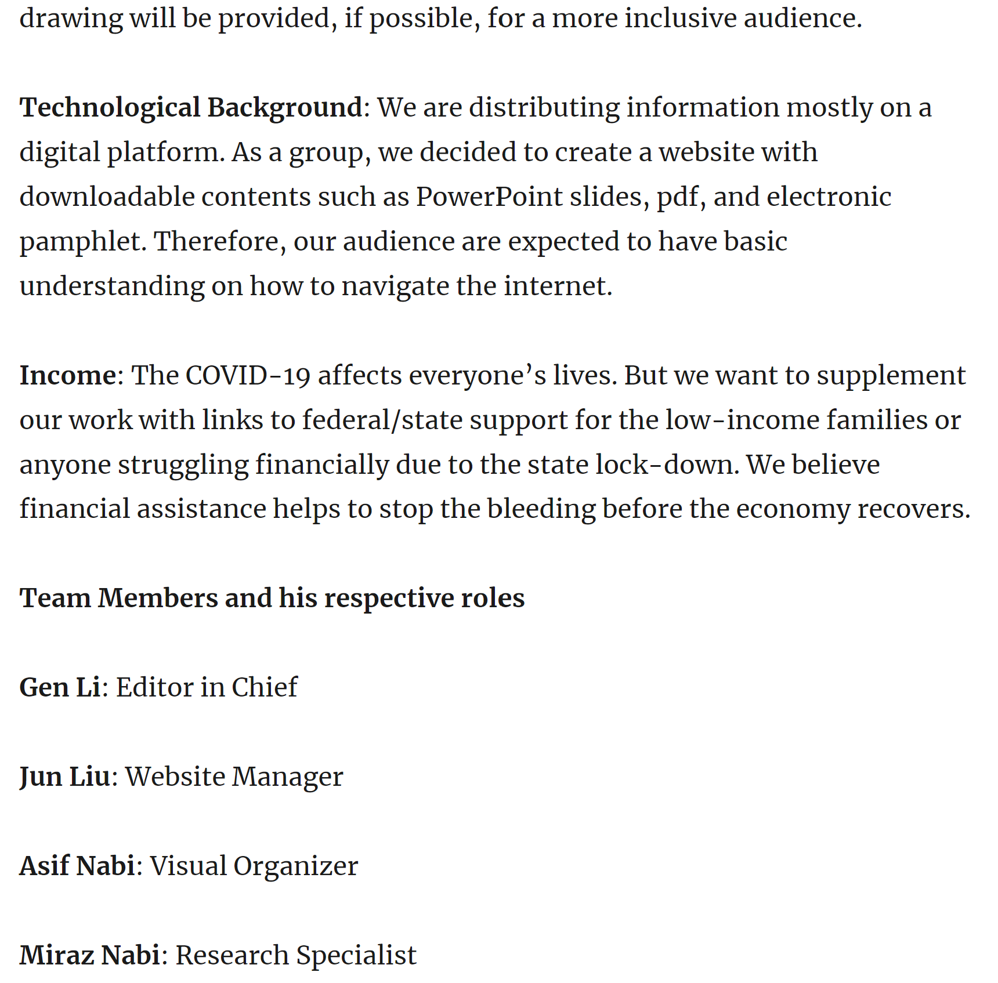

Journal Entry: 8 06/11/2020
I spoke about how we can educate our audience regarding misinformation about the Coronavirus.
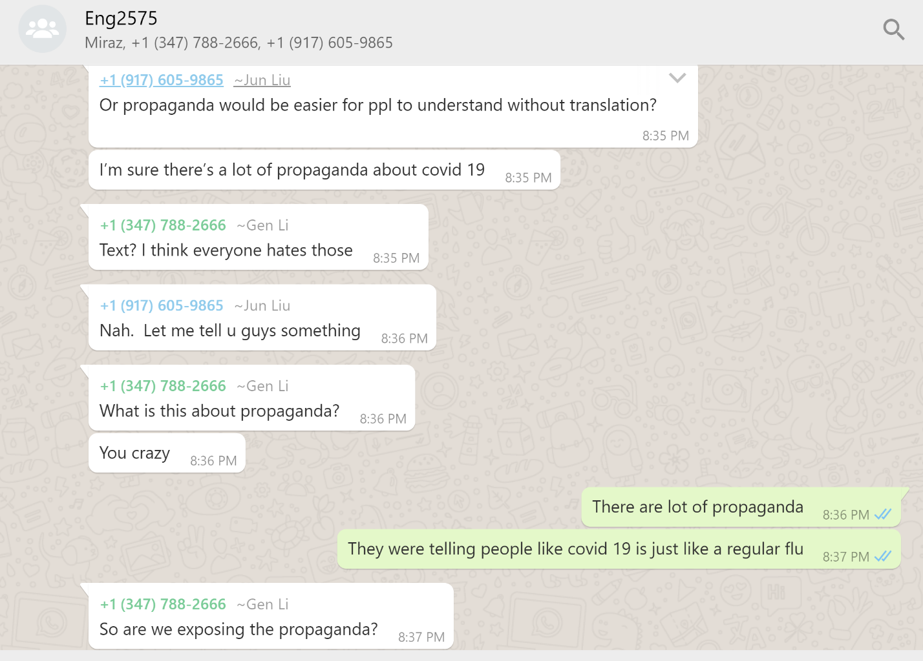

Journal Entry: 9 06/12/2020
On June 12th, Miraz Nabi and I were removed from the WhatsApp Group because I had a disagreement with one of the group members. We immediately emailed Professor Barlow. At this point we were trying to resolve the conflict so that we were able to complete our given group assignment .

Journal Entry: 10 06/16/2020
I received an email from Professor Barlow that I should put aside my differences with the group member so that we can complete our assignment. I took on his advice and reached out to the other members of the group to resolve the issues. Unfortunately, I was ignored and so I emailed Professor again but had not received a response either. Irrespective of the issues with the other members Miraz Nabi and decided to keep doing our part for the project until we received a response from Professor.
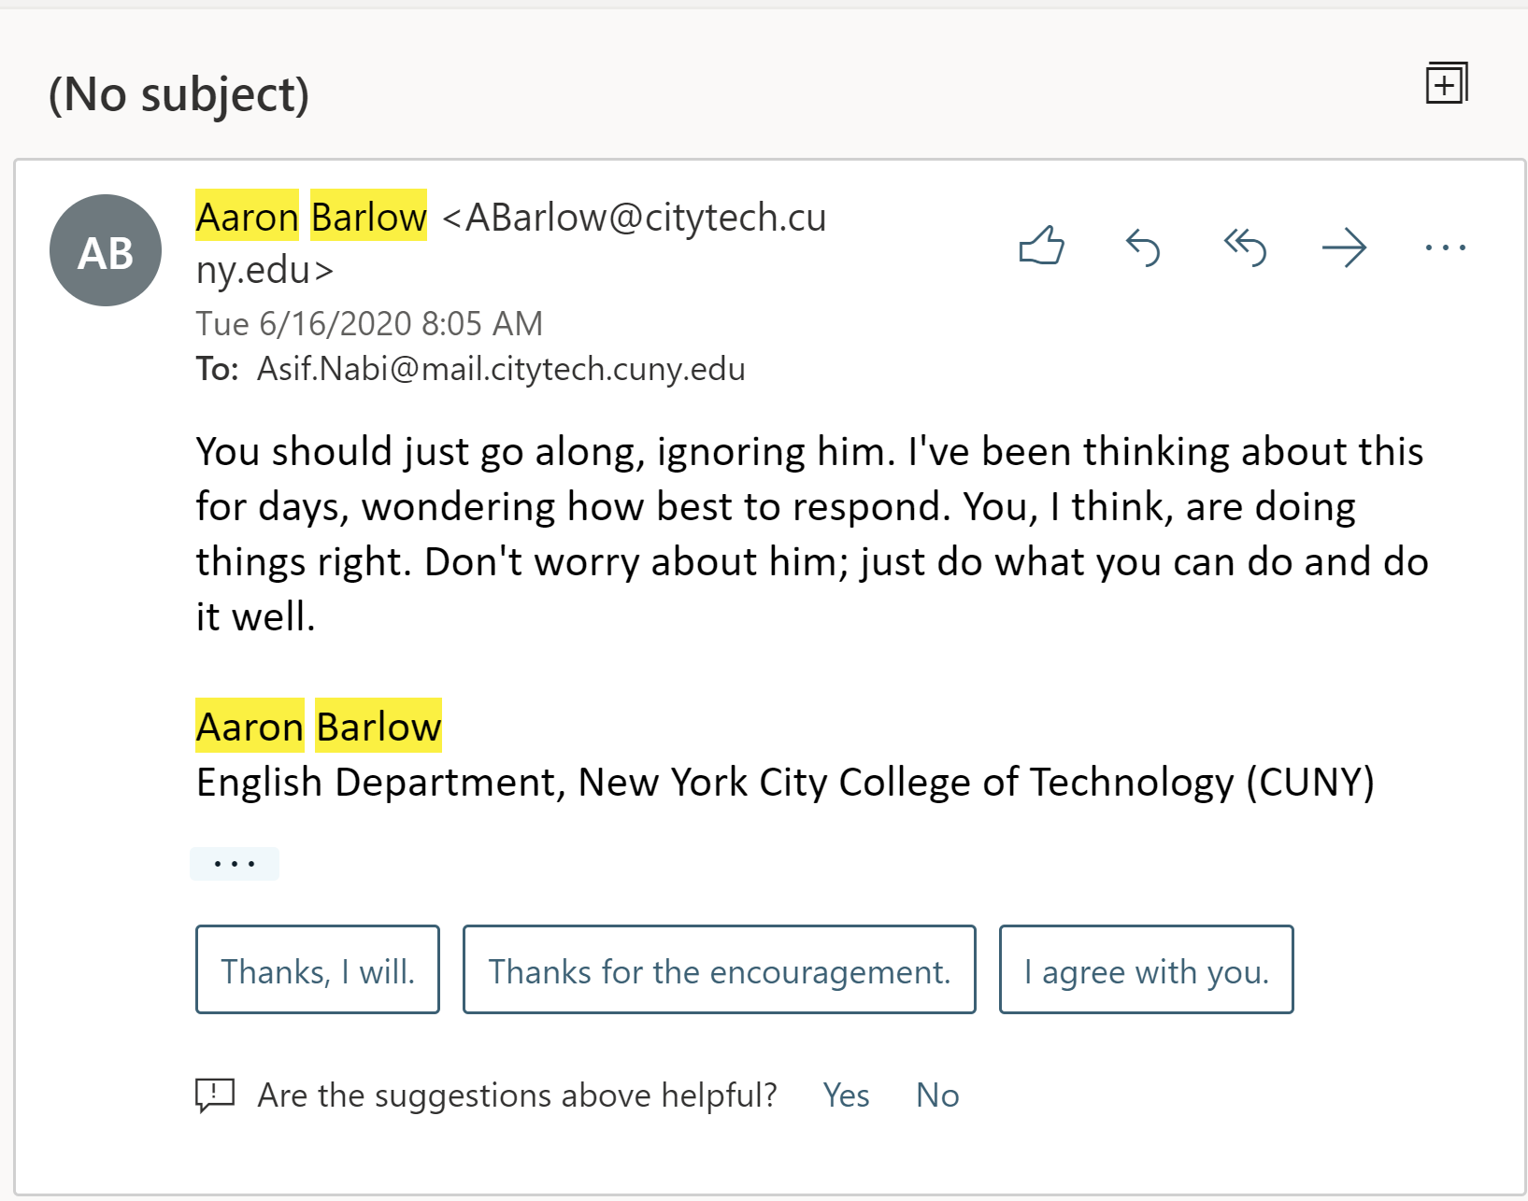

Journal Entry: 11 (06/20/2020)
I started creating flyers and leaflets about spreading awareness about the virus.
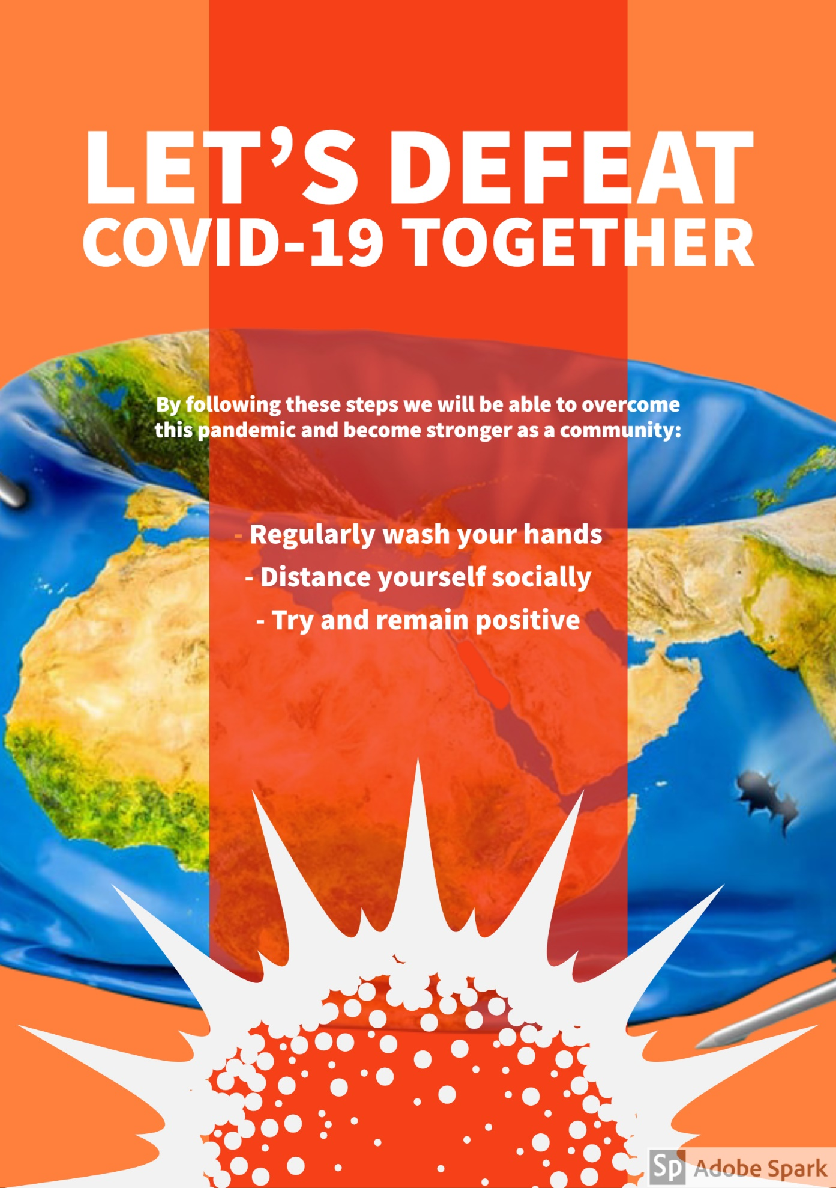
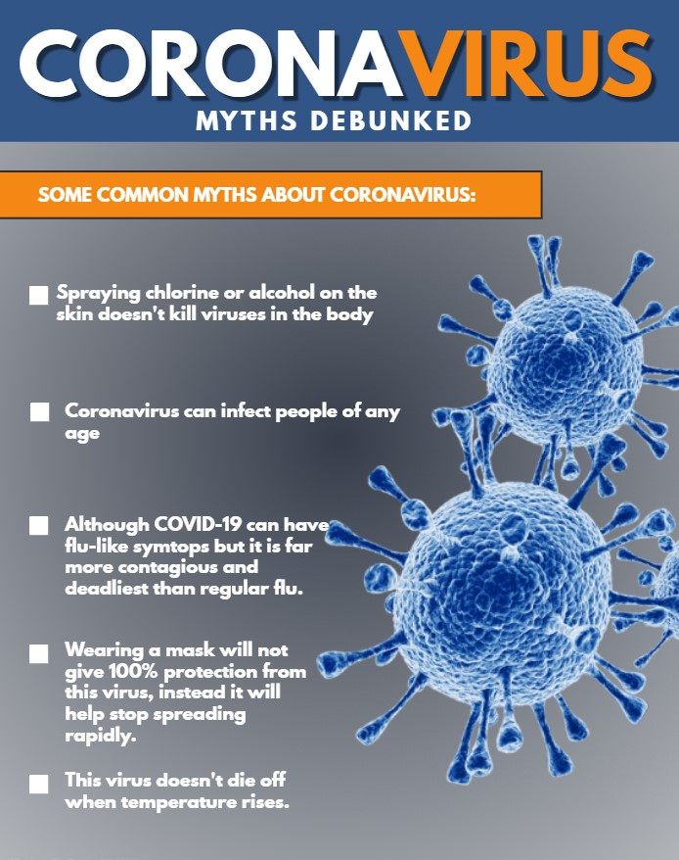

Journal Entry: 12 (06/25/2020)
After receiving an email from Professor Leston that he is going to lead the class from that point, I emailed him about my situation and asked permission to join other groups. I started sharing our resources with the group AlphaBear.

Journal Entry: 13 (06/30/2020)
AlphaBear agreed to give us an opportunity to be part of their group.
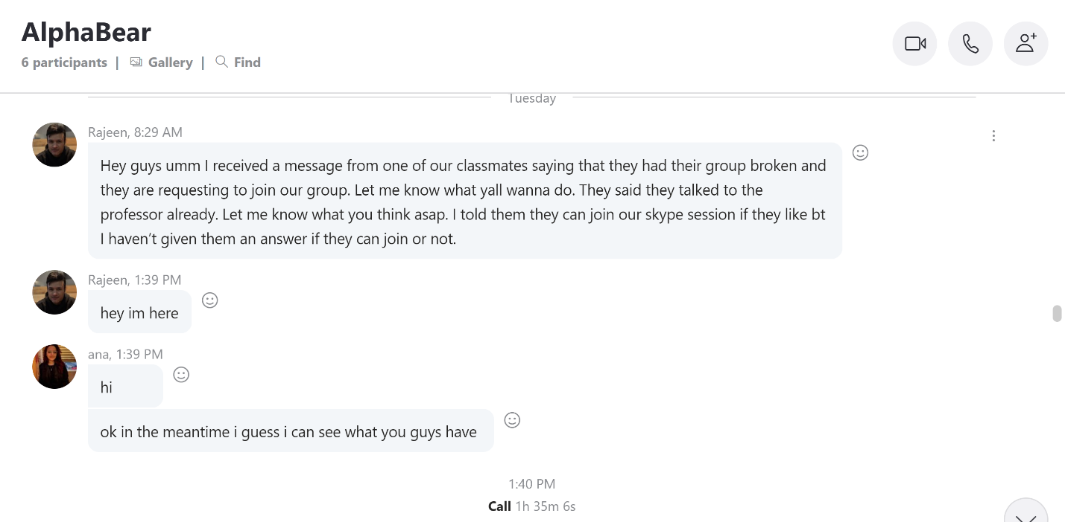

Journal Entry: 14 (07/01/2020)
We took participation in the project and shared our opinions on how our project could impact our audience.

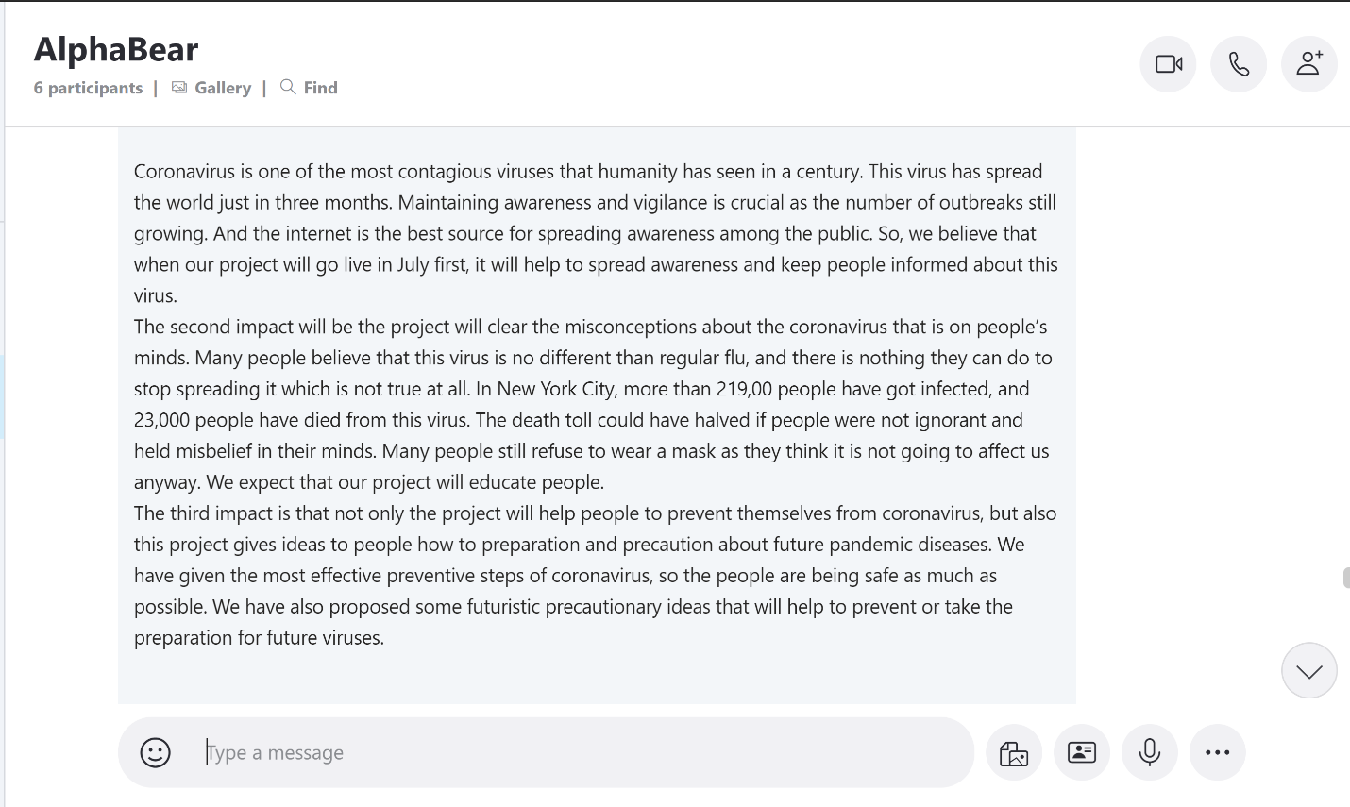

Journal Entry: 15 (07/02/2020)

I shared my opinion on how a country could learn from this situation and prepare for future outbreaks.
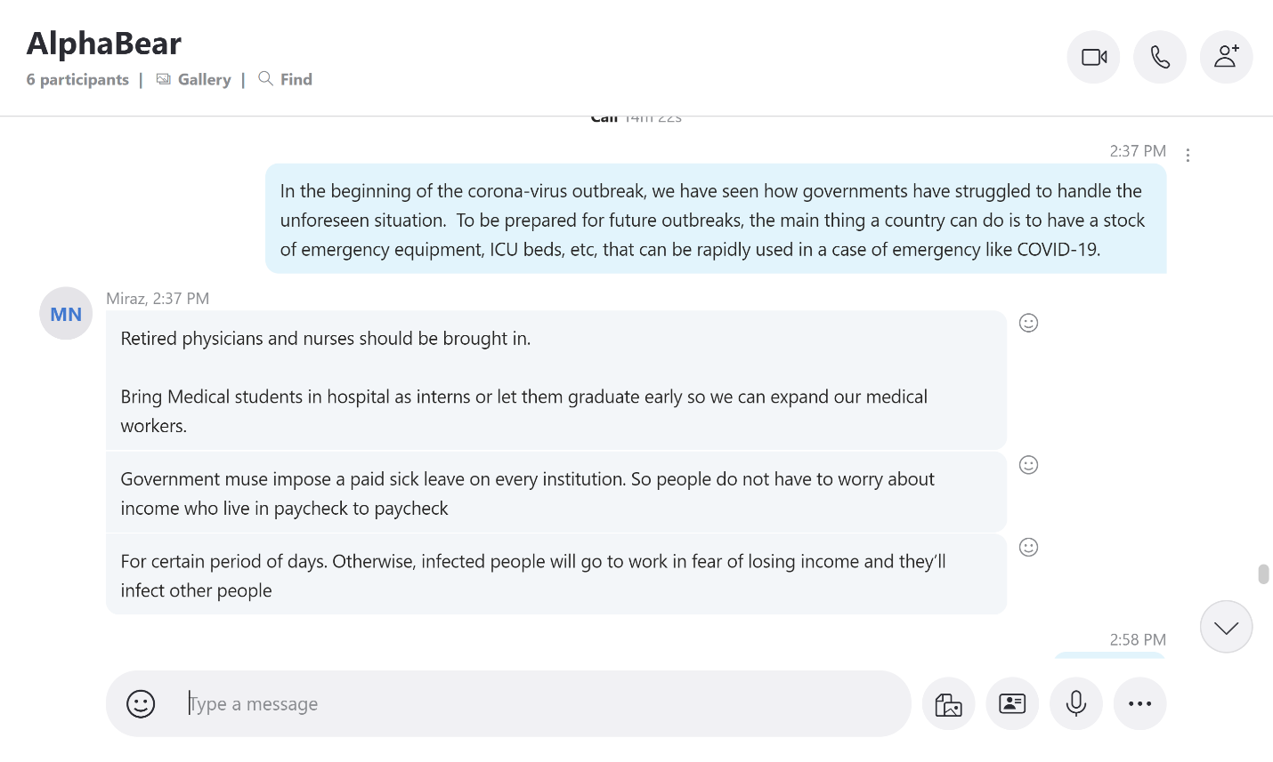

Letter to Professor

Dear Professor Leston,

During the pandemic because of COVID-19 I have learnt how quickly human beings are able to adapt to current climate. For example, from an environment of going into classes and work every day we quickly changed our learning and working methods to online remote distance. I have learnt that although this has been difficult to adhere to in the beginning as this was not something, I was accustomed to. I however, learnt very soon after that I could utilize my time at home and optimize my learning experience. I was able to optimize my learning experience because due to the pandemic I was not only required to stay at home to study but also to stay at home and not go out to work. Therefore, I had abundant to learn to structure my learning better, to research more on current topics to do with my course and to further read up on related matters.

During this semester I was assigned a group project, and this was a new experience for me as I had only ever worked previously independently. Although the current pandemic made things difficult in terms of meeting up, we utilized our new remote distance learning tools to also apply for this group assignment. I have learnt a very important lesson from this group assignment and that is that not everyone will get along or will share the same opinions or have the same work ethic. However, in order to accomplish the task, it is important that together to put aside differences in order to complete what is asked from you all. This not only is applicable to study groups but will also be a valuable lesson in the future when working in teams in my career relating computer systems.

Lastly, I would like to say I enjoyed how my course is relevant in all situations. For example, I was able to use my course to apply to the current pandemic. I was able to create leaflets and websites to address the issues and lack of information to those lacking awareness as well as ensuring accessibility to all. This is something that is important with regards to all issues and situations that may arise.

Kind regards,
Asif Nabi

