Lutfar Nahar
ENG2575
Summer 2020
Individual Final Work
1.The research I did during the semester was about Covid-19 and the way to prevent subsequent outbreaks. We have actually experienced the corona virus which is a deadly disease and has spread all over the world in a very short time and people cannot live long if they become seriously infected. A lot of people have died in the world and NYC have affected by the virous and also died from being infected. I have tried to research COVID-19 online from trusted sources. The virus has reached epidemic proportions that’s why the lockdown issued in NYC. This pandemic has affected many social, political, cultural, and economic issues within our lives. Socially, it has encouraged social distancing and a fear of coming in contact with another person- perhaps increasing isolation and the degree to which people are affected by loneliness.
Most of the companies, offices, schools and colleges were closed. The hospital had to work hard to handle the patients. Our cities and hospitals were not prepared for this sudden transmission of the deadly virus. Through the research I have tried to figure out how we can fight such a virus in the future.

2. My first task was to introduce myself to the class and my second task was to describe my neighbor's lifestyle and their activities. I finished those tasks individually. In the third task my professor paired me and Anna Panameno, we finished our task that founds similarities and inequalities between her and my neighbor. In the fourth task, the professor added two more of us, Rajneen Khadka and Sahariya Tushar, in a new group. Then we completed our fourth task which is about finding similarities and inequalities in our neighborhood. Then, we were working on our final project proposal and I was assigned to complete the technical background after finished the project proposal that we submitted. In the final project, I was assigned to work about COVID-19 and how to prevent next outbreak. I researched the current situation in New York City during the epidemic and how to prevent further outbreaks with my other partners. First, I researched on COVID-19 that how affected our life and health. I shared my idea in the website how we can prevent and prepare ourselves for next outbreak.

3.

Journal Entry
Entry #1: 06/01/2020
At the beginning of the semester, I posted the first part of the assignment which was a separate assignment.
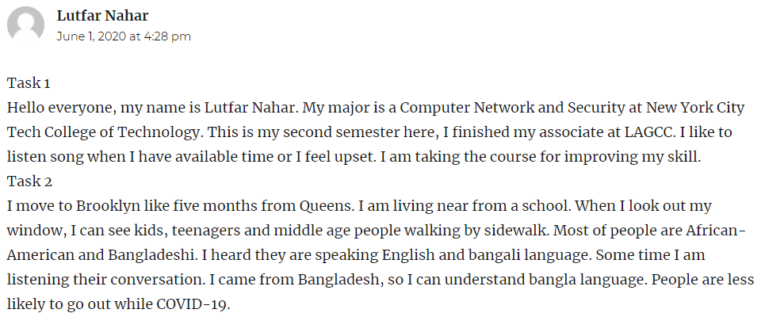
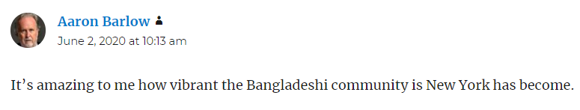
Entry #2: 06/02/2020
The professor paired me for the second part with Ana Panameno. We made a contract with each other through Gichat.
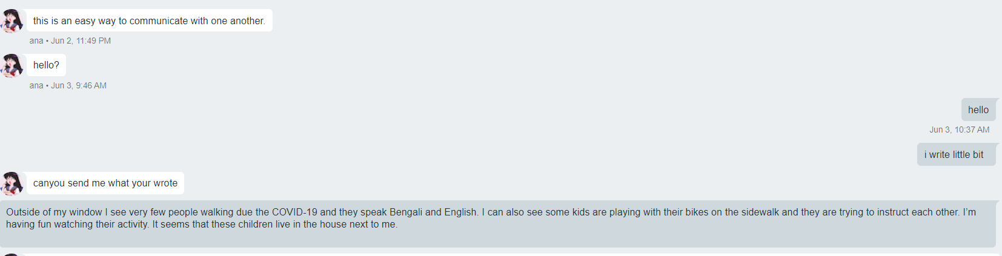
Entry #3: 06/03/2020
We’ve posted the third part of the assignment that combines similarities and differences between me and Ana’s neighborhood.
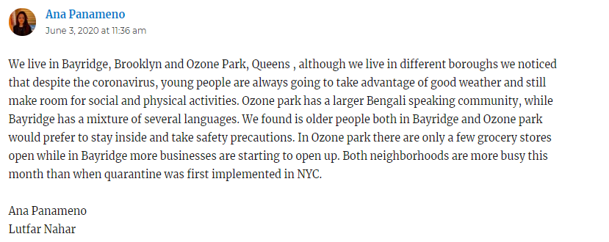
Entry #4: 06/04/2020
Professor paired a new group with me, Ana Panameno with Sahriar Tushar and Rajeen Khadka for the next task IV. We contracted between each other on Skype. Our group task was to compare all our neighborhoods with each other.
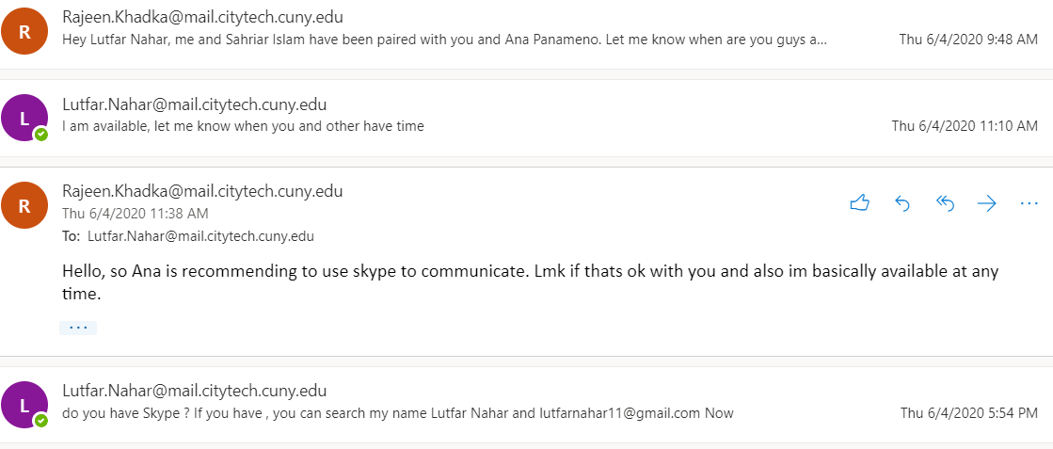
Entry #4: 06/06/2020
We have completed Task-4 and posted it in OpenLab. It was about comparing the conditions in our neighborhood during the epidemic.
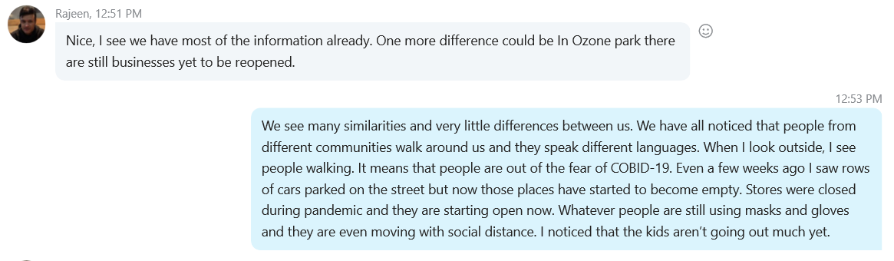
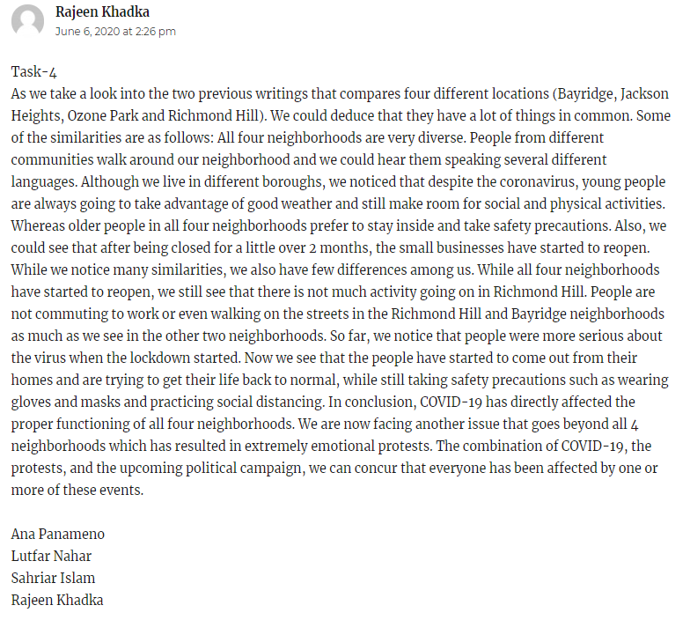
Entry #5: 06/10/2020
After a long discussion with Skype call, we chose our topic for the final project and we informed the other groups about our topic.

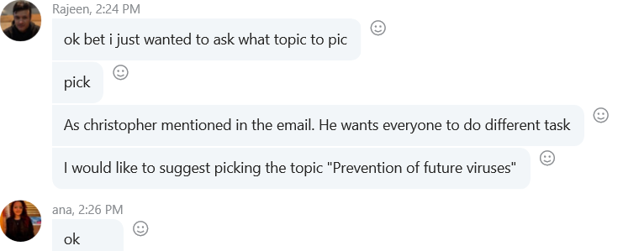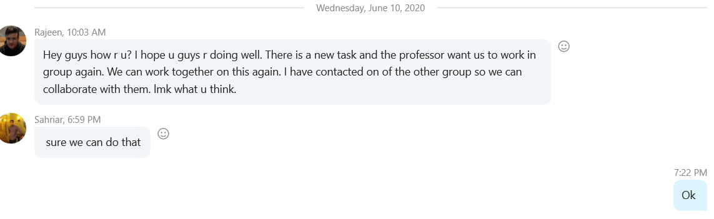
Entry #6: 06/12/2020
We decided on our topic of the final project proposal and we started working on it.
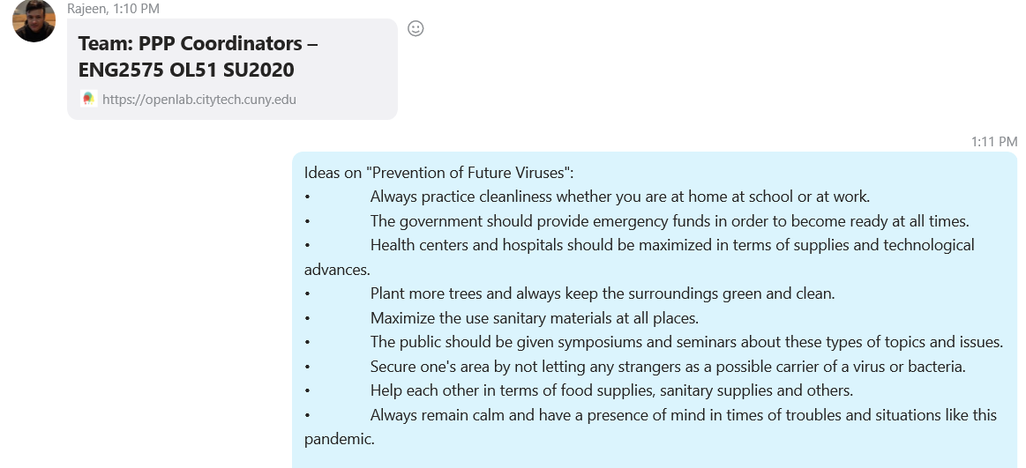
Entry #8: 06/16/2020
Me and the group met a couple days in a row to work on the proposal of our final project. We posted our proposal on the discussion section on openlab.
Entry #9: 06/20/2020
My task was as a project researcher with Sahriar Islam and Ana Panameno. Other hand, Rajeen Khadka task was to design and update the website. We have started working individually on different parts of our project to create a resourceful website.
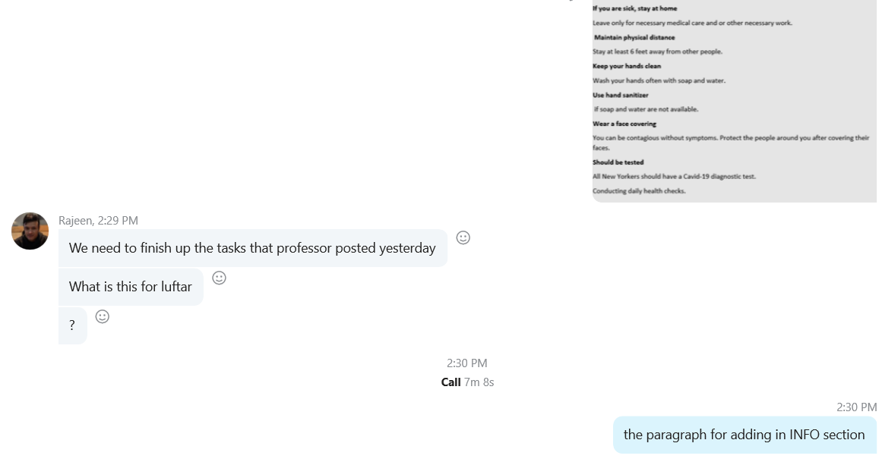
Entry #10: 06/25/2020
The group met daily to discuss our resources for the final project. We created our first primary website.
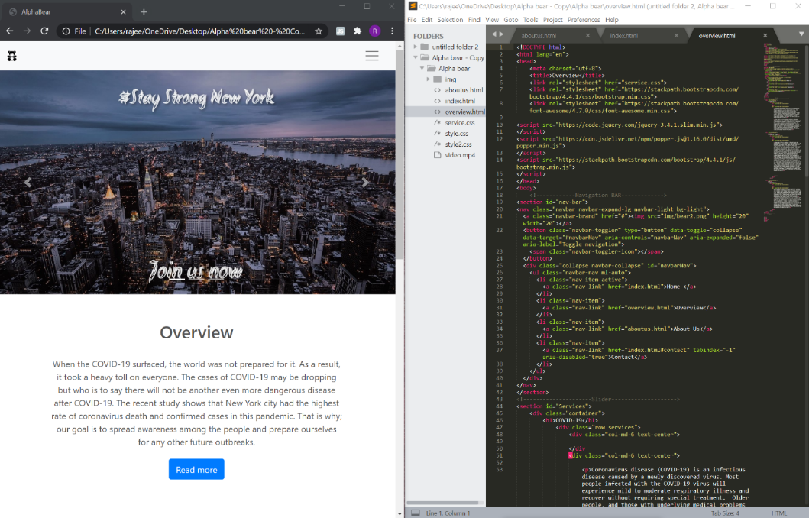
Entry #11: 06/29/2020
We combined all our ideas and update our website with all resources for our project.
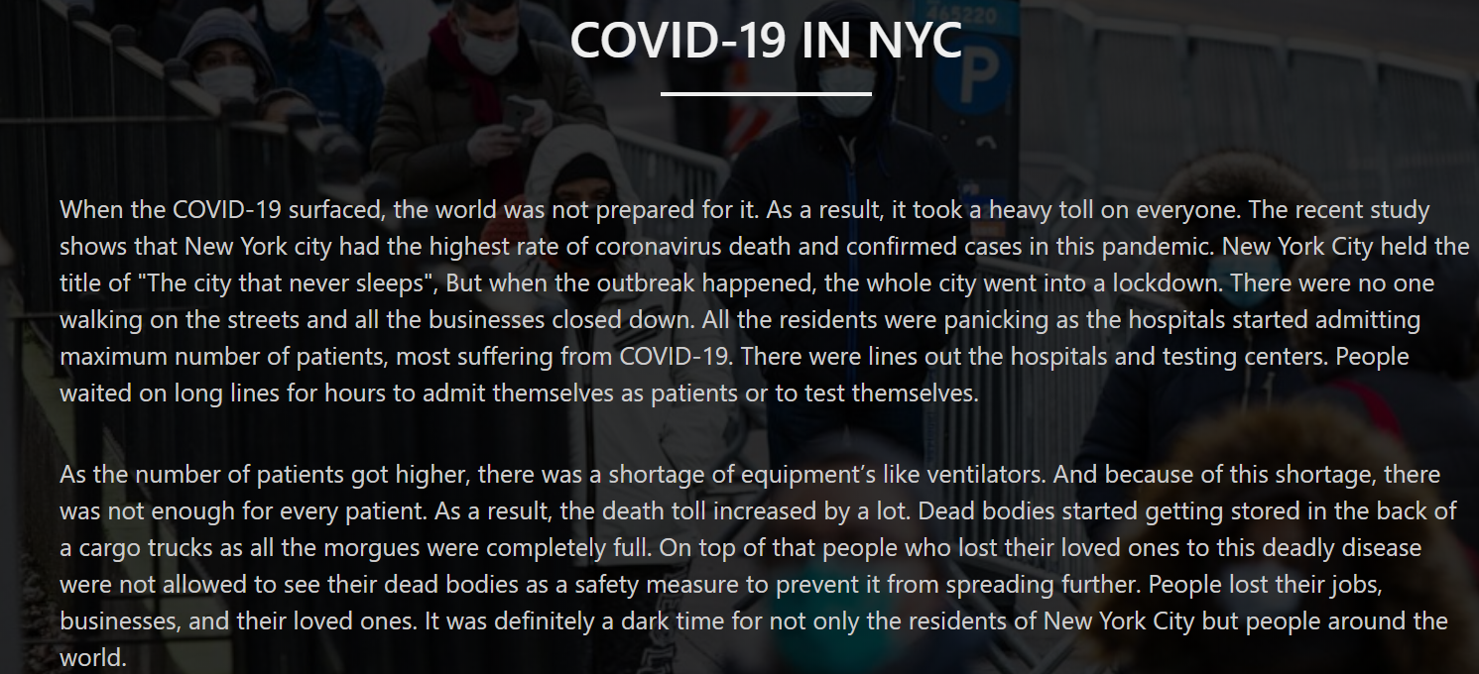
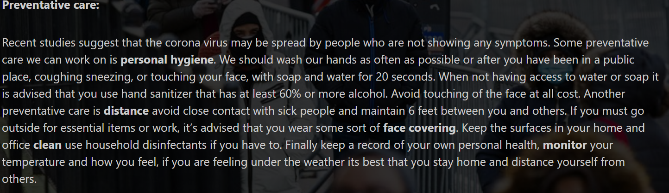

Entry #12: 06/30/2020
One of my group members emailed me that two students from other group who had a falling out on their group and they needed help to join another group. They get permission from professor for joining another group and would finish final project. My group members discuss to invite them for joining with their resources and ideas.
Entry #13: 07/01/2020
We wrote an overview and we did also review our project before submitting our final project.
4.
Professor Lestón,
This is my first-time summer class in NYCCT, before I started the class, I was afraid of how I would complete the express class. But this semester has been very exciting for me as I have never had such a fun experience before. From the beginning of class I did task individual. From the third number task, the professor made me a partner who is a such nice girl. The two of us discussed our task topic and combine each other idea for finishing our task. After finish the task, the professor made a new group with four members. I was feeling a little uncomfortable about what our group members might be like. Earlier I did group projects but my experience in other classes was a bit bad. When I paired with other people in other class, I see that someone wanted to be influential. There was some group member who just like to give importance to their own opinion. In this class, the group in my class has gotten a lot better with everyone who knowns how to understand and value others. We have shared each other’s ideas and discussed and combine our task and project.
My first task was to introduce myself and my second task was to describe my neighbor's lifestyle and their activities. I feel interested to describe about my neighbor because I haven’t been in my area for a long time, through the task I got a chance to observe my area. In the group, I have research topic about COVID-19 and how to prevent next outbreak. When I did research on my topic online and again, I discussed it in my group, they appreciated me very much and explained to understand if I needed. I researched the current situation in New York City during the epidemic and how I could work with my other group members to prevent further outbreaks. First, I researched COVID-19 on how it affects our lives and health. I shared my idea on the website on how we can prevent and prepare ourselves for the next outbreak.
Lutfar Nahar

