Azula Camara
BUF3310
PROJECT

During the age of steel, steam, and locomotives, Hamilton Carhartt founded the Carhartt company. Starting with overalls, Carhartt began surveying railroad workers in order to design an overall that fit their every need. Carhartt’s motto of “honest value for an honest dollar”, carried out the brand’s mission of providing their clients with an honest durable quality clothing for an honest value. This motto allowed for trust in the brand and led the brand to evolve into what it is today.
Founded in 1889, Carhartt is an American apparel company that specializes in work clothes. These work clothes include: jackets, coats, overalls, coveralls. vests, dungarees, fire-resistant clothing and hunting clothing. Carhartt believes in the diversity of their hard working clientele and provides them with an extremely durable clothing to carry out hard work. From t-shirts to overalls, Carhartt highlights the hard working individual that is committed to their craft. Carhartt is dedicated in creating a durable form of clothing made to withstand the harshest conditions. Carhartt’s strengths include the extremely durable fabric we use in all of our apparel. This allows our brand to be trustworthy and gives our customer’s confidence in the longevity of their purchase. Each Carhartt purchase should be done so with the assurance of heavy duty quality and long lasting guarantee. Our brand follows the American ideology of achieving your goals through hard work, Carhartt hopes to keep this ideology alive through our upcoming collection. A weakness of Carhartt is our lack of brand awareness throughout popular culture. The company hopes to shift into a more mainstream market segmentation in order to increase sales and raise brand prestige. Carhartt has great opportunity ahead, our new Spring Summer 21 collection will be the first step in breaching into a new demographic. Through new brand partnerships, we will revive our brand into popular culture. The threat that is already imminent are our existing competitors: Timberland and Levi’s. These companies are established household names that have mainstream success through their successful brand partnerships. Carhartt hopes to follow suit by establishing ourselves as a household name. Deep rooted American ideology of working your way to the top starts with the best heavy duty clothing, you will find what you need at Carhartt.
Carhartt’s new Spring Summer 2021 collection will feature a new perspective on our existing designs. The designs will feature the classic overalls, pants, t-shirts, and our cash cow product: the Carhartt jacket. The collection will resemble the classic looks of Carhartt that will be marketed through our brand partnerships. The collection will attract a new mainstream demographic while still catering to our core client that has been with us from the beginning. All aspects between fabrics and design will remain the same in order to keep value of our product the same. As this new demographic comes in, brand prestige and sales will increase. The goal of our Spring Summer 2021 collection is to begin the steps into establishing the Carhartt jacket as a household name that holds a significant part of your wardrobe and culture. Similar to the Timberland boot that carries a New York culture and streetwear ideology while maintaining the durability of the Timberland quality product; Carhartt will begin to push the Carhartt Jacket in this similar marketing and cultural fashion.
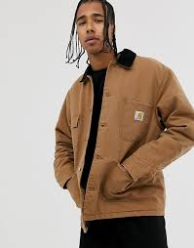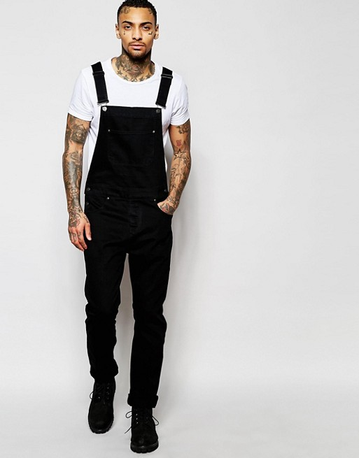
The target market for the Spring Summer 2021 Collection is geared mostly towards men, this is the simple fact that the labor force is made up of predominantly men versus women. However, women can be seen sporting the collection in a fashionable sense, like that of the Timberland boot. The target age will be about 18-35 years old, this is the age of the predominantly strong working class individual and represents ages of full strength. The collection will gear towards every ethnicity, no limits. The target market are rugged, hard-working individuals who always have that “tough guy” look to them. These individuals spend most of their time in the outdoors and doing extracurricular activities. The highest level of education these individuals usually maintain are high school level diplomas, and have careers in the labor force. Carhartt sells globally, however we are focusing our new Spring Summer Collection in the major cities of the U.S. such as New York, LA, Miami, and Chicago. We will utilize social media and traditional media outlets by contracting influencers and celebrities to sport our brands in posts and outings in order to raise brand awareness.
The marketing strategies we plan to utilize are sponsorships and influencer marketing. Through sponsorships, Carhartt’s new collection will be publicized on social media platforms such as Instagram, Twitter, Facebook, and other blog websites. In doing these sponsorships, we will raise brand awareness of certain individuals who are constantly searching the web of similar products to our brand. By internet data analysis, we are able to directly put ads onto user’s internet engine for the most effective outcome. Carhartt will particularly be working with Sports Illustrated in placing ads on their website. Sports Illustrated has a target market of men 18-34 years of age that have an education of a high school diploma and have ranging income levels. These individuals are accustomed to the outdoors and constantly delve into sports which calls for the tough and rugged audience. The target market of Sports Illustrated is highly reciprocal to our target audience therefore this sponsorship is absolutely perfect in reeling in new clientele for our brand. Another brand partnership Carhartt will delve into is influencer marketing. This is the most important of the brand partnerships because this will bring in a new and more hip audience to Carhartt. Potential influencers Carhartt plans to work with are rap/country stars: Lil Nas X and Megan the Stallion. The new profound hype around southern culture will catapult our brand into becoming a household item in everyone’s wardrobe. Lil Nas X and Megan the Stallion have extremely high influence on the younger and hip crowd that Carhartt is trying to reach in this new Spring Summer Collection. According to Social Blade, Lil Nas X and Megan the Stallion have an average of a 5% engagement rate which calls for very high interaction between them and their followers. These two celebrities are perfect catapults for the brand’s ongoing success in engaging with their audience to promote the new collection. We will correlate success with the increase in sales and website activity after posts have been made by both influencers.
By the general public constantly seeing these celebrities in Carhartt, the brand will begin to gain momentum in becoming a staple in popular culture. Within Carhartt’s company portfolio, a flanker product is a tool belt; cash cow product would be the overalls and jacket; high end prestige product would be the flame resistant line, specifically the flame resistant jacket; and a low end prestige product are socks.

REFERENCES
Carhartt. (2020). Carhartt. https://www.carhartt.com/nl/nl-nl

Hot Girl Meg’s Instagram Stats Summary Profile (Social Blade Instagram Statistics). (2020). Socialblade. https://socialblade.com/instagram/user/theestallion

Socialblade. (2020). Socialblade. https://socialblade.com/instagram/user/lilnasx

