Henri Bendel: Bendel Girl

Azula Camara

City Tech-CUNY

Abstract

In this body of work I will be discussing the background, advertisement, and legacy of Henri Bendel. Coming from a small town in Louisiana, Henri Bendel brought New York to a new level of luxury through his infallible fashion sense. With custom furs, original apparel designs, hats, cosmetics, and handbags; Bendel became a staple to New York luxury. For 110 years, the classic brown and white stripe pattern has been a staple image of elegance and sophistication of the brand. Through the advertising concept of the “Bendel Girl”, the brand illustrates the ideal target customer in her latest Bendel designs. Effortlessly, Henri Bendel is a pioneer of metropolitan fashion luxury.
Keywords: Henri Bendel, luxury, handbags, brown and white stripes, Bendel Girl

Bendel Girl
History
Henri Bendel was born in Lafayette, Louisiana in 1868. Coming from a small southern town, who knew that Henri Bendel would be a pioneer of New York fashion and luxury. Moving to New York in the late 1800s, Bendel opened his own millinery shop right in Greenwich village. After a couple of years, the store moved up the west side. This store became one of the leading departments in the latest couture during its time. (Henri Bendel website)
Henri Bendel became one of the first retailers to brand themselves. In 1895, Henri Bendel registered his own trademark. His iconic brown and white stripe print became the legendary image for his brand. Breaking fashion boundaries, Bendel was the first luxury retailer to reside in Upper Fifth Avenue, first to have a semi annual sale, and first to give in-house makeovers. (Henri Bendel website)
During the 1960s, the Henri Bendel brand began to go through some changes. After World War II, the company began to decline. During its decline, a conglomerate, Genesco Shoe Company, decided to acquire the Henri Bendel brand and totally renovate it. The conglomerate appointed Geraldine Stutz as president of the store. During this time, women were still on the rise to becoming more prominent at the executive level of business. The conglomerate gave Stutz full control to make changes as she seemed fit for the overall success and longevity of the store. One of Stutz’ merchandising concepts was the “Street of Shops”, which allowed European and local designers to showcase their work in the store. This idea restored the attraction of the wealthy, elite, and well renowned celebrities. (Henri Bendel website)
In 1980, Stutz purchased the store from the Genesco Shoe Company. This was not only a big step for the company, but a big step for Stutz and women overall. In the purchasing of Henri Bendel from Genesco, Stutz became the first woman to own a major New York fashion store. In 1985, she then sold the business to a retail conglomerate, The Limited. This retail conglomerate then relocated the Henri Bendel store to its now current address, 712 Fifth Avenue. (Camelot on 57Th Street: A History of Henri Bendel)
Market Segment
In 1994, Henri Bendel collaborated with Andy Warhol. Andy Warhol’s illustrations painted the picture of Henri Bendel’s ideal customer. Partner, Izak Zenou, assists Andy Warhol in creating the iconic brand image of the Bendel Girl. The Bendel Girl is seen strutting the metropolitan streets in her latest Bendel designs. The Bendel Girl is just as recognizable as its traditional white and brown stripes. (EastonWay Blog)
The Bendel Girl is Henri Bendel’s ideal target market. Henri Bendel caters to the upper middle class working metropolitan woman. The target market is the fashionable and sophisticated woman. She works a traditional 9-5 job and cares about how she is presented. Going to work through train, bus, or taxi, she hopes to catch all of the attention with her latest Henri Bendel apparel. Women who wear Henri Bendel are usually the older working woman who have already established careers. Women are usually 25 and older. These women are seen as sophisticated and intelligent, a younger woman would not want to pull off this style because they still want to be playful and witty with their fashion
The Bendel Girl is described as chic, quirky, a fashionista, sporty, or glamorous. Henri Bendel is able to provide handbags for different personalities. Bags such as, the Jetsetter backpack, are more for the women who are on the go and need a backpack to throw their belongings in. This type of woman falls under the sporty Bendel Girl. Bags such as, the Rivington tote, are for the women who are going to a classy event and need to dress to impress. This type of woman falls under the glamorous Bendel Girl. (Henri Bendel website)
Individuals who purchase Henri Bendel have typically high household income. The women who purchase Henri Bendel have established careers, their household income ranges from $150,000-$200,000. They have a great amount of discretionary income. Individuals who wear Henri Bendel have a chic, sophisticated, and knowledgeable fashion sense. Henri Bendel is seen as a very upscale and classy brand. The brand holds a tradition of protruding elegance and class. When wearing Bendel, you exude a sense of wealth and power. Just being located on Fifth Avenue, Henri Bendel is located in an area of high luxury and prestige.
Design
With elegance and grace, Henri Bendel exudes class and sophistication. The iconic and legendary white and brown stripe pattern signifies the simple elegance of the brand. The brand is best known for their handbags, jewelry, and accessories.
Back in 2009, Henri Bendel announced that they will no longer be selling apparel from its brand. Henri Bendel decided to stop selling clothes and put their focus in their accessories. Bendel also changed its business model during this transitional time. From the beginning, Henri Bendel acted as a department store and sold third party fashion brands within the store. After 2010, the company decided to eliminate the selling of other brands and focus on the in-house brand instead. This change was a reaction to the changing economy and a way to elevate the essence of the Henri Bendel name. (New York Times)
Henri Bendel is versatile in creating the perfect handbag for their consumer. The designer handbags can be used in sport settings, or classy events. With their marketing strategy, the “Bendel Girl”, individuals are able to identify with one of the illustrations and find the perfect bag that suits their personality. Bags are created with a clean and sleek design. Smooth leather and compact size, the handbag is easy to carry throughout your travels. A particular favorite of mine is their Convertible collection of handbags. This particular handbag is designed to be able to worn as a backpack, a handbag, or a crossbody. The bag comes with back straps but also features a large handle at the top so that you can hold it as a handbag. The bag also comes with an additional single strap so that you can use it as a crossbody as well. This unique design of a bag doesn’t usually occur amongst designer brands. Henri Bendel designs handbags for the modern metropolitan woman who has a variety of activities in her daily life. (Henri Bendel website)
Promotion
Henri Bendel was established in 1895. Through registering his own trademark, Henri Bendel began a legacy. Through tradition and age, Henri Bendel will forever be a staple in high end fashion.
Henri Bendel has their flagship store right here in New York City. The flagship store is located at 712 5th Ave New York, NY. After renovation in 1991, the Fifth Avenue location received landmark status by the Landmark Preservation Commission. (Henri Bendel website) Being on 5th Ave, your business will always strive. People come from all around the world to come and shop on Fifth Avenue. All high-end retailer and distributors are located here. Locking in a location on Fifth Avenue guarantees great success for your brand. Henri Bendel places promotional ads on billboards and through website advertisements. I will always catch a little Henri Bendel ad on the sides of my computer screen or phone. Henri Bendel stores are found all across the nation. Through brand identity and tradition, people will always visit the store and purchase an iconic handbag.
As an iconic brand, Henri Bendel doesn’t have to prove that they are a legendary brand. The greatly known white and brown stripe print, personifies the brand as elegant and upper class. The promotional efforts for the brand are not diminished but is not kept at great demand. With having the latest trends in fashion and technology, the brand is able to maintain their stance in the fast pace market.
Relevance
Henri Bendel is seen as a staple to luxury metropolitan fashion. The brand still remains very relevant through always having the new and the next. Coming out with the latest fashion trends and the next fashion trends is what Henri Bendel does. I believe the brand is able to provide the consumer with a sense of class and sophistication. I have a family tradition perspective of the brand. My grandmother is the reason why I am infatuated with the brand. My grandmother always has the latest Henri Bendel handbags and I became obsessed with them.
Henri Bendel has the cutest backpacks that turn into a purse depending on how you hold them. Whenever I see my grandmother wearing her Henri Bendel purse, it forces me to want to purchase one of my own. We constantly take trips to their flagship store and go shopping together. The employees at the store all know us and we’ve become particularly close with our favorite consultant, Bernadette. The Henri Bendel brand has become a bonding experience between my grandmother and I. I’m sure for other families and friend groups, it’s the same. The brand has been around for over 100 years, the brand has already established itself as one of the greats.

Conclusion
Henri Bendel is a staple in metropolitan luxury. The brand has become one of the most iconic luxury brands in the world. Having the same brand recognition as Tiffany and Co. and Brooks Brothers, Henri Bendel is a historical name. Henri Bendel came to New York with a dream to open his own business and to become a one of the fashion leaders in New York. As you can see from the success the brand has today, Henri Bendel has done rightfully so. The brand is a beacon for metropolitan luxury. The brand is always ahead of the game and keeps up with the ever changing fashion market. With great poise, Henri Bendel is one of the most successful fashion brands in the world.

References
Henri Bendel: Behind the Stripes. (2015 January 18). Retrieved from https://eastontowncenter.com/blog/henri-bendel-behind-the-stripes

Girls Playground. (n.d.). Retrieved from https://www.henribendel.com/us/girls-playground/bendel?fdid=bendel-heritage

Camelot on 57th Street: A History of Henri Bendel. (n.d.). Retrieved from http://adht.parsons.edu/GeraldineStutz/?page_id=742

Wilson, E. (2009, April 30). Henri Bendel to Stop Selling Clothes. Retrieved from https://www.nytimes.com/2009/05/01/business/01retail.html

Mau, D. (2014, April 28). Henri Bendel’s Decision to Stop Carrying Outside Brands Puts Designers in a Bad Position. Retrieved from https://fashionista.com/2014/04/henri-bendel-discontinues-third-party

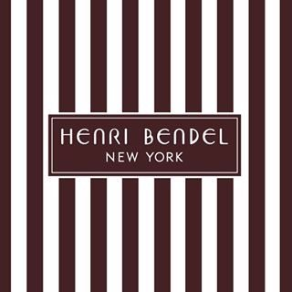
(iconic white and brown stripe print)

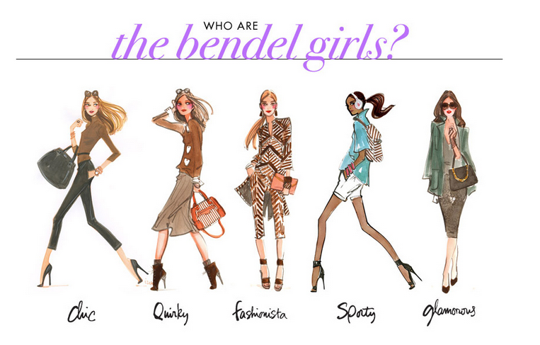
(the target market – “Bendel Girl”)

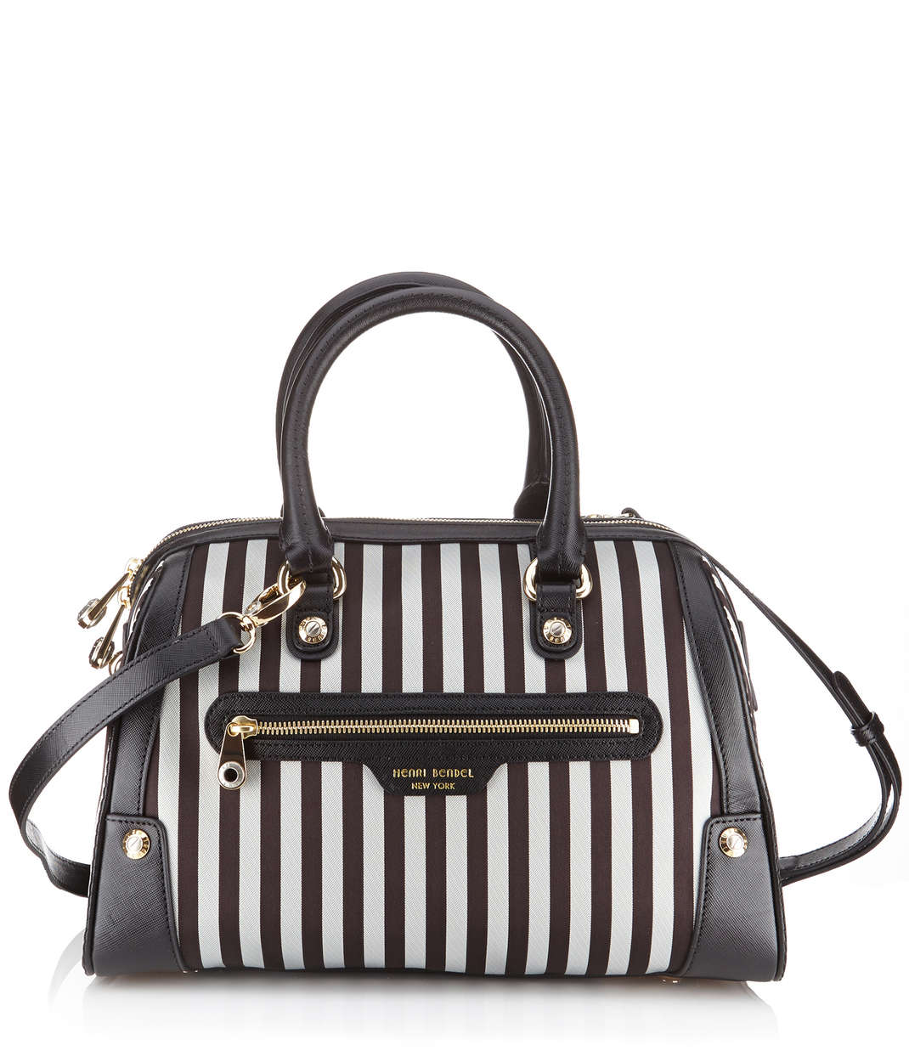
(classic Henri Bendel handbag)

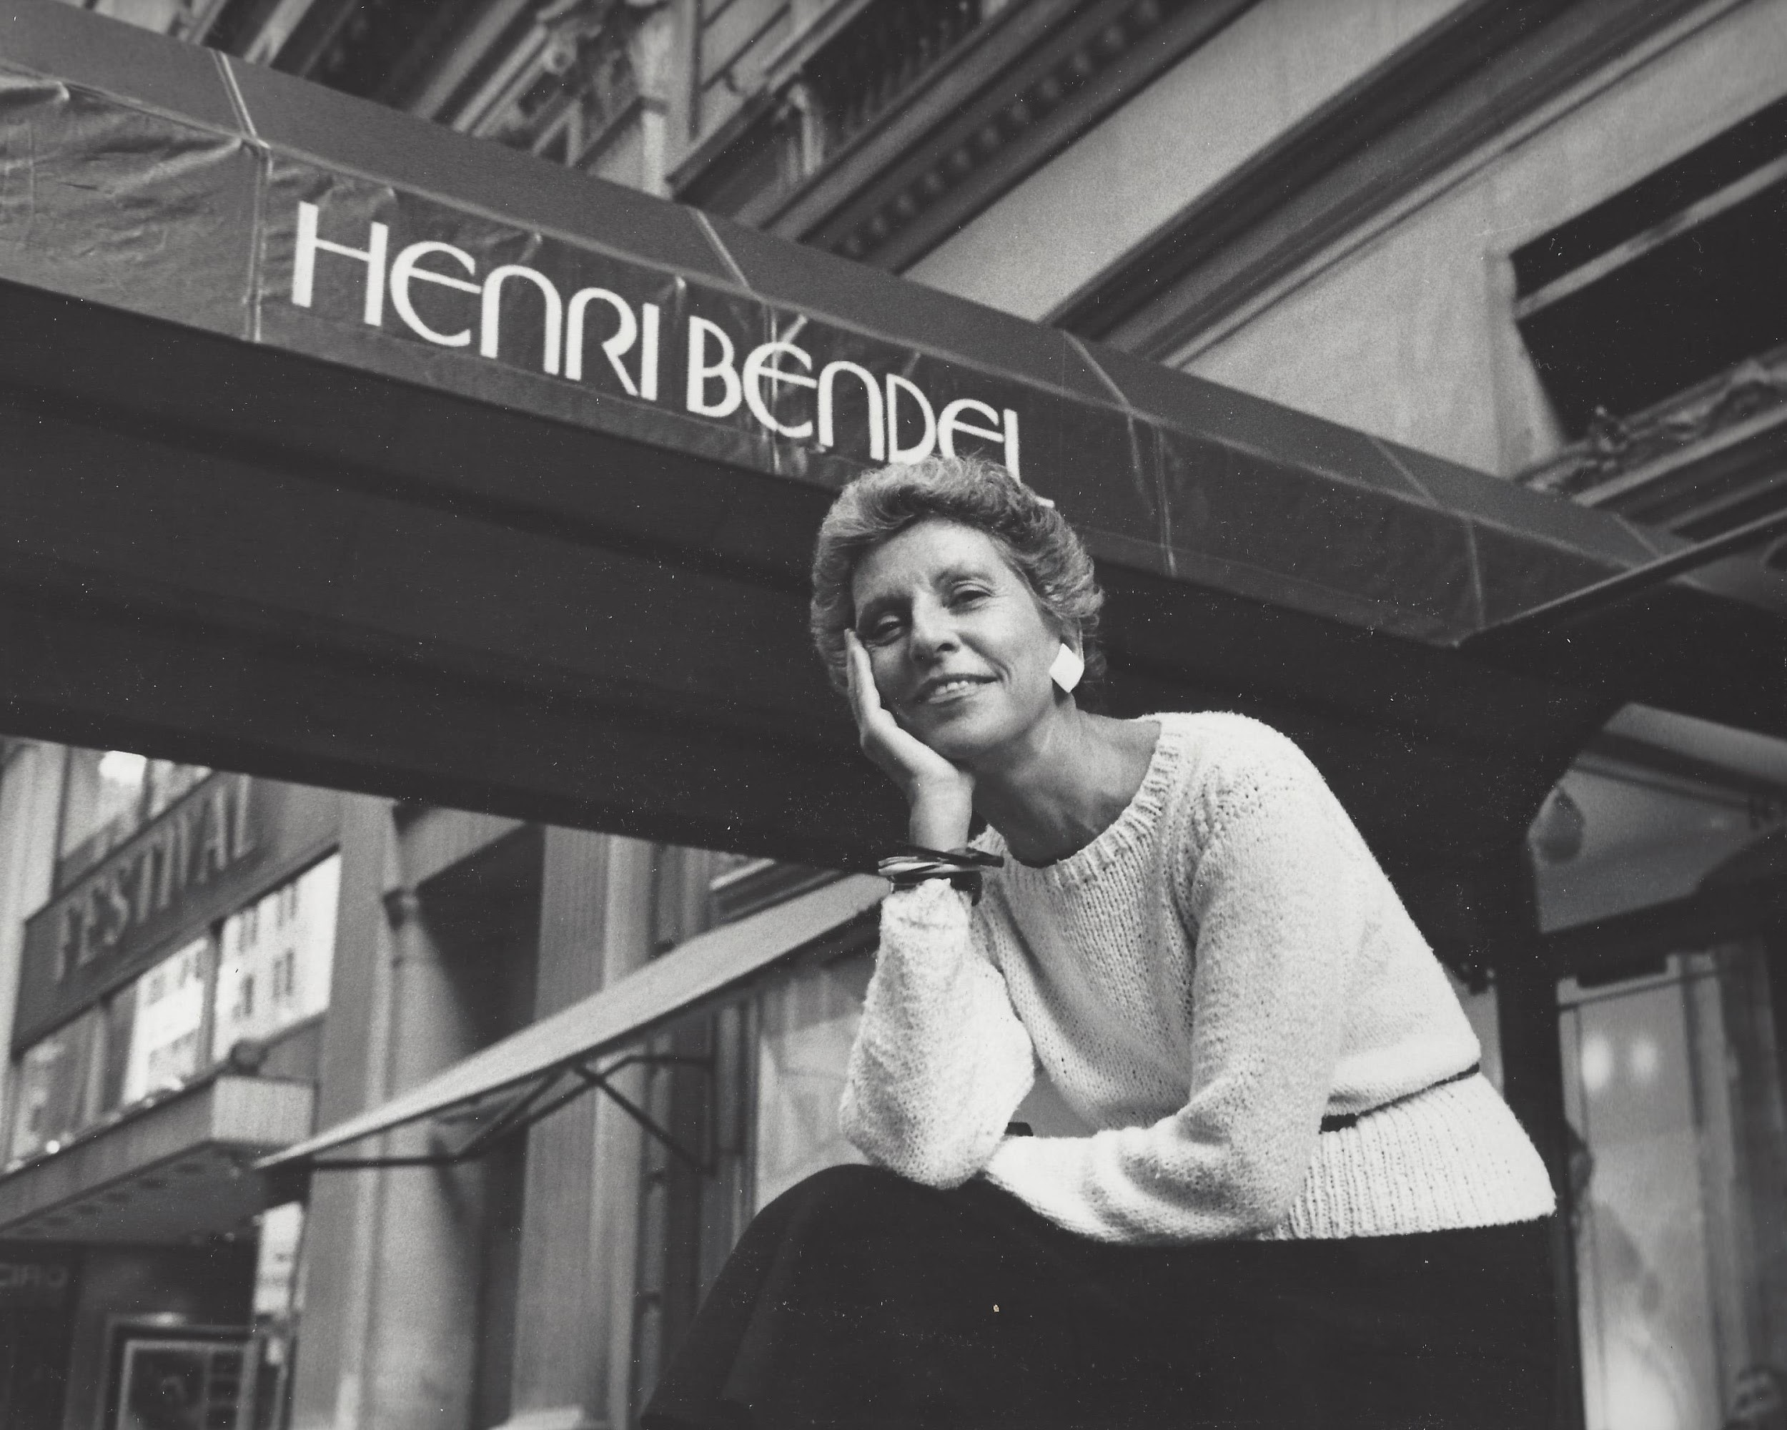
(president of Henri Bendel, Geraldine Stutz)

