Amanda Wong
Section OL10
December 10, 2021

Toothbrushing & Flossing Writing Assignment

Part 1: Understanding Gingivitis & Periodontitis
Most people know that toothbrushing is an important “activity” to incorporate into their daily lives in order to keep their oral cavity clean. What they usually do not know however, is that, oftentimes toothbrushing alone is not enough. The toothbrush only cleans the facial/buccal and lingual surfaces of each tooth. But what about the crevices in between each tooth and the sulcus/pocket of each tooth where toothbrushes cannot easily reach? This is where floss comes into play. Flossing can help clean in between each tooth and each respective sulcus/pocket of each tooth. Without a proper oral hygiene care routine, gingivitis and periodontitis can develop causing the person to have poor oral health and other complications. Gingivitis, being an early stage of gum disease, is an inflammation to the gums. According to Crest and Oral-b, gingivitis is caused by the buildup of plaque on the teeth and around the gumline. Plaque contains bacteria that produces toxins, which can irritate the gums. This can lead the gums to become red, puffy, inflamed, and can even bleed. Gingivitis can be easily treated and managed, but if left untreated, it can develop into a more severe kind of gum disease, periodontitis, which can lead to tooth loss entirely. Other factors that can increase one’s susceptibility of gingivitis, besides poor oral hygiene, is smoking, stress, hormonal changes, poor nutrition, pregnancy, medications, and chronic diseases (Oral-B, n/a). Patients should be taught proper toothbrushing and flossing techniques to prevent gingivitis. For instance, an important tip to provide patients with is to make sure the floss gets underneath the gums and around the tooth (floss should make a “C” shape) to ensure proper flossing and cleaning. Most people remove the floss right after it goes in between the teeth, however this should not be the case and must be more thorough. In addition, toothbrushes should be placed at 45° angle, where the brush is partially in/on the gums. This can help stimulate the gums and remove debris and/or deposits located in the gingival margin. Gum disease is common and is something 75% of Americans experience, but is also easily preventable (Crest, n/a). Therefore, having all this knowledge at hand, it is imperative for dental professionals to educate their patients on how to maintain good oral health.

Part 2: Toothbrushing (TB) Methods & Types
TB Methods:
Toothbrushes have been around as early as 3500 BC. The very first evidence of a toothbrush was the Babylonian chewstick. They are made from various types of wood by crushing the end of a twig or root and spreading the fibers in a brush-like manner (Boyd, Mallonee & Wyche, 2021). As time passed, wooden bristles were replaced with horse hair and eventually changed to what we use now, nylon bristles.
Regular daily toothbrushing is just as important as showering regularly. It helps reduce the risk of caries incidence and the risk of severity of periodontal disease. The toothbrushing method most recommended by dental professionals is the Modified Bass. This method has the person angling the toothbrush 45° towards the gingiva, thus allowing the bristles to be partially inside the gingiva to remove any debris underneath. While the bristles are placed underneath, the person would vibrate the toothbrush gently for approximately 10 seconds and sweep towards the crown of the tooth. To ensure all the teeth are being brushed, patients should be advised to have a consistent and systematic brushing sequence. Divide the mouth into sextants/quadrants and start brushing from the last molar (either buccal or lingual) to the midline. Afterwards, go back to the last molar of that region and brush the other surface (buccal or lingual) followed by the occlusal surface. This sequence is then repeated on the other parts of the oral cavity. While brushing, the patient should make sure the placement of the toothbrush overlaps one tooth from the previous section as they move onto the next section of 2-3 teeth. Without a consistent and systematic brushing sequence, the patient can easily miss an area in their mouth. In addition to having a brushing sequence, the patient can also incorporate a combination of the “count” and “clock” system to ensure even more thorough brushing (Boyd, Mallonee & Wyche, 2021). The patient can set a timer for 2-4 minutes while counting the number of strokes (5-10) brushed in each area. After brushing, the head of the toothbrush should be rinsed thoroughly with tap water until clean of any visible debris between the bristles and placed upright in open air away from contact with other toothbrush to avoid cross contamination. However, if the patient has a compromised immune system, the toothbrush should be soaked in an antimicrobial rinse to reduce bacterial load (Boyd, Mallonee & Wyche, 2021). Furthermore, closed containers are not recommended as it prevents the brush from drying encouraging bacterial growth.
With daily brushing, bacteria accumulates in the toothbrush. Therefore it is important to replace the toothbrush every three to four months or earlier if the bristles are frayed or lose resiliency (Dudala,2017). Some individuals may also choose to replace their toothbrush after a cold or respiratory infections (Sinclair, 2020). A damaged and/or worn out toothbrush will not get the job done properly and affect the cleanliness of the mouth.

TB Types:
There has always been a big debate on which type of toothbrush is “superior” – manual or powered. The answer still remains unclear as there are multiple factors that come into play when choosing and/or recommending a toothbrush for person. A manual toothbrush, like in its name, needs the person to manually “scrub” their teeth by moving their hand for it to provide cleanliness. A powered toothbrush, on the other hand, is automatic and requires batteries or a charging device. The person using it does not need to move their hand because the motions and vibrations of the brush mimic the ones of brushing manually (Boyd, Mallonee & Wyche, 2021). Because the toothbrush does all the work, the person would simply place the bristles at a 45° - 90° angle to the long axis of the tooth and turn the brush on (Boyd, Mallonee & Wyche, 2021). Then move the brush over the buccal or lingual and interproximal surfaces of each tooth for approximately five seconds. The person should not be manually moving the brush when using a powered toothbrush. In contrast, the person using the manual toothbrush, instead of just leaving the brush at a 45° angle, they would have to use their hands to make small vibrations to clean the teeth. The Modified Bass toothbrushing technique is the most recommended by dental professionals when using a manual toothbrush. The two types of toothbrushes has its own pros and cons that does not necessarily make one better than the other.
One of the major differences between the two is affordability. Manual toothbrushes are more affordable and, not to mention, more widely available compared to powered toothbrushes. Younger age groups may have a more frequent replacement of toothbrushes due to their dentition changes and them chewing on bristles (Bradley, 2020). With the constant replacements, manual toothbrushes might be a better option than powered toothbrushes. Manual toothbrushes also have a larger variety of brush configurations compared to powered toothbrushes. Therefore, manual toothbrushes may have a higher chance of having the brush head a person is looking for. For example, a patient with fixed orthodontic appliances may want a brush with bristles that can assess tight contacts and hard to reach areas. A manual toothbrush with “v-trimmed” bristles, a brush configuration a powered toothbrush does not have, is perfect for cleaning in and around the brackets (Sinclair, 2020).
On the other hand, certain patient groups with limited dexterity may prefer using a powered toothbrush because it does the manual work of brushing for them. The larger handle of the toothbrush can also make it easier to use. Other individuals that would benefit from using a powered toothbrush are those that are harsh and apply a lot of pressure when brushing. Excessive force and pressure when brushing can cause gingival recession and mechanical wear to the teeth (abrasion). Pressure is not needed when using a powered toothbrush because it does the job of “scrubbing” for you and knows the precise pressure that should be applied. However, there are individuals, like those with Parkinson’s disease or those with sensory issues, that cannot tolerate the constant vibration and prefer using a manual toothbrush. Powered toothbrushes are also becoming more advanced as some have built in timers and changes in pressure, which can facilitate brushing for two to four minutes as recommended.
In terms of effective cleaning, it has been suggested that powered toothbrushes are more effective at removing dental plaque (Bradley, 2020). But, if using the proper method to brush with a manual toothbrush, the effects are the same. What matters is the technique and not necessarily the type of brush. It ultimately comes down to the individual’s preference and what is most suitable for their situation.

Part 3: Flossing Methods
There are no records of the first time someone used floss, but anthropologists have found evidence that ancient people used various kinds of interdental tools for cleaning in between their teeth. A dentist in New Orleans named Dr. Levi Spear Parmly, also known as the father of dental hygiene, was given credit for the invention of dental floss in 1815 (Oral-B). He advised patients to use a thin silk thread to clean in between their teeth to get rid of food debris. Parmly knew that food debris led to cavities, but did not realize that flossing can be a huge preventative measure for periodontal disease (Duenwald, 2005). During the 1940s, synthetic materials like nylon replaced silk as the material for dental because of its consistent texture and resistance to shredding (Oral-B).
Flossing is an important step that has been recommended by all dental professionals to incorporate into one’s oral hygiene care routine. It helps clean under the gingiva and the interproximal surfaces of the teeth where a traditional/manual toothbrush and a powered toothbrush cannot get access to. These hard to clean areas trap food making it the best environment for bacteria to reside in and grow. As bacteria begin to buildup in between the teeth and gums, plaque and biofilm form causing gingivitis. If not removed, biofilm mineralizes becoming calculus and eventually leading to periodontal disease in the oral cavity. Flossing can reduce the risk of gingivitis and periodontal disease, however, it should be done correctly.
There are two types of flossing methods when using traditional floss. The Spool method, which is the most common, involves holding the floss between the thumb and index finger. The majority of the floss is wrapped around the middle finger of your non-dominant hand and the remaining is wrapped around the middle finger of the dominant hand, while the thumb and index finger is holding the short middle piece. The middle piece held by the thumb and index finger is worked in between the tooth using a slow sawing motion. As it reaches the gingival margin, wrap the floss around the tooth so that it creates a “c-shape” and gently slide the floss up and down the tooth a few times while pressing it firmly against the tooth. This allows the floss to remove the debris adhering to the tooth. When finished, remove the floss and wrap the used piece of floss around the middle finger of the dominant hand while the index finger of the non-dominant hand rolls out a clean piece to use. These steps are repeated for each tooth. An alternative method to use traditional floss is the Loop/Circle method. The ends of the floss is tied together and the thumb and index finger is used to hold a section of the floss to maneuver between the teeth. The same steps are used, as the in the Spool method, where the floss should be against and wrapped around the tooth, and then gently moved into the gums. When the floss is removed, the next section of the circle is used and the same steps are repeated until each tooth has been flossed. The Loop/Circle method may be easier for kids and people with limited dexterity to use because it can be easily managed compared to the Spool method (Boyd, Mallonee & Wyche, 2021). Nonetheless, the technique chosen to use is entirely up to the person and what they feel more comfortable with. Moreover, traditional floss may not be suitable for everyone. For instance, people with larger embrasures should use other interdental products like an interdental brush. Selecting a floss most suitable for one’s teeth and using it daily can help maintain good oral health.

The Spool Method

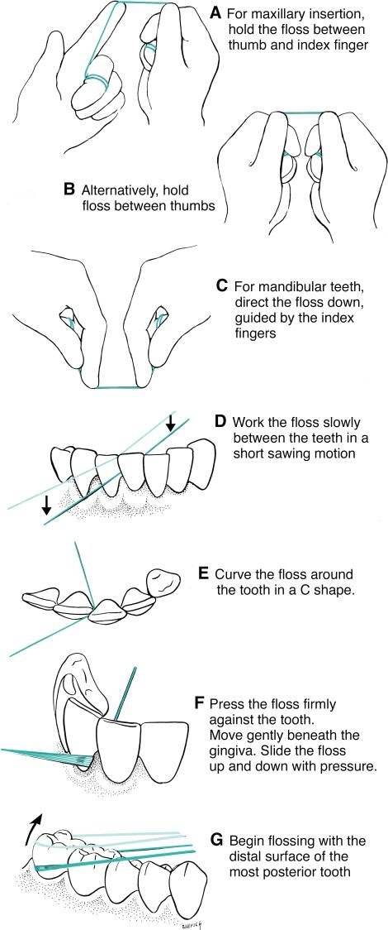

The Loop/Circle Method

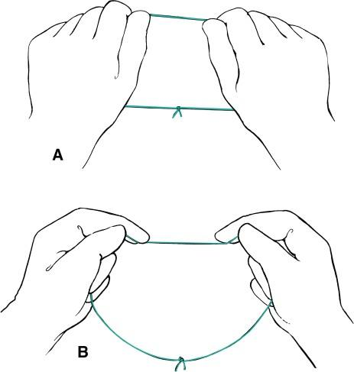

A: for maxillary teeth
B: for mandibular teeth

*figures shown above are from the 13th Edition of the Wilkins’ Clinical Practice of the Dental Hygienist

Part 4: Patient Care
When it comes to providing advice and suggesting change, there are different ways to inform and approach the patient. This may vary depending on various factors such as, the situation and the age of the patient – how someone would explain a concept to a 13 year old would obviously be different from someone explaining it to a 28 year old.
A 13 year old teenager who has orthodontic appliances says that he only brushes his teeth once a day and has never flossed before getting braces. I would start off by informing him that brushing at least twice a day is essential, once in the morning and once at night. In the morning you may feel a thin layer of film on your teeth after you sleep that can be scraped off using your fingernails. The film is called tartar, which is made up of bacteria making it important to brush your teeth in the morning to get rid of it preventing build-up. Then throughout the day, you are drinking juices/soda and eating foods that can cause bacteria to build-up again on your teeth. Without brushing at night before sleeping, you are more likely to get cavities. Because you have braces now, it is more important to properly clean your teeth because the braces will trap more food and bacteria. Flossing may seem like a lot of work and a hassle, especially with braces, but there are specific kinds of floss made so that people with braces can floss more easily. They’re called Platypus flossers and look similar to floss picks. I would also advise them to make sure the floss goes all the way down the gums and against the tooth for proper tartar or food debris removal. To ensure the patient knows which to buy, I would show them an image and write down the name of the floss on a piece of paper. A follow-up appointment would be made to check up on their progress.
A 28 year old patient that has localized gingival recession on the buccal surfaces of all posterior teeth indicates that they have been scrubbing their teeth using a medium toothbrush their entire life. It was also mentioned that floss is only used when food gets stuck in between their teeth. I would first show them the gingival recession on their teeth while having them look in the mirror and then educate them on how to prevent further recession. Gingival recession is usually caused by harsh brushing. A recommendation I would make is to use a soft bristle toothbrush along with the modified bass toothbrushing technique (with demonstration) or an electric toothbrush along with the tip that they do not have to apply pressure, and only move the brush around (with demonstration). Brushing the teeth harder and using a more dense toothbrush does not mean cleaner teeth. It is also important to know that consistent oral hygiene will lead to good oral hygiene, therefore it is important to brush as well as floss daily to remove potential food and tartar on the teeth. Foods, like vegetables, may not always be felt when it gets in between the teeth so it is always best to floss because tartar will always be present after eating. However, I would not teach them flossing until the next follow-up appointment because it might be overwhelming to receive more instruction as a brushing technique and a new toothbrush type was already recommended. It takes lots of practice and time for people to learn and change their previous habits.
Knowing how to provide good patient care to all ages is crucial in helping them understand what it takes to have and maintain good oral hygiene. Good patient care involves conversing in a manner which is easy to understand for the patient while thinking about any potential barriers they might have. Oral hygiene is important for all age groups as it can greatly impact, not only the oral cavity, but the body as a whole.

Part 5: Reflection Writing Prompts
After the completion of this writing assignment on toothbrushing and flossing, something new I learned more in depth about are the differences between a manual toothbrush and a powered toothbrush. For example, some powered toothbrushes have a feature made specifically for kids. This encourages brushing by linking their toothbrushes to an app on the phone allowing them to play games and earn points (Bradley, 2020). Many people, including some of my friends and family members, have also been brushing and flossing incorrectly. Most of them use the horizontal brushing method that can cause gingival recession and abrasion. With flossing, the common mistake I noticed is only allowing the floss to go straight down the gums instead of having to go underneath the gums while hugging the tooth (C-shape). I also learned more about gingivitis and periodontitis that can help me better explain the difference to patients in a way that can be better understood. With the knowledge I gained, I feel more comfortable having conversations with future patients about plaque, calculus, and using brushing and flossing methods to achieve and maintain good oral health. Overall, this assignment was very beneficial as the knowledge can help me develop and become a better hygienist in the future.

References

Boyd, L. D., Mallonee, L. F., & Wyche, C. J. (2021). Wilkins’ Clinical Practice of the Dental Hygienist, 13th Edition. Jones & Bartlett Learning.
Bradley, N. (2020, December). Manual vs Power – Which Toothbrush is best? It depends…. Colgate. Retrieved on November 26, 2021 from https://www.colgateprofessional.com/students-faculty/trending-topics/manual-vs-power-which-toothbrush-is-best-it-depends
Crest. (n.d.). What is Gingivitis? Symptoms, Causes, and Treatments. Retrieved on November 25, 2021 from https://crest.com/en-us/oral-care-tips/gum-health/gingivitis-symptoms-causes-treatments
Dudala, L. (2017, January 10). Brushing Techniques. [Powerpoint slides]. Slideshare. https://www.slideshare.net/lakshmi01071994/brushing-techniques-70870057
Duenwald, M. (2005, April 21). The Father of Floss. The New York Times. Retrieved on November 25, 2021 from https://www.nytimes.com/2005/04/21/fashion/thursdaystyles/the-father-of-floss.html
Oral-B. (n.d.). THE HISTORY OF DENTAL FLOSS. Retrieved on November 25, 2021 from https://oralb.com/en-us/oral-health/dental-floss-history/
Oral-B. (n.d.). WHAT IS GINGIVITIS? SYMPTOMS, CAUSES, AND TREATMENTS. Retrieved on November 25, 2021 from https://oralb.com/en-us/oral-health/conditions/gums/gingivitis-symptoms-causes-treatments/
Sinclair, L. (2020, December). Getting the most out of a manual toothbrush. Colgate. Retrieved on November 26, 2021 from https://www.colgateprofessional.com/students-faculty/trending-topics/get-the-most-out-of-manual-toothbrushing#

