Abigail Urquhart
12/14/2015
English 1101-D-376
Research paper

Police Brutality
Benjamin Spock once said, “Most middle-class whites have no idea what it feels like to be subjected to police who are routinely suspicious, rude, belligerent, and brutal.” According to Encyclepedia.com “Police brutality is the use of any force exceeding that reasonably necessary to accomplish a lawful police purpose.” For years and years now, police have been abusing the little power over people that they have. They’ve beat down and even killed people for their own purpose. They know it’s wrong, we know it’s wrong, the higher authorities know it’s wrong, but somehow they’re still right. Something they fail to realize though, is that we’re all human and we bleed the same blood so at the end of the day nobody should be more powerful than anybody. We are all the same. Police brutality is unacceptable and needs to stop because it has a history of happening, affects young people as a whole, and affects colored people as a whole.
Police brutality has a history for going on years back. If it had just started recently, then people wouldn’t be so upset about it. However the problem is it has been going on for too long now. When people used to protest during the time of segregation the police would beat anybody who was protesting. They didn’t care if you were, young, old, a boy, or a girl. The funny part is the police just get away with everything they do when everyone on the earth knows it is wrong. An article from “The Etiquette of Police Brutality” states. “The state has your back. No matter what you say, your superiors, the courts, everybody will nod and mumble: seems legit.” The police clearly know this and that is exactly why they do it. Even when videos are taken and put out there, nothing is done when you clearly see what was going on there. The public has been recording and spreading videos of police brutality back from the 1990’s when someone recorded the Los Angeles police brutalizing Rodney King.
To add to that, Police make up excuses for their actions and get away with it. Richord Pryor on California Police in 1973 said, “They accidently shoot more niggas out here than any place in the world. Every time you pick up the paper: nigga accidently shot in the ass. How do you accidently shoot a nigga six times in the chest? Well my gun fell and it just went crazy.” Honestly, I would like to know the answers to that question too. Police has been telling these lies for years and getting away with it. The sad part is, they don’t even have to make up a good enough lie to get away with anything. From they killed the person they already know that they’re getting away with it so they don’t even worry. They don’t even show a little remorse. It’s disgusting. According to “The Etiquette of Police Brutality”, “Fourty-one police shots took Amadou Diallo’s life in the Bronx and all he had on him was a wallet” but yet he was armed right? Even back in the 1960’s when the civil rights protestors were protesting the police came and hosed them down with the fire hoses. Everything that’s going on now with the police beating the people isn’t anything new.
Police brutality affects young people as a whole. Between 2014 and 2015 a couple young people were killed by police. A quote that really drew my attention from the article “The Etiquette of Police Brutality” says “Grab him from behind. Maybe use the baton. Don’t be swayed by his screams and pleas of innocence. As a matter of fact, don’t hear them at all. Be deaf to his cries. Innocence doesn’t really matter here anyway. Sort it out later. Don’t be inhibited with the violence- punches, kicks, strangulation holds, baton blows, tasers and so on. Don’t worry the state got your back. Make up any excuse you want. It doesn’t need to sound good. As a matter of fact it would be insulting to make it sound too plausible. Say something like: “he was looking at us all leerly and then he raised his hands. We had to throw him on the ground, smash his face to the concrete, knock his teeth out and put him in a chokehold. It’s important to neutralize the threat.” I’m not saying that anything that happens between a police officer and another person is always because the officer starts it but recently this is how the cops have been reacting to young people; for simple things that they “feel offended by” and things like this aren’t right at all no matter how you put it.
According to “Young voices echo at City Hall” young people went out and protested in front of City Hall in regards to the shooting and killing of innocent Amadou Diallo. The coordinator of the protest Conrad Muhammed stated “We are not against the police, what we are against is the abuse of the authority by the police.” The respect was still kept towards the police as he stated their purpose of doing it in “The Etiquette of Police Brutality.” “According to CBS Miami, Miami policed choked a fourteen year old boy on memorial day 2013 because he watched them with what police described as “dehumanizing stares.” I honestly didn’t know you try to kill someone because they “look at you”. Funny how police can get away with that but teenage girls get in trouble for fighting each other over those same little things. I guess the police are now little girls with nasty attitudes also. After the shooting and death of Treyvon Martin who was 17 back in 2012 set off a national debate on race and gun laws according to CBS news. The crazy part about this case is that Zimmerman who is the cop who shot him didn’t get charged but somebody else got him. When this teenager was shot it affected so many youths nationwide. They wore shirts for him, they got the skittles and Arizona and wore their hoodies in honor of him. Everybody shared it and made it known what had been done to this young boy but yet no chargers were giving. This is exactly why the teens now tell the cops to their face that they’re no use and are disrespectful to them. They are tired of how their peers are being treated and they know it isn’t right.
Police brutality affects colored people as a whole. Everyone knows colored people try to stay together and when one is hurt, they are all affected in some way. Colored people feel as if they’re just a targeted group and it appears to be that way also. “People of color have been the victims of systematic public and spontaneous private violence since the slave trade and the colonial conquest of the Americas,”(Contemporary Police Brutality and Misconduct). Colored people has been the target to anybody higher than them since history started. Back when slavery was around they only used colored people for slaves. When slavery was abolished they segregated them and whites were supposedly higher and better than them. Up till now there is still inequality; it never ends.
To Conclude, Police Brutality is unacceptable and needs to stop because it has a history of happening, affects young people as a whole, and affects colored people as a whole. We are all the same human mankind so why should others be treated differently and beat on because their skin tone or race? Just because you have a badge doesn’t mean you can treat people anyway you feel like. The Police brutality needs to be dealt with but the people that should be dealing with it is the same people letting them off. I guess that’s just how the world works right?

Don’t Shoot !, I ain’t do nothing !

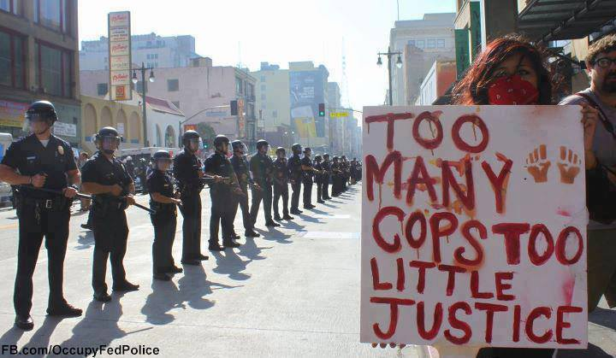
By: Abigail Urquhart

Bibliography

- "Police Brutality." Dictionary of American History. 2003. "Police Brutality." Encyclopedia.com. HighBeam Research, 01 Jan. 2003. Web. 30 Nov. 2015.
- Amalcar Scott, Rion. "The Etiquette Of Police Brutality." Crisis (15591573) (2015): 12-17. Academic Search Complete. Web. 30 Nov. 2015.
- Reyes, Damaso. "Young voices echo at City Hall. (Cover story)." New York Amsterdam News 11 Mar. 1999: 1. Academic Search Complete. Web. 30 Nov. 2015.
- "Trayvon Martin Case: Department of Justice Will Not Press Civil Rights Charges." CBSNews. CBS Interactive, n.d. Web. 30 Nov. 2015.
- Progress, Black Racial. "Contemporary Police Brutality and Misconduct: A Continuation of the Legacy of Racial Violence." CIVIL RIGHTS TEACHING. N.p., Mar.-Apr. 2001. Web. 30 Nov. 2015.

