# Dr. Woods Fashion Forecasting Spring 2020

Forecasting Project Table of Content

* About The Author …This is due on Monday (h.) Make certain that space for your photo is included as noted in class. Please avoid submitting short paragraphs. Try to give reader a solid image of the Author of this work. Follow instructions given you in Monday’s class
* Letter to the Reader
* Consumer Profile
* Six Trends
* History of your Trend
* Create a Time-line of your Trend starting with the year 1980, 1990, 2010,2018, 2020 (The time line of your trend can also be reflected in the History of your Trend.
* Trend Report (6-8 pages: 1 for each trend forecast) - Write a descriptive page outlining the importance of the trend and the direction it is taking. Descriptive page must me supported **by a news article** that indicates the accuracy of each of your predicted Trends.
* 2 Sketches of each trend for 2 years from now.
* Proposed silhouettes for your Trend
* Influencers & Direction
* Proposed colors for the season. (Provide paint swatches, but create color names.) • Proposed fabrics for the season. (Provide fabric swatches.)
* Conclusion
* Citations
* Appendix

Topics to be mentioned in your Work:

Theories that support your Trend

Influencers of your Trend

Pendulum swing

Zeitgeist (Spirit of the time

What’s happening Politically, Economically, and Socially with your Trend (might be included in History of Trend.

# **Trend forecasters predict a more trendless future**

Without customer data, brands are relying more on trend forecasters, who advise them to invest in sustainability and basics.

BY [GEORGE ARNETT](https://www.voguebusiness.com/contributor/george-arnett)

20 APRIL 2020

SHARE

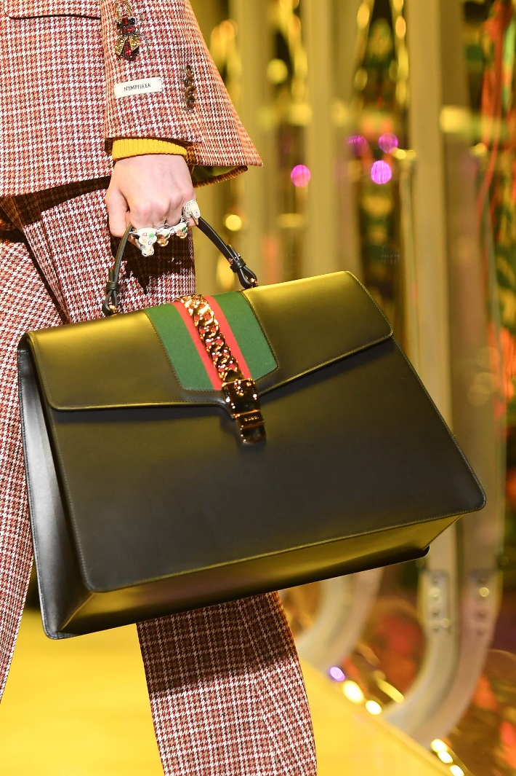

VENTURELLI/WIREIMAGE

**Key takeaways:**

* Trend forecasters say they are becoming an increasingly important information source to brands as purchasing data dries up.
* Forecasters are forced to adapt themselves by moving off the disrupted fashion and design event calendar while increasing their contact time with clients.
* Most believe that Covid-19 has validated their predictions that the fashion industry needs to slow down and fashion brands need to have more of an individual voice.

With Covid-19, everyone wants to know what is going to happen next.   
  
Trend forecasting is usually utilised in tandem with a brand’s own data on purchases, inventory and social media tracking. But fashion brands are in crisis mode. Starved of information due to the lack of customer activity, brands are increasingly leaning on forecasters to provide guidance on navigating the crisis. For the major firms like WGSN and Stylus, that has meant more regular updates and in-depth video meetings with clients to advise them on what the post-Covid-19 world might look like (and what comes before that).

But the world has changed for forecasters, too, with the demands made of the sector changing from providing seasonal trend analysis to serving as a guide for how brands can best survive the current morass. Many high profile events including Milan Design Week and Pitti Uomo have been cancelled and, in many cases, they have had to adjust the data points and information sources they are prioritising. Fashion firms are keen to know more about the consumer response in more open economies like China and hear predictions about how people will behave after lockdowns end.

In spite of global disruptions, most forecasters say that the macro trends they were anticipating — a consumer call for sustainability or a move away from seasonality — have not drastically changed in light of Covid-19. But they are accelerating at a faster than anticipated pace, in effect putting trend forecasters into a more pivotal role.

## **Increased reliance**

Carla Buzasi, managing director at WGSN, says demand is up for her company’s services as fashion firms work out how to navigate a world that is significantly changed on both the production and marketing sides.

“They are now looking at us as one of the main forms of data that they have on the market, because they were quite, quite blind on what's happening to be frank,” says Célia Poncelin, chief marketing officer at Paris-based forecaster Heuritech, which relies on AI-driven insights drawn from analysing social media posts.

For most of these firms, that means speaking to clients and sending them information much more regularly. Emily Gordon-Smith, director of consumer product at London-headquartered trend analysis firm Stylus, says that during Covid-19, she has spent much more time with clients than she used to. “Last week, I think I did 13 presentations directly to different brands, retailers or different businesses,” she says. That’s up from around a typical two client meetings per week in April.

While their subscriber base would typically be reading through reports that trend forecasters produce, many fashion firms now want more detailed presentations and the chance to ask questions about what is happening. Like many insight businesses, Stylus is now running webinars with live Q&A sessions to its subscriber base. These generally sit within current subscription models; raising prices or cashing in on the situation would likely play badly with clients and most of these forecasters rely on the fashion sector for their income.

That is partially a function of the needs of clients changing. Heuritech, who have switched from monthly to weekly updates at no extra cost, are helping much more with short-term inventory movement rather than the long-term planning that was the norm before, says Poncelin.

Gordon-Smith says about 40 to 50 per cent of what they are sending out is dealing with the here and now for brands, but that Stylus have simultaneously seen a rising focus from clients on their future-facing design directions, which look ahead 18 months to two years into the future.

VOGUE BUSINESS