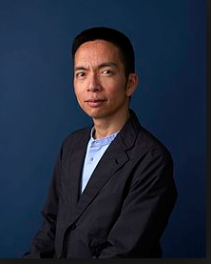
Popular contemporary American graphic designer

John Maeda a popular Graphic designer

John Maeda was born in 1966 from a Japanese origin. Maeda was raised in Seattle, Washington. His father was an owner of a Tofu factory. He helped this father in that factory company by managing small business paperwork on the computer. By the help he did in the factory, he found his passion. John Maeda choose computer science to study. He was enrolled in Massachusetts Institution of technology and studied electric engineering and computer science.

However, he was not fulfilled he moved to Japan to pursued a degree in a completely different field. He attended the University of Tsukuba Institute. Where he decided to study and obtain a degree in Arts and design. In Tsukuba Institute he also earned a Doctor of Philosophy in Design science. According to Maeda “the learning experience enable him to rediscover three things mind, paper, pen”

In 1990s Maeda he returned to MIT to establish the Aesthetics and computation Group the research studio was made to unite fields of interest like, engineering, art, computation thinking and craft. Maeda’s first video titled “Elements of reactive Form” discussing the power and effectiveness of form that he previously addressed in his essay ‘Reactive Graphics’ published in MDN magazine. Johan Maeda is a renowned author for writing “The Laws of Simplicity’. The law of simplicity is considered to be a landmark in graphic design.

A retrospective of his work was held in London, Paris and New York. The San Francisco
Museum of Modern Art has his artwork stored in its permanent collection. Johan strongly believes in the possibility of art and design and that it will affect and transform the 21st century economy like science and technology did in the last century.
Johan Meade was the author of the book called simplicity. It describes 10 laws that he identifies as simplicity or that leads to simplicity.
Simplicity is about subtracting the obvious, and adding the meaningful. Johan Meada has his own way of design. He is a graphic designer that is addicted to repetition of pattern. He likes depth and all his designs give the allusion of depth.

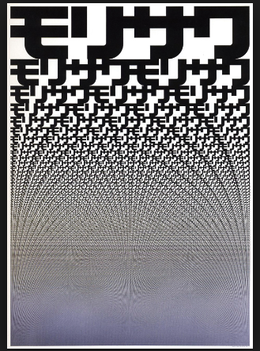

Sources
https://www.moma.org/artists/30299?=undefined&page=1&direction=

