Alaa.M.Sultan
COACH

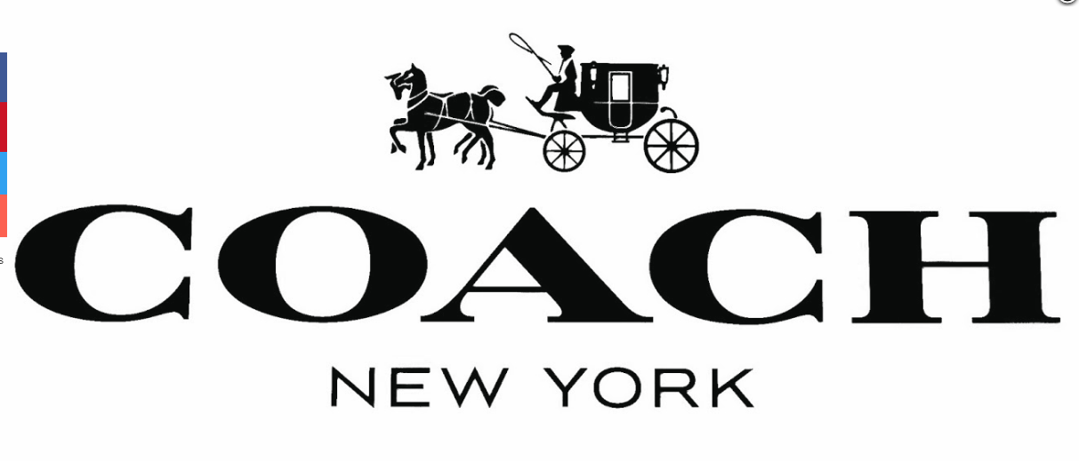

In 1941 in New York City one of the most well-known high-end fashion companies have lunched. It was located on 34th Street in Manhattan. Coach is a run on company.
It is a fashion company that is known for its leather and diversity of fashion. My paper will prove who designed the logo of coach, what does the logo mean, and how is coach unique.
In 1962 the logo of coach was designed and launched by Bonnie Cashin. The Coach logo is probably the most memorable logo in leatherware industry. She did not only design the logo for the company but she was responsible for designing shoulder bag and a clutch-style purse with a removable shoulder strap. Coach logo represents the old days. The logo simple’s prestige. It represents the old days. when there was no transportation. The black color in the Coach logo represents the prestige, strength and refinement of the brand.
The classic Coach logo carried the impression of luxury, royalty, and elegance. The logo featured the image of a horse and carriage which was created and designed by Bonnie Cashin.
Coach fashion company is unique because it sells everything a person wants. It’s a brand that simple’s old American days. However, its sells modern cloth and its always up to day with the new fashion trends.
The coach logo is unique because it was designed just for coach. The typeface for Coach was especially for coach. Coach has a classic logo which consists of the wagon and the horse, which was introduced in 1962.

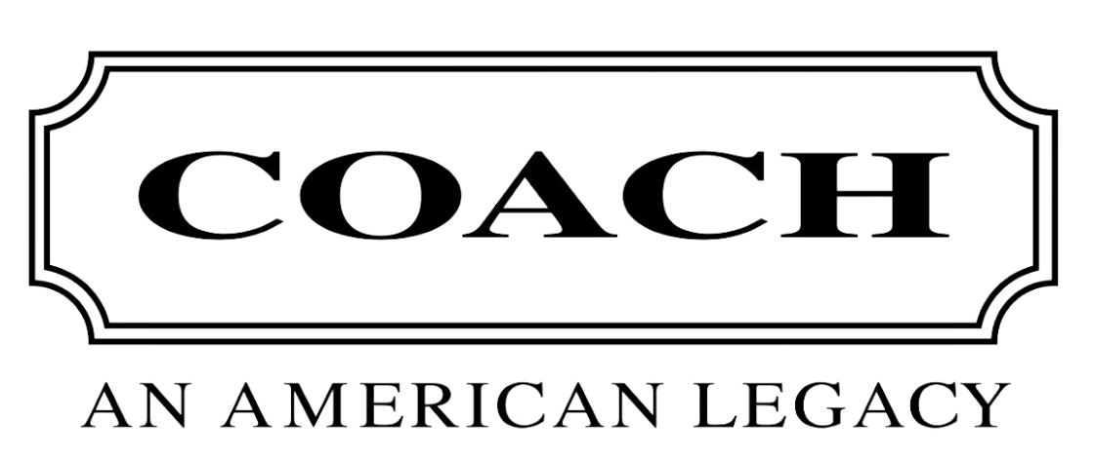
In 2007 coach lunched a new logo. It appears on all products manufactured by the company. Although the new design has a greater degree of modernity, it has inherited the elegance of the previous one and symbolizes prestige, wealthy, and perfection. The Coach logo is entirely black, and the color represents excellence, prestige, and well-being.
Coach is an all over the world brand. Women and men tend to wear, but it is a feminist brand because of the verity of fashion it offers.

