Lost In What She Wore

\By: Ashley Roberts

Lost In What She Wore

Forward

I am delighted to introduce my sister’s novel. From awkward teen years through adulthood we endured a whirlwind of challenges. This novel share short stories of Ashley’s most memorable moments. Her triumph, growth, and development. I amazed at the talent, wit, and style she possesses and hope that you come to adore her too. Let’s peek through the looking glass of Ashley’s adventures.

i.
Table of Contents

Hawks International………………………….……1
Go Shawty It's Ya Birthday!....................................3
P.S. 308 Clara Cardwell…………………………...5
Imani Aguilera…….………………………………7
Hair Chronicles……………………………………10
East Harlem……..……………………………..…12
Burundi Chung……………...……………………15
Teenage Dilemma……………………………..…17
Heartache …………...…………………………...19
Joe Grinds Kids Glow Boatride …………………22
SVG……………………………….……………..24
The Meaning of Color………………..…………..26
“The Greatest Show on Earth”……..…………….28
Baby Banton……………………………..……….31
Mrs. Daly……………………………………...…34

ii.
Hawks International
August 30, 2003, I was seven years old and participating in kiddie’s carnival for the first time. My sister, my mother and I walked down Kingston and St. Johns street in Brooklyn to meet our band Hawks International. Aisha, my sister who is two years older than me, had participated before. She walked in front of us in a hurry, with no care to hold mammie’s hand.
I can remember the long hot summer nights meeting my father in the warehouse where he designed hundreds of costumes. It was special moment to finally wear one of father’s creations, our matching silver and red costumes. The collar was silver and studded out in red and silver gem stones with a matching crown. Layered with a red spandex bodysuit underneath. The skirt was my favorite part, a silver wide belted skirt covered in red feathers all around. With matching glittered silver shoes my mother had spray painted for my sister and I the night before, which became an annual chore.
My moist hands gripped my mother’s so tight as we got closer. I became over whelmed with excitement and fear. But I could feel my mother tugging at me to let go of her hand. When we finally reached the band, I saw my cousins and cut loose of my mother’s hand running towards them.

1
We danced, we sweat, we ate, we jumped, we played “A Mas” as my father would say. I had forgotten all about mammie. Until we reached The Brooklyn Museum on Eastern Parkway, that overwhelming feeling took over again. This was the Grand Finale/ the moment of truth so to speak. The Museum is where we crossed

the stage to be judged and ultimately to winning “Band of The Year.” Over the years I have come to realize that this overwhelming feeling will never go away. I questioned my mother about these feelings, and she expressed she felt the same. Not only at my age but throughout her life. I asked my sisters and friends about this same overwhelming feeling, they too felt the same.

2
Go Shawty It's Ya Birthday!
The first birthday event I could recall would be my 10th birthday. Mammie and my dad were in preparations all day for my party in our apartment located at 485 Madison. Mammie was in the kitchen all day, making all the party favorites curry, roti, oxtail, etc.
Daddy rearranged the living and dining room to make a “dance floor” I couldn’t wait to see all my friends and cousins but most importantly the new outfit mammie bought me. The weekend before mammie and I visited Bloomingdales on Fifth Avenue. This was one of her favorites places to shop for Aisha and I because they sold Ralph Lauren and of course she had coupons! On our visit I found the perfect racer back green and navy-blue polo dress. Ralph Lauren’s polo dresses were my favorite to wear because they were sporty and fun.
The morning of the party mammie took me to get my hair braided (which I hated) I could never sit too long in the chair and I hated my hair to be tugged on. but the outcome was always my favorite, especially when beads were added. But those were only for special events. I remember this day perfectly because I was so over joyed.

3

4
P.S. 308 Clara Cardwell
"Black and Gold is the colors that we wear...." This was the beginning of the lyrics to P.S. 308 school anthem. It was fifth grade prom and graduation and prom. Mammie and I searched each overly cluttered window on Flatbush avenue looking for the perfect cold dress. The girls were required to wear gold dresses and the boy’s black suits a white button up and Gold in order to resemble the lion of my elementary school’s mascot. As mammie and I walked down Flatbush we entered each dress store but we did not have to look any longer because we found the perfect dress at Berto Kids Fashion Inc. on Flatbush and Beverly Road. This was always mammie's go to store, for any holiday or special occasion. It was totally her style super organized, great pricing and a one-shot deal. I tried on about 5 dresses before I found the perfect one, and I was super excited. Trying on clothing and feeling like a princess excited me. Gold was my second favorite color, something about it made me feel luxurious and beautiful. When I finally found the perfect dress, my face lit up with excitement.

5
The dress was floor length and had a wrapped waist that gathered on my left hip. Along the waist was small gold beading and a big gold flower. On the day of graduation mammie surprised me with a gold studded crown and a white corsage that had gold glitter sprinkled all over. In our culture only on special occasions children could wear their “good jewelry,” which was often gold. Mammie placed my Cuban link gold chain on my neck, which of course a Jesus cross hung in the center. She also placed a Cuban link bracelet that was gifted to me from my dad as a new born, in the center was a carving of Mary with her arms fold as if she held a baby, in her arms where an Emerald gemstone replaced that spot (my birthstone). Mammie also placed on my arm a three-piece engraved bangle set on my arm.

6
Imani Aguilera
Since about the 3rd Grade, Imani Aguilera and I were best friend. We got along very well because of our similarities. Imani was a bout two skin tones darker than me and much taller. But we shared the same big black kinky hair and silly pigtails our mothers gave us. I met her in the cubby room hanging up her jacket, as usual we were always the late kids. I commented on her jacket asking about where it was from because I remember seeing it before in the city with mammie one day. From then on, we were friends forever.
Imani enjoyed clothing just as I did, her mother shopped in a lot of the store’s mammie did and was always in search of a bargain. Beside clothing through multiple conversation Imani and Ii realizes so many of our similarities not only our likings but our lives at home. She also had an Aunt Ms. Dockery who teaches at P.S. 308 school. I loved Ms. Dockery her sense of style was so amazing, and I admired her outfits each day and so did Imani. Ms. Dockery was also a great sense of guidance throughout our friendship. Whenever Imani and I had meaningless arguments and would not speak to each other for days. Ms. Dockery would order us lunch, and have it delivered forcing us to be in the same classroom giving us no choice but to speak to each other. We were in separable, there was never a time you would see her and not see me. Other students began to think we were sisters or related.

7
In the 4th grade Imani decided that every Christmas we would exchange gifts. I would never forget the first present she bought me. A pair of suede black round toe boots, one each side was a shiny multi colored round buckle. The boots were from Daffy’s one of the similar stores our mothers loved to shop in. These boots meant so much to me and I tried my best to take care of them until I could no longer fit into them. I insisted to mammie they were only to be worn on “good occasions.” Looking back now the boots had much greater meaning than its looks. To me it was a token of our friendship, the fact that Imani wanted to take time out of her life each year to give me something showed her consistency and how much she valued our friendship. Other than mammie or my siblings this was the first time anyone else that was my age cared about me and never considered doing anything without me. Imani and I continued to be friends until we graduated from the 8th grade. Till this day we both live in the same neighborhood and when we see each other we still hug like we did during those eight-year old’s in P.S.308.

8

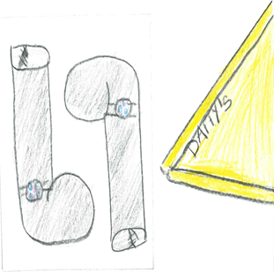

9
Hair Chronicles
In the year 2010 I prepared to graduate from middle school and heading onto high school. I was so over joyed to begin doing teenage things, like going out with friends, school parties, getting my first job in order to buy my own clothing, shoes and getting my hair done at a salon.
It was nearing to picture day and I had been pressuring Mammie about getting my first blowout, which she was totally against. Mammie was big on me protecting my hair, I think she was more obsessed with it than I was. I have big, soft, kinky curly hair which I inherited from my father. Totally opposite from my sister, who’s hair is light brown and thick which she inherited from my mother. Aisha’s hair was so thick and “unmanageable” Mammie took her to the salon for a perm. I also admired Aisha’s hair because she was able to take trips with mammie to the salon. The only time I went to the salon was to get cornrows. Any other time my older sister Kechi would braid my hair at home. My mother was not the best at doing hair, she would always give me these big pigtails and twist with a bunch of colored bobos’ and clipped that would never last the whole day. Daddy on the other hand gave me the best high buns.

10
Finally, the Sunday before picture day mammie took me to the Dominican salon a few blocks away from our house. All the girls in the eight grade had bangs but me. Not only did mammie agree to a blowout but to me cutting bangs as well. She sat in the salon and over looked the hair dresser the whole time. I knew in her head she was criticizing everything the hair dresser did. The heat from the hair dryer and blow dryer was unbearable. On the walk home mammie turned to me and said, “Pain is Beauty Huh?”
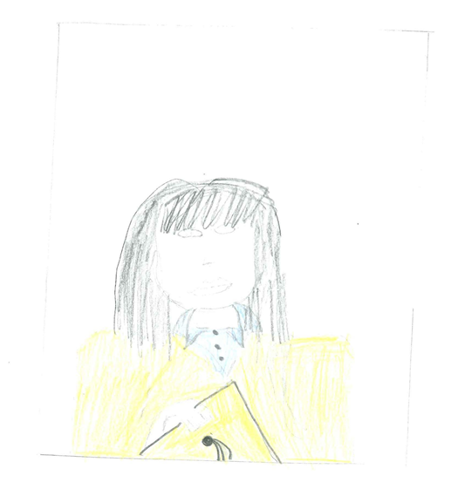
The memory of that photo stuck with me. I wore my favorite Juicy Couture linked necklace with my light blue polo uniform shirt from the Gap and a red cable knit sweater from the Gap as well. Layered over was P.S.308’S Bright gold Gown, for the photo we were not required to wear a cap. For me this was the best thing. I was able to show off my straight shoulder length hair and my freshly cut bangs.

5

East Harlem
In Park East Highschool, I joined the track and field team. I could remember one of the most discouraging and emotional meets for me was when I participated in a senior level 800-meter run. This was the first-time mammie accompanied me and it was devastating because I already trained my mind for failure. I could not understand why my coach would put me as a freshman up against four-year experienced runners.
Crouched down in my four point start position with my front knee over and both hands on the starting line and my back knee on the ground next to my front ankle. As I stayed into this position waiting for the gun to go off, I stared down at my sneakers. I was starring at my first pair of track and field spiked sneakers; the entire show was forest green and the laces and adidas logo were hot pink. When I saw them in the store, I thought they were Perfect, Just for Me! Then this ugly over-sized blue and white polyester uniform, I was so small I had no choice but to flip the waist twice to stay on my hips as I ran.

12
I do not remember the gun going off. I do not remember getting out of the start position. All I remember was it was the last 200-meter lap, I felt my ponytail slapping me in my face, but I did not keep my eyes straight forward off that big clock board. My mind was still racing “I’m never going to make it to the end, I am such a failure, why would coach put me in this position?” I had the urge to look around at my opponents, but coaches voice played in my head “Ash Keep That Head forward, there is Nothing Back There for You!”
Reaching to the finish line I dropped down to my knees and sobbed with my head in my arms. I was exhausted, ashamed, and discouraged; this was my most humbling moment yet in my teenage years. I felt as if I did the walk of shame back to where my team members, mom and coach were seated. As I walked toward them with dry tears on my rosy cheeks, I could hear my team mates cheering me on. I had placed Third Placed in the Senior 800 Meter Race.

13
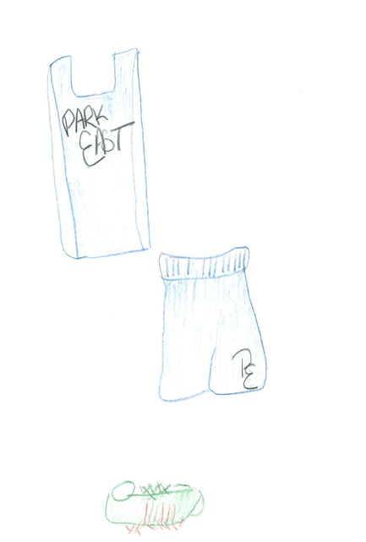

14
Burundi Chung
In high school being invited and attending Sweet 16s were a Big Deal. My very first Sweet 16 I attended was my childhoods friend Burundi's. We also attended the same high school together.
Burundi's family was a well-known family around Flatbush, Brooklyn. A lot of my child hood friends would be at the party along with kids from other high schools around Brooklyn, whom I was familiar with.
This was one of the moments I was grateful to work at McDonald's. The Friday before the party I planned to go Top Shop in SOHO right after school to find the perfect dress. The perfect dress was a mini all black dress. The top was shaped in a corset, covered in blue/purple iridescent circular embellishments. Fitted to my upper body and a sweetheart neckline. I made sure the dress had spaghetti straps because I was uncomfortable wearing strapless dresses or tops. The bottom was a full wide pleated skirt. In top shops fitting-room I envisioned a black pair of Nina sling backs mammie bought me to attend a wedding a few months prior.

15
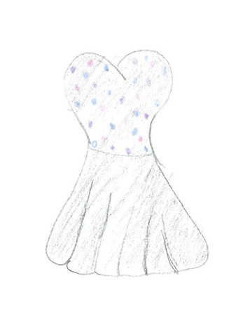
It was finally Saturday evening and time to get dress. This was such an exciting time, finally getting dressed up to go out and see all my friends. Saturday morning mammie sent me to the Dominican salon for a fresh blow-out. When I was finally dressed, I unwrapped my hair and pinned it back on one side to add a bit of flair, well what I thought was a little flair at that point time. My finally touch was a black wing eyeliner. In high school I was not crazy about wearing makeup because I had smooth skin. My signature look to go out was a black wing eyeliner and my MAC lipstick in the shade Saint Germaine.

16
Teenage Dilemma
Throughout my adolescence in high school is when I began playing with my sense of style. These were the years I wanted to figure of what dress meant to me and what did my sense of dress portrayed about me within society. I was able to experiment on my own because I was working at McDonalds at the time. Majority of my paycheck went toward clothing and food.
I began shopping in stores like Zara but mainly online United Kingdom trendy stores, such as Miss Guided and Asos. In high school we had Homecoming week in Novemeber which lead to the Thanksgiving break. At the end of the week the day before Thanksgiving my school would have a homecoming party.
My friends and I were so excited about going and I needed to find the perfect outfit. So, I searched Asos where I had a student discount and free two-day shipping, so there was no way I would not receive my package on time.
I purchased a black jumpsuit. The black jumpsuit had a sweet heart neckline which gave me a little cleavage but not too much, appropriate for a high school student. The arms were capped sleeves and the waist had a peplum. During this time, I have discovered that the peplum style was great for my figure. So anytime I saw it, it was my number one choice.

17
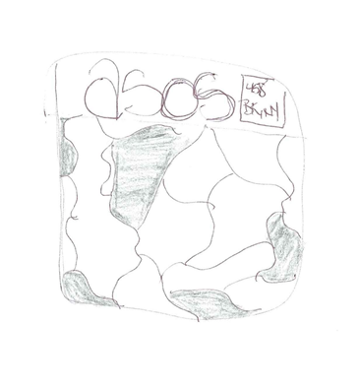
But I was all wrong! The weekend before there was a snowstorm and I received a email that my package would be delayed another day because the weather conditions. I did not panic because I had a few more days. The day I was supposed to receive the package I rushed home from school. NO PACKAGE! But of course, again my mother came to my rescues on her way from work she stopped by Zara and picked me up a dress to wear for the night.

18
Heartache
Finally, I was graduating from the high school I’ve always wanted to attend, Benjamin Banneker Academy High School in Clinton Hills. My Freshman year and a few months into sophomore year of High School I attended Park East High school in East Harlem. Which was about a two hour commute every day. My sister at the time was a Senior at Benjamin Banneker and within her four years there she built a strong relationship with the principal, Mrs. Renee. My sister visited the principal’s office, explaining my situation; in hopes of her accepting me into her school. She requested my grades my current high school and a meeting with my mammie. Of course, after a meeting with my mother and Mrs. Renee and my mother discovered they were born and raised in the same island, Trinidad and Tobago. From that moment on the meeting was over and I was automatically accepted.
Fast Forward to Senior year, I was over joyed about finally reaching this milestone. During my senior year I only had three classes left to complete in order to earn my diploma. This left me with half of my day being free time but instead of wasting that time I obtained a job at McDonalds the summer before to fill that free time.

19
Senior year was a growth period in my life. Attending school and maintain a job began to show me the importance of time management and prepared me for college life. Mammie was always proud of me, she never had to ask me to go out and get a job it was always out of my free will and self-motivation. I always helped mammie out a great deal, with each check I received I was able to pay off my senior dues and my prom dress all on my own.
At this point in time I already set my mind out to attend college for fashion and my prom dress would be my first official project. I refused to go down Flatbush Avenue and purchase a dress like all the other girls in my school. So, I worked every day in order to save up enough to pay for a custom-made dress.
I always admired my sister in law, Raquel’s sense of fashion. She was eldest brother, Marlon’s wife. Anytime she attended an event she always wore these over the top custom-made outfits. Raquel helped me to brainstorm ideas of what I wanted my dress to be like. I examined some of her prior outfits and some the vogue and bridal magazines she had given me.

20
Eventually, I decided on a fishtail white dress. The dress consisted of gold embroider cap sleeves. Down the middle of the gown was a gold beaded applique, I remember going to Fashion Ave with Mammie to pick and purchase the applique myself. About a month before prom, one of my best friends, Kendra and I went to get our first tattoo’s. I was always mindful of my body and lack of bosom’s. With that in mind the placement of my first tattoo would be seen in my gown. Instead of having low revealing cleavage in the front, the gown had a low fitted back. The letter A shaped in a heart tattoo was placed right on the side of my bosom so been seen in the back of my gown.

21
Joe’s Grinds Kids Glow Boat Ride
Every Father’s Day weekend my family and I would attend an annual all white dress code boat ride/ party. I have been attending this party yearly from about the age of 7. It was an exciting time because it was the starter of the summer. It was a time I would see all my friends, cousins, and family whom I haven’t seen during the winter.
In the year 2014, my mother and father stopped attended. But they allowed me to go with my friends instead. I went with, Joshelle whom is one of best friends till this day and a few of her friends from Highschool. Joshelle’s father was the host of the boat ride and business partners with my eldest sister, Aleah. Which is how Joshelle and I have become friends. She is one year older than me and she is always protective over me as her little sister. In 2014 she had obtained her license and her parents gifted her with her first car.
The summer of 2014 was also a mile stone for me as well, I just graduated from Benjamin Banneker Highschool. About two weeks before I attended my high school prom. Mammie allowed me to color my hair jet black and get my first weave. I knew the boat ride was two weeks later, so I made sure to maintain my hair until then.

22
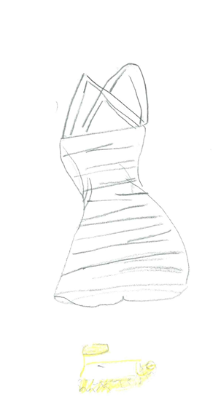
We were so excited to pull up in front The Sheepshead Bay Boating dock in her brand-new car. As I stepped out of the passenger seat, I wore a white dress I had purchased from Forever 21 a week prior. The dress was a stripped skater styled dress. It also had spaghetti straps and had an X back. I paired them with the shoes I wore for prom after party. I purchased them in mammie’s second favorite store Fox’s located on Kings Highway in Brooklyn. The she shoes were sparkle rose gold, platformed peep toe sandals.

23
SVG
After two years, I finally quit McDonalds in hopes of better opportunities. Going into the New Year of 2016 my resolution for the New Year was to obtain a better paying job, that worked with my schedule and allowed for vacation time. I started applying to every retail store I could think of but made sure to stay away from any food services. For a couple of months, I was out of work but being enrolled in college which occupied my time.
By the summer my best friend, Joshelle invited me to carnival in St. Vincent the island where her parents were born. I was super excited for this experience and was determined to find a job to fund this vacation. Eventually, I landed a job at Century 21 in Bay Ridge. It would be long commute from Bed-Stuy to Bay Ridge every day, but I was determined to save up just enough for the vacation. My older sister, Kechi and her best friend Wendy were also going to St. Vincent, they always took care of me, so I knew making just enough was okay and they would cover the rest.

24
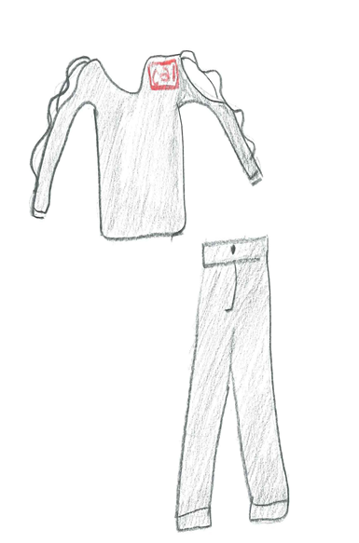
Century 21 opened at 10:00am every morning, employees were required to be there an hour before 9:00am. To be on time, I need to allow myself about an hour and 30 minutes to be early or on time. The cold brisk mornings rolling out of bed around 7:00am to leave about 7:45. I dragged on the same uniform every day. Pair of extra fitted, extra-long black slacks and the first black top I could find. This was the most dreadful job ever and my appearance made it no better. But I was determined to save up.

25
The Meaning of Color
As a child I could always remember mammie expressing her dislike for red and rarely would she ever buy I or Aisha anything in that color. But as I got older, I've found love for the color, but I can see mammie's view on the perception of the color as well.
On one our annual girls' vacations to St. Vincent for carnival, my boyfriend Osei of three years came along too. Osei and his family were also from St. Vincent. Which is why it was so easy for us to bond as couple because she shared the same culture. July 8, 2016 it was Carnival Monday, my friends and I were playing with a band called Digicel. With this band you were required to wear a red bodysuit that had to be purchased at their store. From the moment I saw it I fell in love; the bodysuit was made from spandex which meant it was very forming fitting. The neck was held up by a white elastic band which formed a halter and the bodice consisted of a keyhole top. Right under the keyhole marked "Digicel Monday Jam." On the bottom each said of the body suit had about six crisscrossed elastic bands from the waist to the hip. One of my best friends, Isiss and I decided that our group of friends should pair the body suit with gold rhinestone shaped cat ears.

26
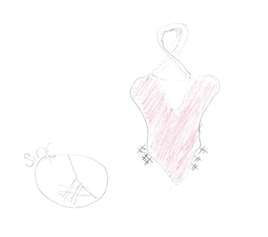
The sun began to go down my friends and I were exhausted and WASTED. I did not see Osei for the day yet but in the mist of the crowded drunken people and loud music I could see him rushing towards me. He saw me and held me from behind and whispered in my ear "I never realized how good red looks on you, you should wear it more often." I began to blush. It's something about receiving a compliment from your significant other that makes you feel Ten Times more attractive despite what anyone else thinks, like mammie. I could understand mammie's views on the color red. It's the color of passionate love, seduction, violence, danger, anger, and adventure. It was all these things but for Osei I would gladly be.
27
"The Greatest Show on Earth"
Another spectacular experience for me was Trinidad Carnival in 2015. I have always watched on Instagram and admired every year, how much fun everyone was having. My eldest sisters Aleah and Kechi would always go to carnival religiously every year. They used to stay about a month in Trinidad. Carnival is a very important and exciting time in
Trinidad, it is celebrated from the day after Christmas till mid-February.
When I finally got the chance to go in 2015 1 was elated, choosing the right outfits for each event and my costume of course. The most popular band to play with was called Tribe Mas Band. They were known to have the best vibes carnival day and of course I was playing with them. I choose the section peacock, the costume consisted of a feathered head piece. They were placed in each side of the headband in an arched shape. The band across my forehead was an eyelet bronze and the feathers were tan and teal.

28
The bra reflected the same colors at the head piece, the entire bra was nude, and the neck piece formed to a halter shape was the same bronze eyelet that was placed on the headpiece. The cups of bra were studded with teal and emerald stones. I did not get to Trinidad in time to pick up the costume for myself, so my sister showed me the costume over facetime. When she finally got to the under my heart dropped, the underwear was entirely too small and revealing. I could never imagine myself leaving home that way. I began to panic, I thought that was it my look was ruined. After getting off the phone I remembered I had an old underwear from a prior costume that was like the emerald green on the costume. A LIFE SAVER!

29
Baby Banton
Wow who would have thought my best friend, Joshelle would be having a baby so soon and guess who's the god mother? Me! Becoming a god mother to me is a huge responsibility to take on. When Joshelle ask me if I would like to be her son’s god mother, I was excited, but I needed to call my mother just to hear her opinions. Her words were very reassuring to me, that I can take on this responsibility.
On September 10, 2018, Jahadi was born healthy and strong. Three months later we had his baptism. Within our culture this is a very spiritual time and Jahadi's father and family practice Rastafarianism. But his mother was a Baptist, to say the least they are a very spiritual family. The Baptist took place at a Baptist church in Crown Heights, Brooklyn.

31
Typically, when attending a Baptist church woman are expected to wear all white. I was very familiar with the procedures because as a child I grew up attending multiple Baptist churches with my mother and god mother. Especially during a child’s baptism, the parents, grandparents and god parents are required to wear all white. Women are required to be mindful of their bodies and exposing of the skin. Women are required to wear a dress or skirt which falls beneath their knees, their top should not reveal any cleavage nor their shoulders or arms. Finally, the women were required to wrap their heads with some form of cloth whether it is cotton, silk or etc.
This was a very funny experience because some of my friends were not familiar with the practices of a Baptist church. The eyes they received from the older women of the church was indescribable. I think Joshelle could have done a better job of explaining the dress to her friends who are not of West Indian decent. Typically, if you are, you might not practice but you are very aware of how the women dress when attending church.

32

33
Mrs. Daly
My eldest brother, Marlon was having a vow renewal (well what I thought was a vow renewal. Ever since I was a toddler, I have memories of my brother’s wife, Raquel. Raquel moved from Trinidad about two years after my brother did. She came to live with my mom and me. From ever since I believed they were married, and it was always said by others. Even Raquel would refer to my brother as her husband.
Wow how some family secrets are funny!
For the wedding the dress code was white and teal. This was perfect for me because I bought a backup prom dress the year before.
I can recall every element of the gown because I fell in love with it. The top was a one shoulder, long sleeved white mesh material. The material had triangular shaped iridescent embellishments, layered over the mesh. From the waist down the gown consisted of a white polyester material. I remember being unsure of the gown because of its split.

34
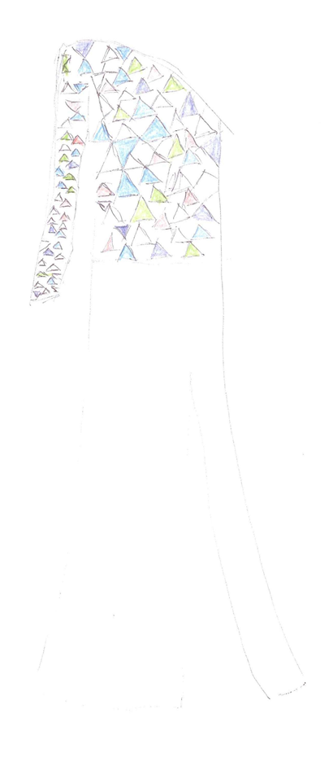
I was always felt awkward about my legs, I was skinny and short but with extremely long legs. I often got compliments on them but that did not increase my feeling toward them but there were so many elements of the dress which I fell in love with I was willing to take the risk.
35

