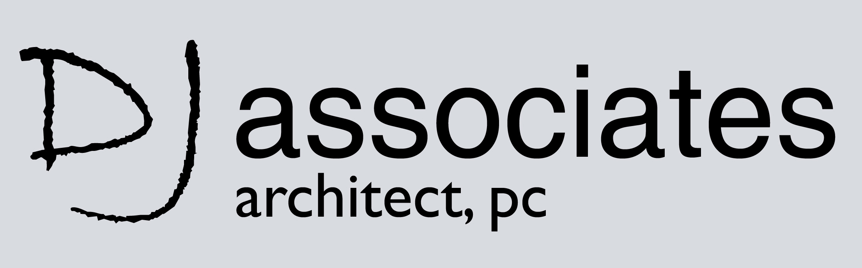

|  |
| --- |
| 32 BROADWAY, SUITE 114 NY, NY 10004  PHONE: 212-968-7127 |

**Architectural Draftsperson for Architectural Office:  
  
Immediate open position for a self-motivated architectural draftsperson at our busy Architectural Office located in Downtown Manhattan.  
Must be proficient in AutoCAD, and must have an Architectural background. Five Year Professional Architectural Education preferred. Candidate must have great attention to detail, and will be involved in zoning and code review and creating Construction Document Sets. Great opportunity for the right candidate who is dedicated, eager to learn, and willing to do what is needed to get the job completed. Candidate must be a quick learner, a team player, and will be exposed to many aspects of the building industry.  
  
Qualifications:  
-minimum 3 years of experience in a professional setting  
- Quick learner and team player  
-work samples that demonstrate strong design sensibility AND technical knowledge  
-experience and ability to produce detailed and coordinated construction documents  
-must know AutoCAD  
-knowledge in Sketchup, Rhino, Photoshop, and 3D rendering is a plus  
-experience with Microsoft Outlook, and Word preferred  
-ability to work with and without supervision  
  
Please send all resumes and work samples to:**[**archpos@aol.com**](mailto:archpos@aol.com)