Lisset Garcia
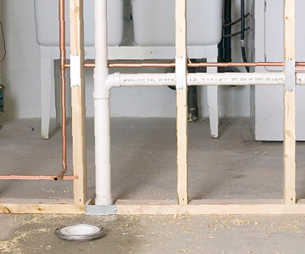
Wet wall: A wet wall is a structural wall designed to house plumbing pipes for fixtures like sinks, dishwashers, and toilets. Having a wet wall makes repairing easier since only one wall has to be accessed for reparation of plumbing, cuts down on costs and is more efficient. More common to build a wet wall between a bathroom and kitchen. Wall of wet wall is usually not structural but joist are used to support wall, not the whole bldg. Wet walls require special materials such as sheet rock, which will withstand getting wet. The wall may need splashbacks in the room to prevent water from hitting the wall directly.

Cleanout: A plumbing cleanout provides a convenient place to access a building's drain pipes to clear clogs and debris.
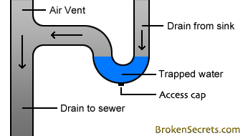
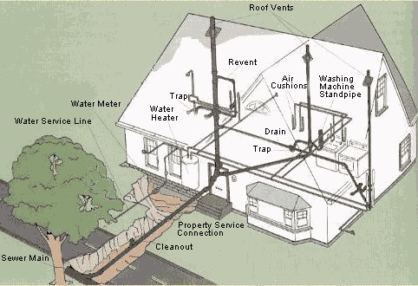
Trap water: This water in the trap creates a seal that prevents sewer gas from passing from the drain pipes back into the occupied space of the building. Essentially all plumbing fixtures including sinks, bathtubs, and toilets must be equipped with either an internal or external trap.

