A list of target tenants uses by square feet, both for office and retail by block. It is not useful to just mention the names of the shops or offices without putting the square footage for each. We want to know if the students are understanding scale and what can fit in a 10,000 SF (4 to 6 retail spaces) line of retail, and what can fit, for example, in a 120,000 SF mid-rise office. The list of suggested retail uses, community facilities, non-profit offices and offices, chosen in each block, specifying the square feet for each use, gives the city council members an idea of the vision the students have and also shows that they understand scale.

Examples of target tenant list for block 1 and 2:

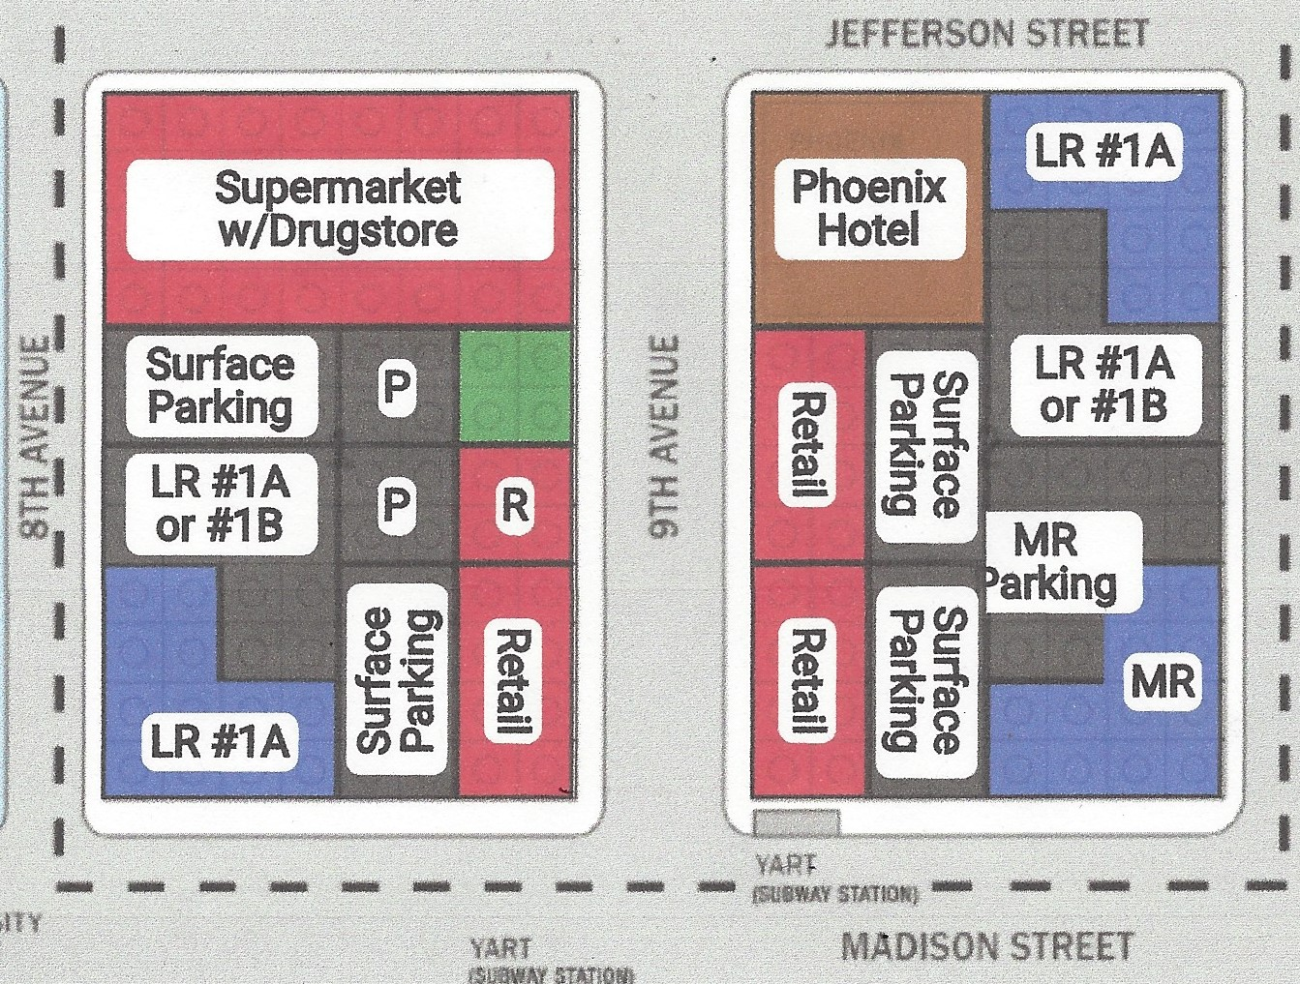

Retail |  |  |  |  | Block 1
Location | Potential Tenants | SF | Units |  | Retail | Potential Tenants | SF | Units
Block 1 |  | 15,000 | 8 |  |  |  | 15,000 | 8
 | Carol's Coffee bar | 1,500 |  |  |  | Carol's Coffee bar | 1,500
 | Dave's Deli | 2,000 |  |  |  | Dave's Deli | 2,000
 | Yasmine Boutique | 2,500 |  |  |  | Yasmine Boutique | 2,500
 | Great Minds Bookstore | 3,000 |  |  |  | Great Minds Bookstore | 3,000
 | Cinnamon Bakery | 1,500 |  |  |  | Cinnamon Bakery | 1,500
 | Greetings Card Store | 1,000 |  |  |  | Greetings Card Store | 1,000
 | Persimmon Boutique | 2,000 |  |  |  | Persimmon Boutique | 2,000
 | Yasa Gift Shop | 1,500 |  |  |  | Yasa Gift Shop | 1,000
Block 2 |  | 20,000 | 11 |  | Office | Potential Tenants | SF | Units
 | Tom's Sports Bar | 3,000 |  |  |  | Low-Rise | 60,000 | 3
 | Billy's Bagels | 1,500 |  |  |  | Green & Morse Law Group | 20,000
 | Tom's Barber Shop | 2,000 |  |  |  | Orange Technologies | 20,000
 | Dreams Ice Cream | 1,500 |  |  |  | Cobol Engineering | 20,000
 | Weeblicious Sushi | 2,500 |  |  | Block 2
 | Perry's Pet Shop | 1,500 |  |  | Retail | Potential Tenants | SF | Units
 | Best Walks Shoe Store | 2,000 |  |  |  |  | 20,000 | 11
 | Pizzeria Geronimo | 1,500 |  |  |  | Tom's Sports Bar | 3,000
 | Taqueria Picante | 1,500 |  |  |  | Billy's Bagels | 1,500
 | Frank's Cards and Gifts | 1,000 |  |  |  | Tom's Barber Shop | 2,000
 | Irish Pub | 2,000 |  |  |  | Dreams Ice Cream | 1,500
Block 2 | Rehabbed Phoenix Hotel | 10,000 |  |  |  | Weeblicious Sushi | 2,500
 | Chez Maurice Restaurant | 3,000 |  |  |  | Perry's Pet Shop | 1,500
 | Sweet Dreams Toys | 2,000 |  |  |  | Best Walks Shoe Store | 2,000
 | Elements Boutique | 2,000 |  |  |  | Pizzeria Geronimo | 1,500
 | Look Optical | 1,500 |  |  |  | Taqueria Picante | 1,500
 | Coco Cheese & Pizza | 1,500 |  |  |  | Frank's Cards and Gifts | 1,000
Office |  |  |  |  |  | Irish Pub | 2,000
Location | Potential Tenants | SF | Firms |  |  | Rehabbed Phoenix Hotel | 10,000
Block 1 | Low-Rise | 60,000 | 3 |  |  | Chez Maurice Restaurant | 3,000
 | Green & Morse Law Group | 20,000 |  |  |  | Sweet Dreams Toys | 2,000
 | Orange Technologies | 20,000 |  |  |  | Elements | 2,000
 | Cobol Engineering | 20,000 |  |  |  | Look Optical | 1,500
Block 2 | Low -Rise | 60,000 | 4 |  |  | Coco Cheese & Pizza | 1,500
 | Compass Homeless Services | 5,000 |  |  | Office | Potential Tenants | SF | Firms
 | Optimum Insurance Co. | 20,000 |  |  |  | Low-Rise | 60,000 | 4
 | Forward Investment Co. | 15,000 |  |  |  | Compass Homeless Services | 5,000
 | Swifty's Software Dev. | 20,000 |  |  |  | Optimum Insurance Co. | 20,000
 | Mid-Rise | 120,000 | 4 |  |  | Forward Investment Co. | 15,000
 | Raymond Business Consulting | 20,000 |  |  |  | Swifty's Software Dev. | 20,000
 | Corrigan Gross Law | 40,000 |  |  |  | Mid-Rise | 120,000 | 4
 | Tolles, Breuer & Ricker | 30,000 |  |  |  | Raymond Business Consulting | 20,000
 | Johnson Capital Investments | 30,000 |  |  |  | Corrigan Gross Law | 40,000
 | Rehabbed Phoenix Hotel | 50,000 |  |  |  | Tolles, Breuer & Ricker | 30,000
 | Brick Architecture & Design | 20,000 |  |  |  | Johnson Capital Investments | 30,000
 | Energy Innovation Firm | 20,000 |  |  |  | Rehabbed Phoenix Hotel | 50,000
 | Lighting for the Future | 10,000 |  |  |  | Brick Architecture & Design | 20,000
 |  |  |  |  |  | Energy Innovation Firm | 20,000
 |  |  |  |  |  | Lighting for the Future | 10,000

Examples of Community Facilities are things like a Child Care Center, Teen Center, Senior Center, Police Substation, etc.

Examples of Non-Profits are offices like “Help the Homeless”, “The Red Cross”, “Elmwood Education Foundation”, etc.

Examples of For-Profit offices are law firms, design firms, development firms, etc.

