Farragut Houses

https://bklyn.newspapers.com/image/53775960/

https://en.wikipedia.org/wiki/Farragut_Houses

https://www.newspapers.com/image/53704481/

https://www1.nyc.gov/assets/nycha/downloads/pdf/Farragut.pdf

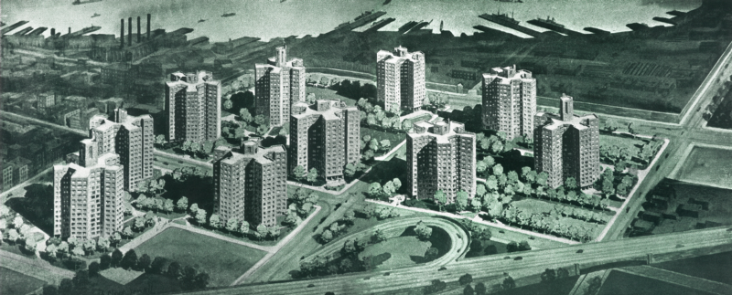

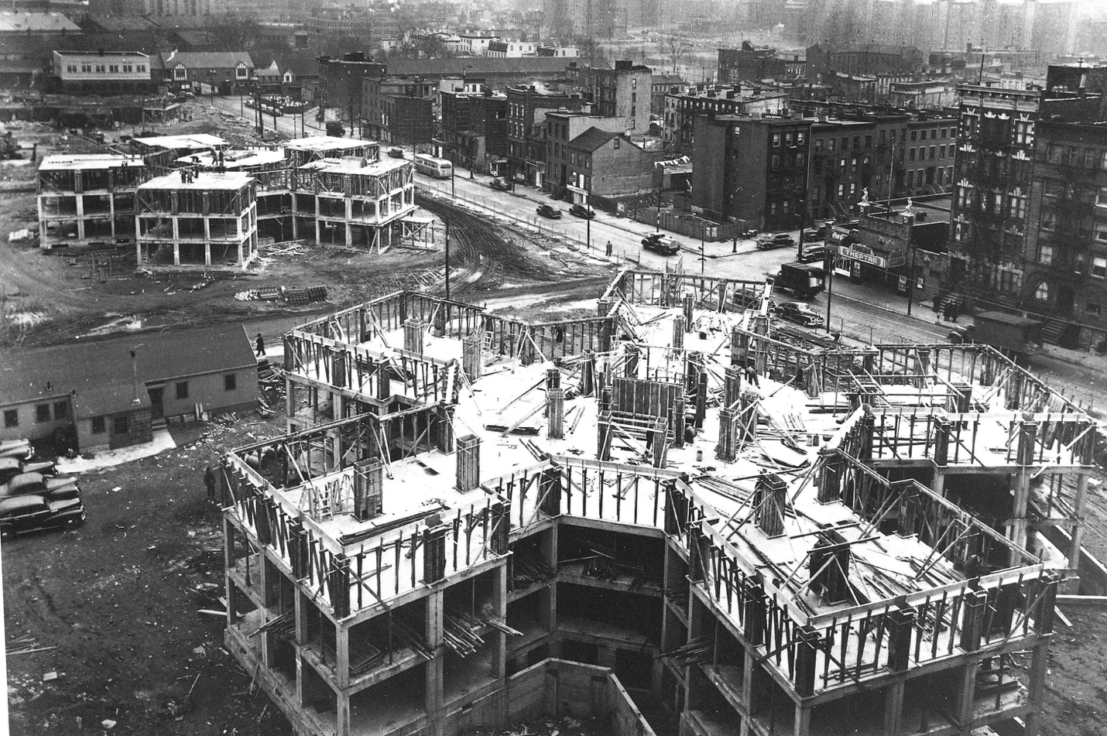

FARRAGUT Housing
Borough: Brooklyn

Number of Residential Buildings: 10

Number of Non-Residential Buildings: 0
Total Units: 1,390
Total Population: 3,143
Senior Development: ??
Hurricane Zone:

9min documentary on Farragut Housing: https://www.youtube.com/watch?v=8CjIrBzhR54

https://newyorkyimby.com/2020/09/peterson-rich-office-and-regional-plan-association-reveal-comprehensive-design-strategy-for-nycha-properties.html

https://www1.nyc.gov/assets/nycha/downloads/pdf/NYCHA-Fact-Sheet_2020_Final.pdf

General NYCHA

Great exhibit at the Skyscraper Museum
https://skyscraper.org/housing-density/history/#NYCHA-production
https://skyscraper.org/housing-density/

Plans – but not Farragut
http://www.astralgia.com/enyprojects/gallery/archeology6.html

Design improvement Guidelines: https://www1.nyc.gov/assets/nycha/downloads/pdf/nycha-design-guidelines.pdf

Building Community at NYCHA:
https://www1.nyc.gov/assets/nycha/downloads/pdf/Connected-Communities-Guidebook.pdf

Demographics: https://www1.nyc.gov/assets/nycha/downloads/pdf/Resident-Data-Book-Summary-2021.pdf

Design Ideas:
https://archive.curbed.com/2020/10/5/21499271/nycha-infill-renovation-peterson-rich-office-rpa

https://urbanomnibus.net/2016/05/disrupting-the-superblock-speculative-designs-for-nycha/

https://www.archpaper.com/2019/07/nycha-crisis-can-architects-design-the-way-out/

https://www.nydailynews.com/new-york/ky-high-cost-towers-nycha-residents-article-1.1369946

https://www.theplan.it/eng/architecture/nycha-superblock

Project looking at exterior space- analyzing use: https://www.behance.net/gallery/83622427/Drift-Mapping-of-NYCHA-Fences-Prof-Elliot-Maltby?tracking_source=search_projects_recommended%7CNYCHA

Videos:
NYC Urban Renewal Overview: https://youtu.be/mWGwsA1V2r4

Why do we build high-rise public housing projects: https://youtu.be/7eGTU_uXLKk

A Dream Deferred: The Broken Promise of New York City Public Housing:
https://youtu.be/oGmQtgbJHhc

