Department of Architectural Technology
Bachelor of Technology in Architectural Technology

ARCH 3512 ARCHITECTURAL DESIGN V

Adaptive Reuse

There were three different types of adaptive reuse described in the lecture:

Installation

Insertion

Intervention

For this assignment, find an example of each one and document and analyze each example. (11x17 – digitally, collage of images, diagrams and notes- 1 per sheet)

Note:
Type of Adaptive Reuse
Location
Architect
Previous Use
New Use

Diagram:
changes to the building
including: Entrance
Fenestration/natural light
Circulation
Structure
Volumes
Site
Any other major impacts

Example of a water tower that was transformed into housing. The process is shown through a series of simple diagrams, including looking at design alternatives of how to manipulate the existing structure. Jaegersborg Water Tower; Copenhagen, Denmark / Dorte Mandrup Arkitekter
https://www.archdaily.com/783283/20-creative-adaptive-reuse-projects

Additive process to create space that would be viable for living and space organization.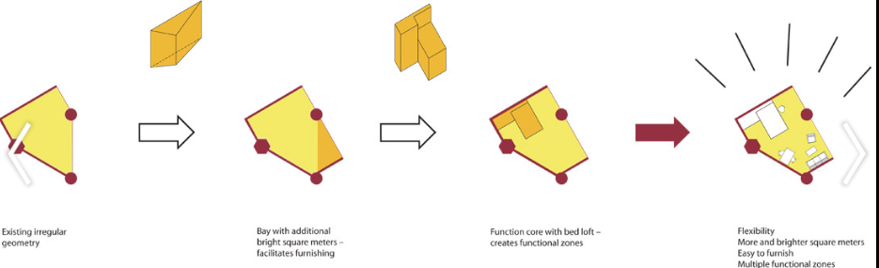

Design Alternatives for manipulating the existing structure.
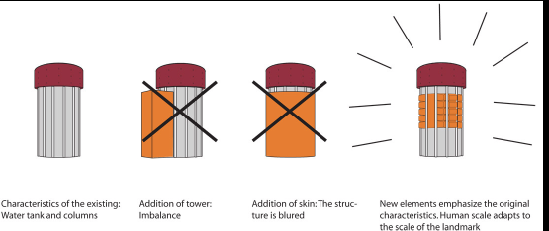
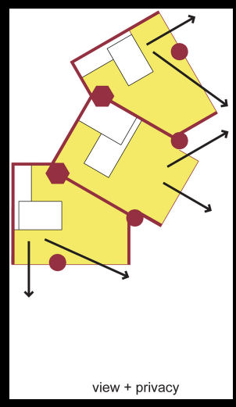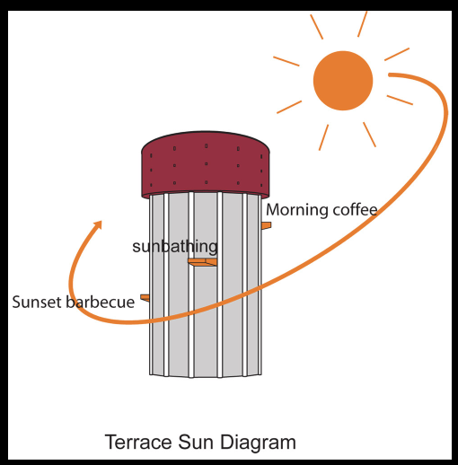
Design solutions based on site/program strategies.
