REFLECTED CEILING PLAN

For this Assignment you will develop your reflected ceiling plans, or RCPs for the lobby. These should be at the same scale as your lobby floor plans done in the previous assignment
The purpose of the RCP is to show the building geometry at the ceiling level (including any openings in the ceiling), ceiling materials (including any penalization), ceiling heights, lighting types and locations, and anything else located at the ceiling plane.
You will need to select all of the light fixtures you will be using, and locate each of these fixtures on your RCPs. The location of your lighting should relate to the location of furniture.
Select light fixtures and show images of the light fixtures .Give each light fixture a code, RCPs with these codes. Your drawings should also be tagged with the material codes from your material palette and material list to show the ceiling material(s). You may want to use a key or legend for clarity.
As always, continue to use your theme to guide your work

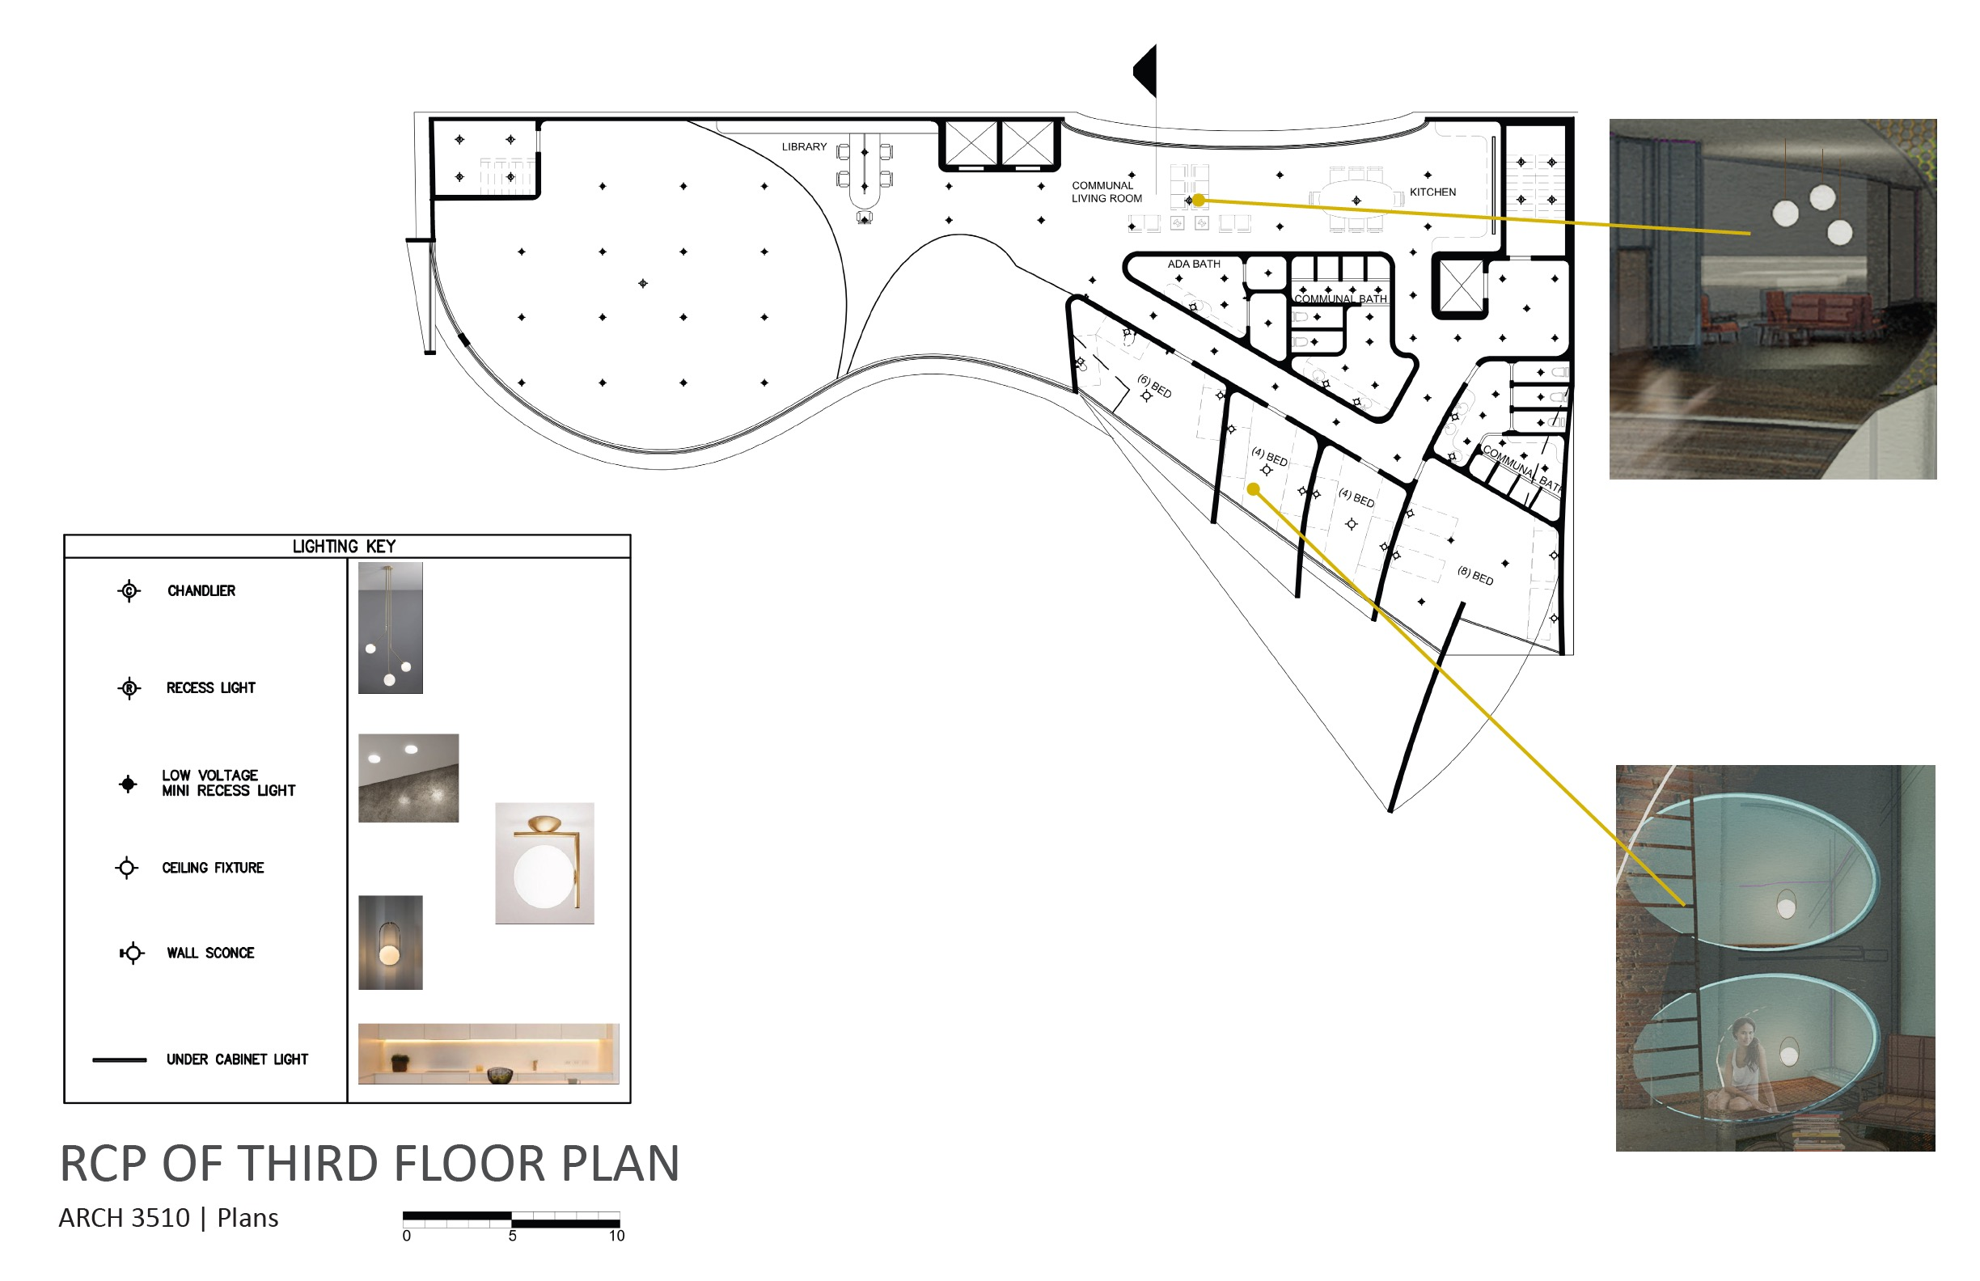 Evelyn Richardson

