Assignment: Lobbies and Lounges

The lobby is at the forefront of customer service and it is strategically situated at the entrance of the hostel. The lobby is where guests check in, check out, inquire about necessary information. It is where the guests and customers first experience the hostel itself.

* Lobbies and lounges host social events and merge exterior with interior spaces. These areas are real windows into the character of the hotel.
* They Contribute in forming the overall atmosphere and the real back bone of the hotel

HI New Orleans Hostel, New Orleans

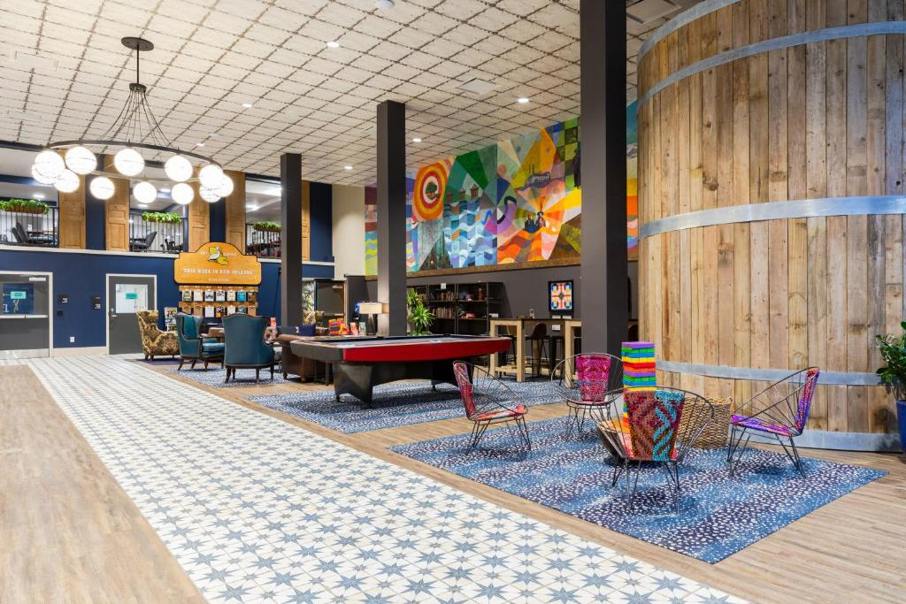

Stayokay Amsterdam Oost – Hostel

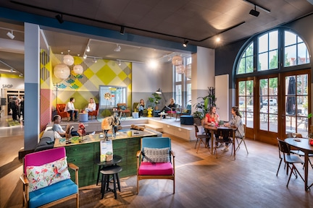

Wombat’s City Hostel London, England

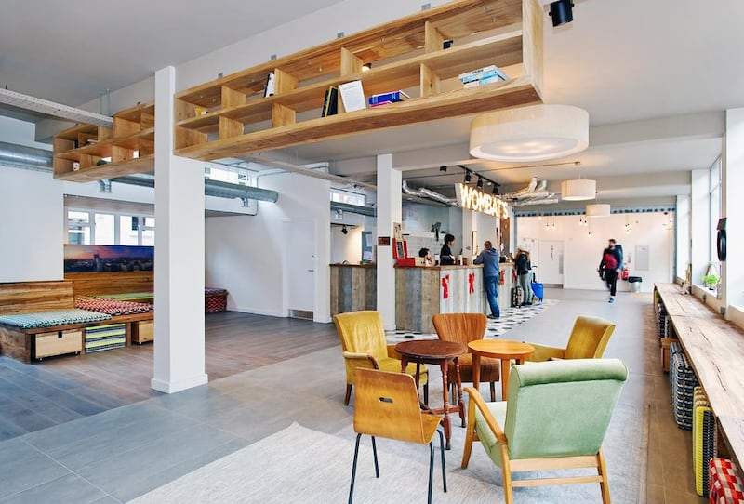

For this assignment you will first develop a Mood board for the lobby.   
(use Pinterest for inspiration).

You will proceed to develop your lobby layout, floor plans and elevations. These should be at a larger scale than your overall floorplans, so that all of the information is legible.

As part of this, you will need to select all of the furniture and fixtures you will be using in your lobby/lounges . This includes things such as lounge chairs, coffee tables, sofas, Reception desk, flooring materials and lighting fixtures. Collect your cut sheets of each piece of furniture and fixture as you choose them. Materials used are to reflect the theme and concept of your project.

One drawing will be dedicated to your Lobby/Lounges

It will have:

1. Plan of the lobby/lounges – showing location of all furniture and floor patterns

2. Elevations of all walls – showing location of all fixtures and furniture

3. Images of all the materials you have selected for your lobby/lounges

Plans and Elevations are to be the **same scale.** Use human figure for scale

**As always, continue to use your theme to guide your work**

