Professor: Jill Bouratoglou jbouratoglou@citytech.cuny.edu
Lia Dikigoropoulou prof.liamd@gmail.com

ASSIGNMENT: Site Documentation….then Analysis

Site Analysis discussion. Site Visit.
Site is located on 16 Main Street, Brooklyn NY 11201

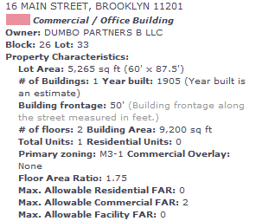

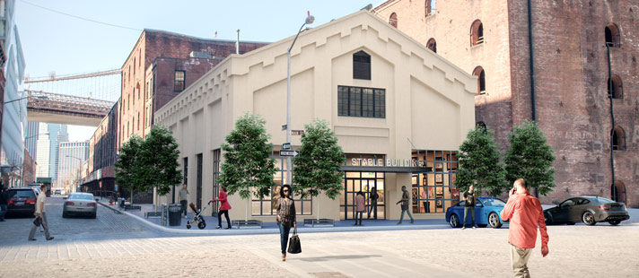

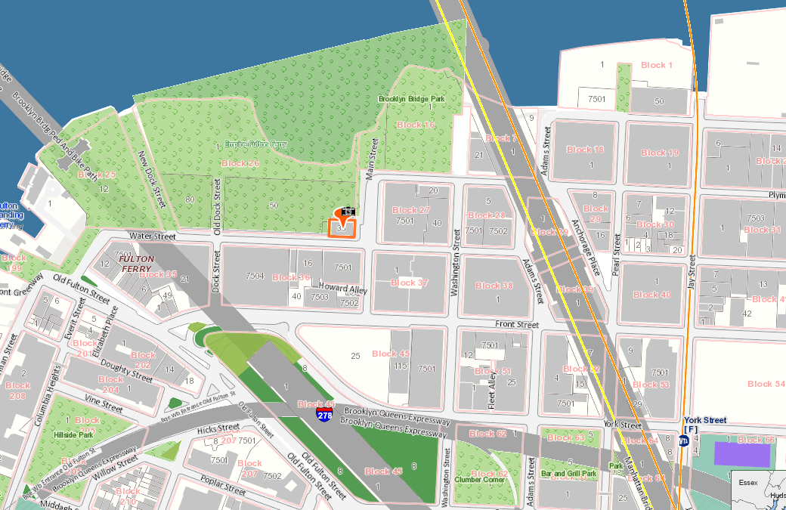

Site analysis is an integral and necessary step in the design process that involves research and understanding of a specific site and its environment.
The process is essential to understand design opportunities and challenges at both the urban and building scales.
The process involves Site Documentation and Site analysis.
More than just one element goes into a given site analysis. These elements include location, neighborhood context, site and zoning, legal elements, natural physical features, man-made features, circulation, utilities, sensory, human and cultural, and climate components.

Objective
Students will analyze social patterns, behaviors, flows, and narratives specific to our site
Initially, student groups will form to collaborate and document site-specific characteristics.

Structure
The studio will work in four groups. Each group will select an area of expertise from the list below.
The studio will collectively generate the following documentation:

Site Documentation: To develop drawings documenting existing conditions that serve as a basis for contextual analysis and architectural design work

Site Analysis: To develop a clear understanding of contextual forces in society and within the built environment that inform architectural and urban design strategies.

Document your site by gathering photos and visiting the site and taking your own photos. Make sure you show a map and a site analysis as to why this is an ideal location for your clients.

Answer the following:

SITE: Location- The site should be related to major streets or landmarks previously existing. Aerial photographs help in this assessment stage. There should be documentation of distances and time from major places.
SITE: History includes neighborhood history
SITE: Generalities- Includes, figure ground, neighborhood context, greenspace, places of interaction, accessibility, schools, places of worship, community centers, etc.
SITE: Legal Elements Includes zoning classifications, FAR, set-backs, height restrictions, allowable site coverage, uses, and parking requirements etc.
SITE: Demographics Includes race, income, ethnicity, national origin, building cost, etc.
SITE: Commerce Includes hotels, restaurants, lounges, cafes, bars etc.
SITE: Circulation/Pathways Includes Residential to Commercial, Residential to Residential, Subways to Residential & Commercial, Schools to Commercial, etc.
SITE: Urban Fabric Includes façade patterning, materials, hierarchies, solid/void, rhythm, repetition, etc.
SITE: Views
SITE: Climate and Natural Light Includes natural light intensity, natural light density, analysis over time/space, etc.

HOMEWORK: Site Analysis is due next meeting along with a group site model.

Sources

Sanborn Maps
Google Earth
USGS surveys
U.S. Census
www.oasisnyc.org

Field Study

Visit and document site-specific information related to your chosen area of expertise. Your field study should extend beyond into the greater neighborhood vicinity. Using a camera, measured sketches, mapped documentation, and other devices--record what you see.
Your documentation may include:
street widths, sidewalk widths, building dimensions, façade elevations, site context sketches, site sections, etc.

Requirements
Student groups will generate precise base drawings of the following:
context plan, site plan, site sections, site elevations, massing diagrams, etc.

Produce four (minimum) analytical site mappings/diagrams.

Your documentation may include various themes, depending on your area of focus, including demographics, architectural context, sectional qualities, density, accessibility, site lines, places of egress/entry, transportation links, subway locations, movement and flows of the site, paths, circulation, lighting conditions, etc.

