Day 4 IN CLASS: REVIEW DIAGRAMS OF SITE LAYOUT

Layout of your Unit (micro)
HOMEWORK: Board 5: Diagrams of Massing: Generate a series of diagrams showing different variations of your unit with relation to the site. There should be at least ten different massings of your unit. They should be color coded or noted of which program is located in each container. (refer to Board 2)

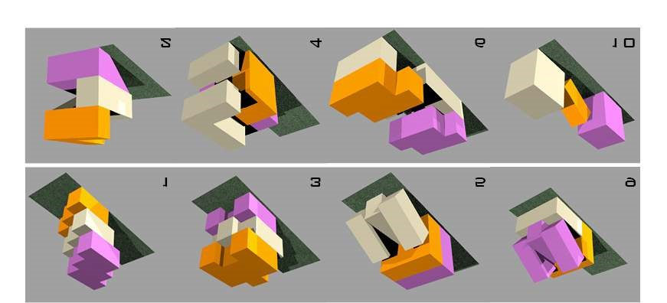
The images shown above are for another project, your diagrams will be more specific to your family’s program.
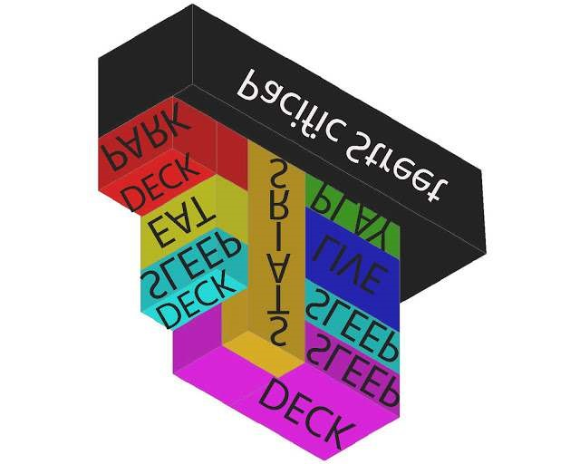

All living spaces must have natural light and fresh air. These spaces are living rooms, dining rooms, and bedrooms. These windows must be a minimum of 30’ from the face of another building.

Give a legend for the colors used – refer to Board 2.

Board 5 is due next class

