ARCH 2431 BUILDING TECH III Steel Connections Study Assignment 03

Steel Connections Study:
Based on Building Construction Illustrated: 3rd Edition: Frank Ching: Page 7.24. (See attached) This assignment will focus on the nature of structural connections that can be made using steel columns, beams, and angles that support concrete slabs on metal decks. The goal is to recreate the page including all steel pieces, assembled in place, with annotation and dimensions, formatted on titleblocks. The project will be completed in several stages.
Note: Multiple coordinated views (plan/front elevation, side elevation or section) are typically the same scale. At times we use a smaller scale for the isometric in order to fit it on the same sheet. Views must be clearly readable.
Stage 1: Start the project by creating two 3D families one for the Steel Column and one for the Primary Steel Beam and compose these together in a project file. (See reference sheet for sizes) Create a 22 x 34” sheet and format an isometric view that matches the steel connections page. After you create the Isometric view, create the three coordinated views that are always part of our detail studies (plan, front elevation and side elevation or section – all at the same scale). Try to work at ½” or ¾” scale – we will adjust as needed when we begin sheet layouts)
Stage 2: Add additional 3D families for the different steel components shown in the illustration. Select a set of related components and produce a callout at 1 ½” or 3” and create a second sheet that includes a minimum of 4 views, an isometric, plan, front elevation and side elevation or section – all at the same scale) You will create several of these sheets – with the minimum acceptable is one sheet of enlarged details.
Stage 3: Add annotation information to your drawings – both notes with leaders and dimensions. Reference Ching
Research: You must complete research as part of this assignment. When you have chosen a particular set of steel components to build and study you must research these items. Locate photographs that describe them clearly from a catalogue and find photographs of these used in construction. Look to understand and explain the role they play in the photographs you find.
Creation of 3D families: We will review the creation of 3D families in Revit in class. They will be created with the use of reference planes as well as instance parameters so they can be modified in the project file. It is important that they be logically named. All of your families must be prefixed with your name or initials.
Grading: Criteria for grading will include but not be limited to the following
(Remember quality is more important that quantity)

- A minimum of two sheets are required, one overall composition and one detail composition
- How well are the drawings composed?
- Are the proper views included? (Multiple coordinated views and an isometric) at a minimum
- Are appropriate annotation and dimensions included?
- Are the Revit Files well-constructed?

- Are the details well researched? Format your research on 11 x 17 landscape format sheets
- Does the student demonstrate an understanding of what has been drawn graphically and verbally?

- Were the drawings plotted correctly and in a single PDF? Does PDF include research?
Were all files uploaded on time? (Project file and PDF file) Families are contained with the project file.
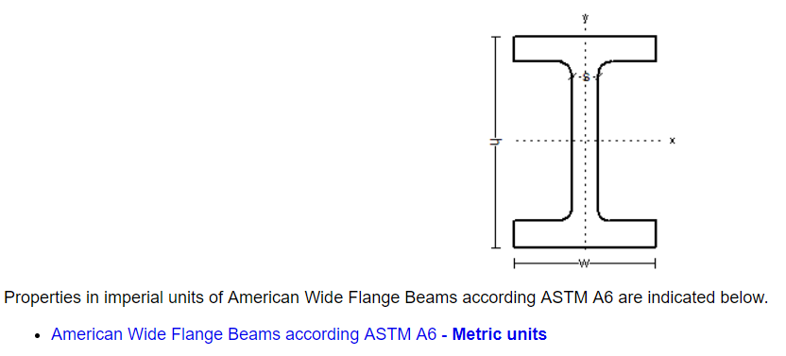
For the Column use W 24 x 162 and for the Beam use @ 21 x 62
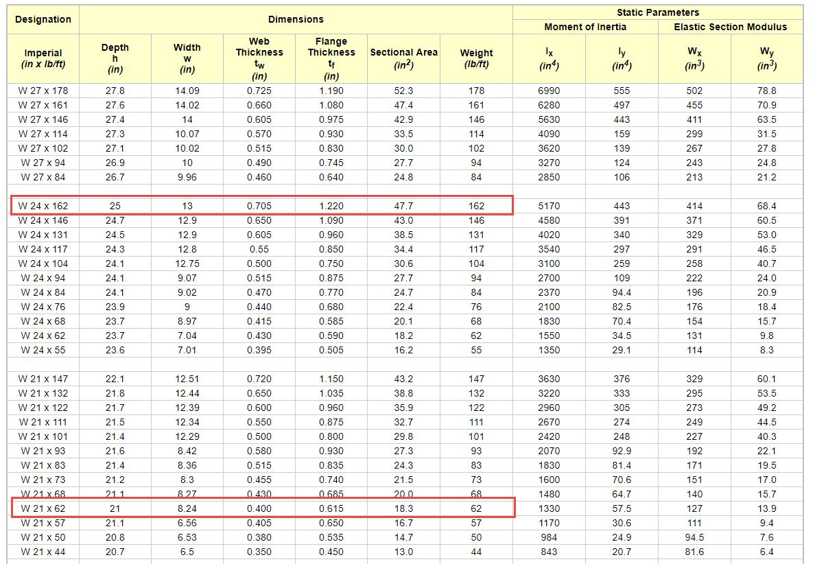
Source of Information: https://www.engineeringtoolbox.com/american-wide-flange-steel-beams-d_1319.html
Additional Reference for steel components: http://products.anssteel.com/category/steel?

