Examples from past semester using Autocad and Solidworks:
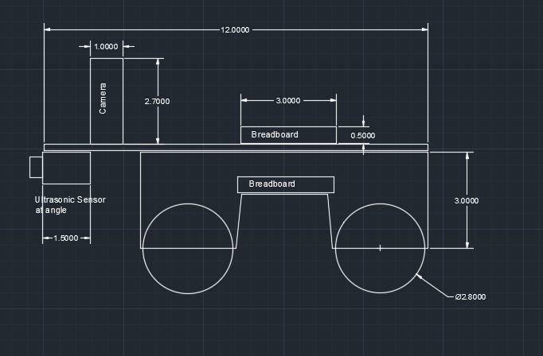
The example above is a 2D side view of the autonomous robot we constructed in a robotics class. Created using Autocad.
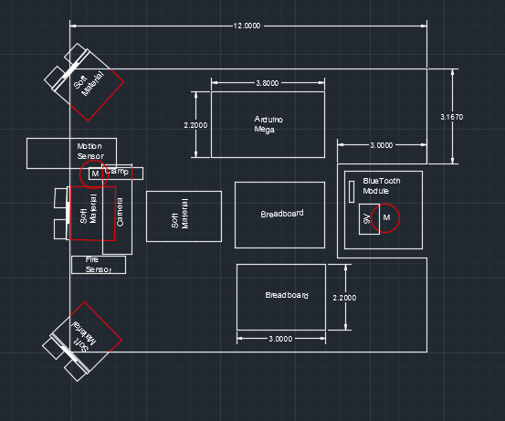
The example above is a 2D top view of the autonomous robot we constructed in a robotics class. Created using Autocad.
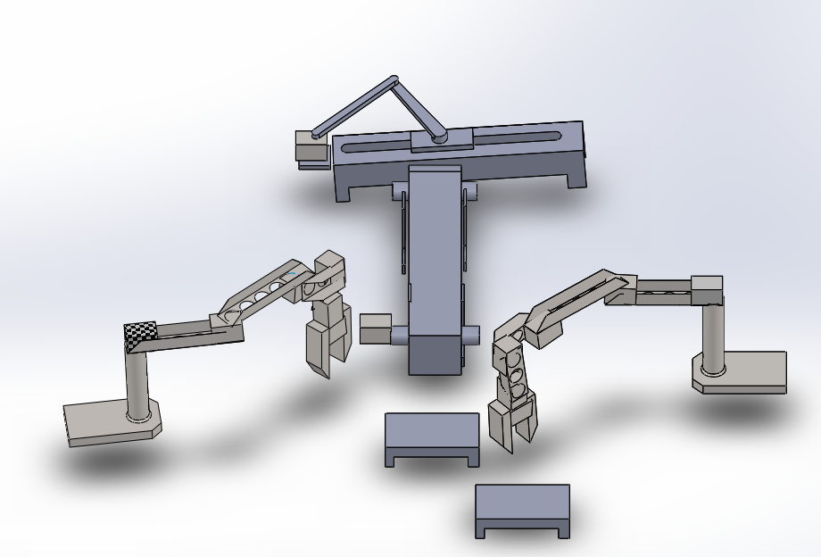
The example above is an isometric view of the 3D representation of the burger assembly environment we constructed in a robotics class. Created using solidworks.
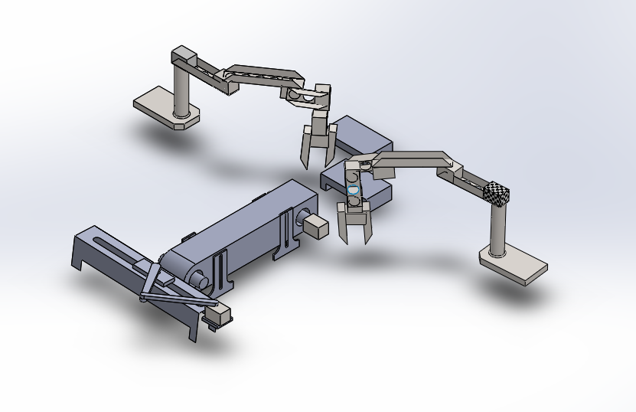
The example above is another isometric view of the 3D representation of the burger assembly environment we constructed in a robotics class. Created using solidworks.

