Examples of Autocad homework assignments:

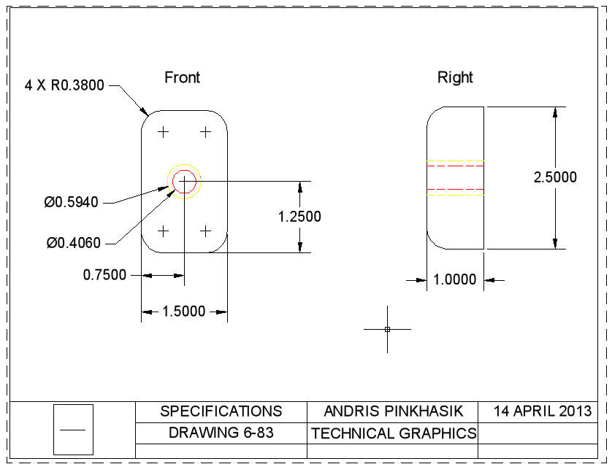
We were tasked to create two views of the bracket in Autocad.

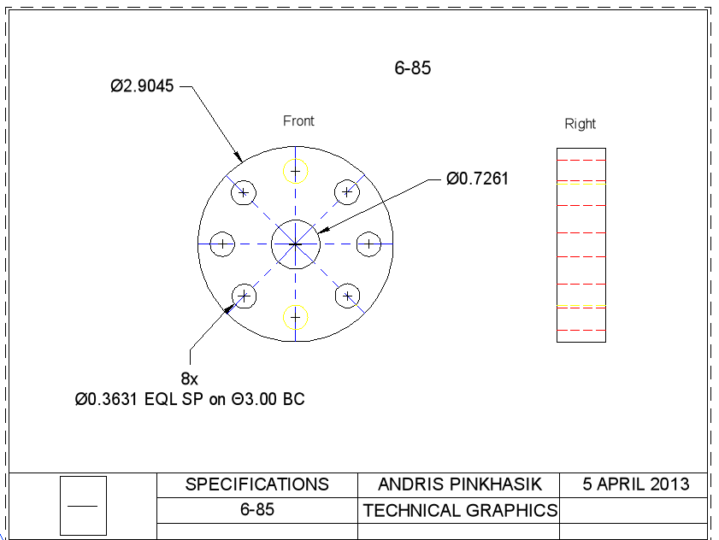
We were tasked to create two views of the bracket in Autocad.

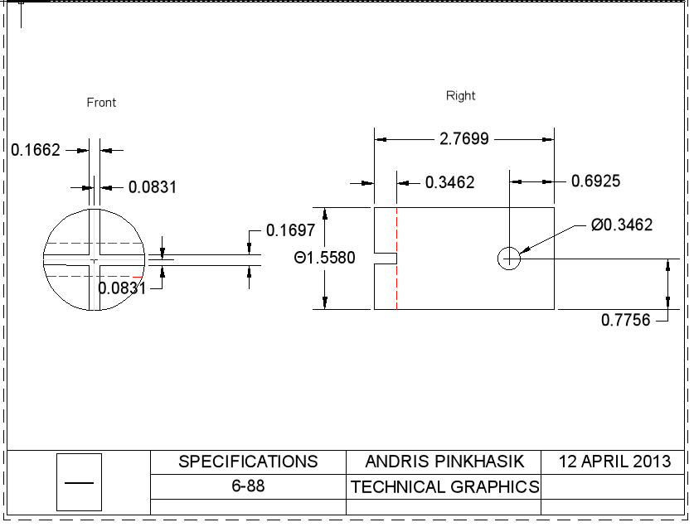
We were tasked to draw the front and left view of the component in Autocad.

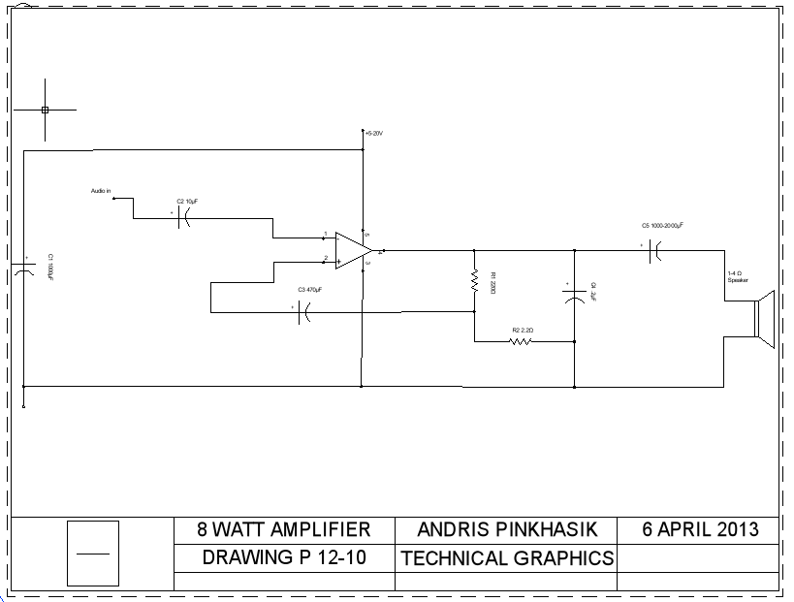
In this assignment, we were tasked to use the drawing in our textbook and draw a schematic using Autocad.

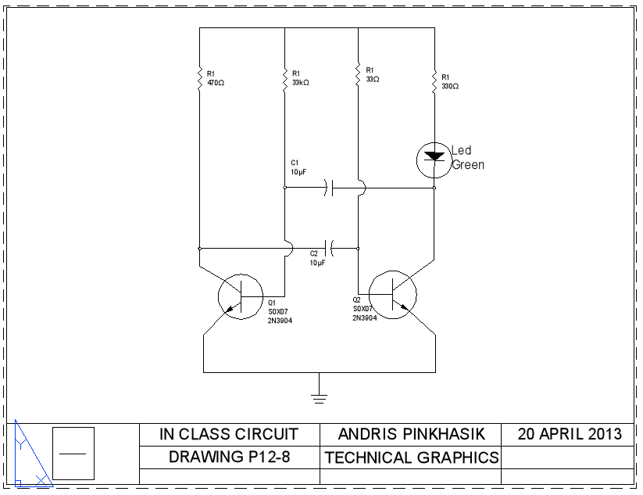
In this class assignment, we were tasked to use the rough drawing in our textbook and create a schematic in Autocad.

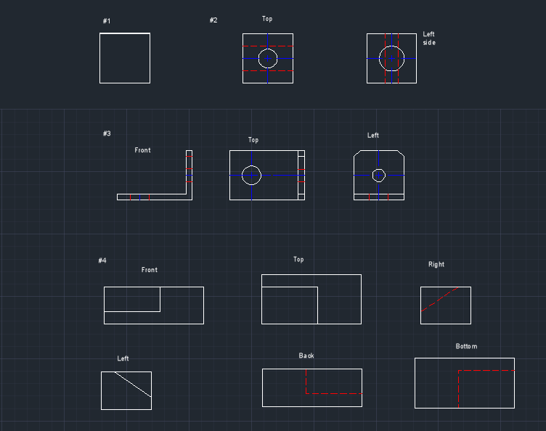

In this example, we were tasked to create three views of the component, bracket, and block.

