Legendary Moments

Written & Illustrated by Anthony Mota

Legendary Moments

**Prologue:**

Legendary moments are memories in my life that are unforgettable and that I will cherish forever. These events describe significant moments in my life and what I wore during those special times. As you read this book, these moments will give you a better understanding of my perspective of life and events that molded me into who I am today. These remarkable events have become part of my life that will live with me forever. The readers will get to understand how I felt throughout these memories, why I chose to wear certain pieces of clothing, and understand my mindset. This book depicts how I was molded by my peers, family, and surroundings.

**Acknowledgements :**

I would like to dedicate this book to my friends, family, and loved ones for being supportive and instilling the confidence that I am capable of doing whatever I set my mind to do. I owe them the utmost respect and love because they believed in me in times where I did not believe in myself. Thank you for holding me to a higher standard and not letting me settle for mediocrity. I will continue to set the bar high for us. More importantly, thank you for being a part of all these legendary moments.

Table of Contents

Chapter 1: High School Graduation ……………..………. page 6-7

Chapter 2: College Graduation ………………………...……. page 8-9

Chapter 3: 23rd Birthday ………………………….….…… page 10-11

Chapter 4: Mets Baseball Game …………………..……… page 12-13

Chapter 5:Vacation to Curacao …………..……………… page 14-15

Chapter 6: High School Prom …………………………… page 16-17

Chapter 7: Job Interview ………………………………… page 18-19

Chapter 8: Virgil Abloh Exhibit …………………………… page 20-21

Chapter 9: Family Trip to DR ……………………………… page 22-23

Chapter 10: Knicks Basketball Game ……………………….. page 24-25

Chapter 11: Meek Mill Concert …………………………….. page 26-27

Chapter 12: Uncle’s Wedding ………………………………. page 27-28

Chapter 1: High School Graduation

The high school I graduated from is Mott Haven Village Preparatory. My high school graduation took place in Fordham University in June of 2016. Fordham University is located in the Bronx, NY and Mott Haven Village Preparatory is located at 701 St. Ann’s, Bronx, NY. My family members attended my high school graduation such as my mother, my step father, my little brother and my little sister. My mother, Ana Blanco called out of work to attend my graduation. My step father, Franklin Hernandez made it his obligation to attend my high school graduation being that he has never been to any of my graduations prior.

For graduation I decided to keep it traditional. I wore a long sleeve white button down shirt that *adhered* to my arms down to my wrist. The button down shirt was a Medium slim fit. The button down shirt had seven buttons going down. Two buttons on the cufflinks were *wrapped.* The collar size was 15-15.5. The chest measurement was 34/35. The khaki slacks were *fitted*, the slacks were slim and long pants. The slacks were 80% polyester and 20% rayon. The sizing on the pants was 30/30. The Maison Margielas Paint Splatter Replicas were the only shoes that had my size so I settled for those. I ended up buying the gray ones with paint splattered in the front. I bought khaki slacks from Gap and a white button up shirt from Zara.

The day before graduation I got a haircut. I trimmed my hair down and *wrapped* it with a half moon design. The half moon design is a signature haircut that has been influenced and posterized all over barber shop walls. In addition, I got a gel manicure on my hands and feet. I knew grooming my hands and feet would *insert* into my appearance. I made sure to do my skin care routine the morning of and made sure my face was moisturized and added sunscreen. The cologne I had on for graduation was One Red edition for him.

The cap and gown for my high school was a teal color. I chose to not personally design my cap even though this was such a significant moment for my friends and I. We came into high school not knowing each other and were able to build a strong friendship that lasted through time. We were able to see each other graduate high school which closed a chapter to go on to start a new journey. It was a great feeling that day taking pictures with all my favorite teachers, staff, parents, and loved ones. After graduation, my family and I went out to El Valle restaurant to eat and celebrate my success. All the hard work I put in to graduate finally paid off. I know walking across the stage and hearing my name made my mother extremely proud. I did not just walk across the stage for myself but for my younger siblings which showed them that if I am capable of doing it so can they. I felt confident, determined, and relieved. 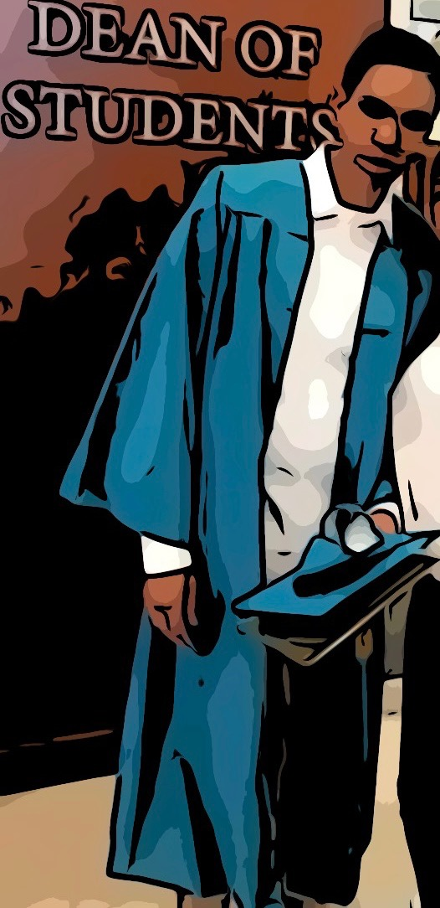

Chapter 2: College Graduation

After high school, I had 2 months off from school. I went to LaGuardia Community College and the semester started on August 25th. I majored in Business Administration with an associate in Science. I graduated with a 2.7 GPA. I was hoping to go to a SUNY college with my friends but none of the SUNY colleges accepted me because I missed the FAFSA deadline. For CUNY colleges, my options were Medger Evers, Hostos Community College, and LaGuardia Community College. Medger Evers was 1 hour and 30 mins away from home so that was the main reason why I chose not to attend. Hostos Community College was located in the Bronx but I wanted to expand my horizon and try something different. I chose LaGuardia because I knew it was going to be a new experience and a new environment. LaGuardia Community College is located in Long Island City, NY. LaGuardia happens to be one of the most diverse CUNY colleges, with students of more than 145 nationalities.

My graduation took place in Barclays Center on June 13, 2019 in Brooklyn, NY. My mother, brother, and sister attended my graduation. It was a rainy day so my family and I took an uber to Brooklyn to make it in time because we were running late. My outfit for graduation was a Milano Di Rouge button down black shirt, red plaid classic slim leg bondage pants, and black cement Jordan 3s. I’m not a fan of wearing tuxedos, suits or dress shoes so I know I wasn’t going for that particular look at graduation. Originally, I was going for Commes Des Garcons converse but they were sold out. The black cements 3s which happens to be one of my favorite Jordans went perfect with my outfit so it worked in my favor. The pants I found online, I saw a close friend of mine had the same pants but a different style which motivated me to get them.

My thought process behind this outfit was stepping out of my comfort zone and wearing something that fits my aesthetic. I wanted to dress up to a certain extent because it adds character and personality. My inspiration for this outfit was being comfortable in my own skin and garments that fit my personal style. My personal style is more urban and streetwear. I’m into designer brands, graphic tees, loud colors, sweatsuits, high end jeans, and retro Jordans. Every individual has their own style that defines them and makes them who they are. It was an accomplishment graduating college with an Associates degree.

Walking across that stage and seeing your name in bold letters on the big screen meant a lot to me and my family. On that bittersweet day, I felt excited and anxious. I felt excited because I earned my degree and I was eager for what was coming next. However, it was a bittersweet feeling because I was no longer going to be in class with my peers or see my friends in the school building. I felt anxious because I was worried about what the future held for me. I do not know what the future holds but my plan is to cherish these valuable moments with my friends and family.

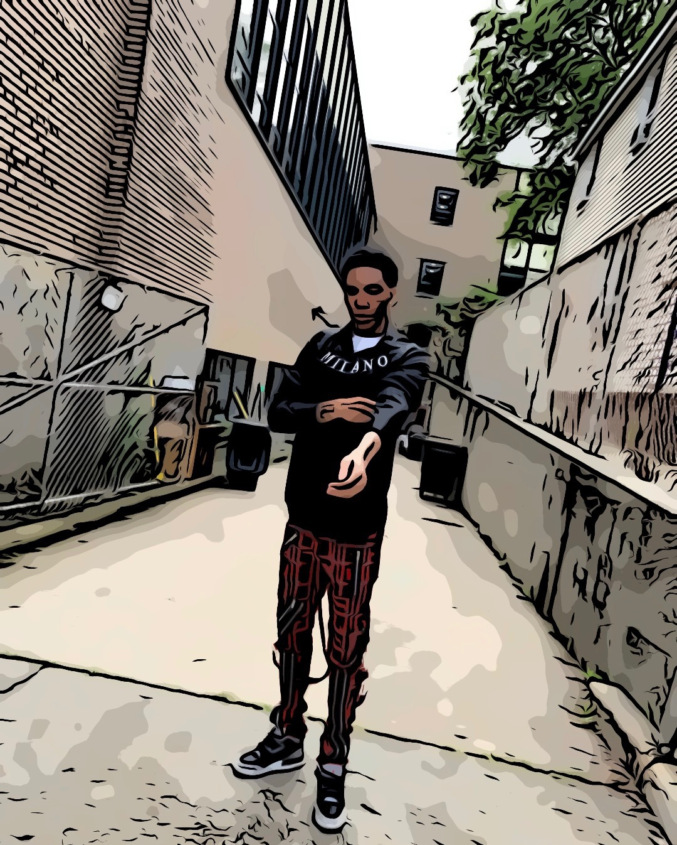

Chapter 3: 23rd Birthday

Every year on this earth is special so being able to celebrate another birthday always makes me grateful. My birthday is July 1st and on my 23rd birthday I made plans to go to Montego Bay, Jamaica. The flight from New York City to Montego Bay was about 3 hours and 55 minutes. The days of the trip were June 30 - July 4 and this was my first year traveling on vacation for my birthday. I went on vacation with my close friend Destiny.

The all inclusive resort I stayed at was the RIU Montego Bay. The beach front resort included 5 outdoor pools, 4 different restaurants, 4 bars and lounges, a buffet, a free water park, sauna, nightclub, and a full service spa. I was supposed to go on vacation last year for my 22nd but because of Covid-19 flight prices were expensive during that time. I usually am content with doing the bare minimum for my birthday but I wanted to step it up and do something memorable. For the trip, I packed 2 to 3 outfits per day depending on the activity for that particular day. When packing for a vacation, I usually bring 2 to 3 sneakers to rotate for those days. The sneakers I brought were Jordan Bred 11s, Jordan Fire Red 5s, and Jordan Bred 4s.

For my 23rd birthday I wore my friend’s clothing brand that goes by the name Fearless Boyz. Michael, who I have known since middle school, is the founder of Fearless Boyz. The brand has been up and running since 2020. I have been supporting him from the start not because I know him, but because I enjoy his creative ideas and like his garments. Prior to my birthday, I ordered clothes from his website. I wore a black rhinestone trucker hat *inserted* with 3 red crosses, a white short sleeved t-shirt with a glitter text that read live fast die young, a black rhinestone shorts with a glitter text that read fearless boys with 2 red crosses on both sides, and Jordan Bred 11’s.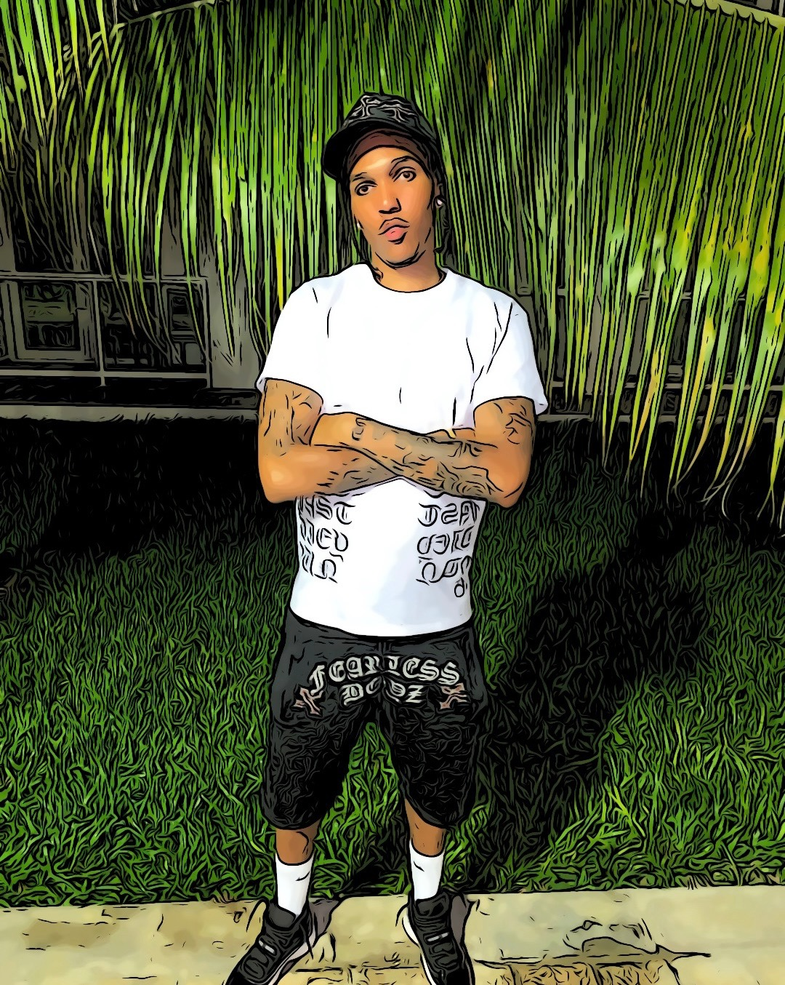

I waited until the last minute to find a birthday outfit because I was so indecisive of what style I was going for. I had my hair braided the day prior to my birthday and I did the Pop Smoke braids. The style is 4 cornrow stitch braids *wrapped* in groups of 4 on each side of the head. This style of braiding became highly popular because of the late rapper Pop Smoke. My inspiration for this outfit was bringing exposure to my friend’s brand to a different region. I received a lot of compliments because of this outfit. Receiving compliments was affirming and helped boost my confidence. It was a monumental day in my life.



Chapter 4: Mets Baseball Game

I went to the New York Mets vs. Seattle Mariners on May 14, 2022. The game took place in Citi Field in Queens, NY. The game started at 7:10 PM. It was raining in the afternoon but it stopped once the game started. If the rain did not stop, they would have most likely postponed the game for later on or another day. Rainy days tend to impact my outfit because I dress based on how I'm feeling that particular day or according to the weather. I went to the game with my siblings, my little sister Karen and my little brother Kendwix. My siblings and I decided to start going out as a group more this year. Prior to that we would never go out because we would all do our own individual activity. This was our first activity together as a group. We took an uber to the game.

It was an electrifying game from start to finish. The crowd was very ecstatic. We sat at Section 112 Row 22 Seat 9, 10, and 11. Before the game started, we bought food at the stadium. We all settled for chicken tenders and fries with a drink. I have been to the Yankee Stadium prior but it did not compare to Citi Field. The interactions with the fans made it fun, all the fans wave surf and the staff at the stadium were asking questionnaires. My siblings and I had a great time at the game. The New York Mets ended up winning that night with a score of 5-4. Nevertheless, the Seattle Mariners ended up winning the 3 game series holding the record 2-1. It was a special experience for my siblings and I because that was our first sports event as a unit. Moreover, having this relationship with my siblings is crucial to me because they mean the world to me. After that game, we made a promise to go to more sports games whether it be baseball, football, basketball, or hockey.

For the Mets game, I wore an Essentials Fear of God oatmeal colored sweatsuit and Jordan black cement 3s. Jerry Lorenzo, an American fashion and sneaker designer, is the founder of Essentials Fear of God. Essentials is one of the largest brands right now because they are comfortable, timeless and wearable garments. The top piece was a cotton blend fleece hoodie *adhered* with a warm inside. The word Essentials was stitched in bold print on the right of the hoodie and on the front of the hoodie and the Essential Fear of God logo flocked in the back of the hoodie. The bottom piece was a *fitted* cotton blend fleece lounge pants. The sweatpants have long drawstrings that have an elasticized waistband. On the fleece pants there is a rubber logo patch in the center and a logo flocked at the bottom right.

I enjoy wearing sweat suits and have numerous sweat suits from different brands. My favorite brands for sweatsuits are Nike Techs, Essentials, and Polo Ralph Lauren. The reason I love wearing a sweat suit is because it suits any figure, it is comfortable, and always a ready to wear outfit. Last but not least, everyone can wear sweatsuits.

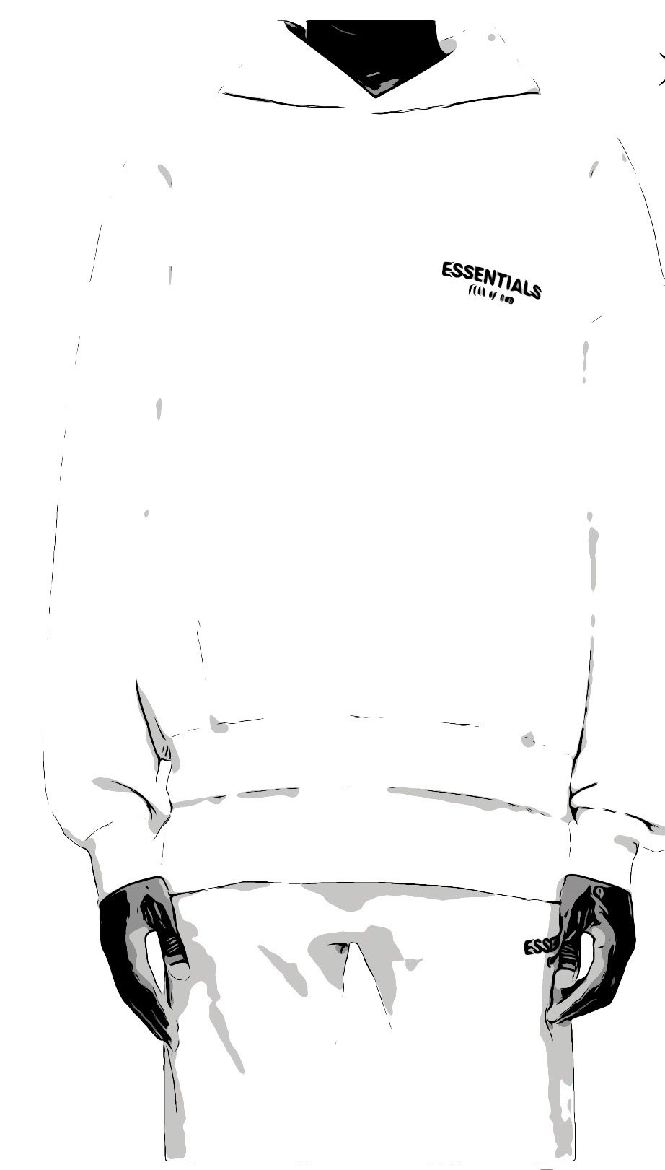

Chapter 5: Vacation to Curacao

Traveling is very essential to me. It is a must that I travel at least once or twice a year. My parents instilled this in me because I have been traveling since I was kid. Now that I am older and able to travel by myself, I see the bigger picture of life. I fully understand that the world is much bigger than just the Bronx, NY. In addition, it teaches you how to adapt to new environments.

I love learning about different places and their cultures. This time around I went on vacation to Curacao with my close friend Destiny. Destiny and I have gone on multiple trips together including Dominican Republic, Mexico, Jamaica, and Houston. The flight from New York City to Curacao was about 4 hours and 35 minutes. The days of the trip were February 19 - 23. For this vacation, I decided to try something different and wear more bright colors like lime green, yellow, and orange. Usually I wear basic colors like black, white, or red.

For this particular trip the hairstyle I did was two strand twists. This is a common hairstyle for males and females. The reason the hairstyle is so common is because it's easy to put in and take down. The hairstyle consists of splitting a section of hair into two then creating a rope-like appearance. I like this particular hairstyle because it covers most of my face, I am able to *adhere* my hair in a ponytail, and I am able to keep the hairstyle in for a long period of time. Once I stopped doing the pop smoke braids, the only hairstyle I was doing would be the two strand twists.

Brands like Supreme and Palace started captivating my attention. Once I found out my size measurements for the clothing and realized the prices were affordable, they became a part of my favorite brands. I packed a lot of Palace t-shirts, Ksubi jeans, Purple brand jeans, and basketball shorts for this trip. The sneakers I packed for this trip were Jordan Bred 4s, Jordan Cool Grey 11s, and Nike Air Force Ones. On vacation and special events I wear my gold chain with the divine child pendant. I have white gold earrings that are *clipped* to my everyday wear. For the first night of the trip I wore a Palace p slub pocket green t shirt, Social Terrorist blue stone denim v2, and Nike Air Force Ones white.

My thought process when deciding an outfit is always making sure it appeals to me and that I color coordinate. Bright colors always look right with denim colorways. On the top left underneath the pocket area on the stone denim there is a bedazzled skull. The bedazzled skull adds more effects to the jeans making the skull sparkle. The jeans were a skinny tapered fit. Social Terrorist is a small business brand that I found through scrolling on Instagram. It is always great taking a risk and trying new clothing that you will not normally wear. I gather inspiration from everywhere when it comes to clothing; from social media, rappers, fashion designers, and my peers. This trip was influential because it made me challenge myself with styles I never tried before. 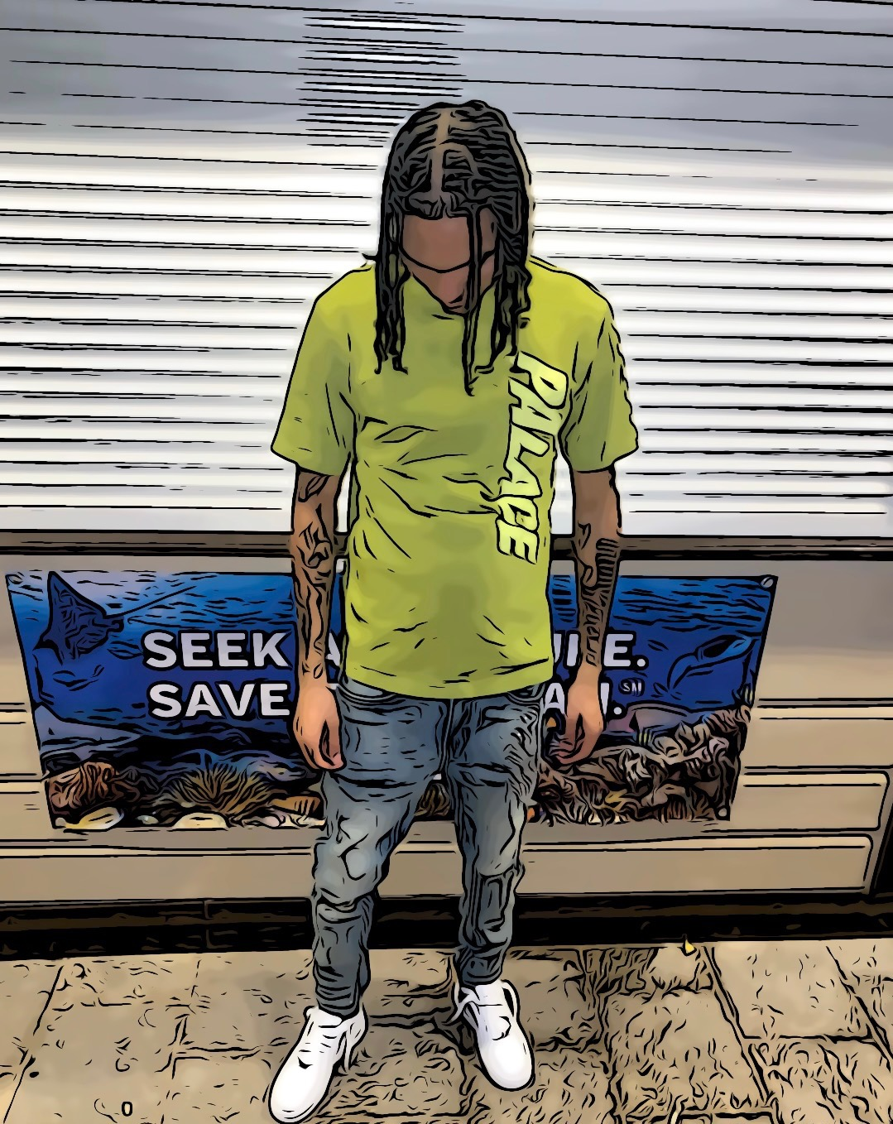

Chapter 6: High School Prom

Prom is a pivotal moment for many seniors. It is usually the last time the whole class is all together before graduation. Prom and graduation marks the conclusion of high school and the beginning of adulthood for seniors. I did not go to my middle school prom, therefore; I was hesitant to go to high school prom. I was not really interested in going at first because I did not think it was necessary. Nevertheless, I did not want to miss this moment and regret it in the future. All my friends were going so that influenced me to go as well. We were celebrating the completion of high school. Not to mention, it is a night where you can dress up and have fun.

Prom was my first time wearing a suit as an adult. Prior to that, I wore a suit for my first communion. I felt accomplished as a young man. It made me look professional and distinguished. Wearing a suit was not a part of my daily basis, so I knew I was breaking the cycle doing so. For certain aspects in life you have to come out of your shell and try new ideas. I bought my suit from Tailor Atelier. The store is located at 1374 Castle Hill Ave. I heard great reviews about the store and it was nearby where I lived so it was perfect for me.

When I was shopping for a suit, I did not have a clue of what theme or color I was going for. After contemplating which suit best fit my personality and style, I decided to purchase a three piece suit. Nigel, who works at Tailor Atelier is very detail oriented and made sure the tailoring for the suit was magnificent. He helped me pick out the colors, which were beige and black. The color black goes great with any shade of beige. In addition, I knew the chances of somebody wearing black and beige was rare. The suit jacket was beige. The waistcoat was a white and black. The bow tie was black. The trousers were black. Once I bought the suit, I had to buy some shoes to go with the outfit. I went to multiple stores in the neighborhood of 3rd Ave located in the Bronx, NY, but I could not find anything that caught my eye. The store I went to called London Boy Station located at 2908 3rd Ave, Bronx, NY had all the shoes and sneakers you could think of. I bought the Jordan 10s Premium GG also known as “Heiress”. The Jordan 10s were a beige and black colorway. My cousin Jossie, drove me to my prom which took place at MJ Catering Hall. MJ Catering Hall is located at 950 Anderson Ave, Bronx, NY. 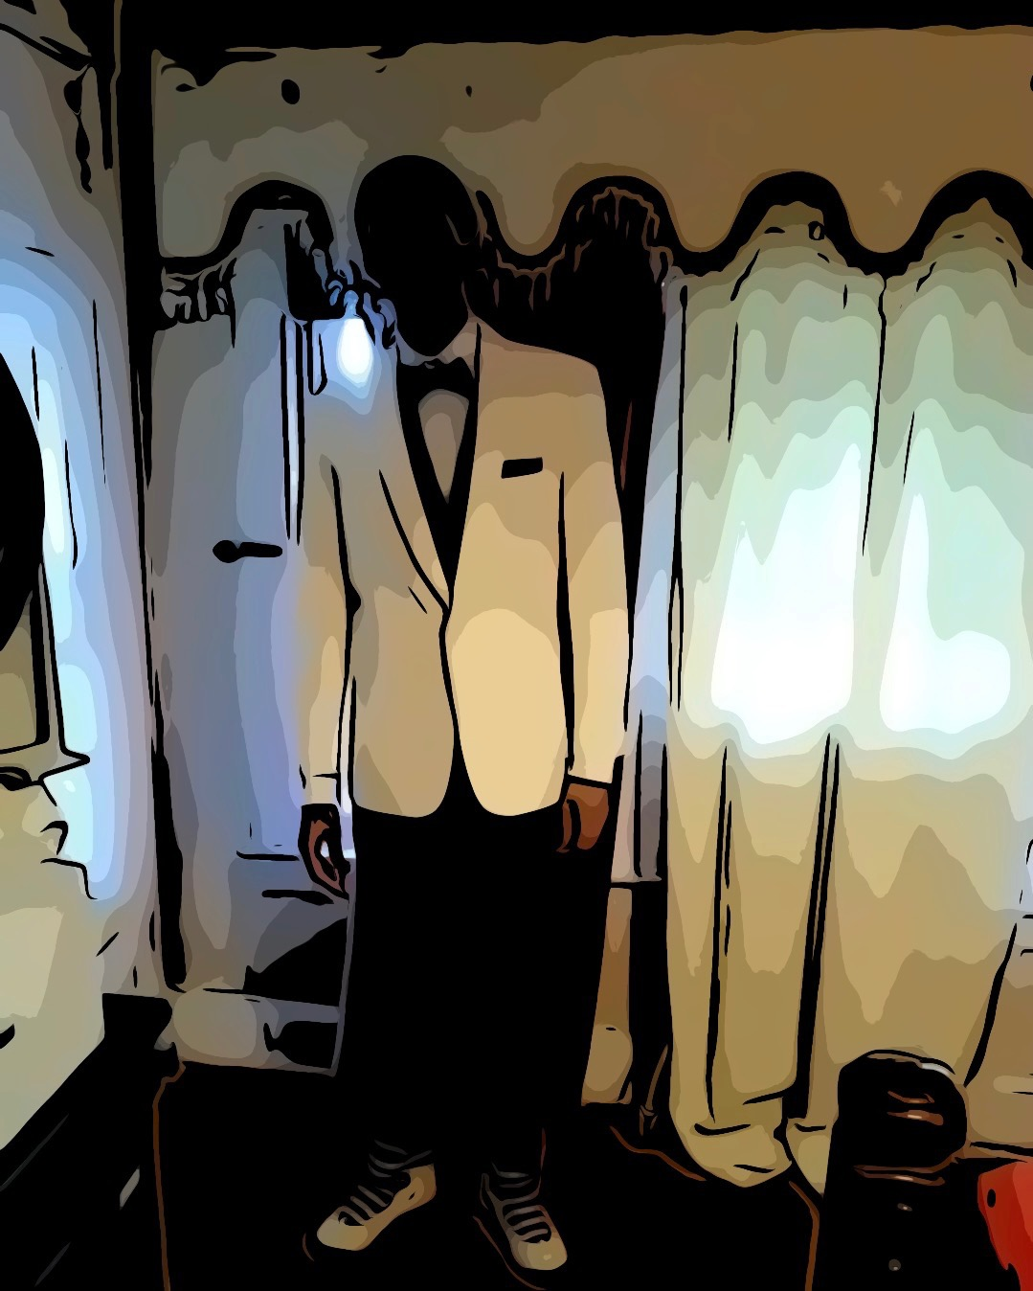

Walking into the hall and receiving compliments from all my peers and staff felt joyful. Seeing everybody dressed up and having fun was a memorable moment. It was definitely a night that I will talk about throughout the coming years. I am glad I made a decision to attend and I knew I would not regret it. Being able to wear a suit made me feel powerful and important. The entire night was very special to me.

Chapter 7: Job Interview

A professional appearance is a major step in making a good first impression. You want to look professional, successful, and the kind of person the business wants to represent. Dressing in the right attire for an interview shows that you are serious about the job. I had a job interview with the principal at P721X Main Site.

The job position was to be a paraprofessional. The role of a paraprofessional includes direct services to students, communication with teachers, and ability to assist in classroom instruction. My aunt, Thelma, who is a paraprofessional, was listed as my recommendation. She was able to put in a good word for me with the principal. I was assured there was positive feedback about me prior to walking into the building. I did not want to let my aunt down because I knew I was representing her, therefore; the outfit I chose for the interview was not only a representation of myself but also of my aunt.

For my job interview I wore a white button down shirt, a hermes belt, black slacks, and dress shoes. The white button down shirt was from ASOS. The dress shirt was a long sleeve muscle fit poplin shirt *clipped* to my arms. The black slacks were from ASOS. The slacks were slim pants *suspended* to my legs. The shoes were Stacy Adams bayne black double monk strap dress shoes. My inspiration when deciding this outfit was knowing I will be judged based on my appearance first rather than my character and skills. I wanted to make sure I presented myself sharp and that my professionalism aligned with my clothing choices. Additionally, I wanted to make sure I fit in with the company dynamic. Clothing is one of the many deciding factors in an interview. For this particular outfit, I was going for business professional attire.

Nevertheless, my thought process for the interview was I did not want to wear colors that were inappropriate or did not want to wear jewelry. My goal was to match the company’s culture. I believe your outfit for an interview is determined by the company’s dress code. Certain firms might be understandable if you are wearing a t-shirt and jeans for a first interview. Other companies might expect you to wear a dark suit, dress shirt and shoes. The way you dress is a reflection of yourself. For an interview, your attire will determine how serious you are about the profession or not.

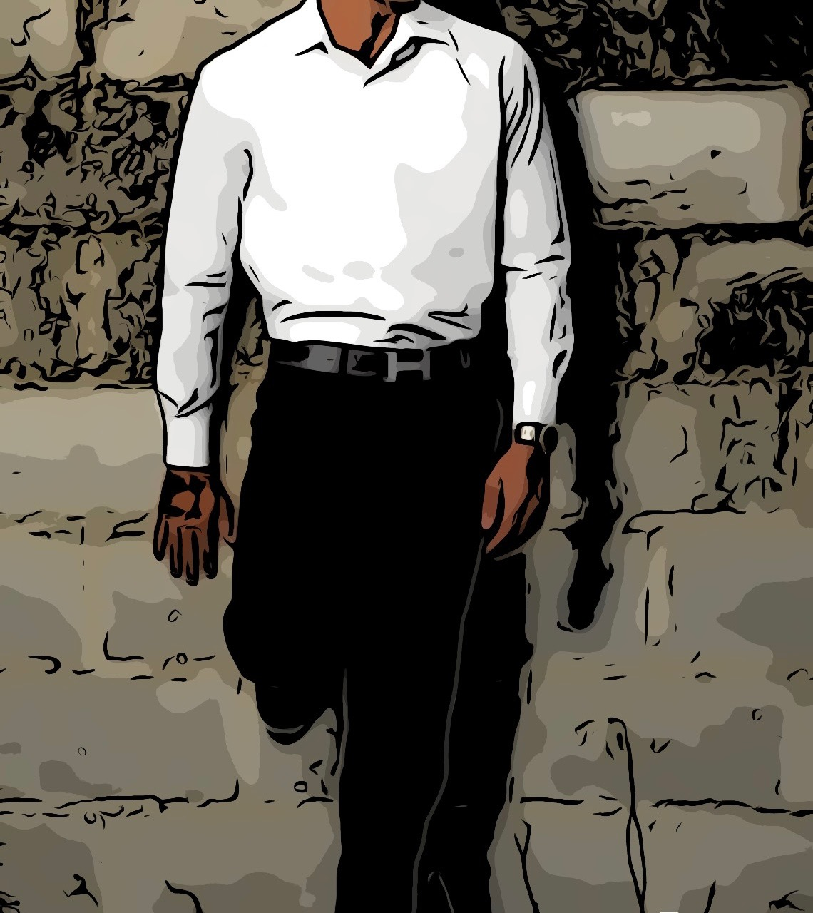

Chapter 8: Virgil Abloh Exhibit

Virgil Abloh is a Ghanaian-American creative director. Abloh, was the founder Off-White and the men's artistic designer at Louis Vuitton. He broke boundaries in the fashion industry. He brought streetwear to the highest levels of the luxury market. Virgil was one of modern fashion’s most popular designers. He influenced numerous individuals of color by putting the spotlight on black talent, bringing streetwear to the world, and he supported the next generation of black fashion industry. Abloh died from a rare form of cancer at the age of 41 on November 28, 2021.

Louis Vuitton and Nike Air force ones made a collaboration created by Virgil Abloh earlier this year. Louis Vuitton and Nike Air force ones hosted an exhibition paying homage to late designer Abloh and displaying 47 styles of the Louis Vuitton and Nike Air force ones. All the sneakers are designed by Abloh. The Virgil Abloh exhibition was located at the Greenpoint Terminal Warehouse on 73 West Street, Brooklyn, NY. The exhibition was from May 21 through May 31, 2022. I went to the exhibition with my co worker, Maggie on May 28, 2022. Our time slot for the exhibition was 1:30. The show was free to attend, individuals did not need a ticket unless you wanted a fast pass. We met up at Grand Central 42nd Street and got off at 86 street. From 86 street, we took an uber to Greenpoint.

The day of the exhibition I was contemplating my outfit. I was indecisive on what to wear. Originally, I wanted to wear a Off-White hoodie to honor the legacy of Virgil Abloh however, the outfit did not go as planned. I decided to wear a Spider worldwide sweatsuit, the outfit was appropriate for the weather. Spider worldwide is a brand made by the artist Young Thug. The sweatsuit was a red hoodie with a spider web in the middle and the angel number listed 555 555. The angel number 555 represents change, freedom, and adventure. The sweatpants were red with the angel number 555 555 in the center. I wore the Jordan 3’s hall of fame, the colors are white and red.

Once we got to the exhibition, the place was adorned with mirrors, LV logo all over the place, and quotes from Virgil Abloh. There were 2 quotes that stood out for me which were “Dream Now” and “Who Did it First? Where Did They Get The Idea? Is It New?”. I strongly believe in those quotes because we all have dreams and aspirations of where we want to be in life. Also, we all get inspired from others whether it may be from our looks, the way we dress, talk, etc. Virgil motivated so many upcoming designers including myself that the possibilities are endless and that we are all capable of being the best we can be.

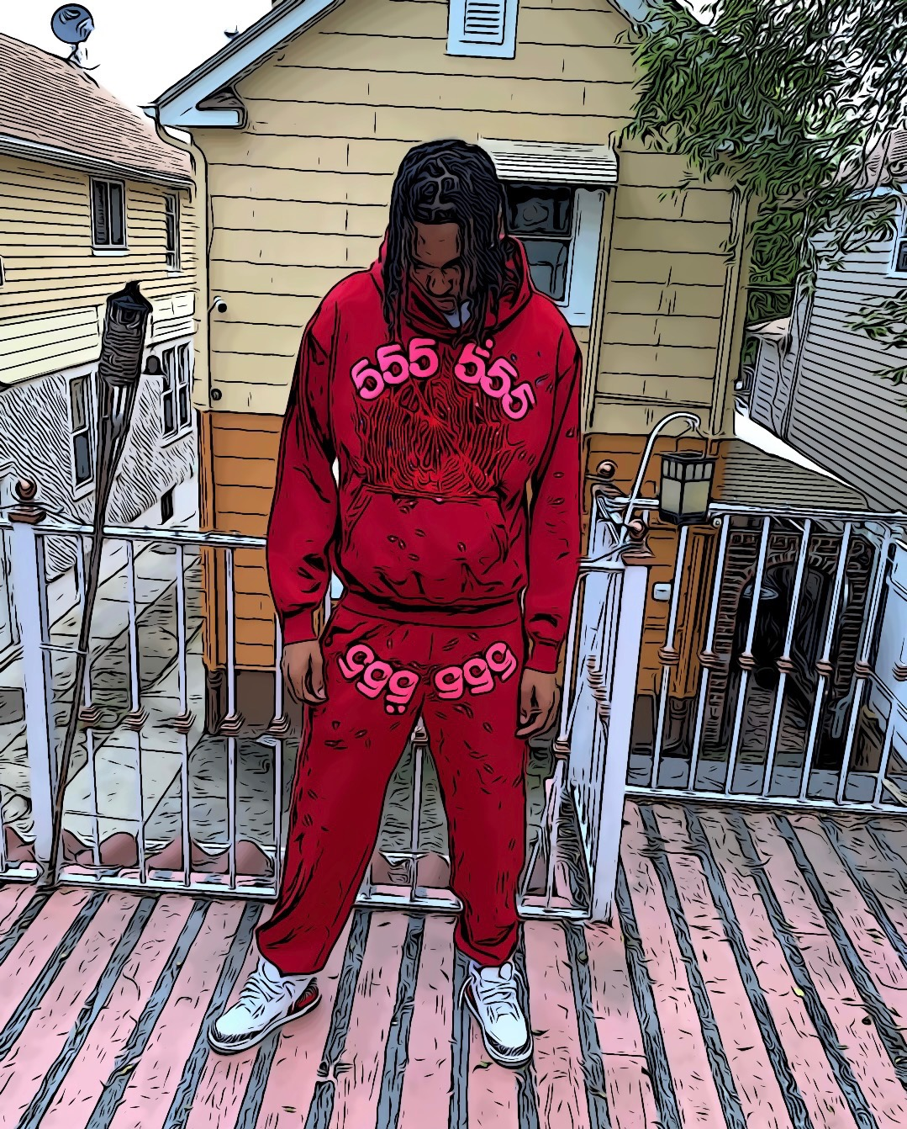

Chapter 9: Family trip to Dominican Republic

My family decided to take a trip to the Dominican Republic in the summer. My parents nationality is Dominican. My mother, Ana is from Santiago, Dominican Republic. My step father, Franklin, is from San Francisco de Macoris. We stayed at the Bahia Principe Grand La Ramona. It was an all inclusive resort which included 2 outdoor pools, 13 restaurants, beach front, and buffet. The days of the trip were August 16 - 21. Family vacations are essential because they build lifelong memories. During the vacation we ate meals together, did sightseeing together, and had lots of fun. Not to mention, this brings us together physically, emotionally, and mentally.

The family trip was amusing. The excursions we did were horseback riding, super buggy tour, and ziplining. For this particular trip, I decided to pack a lot of white polo slim fit t-shirts. I did not pack any other color t-shirts besides black polo slim fit t-shirts. In addition, I packed Ksubi jeans, jean shorts, basketball shorts, sneakers, and slippers to lounge in. During this time in 2019, all I would wear was polo slim fit t-shirts because I knew it would go with any outfit, any occasion. It fit my personality and made me feel comfortable, which is always important.

On the last night of our memorable vacation, we all decided to go out and eat. We agreed to dress up and take pictures for memory purposes. I wore a white polo t-shirt, van winkle highfly ksubi jeans, and the cool gray 4s. Around this year, I started coming out of my shell and buying items I like despite the price. I was buying garments in my price range, it boosted my ego and made me feel good about myself.

Sometimes it is essential to spoil yourself and buy lavish items you always wanted or dreamed of. Before Ksubi jeans, I wore G star jeans, H&M, and Zara jeans. Ksubi jeans became very popular during 2018-2019. New York City is the forefront of creativity, style, and innovation. A lot of these brands are unprecedented until somebody with status wears it and it becomes a trend. Although, the idea of a trend is that it never lasts long, most are short term implications. Some brands are trends, then other brands are timeless. Certain outfits you wear will always be stuck in the back of your head because of particular moments you shared that day.

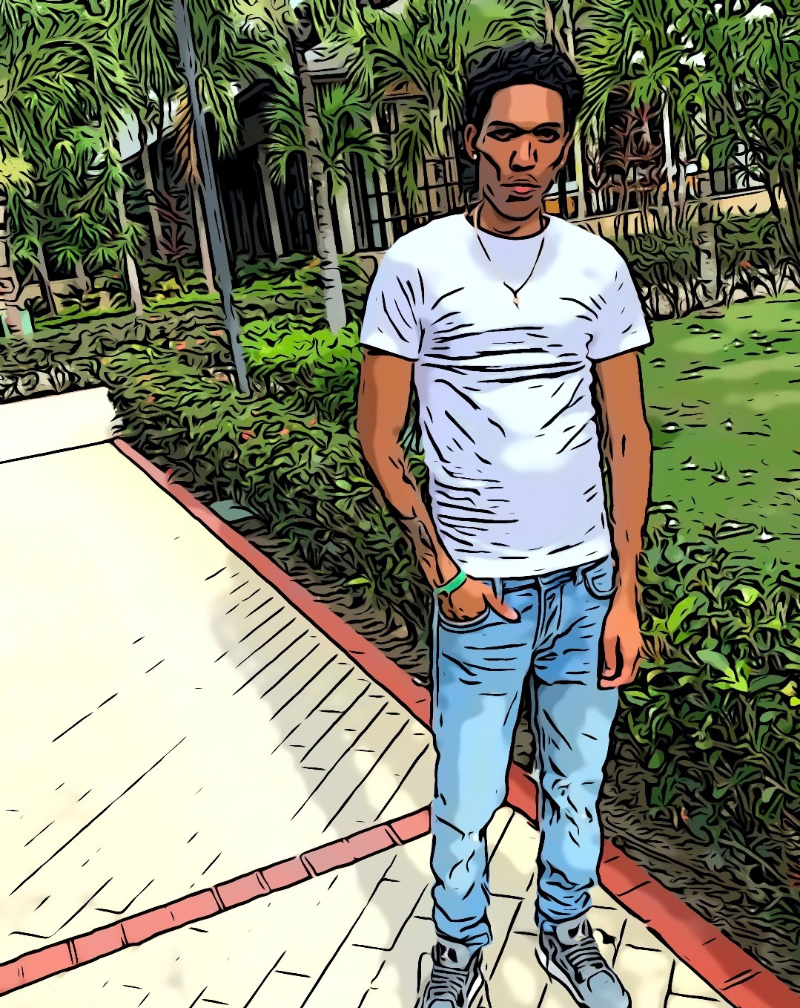

Chapter 10: Knicks Basketball Game

I went to a basketball game with my friend, Austin. We went to see the New York Knicks vs. Phoenix Suns on Madison Square Garden on November 26, 2021. My friend Austin, ended up buying tickets to the game the day of. The total number of people at the basketball game was 19,812. I thought the amount would be less because it was two days after Thanksgiving.

He bought the tickets from this app called TicketFaster. Later on in the afternoon, he called me and asked if I was busy; inviting me to attend the game with him. I was more than happy to go. The game started at 7:00 PM. We took public transportation to the arena. We were worried we would be running late, but thankfully we made it to the game on time. This was during COVID-19 so we did have to show our covid vaccination and proof of ID before entering.

The New York Knicks vs. The Phoenix Suns game was such an exciting game to watch. My friend Austin is a huge fan of Chris Paul so it made it all worth it. He got to see his favorite basketball player live in person. Not to mention, we had great seats for the game. We were able to see everything that was going on. We sat at Sec 110 Row 13 seat 24 and 25. That was the closest I ever sat to in a basketball game. I have been to both Madison Square Garden and Barclays Center. I admire both arenas because they take place in New York City and you are able to see celebrities there all the time. The Phoenix Suns won the game. The score was 118 - 97. Devin Booker had the most points for the Suns, he had 32 points. Kemba Walker who is on the Knicks had the most points for his team, he had 17 points.

The weather for November 26, 2021 was 46 degrees. It was extremely cold that day. I particularly chose to dress warm and cozy on this day. My outfit was a gray Nike sportswear tech fleece zip up hoodie *inserted* with the matching joggers. The sneakers I had on were Nike air max 95 OG neon. Additionally, I had a black Moncler Montgenevre short down jacket. I also had a gray fearless boyz beanie with three crosses with rhinestones. My inspiration for this outfit was just applying pieces together at the last minute and being comfortable. More importantly, I wanted the outfit to go with my sneakers. The air max 95 OG neon is one of my favorite sneakers that released in 2021 because I always wanted those sneakers as a kid. Now that I am an adult, I buy all the sneakers I wanted as a child or I missed out on because I could not afford them.

Sports are a powerful tool that bring people of different backgrounds all together for the love of the game. Watching the NBA game live was a great way to spend time with my friend Austin. Basketball is fun and exciting. Moments like these I cherish for a long time because we will be able to talk about this day for years to come. 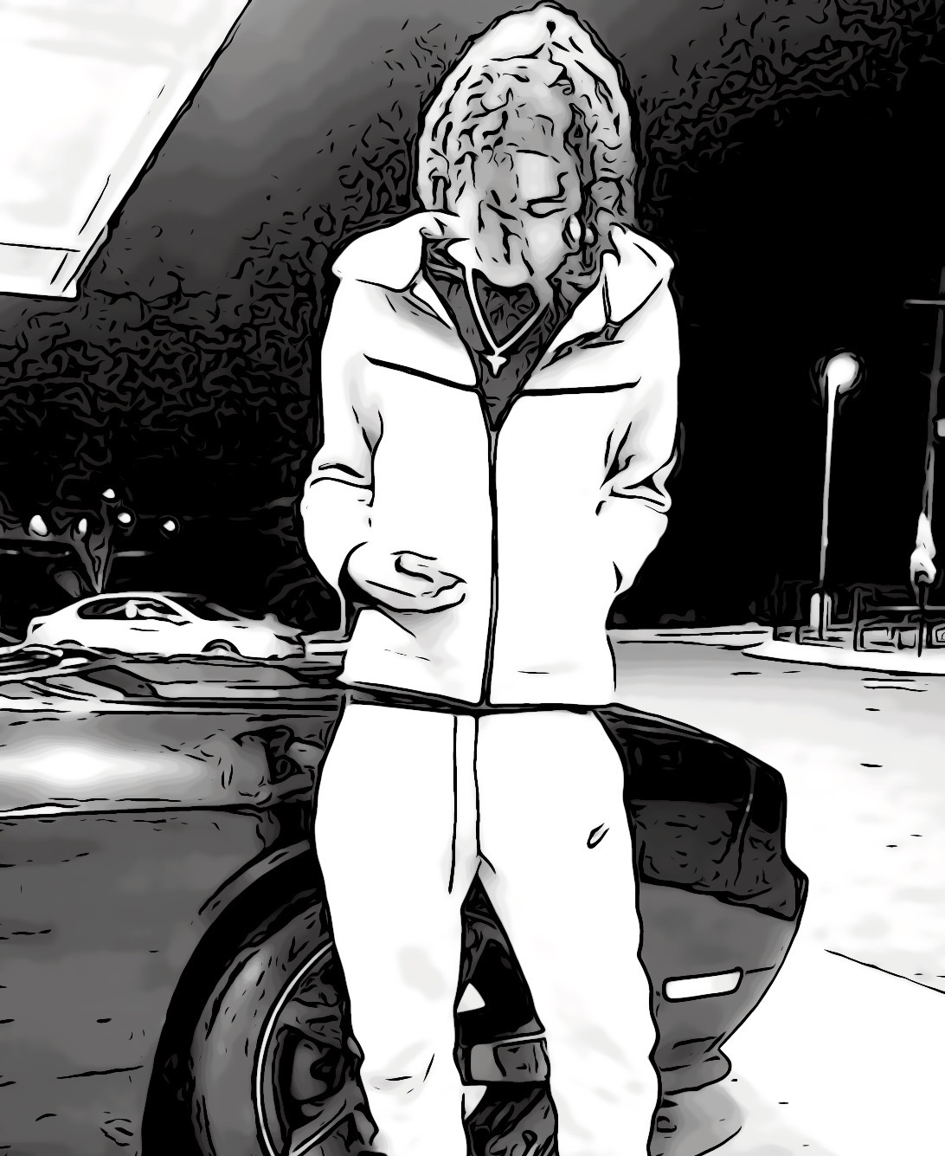

Chapter 11: Meek Mill Concert

Meek Mill is a famous African American rapper. He dropped his anticipated album Expensive Pain on October 1, 2021. All of my friends and myself are fans of Meek Mill. We heard the news that he would be performing live in Madison Square Garden along with special guests. The concert was on October 23, 2021. We all bought our tickets to go to the concert. My friends Kyrek, Austin, Joshua, and Joel were going. Austin and myself were the only two out of the group who had never been to a rap concert.

This was my first time going to a rap concert. I was ecstatic to go to the Meek Mill + friends concert. A lot of A list rappers were a part of the concert. Some of my favorites rappers were featured to perform that night from Lil Baby, Lil Durk, 42 Dugg, EST Gee, Fivio Foreign, Lil Uzi Vert, and many more rappers. The concert followed Covid-19 guidelines, and had to have a mask to enter and show proof of vaccination. The doors opened at 7:30PM. Seeing all my favorite rappers perform live was a breathtaking experience. Being able to sing the song with the audience word for word was astonishing.

For this concert I wore a Palm Angels outfit. Palm Angels is an Italian fashion brand. The owner of Palm Angels is Francesco Ragazzi. In addition, he was the former Moncler artistic director. The brand was founded in 2015. The day of the concert I wore a long sleeve track jacket *fitted* in red with palm angels printed on the left side of my chest. The track jacket included two zip pockets. Also, the jacket had white stripes on the sleeves. Underneath the jacket, I wore a black polo t-shirt slim fit. For the bottoms, I wore long track pants with palm angels printed in the front on the left corner. The pants include white stripes on the side of the legs and zip closure at ankle cuffs. The sneakers I wore that day were the Jordan retro bred 4s. My inspiration for this outfit was to make a statement wearing a bold color. Also, tracksuits give off a vintage look. People have been wearing tracksuits since the 1970’s but as the years developed it just got popularized within time.

Concerts are a great experience, it is thousands of people bonding over music. My friends and I were able to see most of the rappers we listen to on a regular basis in person, that is an experience we will never forget. The energy of a live concert is electric. Fans from all over the world coming together just for that one moment.

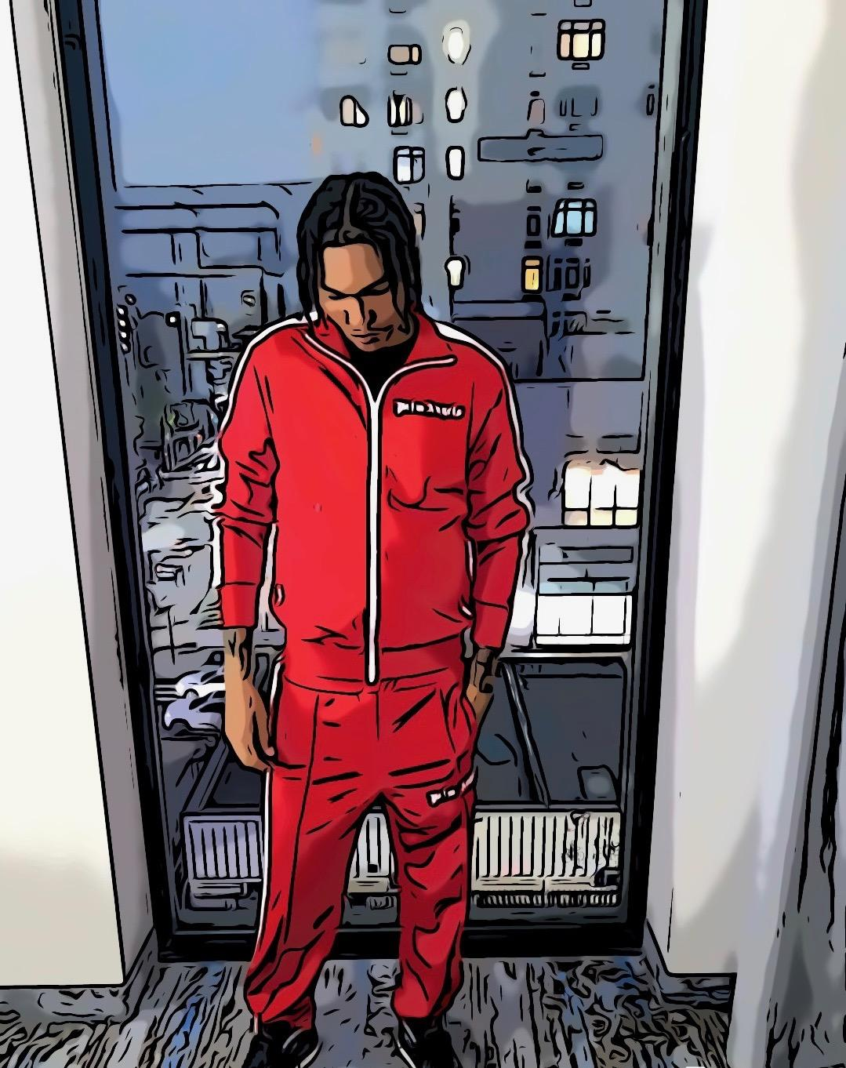

Chapter 12: Uncle’s Wedding

My uncle Jose has been married for 15 years. The first wedding was on December 10, 1999. For his 15th year anniversary, he wanted to surprise his wife by renewing their vows in a venue in a Waterside event that was located at 7800 B River Rd, North Bergen, NJ 07047. The venue had views of the New York City skyline. My uncle hired a chef for the event that catered to the 500 guest list. He invited family members, close friends, neighbors, family friends, and co-workers. The menu consisted of Spanish dishes and drinks.

My uncle took all his siblings, cousins, and nephews shopping for tuxedos. We went to the Tux Guys at 7516 Bergenline Ave, North Bergen, NJ 0747. I found the perfect tuxedo that suits me. I was tailored for a groom's navy and black slim fit shawl tuxedo. That would be the tuxedo I decided to wear to the wedding. The best man, groomsmen, ringbearer, and usher wore a navy and black tuxedo. My uncle wore a groom black and white slim fit tuxedo. His wife Ashley, wore a long stunning white dress designed by Esé Azénabor Atelier. Esé Azénabor Atelier is a black owned brand. After shopping for tuxedos, we went shopping for shoes. The shoes that stood out to me the most were the Dior, Jimmy Choos, Stacy Adams, and Christian Loubotins. The shoes I ended up getting was the Dior timeless derby shoe.

I had my outfit prepared for the wedding. This was my second time wearing a tuxedo, my first time was my prom. I felt empowered the day off the wedding because I was a part of something monumental and I was wearing a tuxedo. A man in a suit speaks volumes of his character. Not only did I feel successful, I felt as if I could accomplish anything I put my mind to. I noticed that many people responded to me in a positive manner because of the way I dressed and carried myself. People take you more seriously when you wear a suit compared to streetwear attire. This day opened my eyes and made me want to start wearing suits more often. The compliments I received on my tuxedo was flattering. It was mind boggling seeing all my family members and loved ones dressed up in tuxedos and dresses because it was a rare occasion.

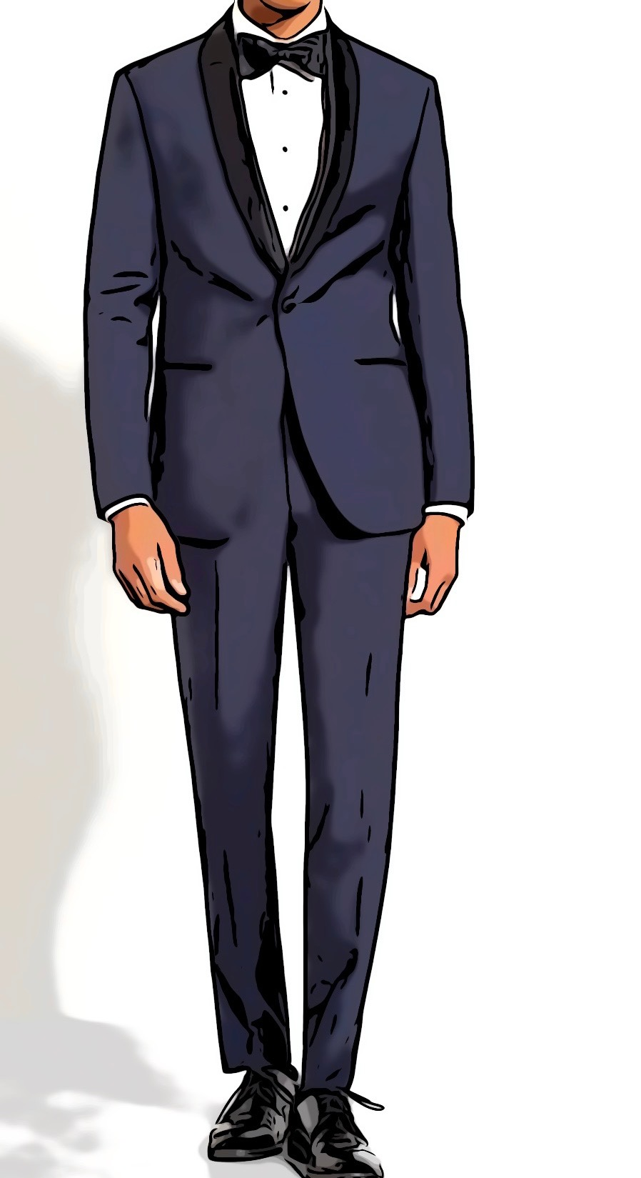

**About The Author**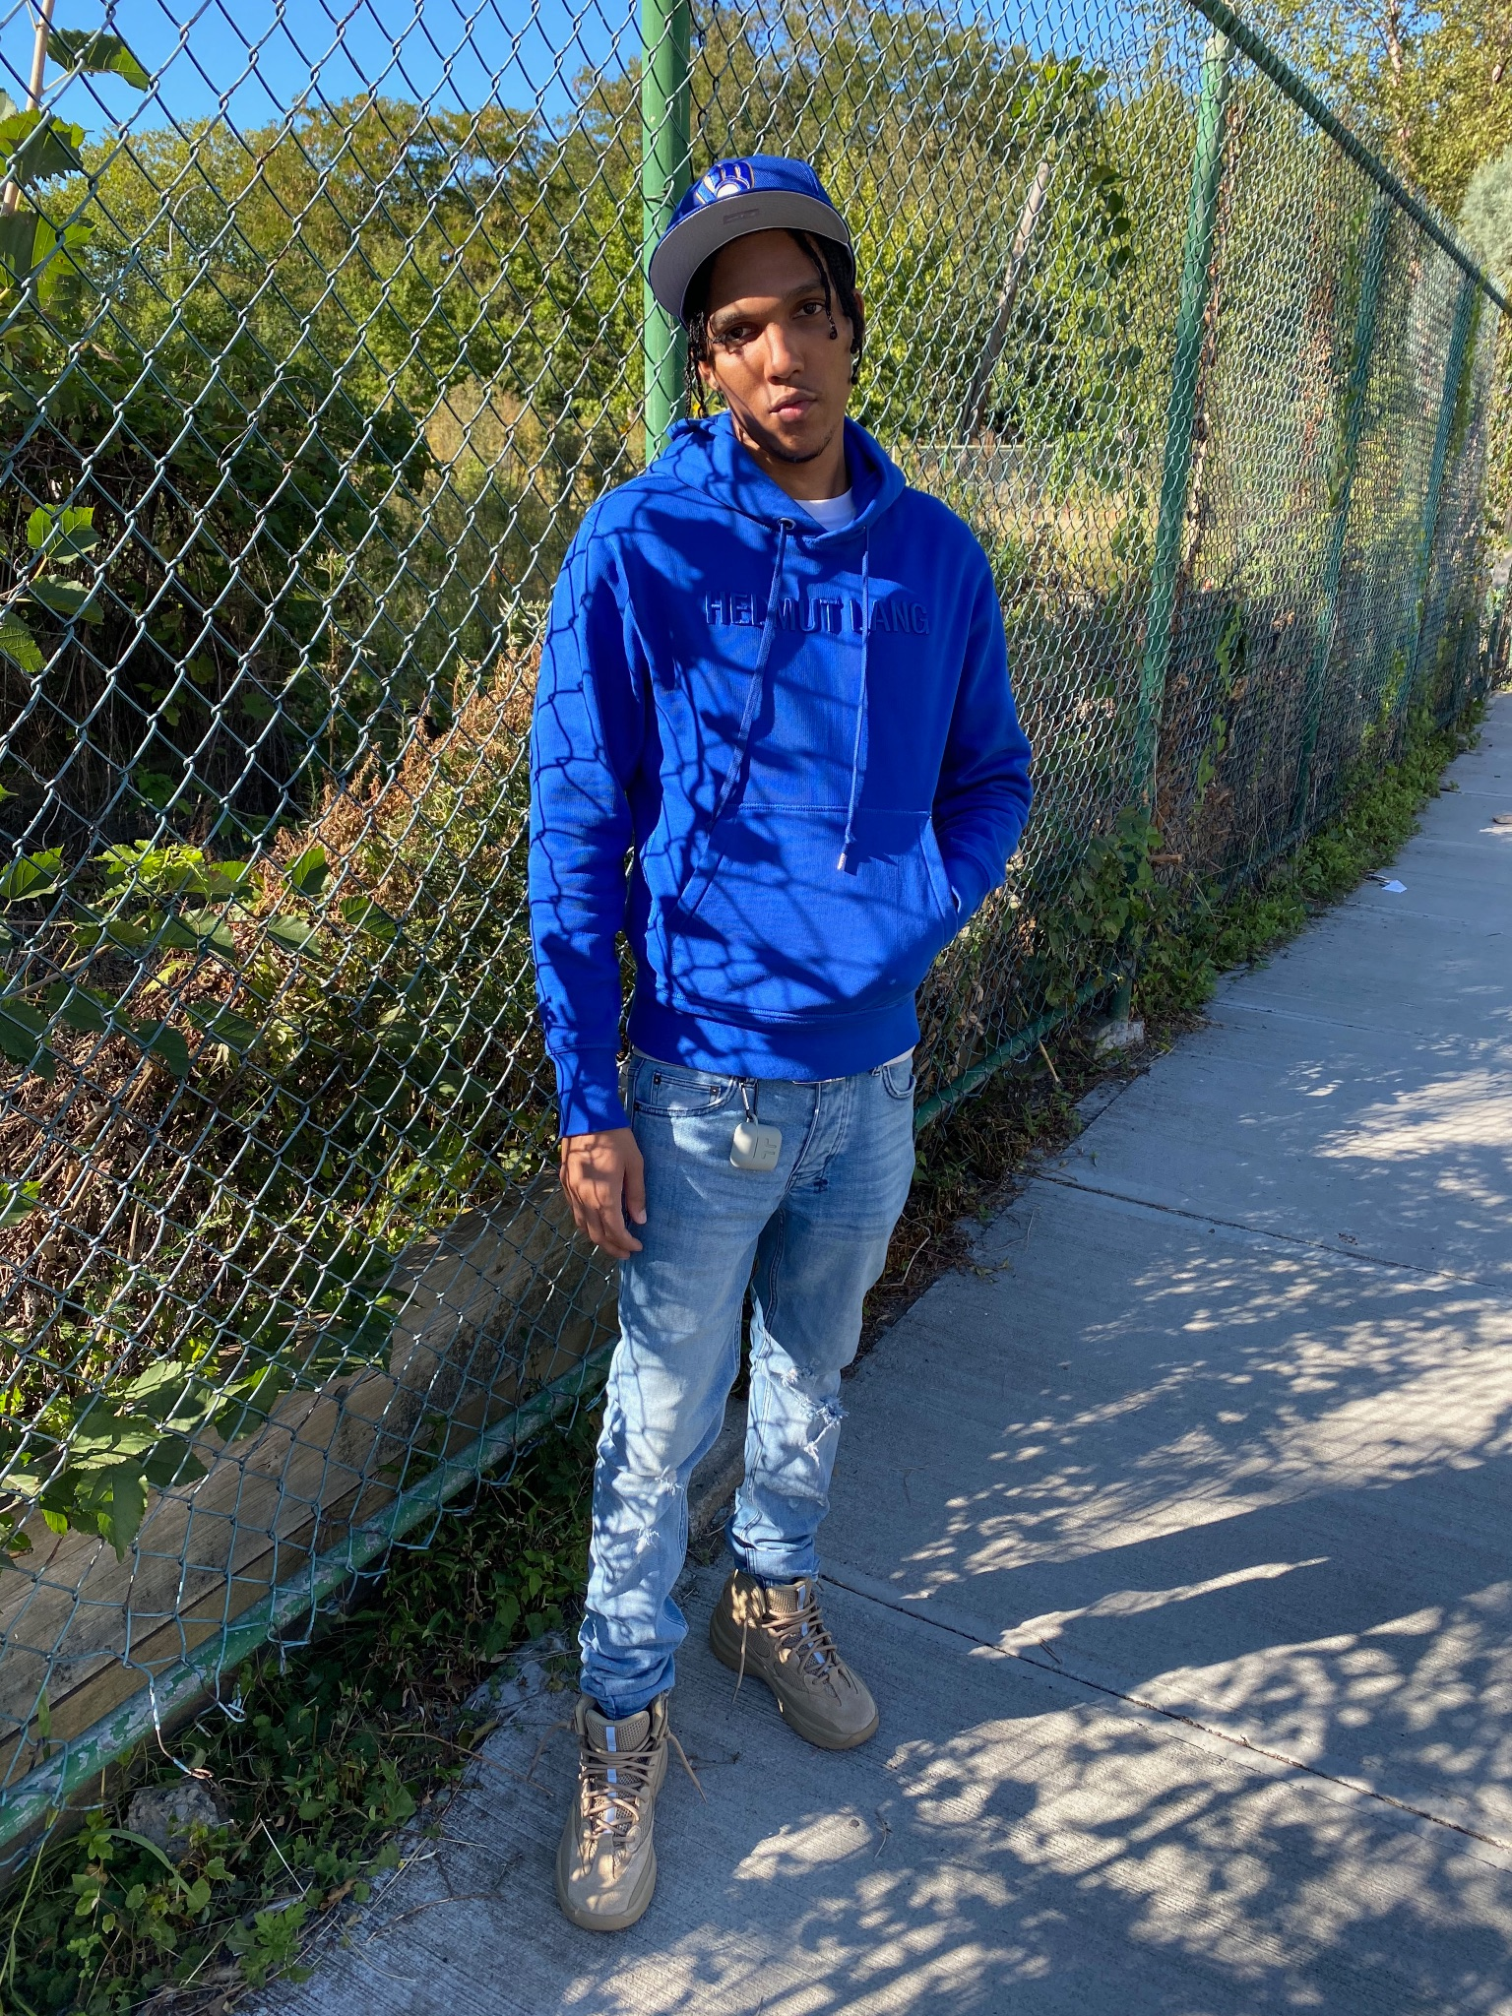

Anthony Mota is a student at New York City College of Technology. His major is Business Technology of Fashion. He’s in his third year. Anthony Mota is from the Bronx, NY. He has a love for fashion, music, and sports. He plans on being a successful entrepreneur of his own fashion company one day. This book illustrates unforgettable moments in his life that impacted or influenced him.