Anna Molina

Professor Boyle

HIS 1103

June 6, 2023

Primary Source 1

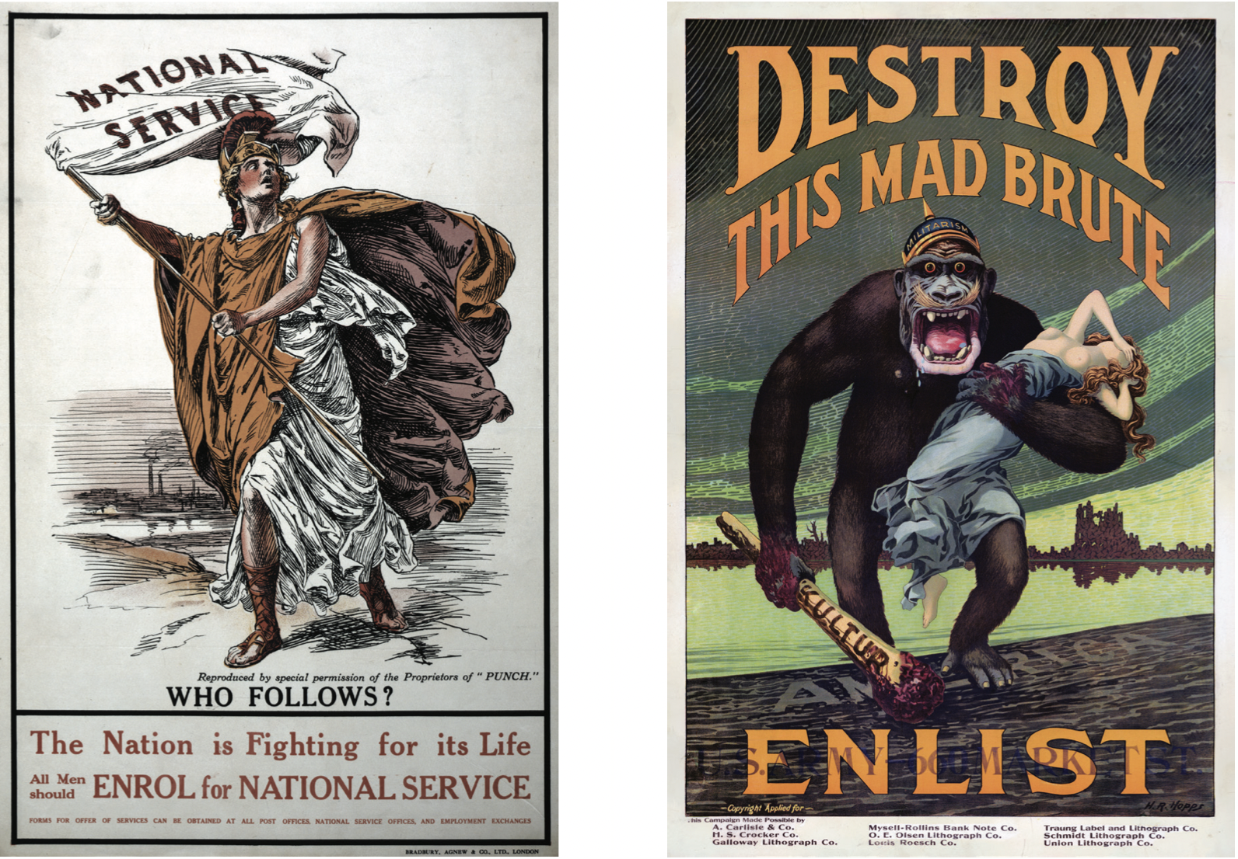

1. What are the sources? (names, what are they actually)

The sources are Destroy This Mad Brute, The Nation is Fighting for Its Life. All Men Should Enroll for National Service, National Service.

2. Describe what you see in the posters

The "Nation is Fighting for Its Life" poster portrays Britannia, waving the National service flag, implying leadership and calling men to enlist. The statement "All Men Should Enrol for National Service" further emphasizes the message that men should follow and enroll.

In the "Destroy This Mad Brute" poster, a gorilla is depicted carrying a half-naked woman, with the word "America" being stepped on. The words "Destroy" and "Enlist" are enlarged and capitalized, drawing attention to the urgency and importance of taking action.

3. Why were these posters made? (function/purpose)

The "Nation is Fighting for Its Life" poster portrays a figure waving a flag, symbolizing the call for men to follow and serve their purpose in fighting for the nation's survival. It emphasizes the idea that the nation's fight is directly connected to their own lives. In the "Destroy This Mad Brute" poster, the depiction of the enemy as wild gorillas serves to dehumanize them, reinforcing the propaganda message that they are savages. This aims to create fear and urgency, suggesting that if the enemy is not defeated, they will harm women.

4. What theme do these posters address and how do they reflect the themes?

These posters strongly convey the theme of nationalism, inspiring men to enlist and serve their nation as a sacred duty to protect what is rightfully theirs. They skillfully emphasize the urgency of the situation, presenting a sense of national survival. For instance, the poster “The Nation is Fighting For Its Life” features the figure of Britannia, a female warrior, passionately waving the national service flag, appealing to men's sense of honor and encouraging them to join the cause. Similarly, the poster "Destroy the Mad Brute" shows fear and savagery, suggesting that failure to enlist could put their loved ones, particularly their wives, at risk. These posters inspire men to serve their nation with a strong sense of duty.

5. What do these posters tell us about WWI?

These posters depict the strong nationalism during WW1. They show how soldiers from different sides were convinced they were fighting for a good cause through propaganda. The posters also illustrate how governments used tactics to encourage men to enlist, emphasizing their patriotic duty.

6. What is your perspective (thesis) about these posters?

These posters played a vital role in recruitment strategies, influencing the motivations of soldiers and instilling a sense of nationalism and fear. Their purpose was to persuade people to support and participate in war. It is important to examine the government's justifications for these wars, as the posters reveal their strategic tactics to convert soldiers and achieve victory.

Primary Source 1 (in paragraphs)

The "Nation is Fighting for Its Life" poster portrays Britannia, waving the National service flag, implying leadership and calling men to enlist. The statement "All Men Should Enrol for National Service" further emphasizes the message that men should follow and enroll.

In the "Destroy This Mad Brute" poster, a gorilla is depicted carrying a half-naked woman, with the word "America" being stepped on. The words "Destroy" and "Enlist" are enlarged and capitalized, drawing attention to the urgency and importance of taking action.

The "Nation is Fighting for Its Life" poster portrays a figure waving a flag, symbolizing the call for men to follow and serve their purpose in fighting for the nation's survival. It emphasizes the idea that the nation's fight is directly connected to their own lives.

In the "Destroy This Mad Brute" poster, the depiction of the enemy as wild gorillas serves to dehumanize them, reinforcing the propaganda message that they are savages. This aims to create fear and urgency, suggesting that if the enemy is not defeated, they will harm women.

These posters strongly convey the theme of nationalism, inspiring men to enlist and serve their nation as a sacred duty to protect what is rightfully theirs. They skillfully emphasize the urgency of the situation, presenting a sense of national survival. For instance, The poster “The Nation is Fighting For Its Life” features the figure of Britannia, a female warrior, passionately waving the national service flag, appealing to men's sense of honor and encouraging them to join the cause. Similarly, the poster "Destroy the Mad Brute" shows fear and savagery, suggesting that failure to enlist could put their loved ones, particularly their wives, at risk. These posters inspire men to serve their nation with a strong sense of duty.

These posters depict the strong nationalism during WW1. They show how soldiers from different sides were convinced they were fighting for a good cause through propaganda. The posters also illustrate how governments used tactics to encourage men to enlist, emphasizing their patriotic duty.

These posters played a vital role in recruitment strategies, influencing the motivations of soldiers and instilling a sense of nationalism and fear. Their purpose was to persuade people to support and participate in war. It is important to examine the government's justifications for these wars, as the posters reveal their strategic tactics to convert soldiers and achieve victory.