E-Cloth: Integrating Electronics with Fabric
By: Andrew Lops
Course: BUF 4246
Professor Munroe

Throughout the textile industry, it has evolved to immense heights that are still growing to this day. The ever-growing expansion of technology and the advances it brings with it have enabled the industry to reach these heights. As of now, the integration of technology within fabrics has heightened the textile industry, creating a breakthrough in fabrics and garments resulting in uses outside their original intent. Now, when going into the specifics, there are three categories in which these advanced textiles can be classified: passive, active, and very smart textiles. Every one of these categories reflects a different degree of technology integration and utility, therefore changing our interaction with fabrics. In our rapidly advancing society, we increasingly see these advanced textiles integrated into our everyday lives.

Passive Smart Textiles
When it comes to passive smart textiles, they are the simplest category of sophisticated textiles (Kettley, 2021). These materials lack technologically embedded components but are improved through chemical processes or unique weaving methods to give them specific features (Kettley, 2021). Additionally, passive smart textiles can recognize signals in the environment around them, and some examples of this can consist of “thermal, chemical, electrical, or magnetic states,” as stated by Sarah Kettley in her book Designing with Smart Textiles. Now, one brand that utilizes passive smart textiles is Patagonia. They have various garments that fall under the category of passive smart textiles. One example of this would be their “Men's Torrent shell 3L Rain Jacket." It is a waterproof jacket that is durable, comfortable, and able to tackle various rainy weather conditions (Patagonia, 2024). This garment is considered to be a passive smart textile as it can operate without the use of outside power sources.

Figure 1 - Men's Torrent shell 3L Rain Jacket from Patagonia.
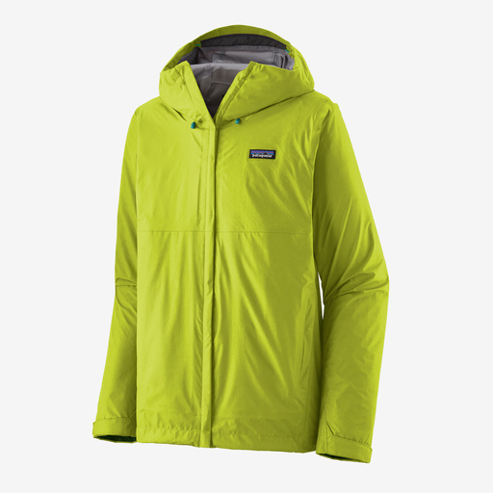

Active Smart Textiles
Active smart textiles are the next category after passive smart textiles, as they enhance their functionality by integrating electronic components that enable them to react to changes in their surroundings or stimuli (Kettley, 2021). The fabric under active smart textiles frequently incorporates sensors or even conductive threads that respond to a sensed environment (Kettley, 2021). Additionally, active textiles need a power source to function and actively engage with their surroundings (Kettley, 2021). One example of this can be found within the fashion brand Ministry of Supply. They offer a sweater adjustment feature that mentions how they can refit your sweater to your liking using only heat from a machine using a heat gun (Schwab, 2018). This is considered an active smart textile due to how the textile displays dynamic changes in its properties, such as size adjustments, in response to an external stimulus that as heat from the heat gun. Active textiles possess components that enable them to experience alterations in reaction to particular stimuli, such as heat, making them more responsive when compared to passive textiles.

Figure 2 - Ministry of Supply displaying the resizing of a sweater through the use of a machine using a heat gun.

Very Smart Textiles
Lastly, beyond active smart textiles, we have the most advanced category of textile technology known as very smart textiles (Kettley, 2021). These textiles are self-adapting, capable of detecting and reacting to stimuli, adjusting to changes, and learning from their environment (Kettley, 2021). Additionally, they can handle intricate data and communicate with other smart devices. One example of a very smart textile would be from the brand Levi's®. They are offering a trucker jacket with a built-in Jacquard sensor from Google that is applied to the left sleeve (Levi, 2020). This sensor can be connected to your phone by downloading the Jacquard mobile app and assigning gestures to various actions (Levi, 2020). These actions can perform multiple interesting features, such as playing music, managing phone calls and text messages, taking pictures, helping with directions, and even updating you on real-time updates going on (Levi, 2020). These textiles combine research, electronics, and software technology, providing an inside look into the future of fashionable technology.

Figure 3 - Levi’s Trucker Jacket With Jacquard™ by Google.

Overall, the transition from passive to highly smart textiles highlights a phenomenal process of development. Passive textiles improve fundamental functionality, active textiles add engagement, and very smart textiles provide intelligence and flexibility, creating new opportunities for the textile business and its potential uses. I found them to be highly intriguing, demonstrating the seamless integration of textiles and technology. Beginning with the passive smart textile exemplified by the Men's Torrent shell 3L Rain Jacket from Patagonia, I would consider purchasing it for its effective rainproof capabilities. Since I enjoy outdoor activities even in wet weather, it appears to be perfectly suited for that purpose. Moving on to active smart textiles, the Ministry of Supply resizing services did not capture my interest because I always ensure my clothing fits perfectly, eliminating the need for resizing. Lastly, the Levi’s Trucker Jacket With Jacquard by Google represents a fascinating example of very smart textiles. I was captivated by its functionality, particularly its ability to allow interaction with my phone through gestures on the jacket's wrist. As someone who uses their phone frequently throughout the day, this feature is particularly appealing. Overall, the intersection of technology and textiles is a rapidly evolving field with immense potential, poised to revolutionize various aspects of our lives.

References
Borrelli-Persson, L. (2016, May 2). The chalayan experience: 3 models on wearing the designer’s high-tech dresses. Vogue. https://www.vogue.com/article/met-gala-chalayan-erika-wall-morgane-dubled
Kettley, S. (2021). Passive, reactive, and interactive textiles. In Designing with smart textiles (pp. 13–15). essay, Bloomsbury Fashion Central Fairchild Books.
Levi’s® Trucker Jacket with jacquardTM by Google. Off the Cuff. (2020, September 30). https://www.levi.com/US/en_US/blog/article/levis-trucker-jacket-with-jacquard-by-google
Patagonia men’s torrentshell 3l rain jacket. Patagonia. (n.d.). https://www.patagonia.com/product/mens-torrentshell-3l-rain-jacket/196924038639.html
Schwab, K. (2018, December 18). Ministry of Supply will tailor this sweater to your body while you wait. FastCompany. https://www.fastcompany.com/90281007/ministry-of-supply-will-tailor-this-sweater-to-your-body-in-minutes

