New York City College of Technology DEN 2300-D222

Professor: Dr. Archer Date: 12/1/2016

Name: Ayman Mousa Case Study: Caries

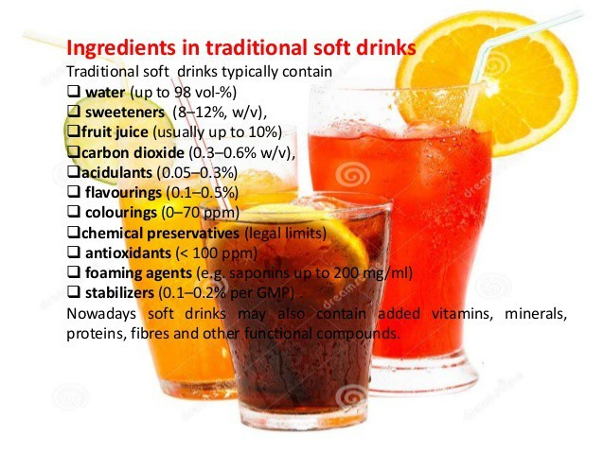
A.M. 22 year old, white male, non-smoker, no medications. Upon completion of the caries risk assessment, this patient scored 42. He never brushed or flossed his teeth his entire life and fortunately two weeks ago he started brushing using the Oral-B power brush. He used to drink a minimum of 12-15 cans of soda (Pepsi) per day, if not more “patient stated.” He has been drinking this amount of soda every single day since he was 10 year old and until the age of 21. In other words, this patient has been exposed to sugar for about 11 years without any brushing, rinsing, or flossing. The first thing I noticed about the patient is that his skin looked very pale and he stated that he barely drinks water and prefers juice or soda instead.

Tooth # 19 was extracted due to caries and # 5 and 30 are missing the crowns due to caries as well. He also presented a combination of erosion and caries on teeth # 6-11. His hard palate appeared very shallow and you can see the patient’s tonsils without even having him say “ahh”. The gingiva appeared very ulcerated, rolled, non-resilient, non-stippled, rolled, spongy, severely inflamed, with severe bleeding upon probing and exploring. When I started scaling with hand instruments, I noticed the bleeding was more than just inflammation and after asking the patient if he ever had/has any systemic conditions. The patient mentioned that when he is exposed to the sun (usually during summer), he starts bleeding a lot through his nose. Furthermore, he went to have a surgery done in his nose in order to help to minimize or stop the bleeding through the nose, his doctor was unable to perform the operation because of the excessive bleeding. Thereafter, every time he bleeds, he would take an injection to help stop the bleeding and he is currently not taking any medication. I was also treating his sister who happened to be caries active (she was given a referral because she had a molar needed to be extracted) and she had the same bleeding issue during scaling which made me think that both of these patients might be hemophilic. Unfortunately, their mom too always has toothache. When I asked about the diet, he said that the whole used to eat a huge amount of desserts and stopped because the three family members are in pain. This particular patient eats about 3 jars of Nutella a week plus other juices and sweets. Here is a little sample from his daily routine:

Item pH Item pH

Orange (bottle/day) 3.30-4.19 Bananas 4.50-5.20

Grapes 2.90-3.82 Watermelon 5.18-5.60

Lime 2.00-2.80 Honey 3.9

Apple 3.9 Tomatoes 4.30-4.90

if he ever had/has any systemic conditions. The patient mentioned that when he is exposed to the sun (usually during summer), he starts bleeding a lot through his nose. Furthermore, he went to have a surgery done in his nose in order to help to minimize or stop the bleeding through the nose, his doctor was unable to perform the operation because of the excessive bleeding. Thereafter, every time he bleeds, he would take an injection to help stop the bleeding and he is currently not taking any medication. I was also treating his sister who happened to be caries active (she was given a referral because she had a molar needed to be extracted) and she had the same bleeding issue during scaling which made me think that both of these patients might be hemophilic. Unfortunately, their mom too always has toothache. When I asked about the diet, he said that the whole used to eat a huge amount of desserts and stopped because the three family members are in pain. This particular patient eats about 3 jars of Nutella a week plus other juices and sweets. Here is a little sample from his daily routine:

Item pH Item pH

Orange (bottle/day) 3.30-4.19 Bananas 4.50-5.20

Grapes 2.90-3.82 Watermelon 5.18-5.60

Lime 2.00-2.80 Honey 3.9

Apple 3.9 Tomatoes 4.30-4.90

he ever had/has any systemic conditions. The patient mentioned that when he is exposed to the sun (usually during summer), he starts bleeding a lot through his nose. Furthermore, he went to have a surgery done in his nose in order to help to minimize or stop the bleeding through the nose, his doctor was unable to perform the operation because of the excessive bleeding. Thereafter, every time he bleeds, he would take an injection to help stop the bleeding and he is currently not taking any medication. I was also treating his sister who happened to be caries active (she was given a referral because she had a molar needed to be extracted) and she had the same bleeding issue during scaling which made me think that both of these patients might be hemophilic. Unfortunately, their mom too always has toothache. When I asked about the diet, he said that the whole used to eat a huge amount of desserts and stopped because the three family members are in pain. This particular patient eats about 3 jars of Nutella a week plus other juices and sweets. Here is a little sample from his daily routine:

Item pH Item pH

Orange (bottle/day) 3.30-4.19 Bananas 4.50-5.20

Grapes 2.90-3.82 Watermelon 5.18-5.60

Lime 2.00-2.80 Honey 3.9

Apple 3.9 Tomatoes 4.30-4.90

