New York City College of Technology DEN 2300-D222
Professor: Dr. Archer Date: 10/25/16
Name: Ayman Mousa Assignment: Erosion

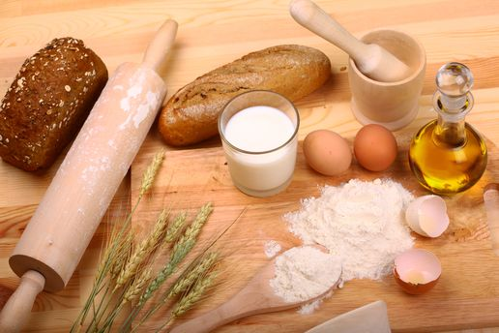

T. B is a 53 years old, white male, ASA 1. No medications or any other medical alerts. This patient started smoking when he was 16 until the age of 24. He used to smoke 3 packets a day (60 cigarettes / day) and 20 cups of tea daily. He had severe shortness of breath difficulty breathing due to blockage of the flow of the air. He never brushed or flossed his teeth until the age of 40 and also had # 1, 2,7,15,16,17,28, and 32 extracted due to active caries lesions. The patient mentioned that inhaling flour during work was causing blackness or darkness of his teeth. His daily diet includes all of the following:
Item pH Item pH
Orange 3.30-4.19 Bananas 4.50-5.20
Apple 3.9 Tomatoes 4.30-4.90
Grapes 2.90-3.82 Watermelon 5.18-5.60
Lime 2.00-2.80 Honey 3.9
Sugar (Min 6 cups of tea/day) 5.0-6.0 Butter 6.1-6.4

He has been working in a bakery since he was 11 years old where he makes bread by mixing yeast with white flour and the process of fermentation starts .The bread swells up and becomes spongy due to the pressure exerted by accumulated carbon dioxide. “Breakdown of starch and sugar by yeast into carbon dioxide and ethyl alcohol in the absence of oxygen is called alcoholic fermentation. The alcohol is the major ingredient in brewing industry.”
Ingredients:
- Flour: is the bulking ingredient of bread, and it contains gluten which helps to form elastic stretchy dough.
- Salt: flavoring agent.
- Eggs
- Water: is used to bind the flour together.
- Fats or oils: prevent the bread from going stale quickly.
- Yeast: is the raising agent and different strains of yeast give the bread its flavor and quality.
- Sugar is needed to provide the food for the yeast to help it grow.

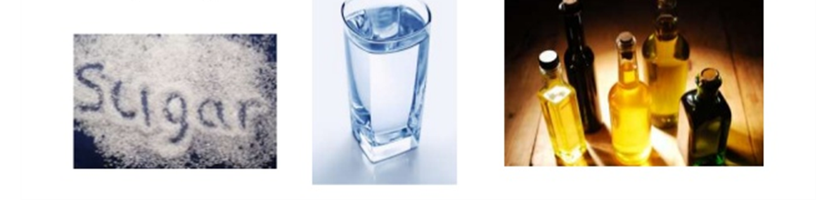
Fermentation & Production of Alcohol:
The primary function of yeast is to produce carbon dioxide gas, which expands the dough during proof and the early stages of baking. Yeast prefers slightly acid conditions to work best. A pH ranging from 4,5 to 6,0 gives the best results. Bread doughs are generally in the region of pH 5,5 so in normal bread making the effect of the pH is not a particular consideration. However' some ingredients used in the bakery, such as mould inhibitors in some bread improvers, lower the pH of the dough and do have a retarding effect on yeast fermentation. This effect is usually taken into account when deciding on the yeast level to use in a given recipe. There are other ingredients which can retard yeast activity i.e. spices or raisins.
- Ethyl alcohol is manufactured by the fermentation of potatoes, cereals, molasses etc.
- C6H1206 + Yeast zymase > 2C2H5OH + 2C02
- (Glucose) Fermentation (ethyl alcohol) + (carbon dioxide)

Microbial spoilage
Molds are the primary spoilage organisms in baked goods, with Aspergillus, Penicillium, and Eurotium being the most commonly isolated genera.

