Name: Ayman Mousa
Course: DEN 2315 Pharmacology
Date: Fall, 2016
Dong Quai
(Angelica)
Dong quai is an herb belongs to Apiaceae family which includes; parsley, carrots, and celery. It’s also called Female ginseng, Angelica sinensis, Danguia, Angelica China, tang-kuei, and Chinese angelica. Dong quai root has been used as a spice, tonic, and medicine and as a source of vitamin A, B12, E, and C; therefore, it’s used to treat many health problems. On the other hand, it has not been approved by the FDA as a medicine that could be used instead of a prescribed medication. Angelica sinensis has been used to treat menstrual disorders, premenstrual syndrome (PMS), endometriosis, and premature ejaculation. Dong quai is called “female ginseng” because of its great benefits for both men and women as it aids in the treatment of infertility. It also acts as a gynecological regulator by balancing of estrogen levels. Dong quai root can be used to treat many other conditions such as: dysmenorrhea, spasms, psoriasis, anemia, high blood pressure, hot flashes, mild sedative, tinnitus, joint pain, migraine headaches, chest pain, cardiovascular diseases and maybe cancer. Also one of the components of Dong quai is Ferulic acid which plays an important role in the treatment of osteoarthritis.
Dong quai is available in many forms such as liquid or tincture, tablet, softgel, dried herb/tea, capsule, and injection (in China and Japan). In addition, the label indicates that Dong quai is an herb that regulates and balances hormones both in men (prostate health) women and can be used as antifungal and antioxidant as well. It’s considered one of the most popular plants in China, Japan, and Korea and can also be found in Asia and it usually grows in high and cold areas of these countries. In terms of clinical trials, there is a lack of definitive data on Dong quai efficacy for menopausal symptoms. In vitro some studies showed that this product has anti-tumor, anti-tuberculosis and neuroprotective effects. It also has many adverse effects includes dry mouth, photosensitivity, diarrhea, skin rashes, loss of appetite, gynecomastia, and it can increase the risk of bleeding. It shouldn’t be taking during pregnancy or breast feeding, and should also be avoided with patients with hormone sensitive cancers as it acts as a phytoestrogen. One of the prescribed medications that treat similar conditions is Fluoxetine which is an SSRI that is used to treat PMDD which is a severe form of premenstrual syndrome that causes mood shifts. What makes Dong quai attractive to consumer is its tremendous benefits listed above and consumers might compare it to a prescribed medicine because Dong quai has been used for thousands of years and it can be easily found in stores such as Walgreen.
As healthcare providers we should have basic understanding of natural products and use regulated websites or peer-reviewed articles to get evidence based information for us and our patients. When reviewing the medial history of a patient who uses this product we should be mindful not to recommend any medication that might interfere with this product. Also, when writing the treatment plan the hygienist should be aware that it increases the risk of bleeding or blood clotting disorder such as hemophilia and it should be discontinued prior undergoing surgical procedures.

References:
- Lee WH, Jin JS, Tsai WC, et al. Biological inhibitory effects of the Chinese herb danggui on brain astrocytoma. Pathobiology. 2006;73:141-8.
- Huang SH, Lin CM, Chiang BH. Protective effects of Angelica sinensis extract on amyloid beta-peptide-induced neurotoxicity. Phytomedicine. 2008;15:710-21
- Drug Information Handbook for Dentistry by Harold L Crossley, Richard L. Wynn, and Timothy F Meiller.
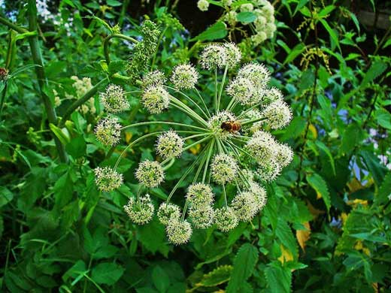
https://www.google.com/search?q=dong+quai&source=lnms&tbm=isch&sa=X&ved=0ahUKEwjF4qvBurbQAhUM5CYKHfvwCE4Q_AUICSgC&biw=1680&bih=979#imgrc=0D5bzIqGHVMdJM%3A
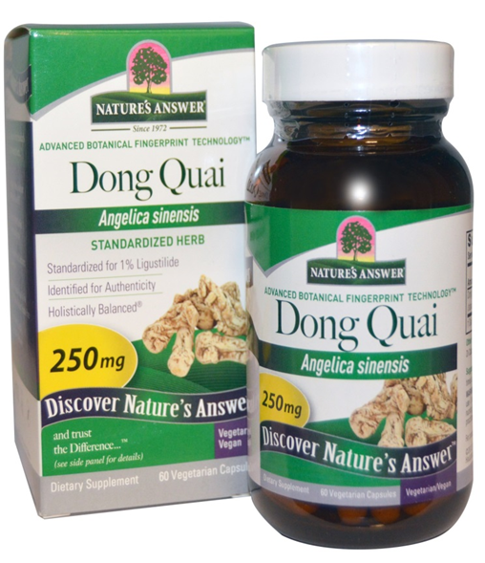
https://www.google.com/search?q=dong+quai&source=lnms&tbm=isch&sa=X&ved=0ahUKEwjF4qvBurbQAhUM5CYKHfvwCE4Q_AUICSgC&biw=1680&bih=979#imgrc=hk5bncnjoIu1uM%3A

