**Project 1**

**Team 1:**  Mamadou Bah, Arie Meiman, Daniel Edwards

1. A 690λ- long lossless Z0=75Ω T-line is terminated in in a load ZL=15+j67 Ω. Calculate and use the Smith Chart to find:

ZL (normalized)= ZL / Z0  = 15+j67 Ω / 75Ω = 0.2+j0.9 Ω

Length=690 λ/0.5(full rotations) = 1380 full rotations,** the length is equal to zero**

1. ΓL=(ZL – Z0)/( ZL+ Z0)=( 15+j67 Ω - 75Ω)/( 15+j67 Ω + 75Ω)= (-60+j67)/(90+j67)

= 89.94 /_ 132° / 112.2/_ 36.6° = **0.804 /_ 95.4°**

b) VSWR=[1+Γ]/[1-Γ]=[1-0.804]/[1+0.804]=**9.2**

c) Zin  = Z0*[ ZL+ j*Z0 *tan(β*l*)]/ [ Z0+ j*ZL *tan(β*l*)]= ZL  ***Since length is equal to zero(*l*=0 λ)

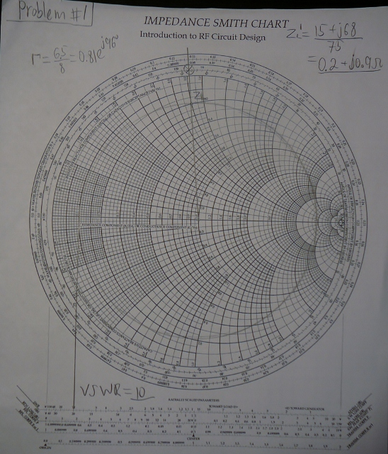

1. The input impedance for a 100Ω lossless T-line of length 1.162λ is measured as 12+j42 Ω. Determine the load impedance.
2. We normalize the load impedance: Zin’= 0.12+j0.42 Ω
3. We moved along the perimeter counter-clockwise going towards the load for a total length of 0.162λ.
4. We found ZL on the Γ circle, ZL=1.5-j0.7 Ω
5. Then we multiply the normalized ZL by the Z0 , ZL=ZL* Z0 =150-j70 Ω

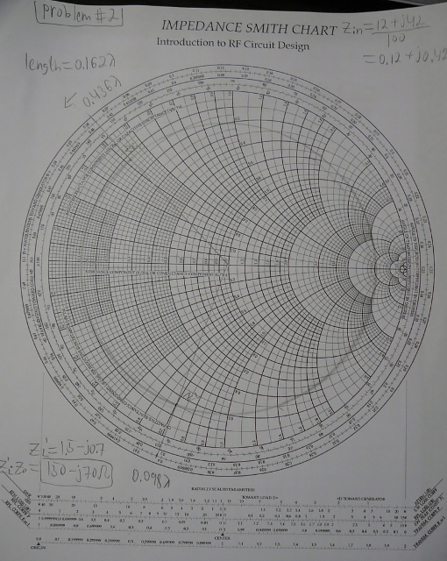

1. Design an open ended shunt-stub matching network to match a load ZL =70+j110 Ω to a 50 Ω impedance T-line. Chose the solution that minimizes the length of the through line.
2. We normalize the load impedance: ZL’= 1.4+j2.2 Ω
3. we found the normalized admittance by passing through the center of the circle and the intersection of the line and  is 
4. we moved along the perimeter clockwise going to the generator until we intersect with the 1+j*b (b=1.9)
5. we found 0–j*b and draw a line that passes to center of the circle;
6. the intersection of the line and the outer circle of the smith chart gives us length and distance;
7. the length is found by subtracting from this distance 0.25 λ, l=0.327 λ -0.25 λ=0.077 λ
8. the distance that we need to travel is d=0.185 λ+0.05 λ=0.19 λ

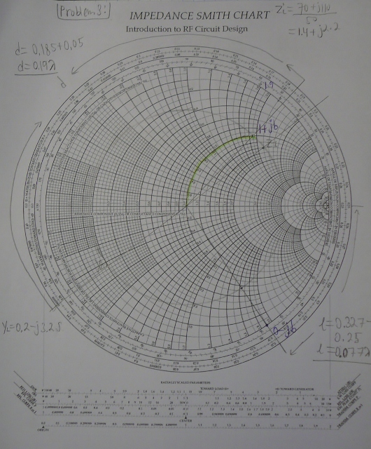

1. A load impedance ZL=25+j90 Ω is to be matched to a 50 Ω line using a shorted shunt stub tuner. Find the solution that minimizes the length of the shorted stub
2. We normalize the load impedance: ZL’= 0.5+j1.8 Ω
3. we found the normalized admittance by passing through the center of the circle and the intersection of the line and  is 
4. we moved along the perimeter clockwise going to the generator until we intersect with the 1+j*b (b=2.6)
5. we found 0–j*b and draw a line that passes to center of the circle;
6. the intersection of the line and the outer circle of the smith chart gives us length and distance;
7. the length is found by subtracting from this distance 0.25 λ, l=0.308 λ -0.25 λ=0.058 λ
8. the distance that we need to travel is d=0.198 λ+0.078 λ=0.276 λ

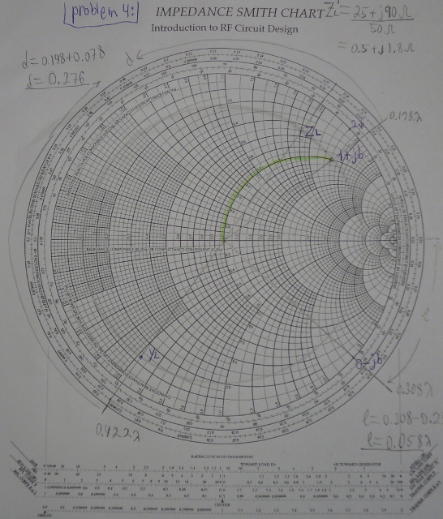

1. A 50 Ω line is terminated in a pair of parallel load impedances of 50+j100 Ω and 50 –j100 Ω. Determine the total load admittance and impedance seen by the line.
2. To find total load impedance we calculate ZL(T)=(50+j100)*(50-j100)/(50+j100+50-j100)=250 Ω
3. Admittance is simply the inverse of impedance, YL=1/ZL=1/250=0.004S
4. To find normalized load we simply divide by 50 , ZL(T)/50=5 Ω
5. Consider the figure with the following values VS=10V, RS=30Ω, R0=50Ω, up=0.666c, RL=150Ω, and l=10cm. Plot out to 2ns
6. the voltage at the source end, Vs=10V
7. the voltage at the middle,
8. 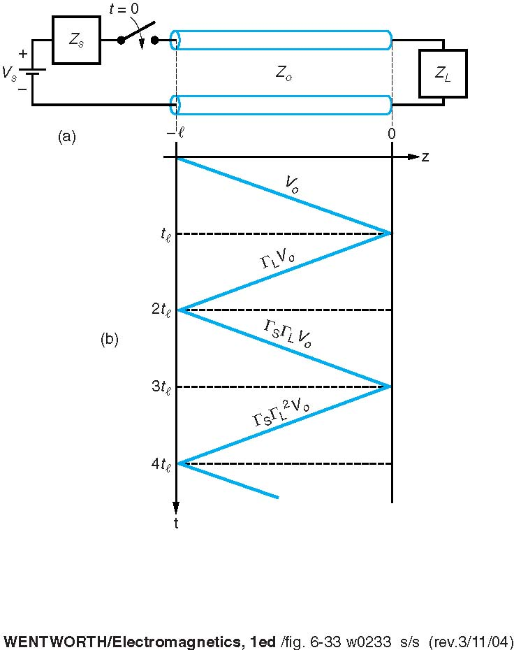the voltage at the load end of the T-line.