City TECH
Adrian McCurchin
9/1/18
Origin of Marvel Logo

As a kid, I always had a passion for drawing. But also as a little boy, I grew up watching superheroes which was the jump-start to my path in pursuing my career as a graphic designer as well as a concept artist. From watching Power Rangers, Superman, Batman and many more. I had multiple favorite heroes but, a certain company made me and a large demographic of people like me who had a same interest has been keeping our “eyes on them” for a very, very, very long time. This company that I’m speaking of is Marvel. Never in my lifetime would of imagine especially the world couldn’t wrap their head around the idea that a company who is known for selling comic books would be such an iconic brand globally. Who would of thought that people who doesn’t know about anything about superheroes would become fans. Who would of thought that every news coming from Marvel was as big of a deal like checking our phones every second. And most of all, who would of thought that superheroes could change the game of Hollywood movies. I mean actors and actresses are willing to be part of the Marvel family or the legacy of Marvel. Even though Marvel is popular now, where did it all started?
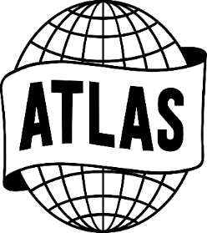
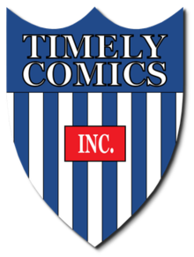
Before I start to tell you about the origin or the beginning of Marvel, I would like to introduce you but also honor the creators of these superheroes. The guys who made characters such as Iron Man, Captain America and Spider-Man. As well as opening the doors to many indiviuals who is into art. Finally, the most important thing that these guys did before their final days on Earth is bringing creativity to life as well bringing the Marvel brand name into the light. These guys were Stan Lee aka “Excelsior” who lived from (1922-2018) and Jack Kirby who lived from (1917-1994). Stan Lee, the man you see in every Marvel movie is a comic book writer, editor and publisher. Jack Kirby was a comic book artist, writer and editor. They both grew up in Manhattan, New York in the 1900s where the Progressive Era was going to an end, The Great Depression, WWI and WW2. These guys lived it all as well as seen “the way of life”. These guys both had the same dream which was to use their talent and make a name for themselves in order to recreate history on a impactful level in the era of struggle and war but for the next century and beyond which as a result is successfully achieving.
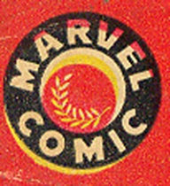
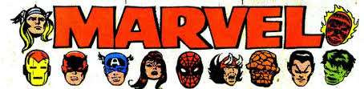
Started back in 1939. It was first called Timely Comics which was owned by American publisher Martin Goodman. Within the eleven-year run, Timely Comics were known as the Golden Age of Comic Books. The reason behind it is based on the success the company had with selling comic books, like “The Human Torch #2”, “Captain America Comics #1”, and “Red Raven Comics #1”. This era also fell in a time where World War 2 happened from 1939 through 1945. Also, it was the era where the creation film-noir films occurred from the early 1940s through the late 1950s. Film noir is a style of filmmaking from the early 1940s through the late 1950s that is mostly black and white and mostly about American crime drama. Anyways, the logo that represented Timely Comics was a shield with blue and white stripes with a small red rectangle saying “INC”. When 1951 arrived, superhero comic books were going out of style because of television shows and other media were being very popular to the public now. Martin Goodman decided to redesign the brand. He started by changing the name to Atlas and replacing the shield for a globe logo indicating a fresh start of comics. Goodman removed superhero comics and created different genres of comic books such as horror, humor, drama, crime, and war. Atlas lasted from 1951 to 1957. Around this time, the name Atlas was changed to Marvel Comics which Goodman kept the name. With this new name, American comic book writers Stan Lee and Jack Kirby had revolutionized superhero comic books. From the design of heroes like the X-Men, Fantastic Four and The Avengers to the story arc of each character that made comic books readers fall in love with them. With Marvel Comics, it had variety of changes within the logo. The first logo was a black circle with a red background. It also had Marvel Comics written in white and a gold wheat leaf inside the smaller red circle. The second logo was MARVEL written with a neat comic book font with character heads like Thor, Iron Man, Captain America, Black Widow and The Thing surrounding the word. In the 1990s, Marvel new logo design was somewhat like the 90s MTV logo. The letter “M” in red with the upper part of the letter forming the word Marvel. It also had the word “comics” written in very funky, edgy font in yellow.
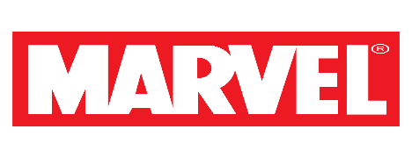
And now, it is the simple Marvel text written in white with a red background. This new simplistic Marvel logo in my opinion has made a very big impact to the brand and to the world in a positive way. What I mean by that is how Marvel decided to step there game up by creating the Marvel Cinematic Universe back in 2008. An idea created by President of Marvel Studios Kevin Feige to make a shared universe just like Stan Lee and Jack Kirby had done with their comic books in the 1960s. As a result, it has been the key to its success globally.

Sources: http://ceoworld.biz/2018/03/28/the-most-interesting-changes-in-the-marvel-logo-design-history/
https://logorealm.com/marvel-logo/
https://heroichollywood.com/marvel-logo-iconic/
https://www.britannica.com/topic/Marvel-Comics
thetechnews.com/2018/03/14/know-marvel-logo-design-history/
https://1000logos.net/marvel-logo/

