Student: Alpha Haque Course: Genetics Lab 2450 E158
Lab Report 1: Cytogenetics and Karyotyping

Abstract
Karyotypes, photographs of stained chromosomes, allow for easy visualization of chromosomal pairing and detection of chromosomal anomalies like missing portions, extra portions or irregular portions. By looking at the structural and numerical changes in chromosomes within a larger karyotype, it could be concluded that the individual being assessed has a 5p deletion (missing portion of the p or small arm of chromosome 5), which is indicative of a cri-du-chat syndrome diagnosis. The disorder is characterized by a cat-like cry in infancy, low birth weight, poor muscle tone and possible intellectual deficits. Early medical and educational interventions allow children to lead healthier and more meaningful lives.

Introduction:
Human cells, which are diploid (with the exception of sex cells which are haploid), contain 46 chromosomes or 23 pairs of chromosomes. Both maternal and paternal contributions in the form of one chromosome per pair, given by each parent to the offspring are responsible for the 23 various pairs. Random shuffling of different parts of chromosomes before they are sorted into egg and sperm cells as well as random mixing of egg and sperm during fertilization further enhance variability in the genetic makeup of offspring and allow for multiple DNA combinations, even within the same family. Karyotypes, photographs of stained chromosomes, allow for easy visualization of chromosomal pairing and detection of chromosomal anomalies like missing portions, extra portions or irregular portions. This is important to the field of Cytogenetics in diagnosing heritable diseases and diseases occurring randomly during the formation of egg and sperm cells.

Methods:
Students in pairs were asked to look at a case study within a Chromoscan Board and to create a cytogenetic report based on the karyotype they were able to put together. On the left side of the Chromoscan Board students were presented with background on why the individual was referred for karyotyping (ie. medical symptoms) and on the right side presented with only twenty-three chromosomes and asked to find the matching chromosome to complete the homologous chromosomal pair. Chromosomes were matched according to size and banding pattern. In order to do so the centromere, telomere, p arm (small arm), q arm (long arm) had to be identified. After all chromosomes are matched, deviations from standard chromosomal pairing could be observed and analyzed.
After all chromosomes were matched by size and banding pattern to form homologous chromosomes, an aberration on chromosome 5 was apparent. The small arm (the p arm) of chromosome 5 was missing in comparison to its counterpart. The individual was determined to be female by the presence of two X chromosomes. (**Depiction to the left is similar to actual karyotype observed in Chromoscan Board)

Results:
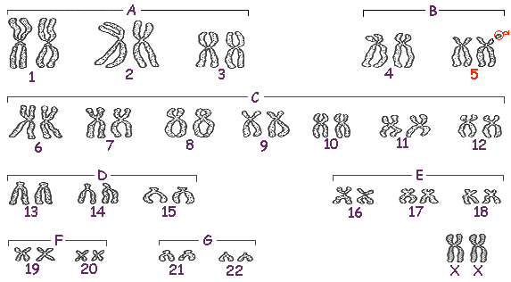

Discussion:
By looking at the structural and numerical changes in chromosomes within a larger karyotype it could be concluded that the individual being assessed has a 5p deletion, which is indicative of a cri-du-chat syndrome diagnosis. The main presenting symptom that brought the patient in was an unusual cat-like cry. According to Niebuhr’s (1978) study, the cry is probably due to anatomical differences of the larynx and epiglottis (small or abnormally developed). Also of the 331 cases studied more females than males presented with the disorder.

Reference List:
Niebuhr E. (1978). The Cri du Chat syndrome: epidemiology, cytogenetics, and clinical features. Human Genetics; 44(3), 227–275.

