LiveWell Assignment: PAPER
Length: 2 pages, double spaced
Due date: May 14th, 2015
Submission Details: via SafeAssign on Blackboard
Over the course of the semester you have interacted with the LiveWell intervention software in attempts to adopt or maintain healthful behaviors. You were encouraged to make behavioral changes as well as informed of which stage of change you were currently in for each behavior (Exercise, Stress Management, and Health Eating)
Your reflection paper will be comprised of three parts:
- Describe what each behavior is, specifically, how much you value each behavior and its importance in your life AND tell me what stage of change the program stated you were in for each behavior.
- Using the chart below, detail how one or more concepts played a role in advancing you into your current stage of change for EACH behavior.
For example, if you were in contemplation for stress management, describe how concepts such as consciousness raising, environmental reevaluation, dramatic relief, or social liberation took place and transitioned you from the previous stage of precontemplation. If you are in precontemplation for any of the behaviors, then describe how these concepts might work to get you on to the next stage of change in the future.
Then move on to the next behavior, until you have described the process of change between stages for ALL THREE behaviors.

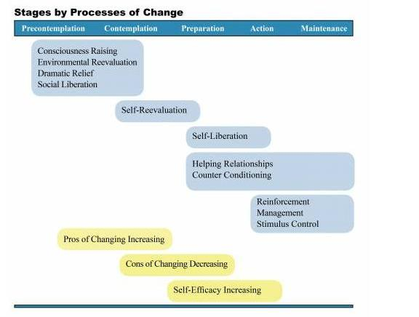
- Lastly, I want you to reflect by providing the pros and cons for ONE particular behavior that you think is most important, and detail the balance of pros and cons as it relates to your current stage. Conclude by describing the amount of self-efficacy you have for that particular behavior and whether or not you think you maintain that behavior in the future.

