Instructions for Finding Psychology Article for Individual Project PSY1101

- Go to college home page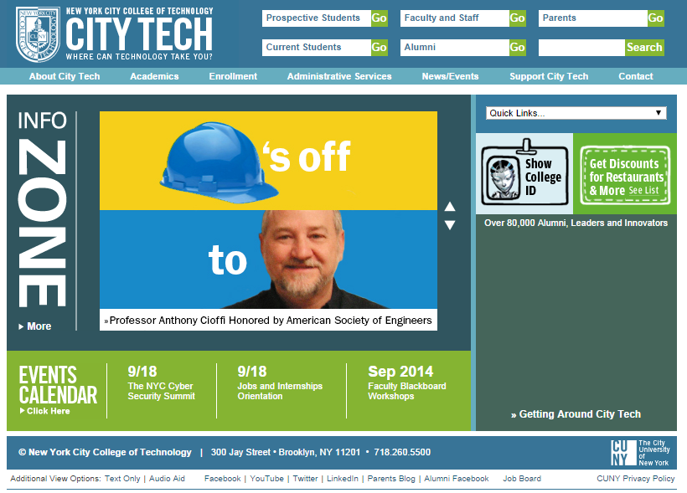
- Click on Current Students
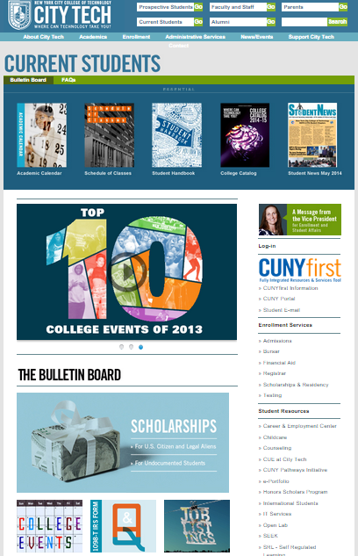

- Scroll down the page looking for “Library” on the right hand side.
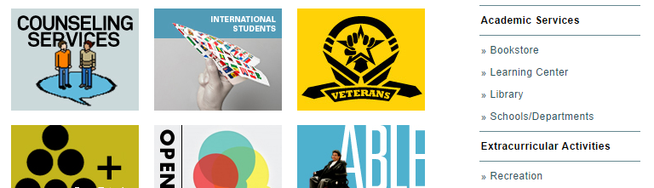

- Click on library, bringing you to the College Library Page.
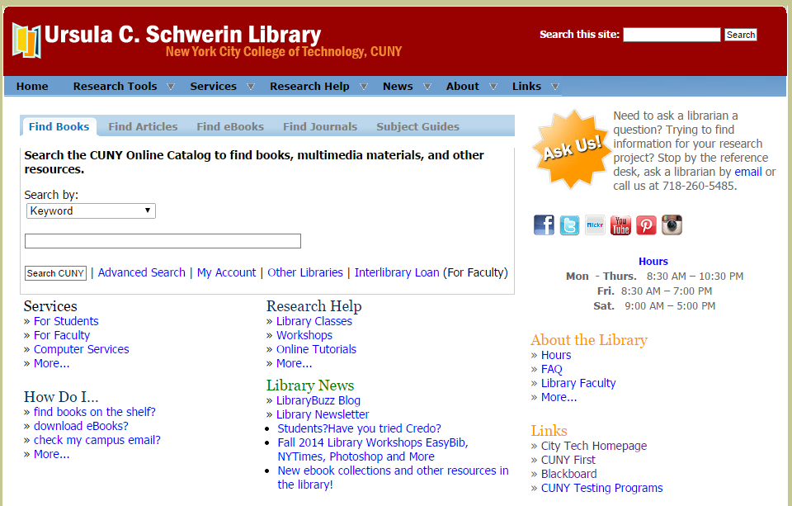

- Click on the “Find Articles” tab; then use the drop down menu below “Databases of Getting Started” and select “More Databases…”
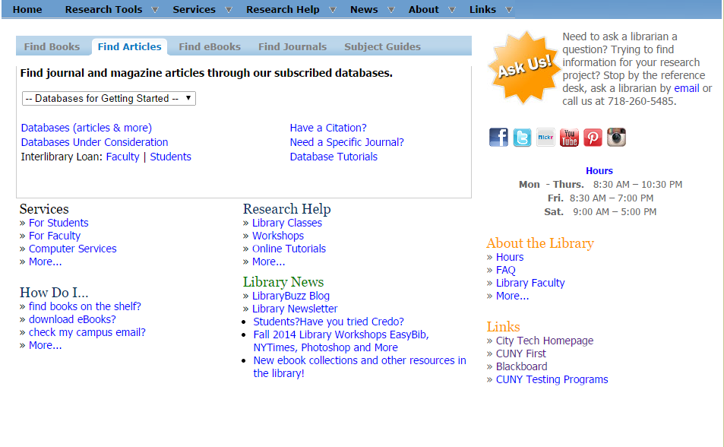
- On this page, click the letter “P” to find the database PsychInfo:
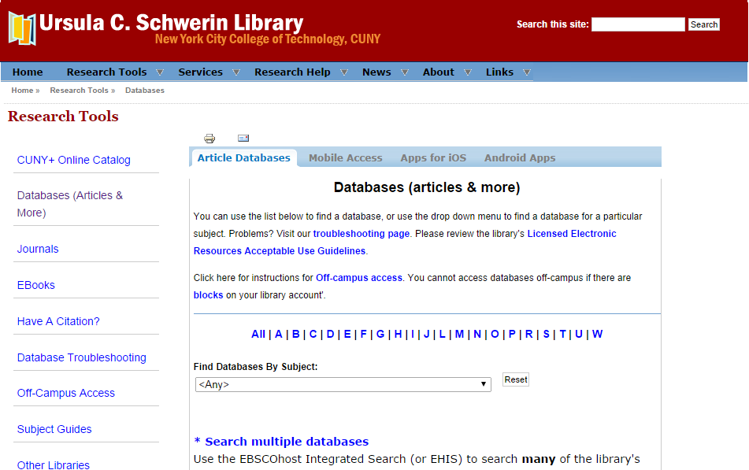

- Select the database named “PsychINFO (EBSCO)”

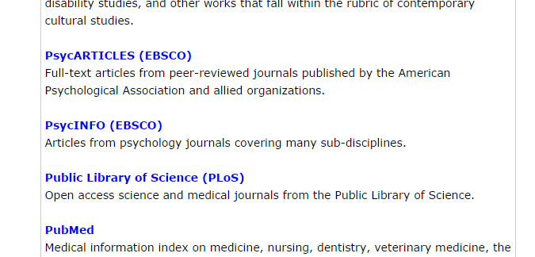

- If you are accessing the internet off-campus, you will be instructed to enter your LIBRARY BARCODE. This is located on the bottom of your CityTech ID. You must have the barcode activated at the Library’s Circulation Desk in order for it to work.
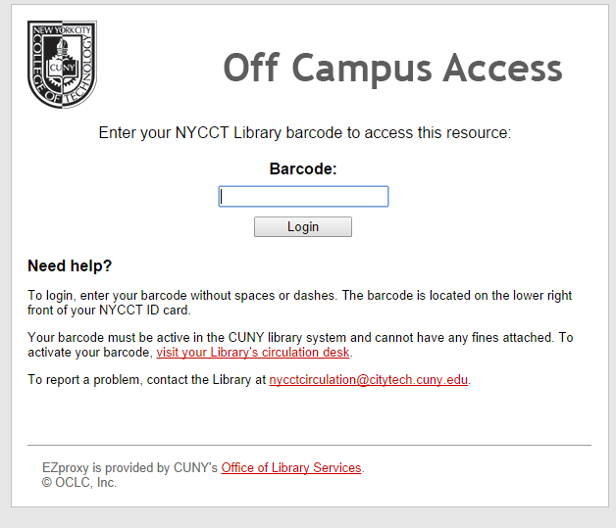
- ENTER SEARCH CRITERIA AS DESCRIBED IN CLASS
Notes:__________________________________________________________________________________________________________________________________________________________________________________________________________________

