Learning Places Fall 2018
SITE REPORT #3A
Honor Students

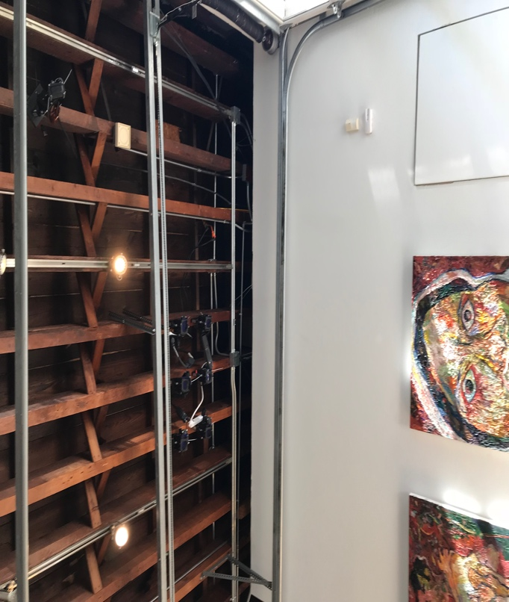

Modern Hipster Theatre – The image is of an open ceiling, with railing units along the wall and topped off with modern art. The space looks purposely unfinished.

STUDENT NAME: Danielle Ali

SITE OBSERVATIONS
Insert 3 photographs and provide a title for each image. The title should be a word or short phrase that sums up the subject matter of the photo or a visual theme present in the photo.
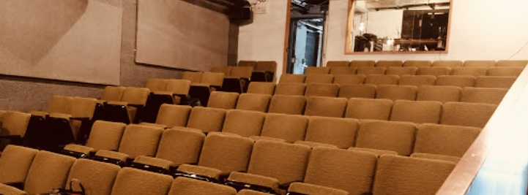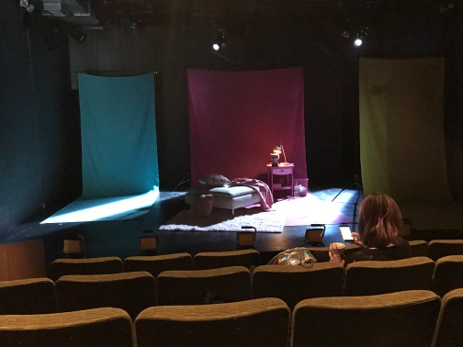
All the Seats are the Worst Seats in The House Three Settings on One Stage
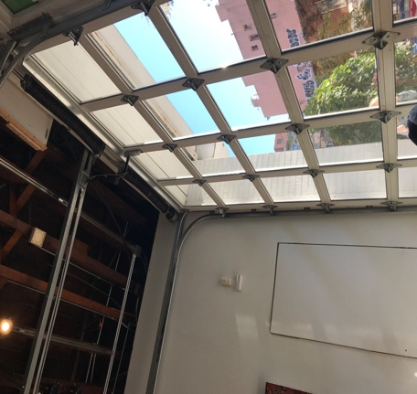
Theatre Inside a Store Front
Why did you choose these images? Do they summarize a feeling you have for the performance space? Do they focus on prominent objects or features? Explain.
I chose these images because it depicts the discomfort I faced in the performance space. Overall the performance space was incredibly cramped and made it difficult to sit through the show. Not only was the space making me uncomfortable but so did the production with some unusual scenes. These pictures also show how a small space can be transformed into something different and unique. This space has a purpose of housing unique productions matching the layout of the theatre. Although it was an uncomfortable experience, I can see that it was designed with a sense of closeness and intimacy for anyone who inhabits the space. The images focus on prominent features such as the compact layout, improvisation of the space, and modern designs.

PERMANENT THEATER
Answer the questions below only if you attended a performance in a purpose-built theater or an adapted space that is now a permanent theater.

- Briefly describe the genre or type of performance (one sentence).

I conducted research on the different types of theatre performance and the genre that best fits this production in my opinion is, fringe theatre.

- Describe the dimensions, shapes, and arrangement of audience and performance spaces in the building: entrances, ingresses, egresses, lobbies, lounges, audience seating, box seats, and stage.

The entrance into The Wild project building was similar to a store front coffee shop with a rolling gate. Inside I was greeted by a staff member checking people in for the show at a plastic picnic table. It was a very relaxed “lobby/waiting area”, warm and inviting. The space had a very hipster atmosphere. There was a barista serving coffee and beverages. One thing that stood out to me about this space was the bathroom layout. The bathroom had a sliding door with a hook, as well as an arm chair, there were many magazines and art pieces as well as a jar of packaged condoms, which was not something I have ever seen in a public bathroom inside of a theatre. Which may be The Wild Project showing it support and openness to safe sexual practices, also a reason why they hosted the Honor Students production because of its themes regarding sex. When the box room finally opened, I saw that the actual theatre was small. The stage was a rectangular platform, extremely close to the audience. There were several rows of seats but very limited space. The box seats were very close to one another, making it uncomfortable. I felt that the theatre was so small and everyone is able to watch the performance and the each and every audience member’s reactions at the same time. There was an exit sign pointing at the back of the theatre but to get to the door seemed nearly impossible. The only other door into the theatre fir the audience to use was the entrance to the box room. Which was extremely inconvenient for anyone who may have had to leave the seats, because of the small space and that you would have to pass directly in front of the stage and actors if you wanted to exit. The ceiling was open and all the wires, and equipment were exposed. The stage was quite small but you were able to understand the different settings in the story.

- Does the architectural design provide opportunities for voyeurism, food or alcohol consumption, reading, talking, or other interaction among audience members? Explain how the architecture might encourage or limit activities other than viewing the performance.

The architectural design did provide opportunities for voyeurism, food/alcohol consumption, reading, talking and other interactions amongst audience members. The staff did not seem to have any restrictions of the things mentioned in the previous sentence. There were no signs restricting anything. Also, the space was very open and inviting to audience. The architecture encouraged this because there weren’t any divisions or partitions in the floor layout limiting any activity. The open bar area had stools for people to sit before/after a show to talk and relax. Inside the performance space the seats were so close together it would be hard to not talk or interact with the person next to you.

- How did the architectural design and fixtures affect your reception of the play (sight lines, acoustics, lighting, etc.)?

The sound quality was great, since the space was small every little noise was able to be heard. The lighting was perfect, since the contrast between the seats were dark and the stage was bright you were able to watch the show with ease. The architectural design of the stage was modest, but the box seats and being so close to the stage was uncomfortable. The design and fixtures of the space made be less receptive to the play.

- Describe the dynamic between the audience space and the performer’s space. Was the stage a proscenium, thrust, or theater-in-the-round arrangement? Did the performance and audiences spaces ever merge (audience in stage area, actors in audience area, for instance)?

Although the space between the audience and performers was very small, it was still clear where one another belonged. It seemed as if the performers were not making eye contact with the audience member but just looking at one another and not the audience. The audience were clearly watching the performers but not once did they look directly at an audience member (which must be difficult to do). The stage was a proscenium arrangement. The performance and the audience never merged.

- Use a metaphor to describe the audience/stage relationship (ocean, layer-cake, peephole, for instance...and don’t use these examples!). Explain why you chose that image or idea.

The metaphor that I feel describes the audience/stage relationship is “shoebox.” I felt that actor/actresses were performing in a mini mock up shoebox and the audience were just spectators looking inside the “shoebox.”

ANALYSIS/DISCOVERIES [FOR EVERYONE]
Use this section to reflect on your observations. Remember to refer to your observations when drawing general conclusions.
Performativity: ways in which theater becomes life, words become actions, audiences become actors, objects become agents, buildings convey meaning, and participants become engaged in broader social concerns.

- Describe the moments in the production where theater became more like life or when something occurred in the performance space that exceeded the internal action of the play itself.
When the performers were transitioning into the next scene and changing the props/fixtures made the theater become more like life, because you are focused in the performance and then all of a sudden, the stage goes dark and the actors and props disappear.

- How might the designed and/or natural features of the performance space enable moments of performativity? Or, on the other hand, do the architectural and/or natural elements inhibit performativity?

Since the performance space and stage is very small and the performers spend their time on stage removing and adding in props and setting up for the next scene within seconds it can enable them during their performativity to focus on their lines and scenes. Also the proximity between the stage and audience can distract the performer if a person decides to get up during the middle of the scene to exit the performance space.

QUESTIONS for FURTHER RESEARCH. Write down questions that require further research to answer. These should follow directly from your analysis section and be complex and specific enough to serve as the basis of a research project; do not include questions you can answer with a quick google search. Focus your research questions on spatial and architectural aspects of the performance space.
- Why are there no alternative/accessible exits to the theatre, besides passing directly in front of the stage and disturbing other audience members? Was this design taken into consideration during the planning phase?
- Since the space is a permanent theatre, why isn’t there a formal admissions area/booth to check people in, collect money and give information to people.
- Why doesn’t The Wild Project present its space/building as a facility that hosts theatre productions and performances to the public and people walking passed the building. (I felt that if I walked by the building I wouldn’t have known it was a theatre without being informed that it was prior to visiting. I also would have thought I wasn’t allowed to enter because it seemed like a small office of some sort and only accessible to staff or expected guest.)

SITE REPORT #3B

STUDENT NAME: Danielle Ali

FURTHER RESEARCH
Develop a new research question (or revise one of your questions from part 3A of this report). This question should concern EITHER:
The relationship between the performance you viewed and the staging (if in a traditional theater space) or the place where it was performed (if in a provisional theater space).
OR
The relationship between a social / political issue and the performance you viewed.
Research Question: How does theme of sexualization of young women relate to the production and plot of Honor Students?

Find 2 sources. *You can choose to use: internet sources, books, archival documents or ephemera, scholarly articles, newspaper articles, or performance reviews. Your choice should be intentional.
1 source should have to do with the production or performance (this could either be about the play itself or about something to do with the performance). For example, if I viewed a production of Hamlet that was interactive, I might research “Hamlet” or conduct research more broadly on “interactivity and Shakespeare.”
1 source should be about the place or social / political issue that is articulated in your research question.
Write an MLA citation for each source:
Source 1: Meehan, Meagan. “Honors Students: Interview with Playwright Mariah MacCarthy.” Blasting News, Blasting News, 25 Oct. 2018, us.blastingnews.com/showbiz-tv/2018/10/honors-students-interview-with-playwright-mariah-maccarthy-002755625.html.

Source 2: MacCarthy, Mariah. “A Rehearsal Room of One's Own.” A Rehearsal Room of One's Own, Gender, Theater and Sexytimes, 2012, nicefeminist.blogspot.com/.

Source 3: “World Premiere of HONORS STUDENTS.” Charlotte's Off-Broadway. - a Fractured Atlas Sponsored Project, www.fracturedatlas.org/site/FiscalSponsorship/profile?id=17701.

Why did you select these sources? How do they address all or part of your research question?
I selected these sources because it was from the screen writer of this production, who has first-hand knowledge of the theme of the performance. It addresses all of my research question because it speaks about one of the many themes of the production as well as its importance and why the writer felt it was relevant.

Describe the process you used to find this source including any keywords and the search engine or tool you used to search.
I used Google as my search engine and plugged in key words such as “Mariah MacCarthy Honor Students” and “Mariah MacCarthy and Sexulaization of Young Women”. I read through several websites focusing on articles and writings that spoke specifically on my topic and the way the screen writer views the social problem.

What other sources or further information would you need to answer your question? Where would you look for that information?
I can conduct more research on sexualization of young women and theatre production as one phrase. I can use articles from different critics, and theatre production research journals to find out more information. I can use the library’s website or google.

