Learning Places Fall 2018

SITE REPORT #3A Performance
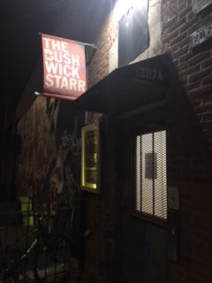
The Bushwick Starr/ Cozy
STUDENT NAME: St.Hill, Gregona
SITE OBSERVATIONS
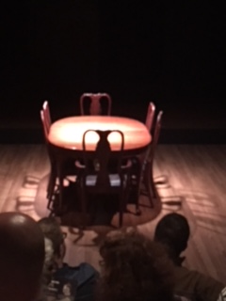
The Bushwick Starr is a performance space located in Bushwick, Brooklyn, New York at 207 Starr Street. It is a regular Brownstone building that surprisingly includes a small theater. The appearance of the building is one of a regular home on the outside. It seems like the last place or location that would hold a performance space. On arrival at the location, I felt like I had misread the address. However, I proceeded to the front door which was opened and showed my receipt to a young man that was standing in the tiny foyer. He politely informed me that I should just proceed upstairs and someone would assist me. I’m proceeding cautiously at this time as I’m not sure what to expect.

Welcome to dinner!
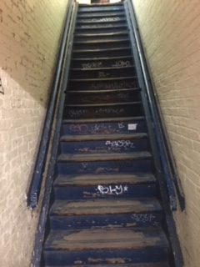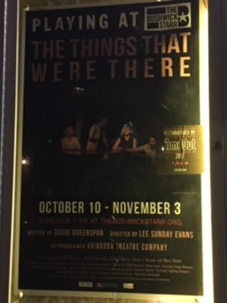
Proceed to what awaits………………………… Now showing
Why did you choose these images? Do they summarize a feeling you have for the performance space? Do they focus on prominent objects or features? Explain.
I choose those images to show how I felt. They describe my hesitance at seeing the site and also there wasn’t much to photograph. I wasn’t sure whether it was okay to photograph the actors. The photos show the night’s performance, the steps to the space and the set where the performance takes place.

PERMANENT THEATER
Answer the questions below only​ ​ if you attended a performance in a purpose-built theater or an adapted space that is now a permanent theater.

- Briefly describe the genre or type of performance (one sentence).

“The Things that were There” is a play by David Greenspan, directed by Lee Sunday Evans and co-produced with Abingdon Theater Company. It is based on memory and meditation loss.

- Describe the dimensions, shapes, and arrangement of audience and performance spaces in the building: entrances, ingresses, egresses, lobbies, lounges, audience seating, box seats, and stage.

There isn’t much of a lobby to the theater. The entrance is through a regular brownstone door on the street level that leads to a flight of stairs and down a narrow passage way. There is no lounge area and audience seating is on an elevated level directly in front of the stage. The space is small and intimate.

- Does the architectural design provide opportunities for voyeurism, food or alcohol consumption, reading, talking, or other interaction among audience members? Explain how the architecture might encourage​ ​ or limit​ ​ activities other than viewing the performance.

There is a small makeshift bar with little standing space directly in front of it for drinking or one has to seat in the audience to have their drink. The architectural space does provide an opportunity for reading, talking and limited interactions between audience members before the production starts. It limits other activities other than viewing the performance as the space is very small.

- How did the architectural design and fixtures affect your reception of the play (sight lines, acoustics, lighting, etc.)?

The design and fixtures did not affect my reception of the play. The actors moved constantly on the stage. There was a table and six chairs in the center of the stage as the setting was for a family dinner. There was a pretend corner that served as the kitchen. The doorbell rang constantly. The lightening was focused on the audience at first and the stage during the performance. All lights were turned completely off after the performance until after the actors left the stage.

- Describe the dynamic between the audience space and the performer’s space. Was the stage a proscenium, thrust, or theater-in-the-round arrangement? Did the performance and audiences spaces ever merge (audience in stage area, actors in audience area, for instance)?

The dynamic between the audience and the performer’s space was one of rapture and concentration as one tried to follow the performance. There was complete silence with a few chuckles here and there at one point.
The stage was a proscenium arrangement. The performance space never merged.

- Use a metaphor to describe the audience/stage relationship (ocean, layer-cake, peephole, for instance...and don’t use these examples​ ​!). Explain why you chose that image or idea.

The metaphor I would use to describe the performance is a circus. The play was a circus for me because I was confused during most of the performance. The fact that the actors were sometimes talking about their past and jumped into their present and midsentence they were back in the past made it hard to follow. It would have served its purpose had I focused on the fact that it was based on memory and over many years. At the end I chocked it up to dementia on the part of many of the actors especially the lead.

PROVISIONAL THEATRE
Answer these questions only if you attended a site specific performance, a space temporarily adapted for this particular performance, or an outdoor performance in a place that was not designed for theatrical performance at all.

- Briefly describe the genre or type of performance (one sentence).

- Why do you think the artists chose this particular space to present their play/dance/show? How do themes, choreographies, texts, or images in the play relate to the surrounding environment?

- Describe the seating arrangement. How was the audience space demarcated from the performance space? Did these two spaces ever converge?

- How did the natural or designed environment affect your reception of the play (sight lines, acoustics, lighting, temperature, etc.).

- What kinds of social interaction among audience members or between performers and audience members did the space allow or encourage? Were there opportunities for voyeurism, food or alcohol consumption, relaxation and repose, talking, movement, or participation in the performance? Explain.

- Use a metaphor to describe the environment (ocean, layer-cake, peephole, for instance...and don’t use these examples!​ ​). Explain why you chose that image or idea.

ANALYSIS/DISCOVERIES [FOR EVERYONE]
Use this section to reflect on your observations. Remember to refer to your observations when drawing general conclusions.

Performativity: ways in which theater becomes life, words become actions, audiences become actors, objects become agents, buildings convey meaning, and participants become engaged in broader social concerns.

- Describe the moments in the production where theater​ ​ became more like life​ ​ or when something occurred in the performance space that exceeded the internal action of the play itself.
There were several moments in the production where theater became more like life. An example was when one of the performers tried to recall the past and for a few seconds he seemed to have forgotten what he was about to say. I did not equate it to a part of the fact that he may have forgotten his lines but it reminded me of how common it happened in everyday life. It was uncanny how sometimes one could have walked into a room to get something and forget completely what it was they went to get. Some may label it old age but I see it happening with my teenage daughter. Sometimes I ask what are you looking for and she thinks for a second before she answers and grab what she came in for.

- How might the designed and/or natural features of the performance space enable moments of performativity? Or, on the other hand, do the architectural and/or natural elements inhibit performativity?

In my opinion, the architectural elements inhibited performativity at the play. There was not enough space for certain aspects of the show. More than one person used what was supposedly the “kitchen” during their performance as other places in the drama. It is my belief that the space was too small.

QUESTIONS for FURTHER RESEARCH. Write down questions that require further research to answer. These should follow directly from your analysis section and be complex and specific​ enough to serve as the basis of a research project; do not include questions you can answer with a quick google search.

  - Question? Why was the play going back and forth between past and present so often?
  - Question? What was the exact intention of the producers?
  - Question? Why was this location chosen for the play?

SITE REPORT #3B
STUDENT NAME: St Hill, Gregona
FURTHER RESEARCH
Develop a new research question (or revise one of your questions from part 3A of this report).
This question should concern EITHER: The relationship between the performance you viewed and the staging (if in a traditional theater space) or the place where it was performed (if in a provisional theater space). OR The relationship between a social / political issue and the performance you viewed.
Research Question: why is present day politics in America so closely imitating art or theatrical performance?

Find 2 sources.​ *You can choose to use: internet sources, books, archival documents or ephemera, scholarly articles, newspaper articles, or performance reviews. Your choice should be intentional.
1 source should have to do with the production or performance​(this could either be about the play itself or about something to do with the performance). For example, if I viewed a production of Hamlet that was interactive, I might research “Hamlet” or conduct research more broadly on “interactivity and Shakespeare.”
1 source should be about the place or social / political issue that is articulated in your research ​question.
Write an MLA citation for each source:
Source 1 Lalami, Laila. “A Reality-Show Presidency.” Nation, vol.306.no3, Jan.2018, p.10. EBSCOhost, citytech.ezproxy.cuny.edu:2048/login? URL=http://search.ebscohost.com/login.aspx? direct=true&db=f6h&AN=127241161&site=ehost-live&scope=site.

Source 2 Peters, Michael A. “TRUTH AND THRUTH-TELLING IN THE AGE OF TRUMP.” Review of Contemporary Philosophy, vol. 17, 2018. P. 20+. Academic OneFile, http://link. Galegroup.com/apps/doc/A554182034/AONE?=cuny_nytc&sid= AONE&xid=f36147ec. Accessed 28 Nov.2018
Why did you select these sources? How do they address all or part of your research question?
I choose these two sources as they closely remind me of the performance I saw. The play was a performance of remembering the way things were and what it is now. As a resident of the United States of America, I recall the way things were in politics and what it is now. Although I’m not that old, I recall presidents who were respected and revered. We now have a president that is a laughing stock the world over who is more concerned about tweeting than governing. The article about truth and truth telling in the age of trump, likens the president to someone who is delusional. In the play the things that were, the main actor was at times delusional when retelling his past especially about his late wife and the elderly man who died in the car accident. For a minute I thought his wife was the driver in the fatal accident of the man. The article “a reality-show presidency” describes the Trump presidency as a reality show with his party enabling his behavior. I look on the state of affairs in this country and it does resemble a reality show and a president with memory issues.

Describe the process you used to find this source including any keywords and the search engine or tool you used to search.
Find these articles was nerve racking. It may be because I have always had issues with doing research but linking politics with performing art is hectic. I searched the online school library from home until I found two articles I thought were appropriate. It helps that the citation is readily available.

What other sources or further information would you need to answer your question? Where would you look for that information?
I would have liked to look into more articles or journals for more information. I would have liked to interview David Greenspan or his director Lee Sunday Evans about some aspects of the production also. I would love to know more about the reasons they put on this product and why they choose the location. There isn’t enough information about the play unless you read the reviews. The reviews made it easier for me to understand after the fact.

