Group 4 – (Jameel Thomas, David Valderrabano, Gregona St. Hill)
Read the Sermon on Pg 64 of the Lane text. Is Reverend Billy’s work a religious critique? Does this example change the cultural meaning of a Christian sermon? Why or Why not?
Reverend Billy’s work is not a religious critique. To an extent yes, because he is not referring back to the bible and any values of Christianity. His sermon comes off as if he has a personal agenda against Disney and large commercial corporations.
What is the Central Political or Social issue that the Church of Stop Shop Shopping hopes to reframe?
What he is trying to reframe is for people to stop shopping and saving their money and putting it towards tiding and offering in the church.
Current Example:
Source (MLA Citiations):

In this article we look at the impact that boycotting Black Friday had on the US economy in 2013. The Nation retail federation (NRF) stated that the spending both in stores and on websites fell 2.9% or 57.4 billion during the four day Black Friday sales. The article also stated reasons why sales where lower during the holiday sales. Some of the reasons are people started shopping for the Christmas holidays well before Black Friday and because of the cold weather. The Malcom x grassroots movements called for blacks to spend their money at large corporations but to spend their money at local and black owned businesses.
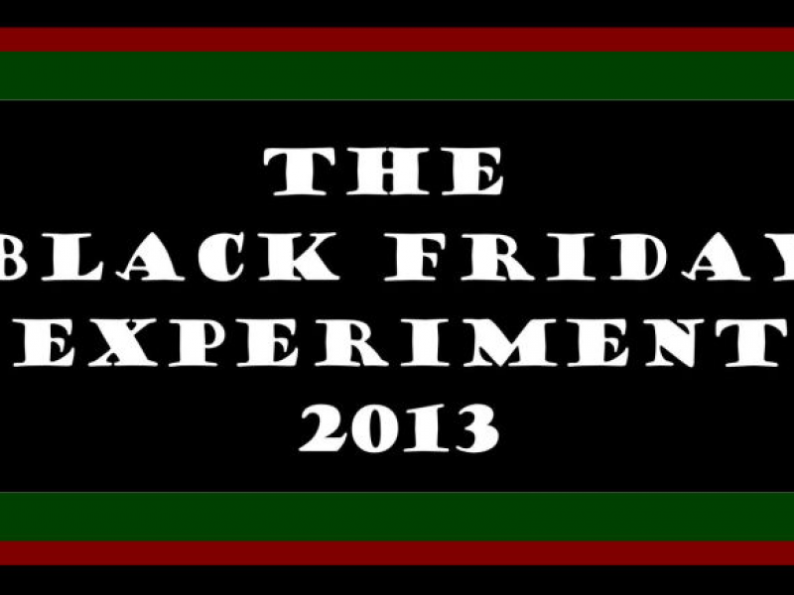

BARKER, CYRIL JOSH. “Did the Boycott Have an Effect as Shoppers Spent Less on Black Friday?” New York Amsterdam News, vol. 104, no. 49, 5 Dec. 2013, pp. 6–38. EBSCOhost, citytech.ezproxy.cuny.edu:2048/login?url=http://search.ebscohost.com/login.aspx?direct=true&db=a9h&AN=103215419&site=ehost-live&scope=site.

In this article you see the question if we should boycott Black Friday again? It has approach to boycott Black Friday because it was successful in doing so the previous year and it makes the common citizen stretch their economic muscle. The article also focus on equal human rights for everyone and mainly black people, after the killing and unfair treatment of blacks in the United States. The article also states that “African Americans make up 1.2 trillion dollars in purchase power and that it would be the 15th largest GDP in the world.”

SHEFFIELD, THOMAS. “Do We Have to Boycott Black Friday Again?” New York Amsterdam News, vol. 108, no. 47, 23 Nov. 2017, p. 12. EBSCOhost, citytech.ezproxy.cuny.edu:2048/login?url=http://search.ebscohost.com/login.aspx?direct=true&db=a9h&AN=128325829&site=ehost-live&scope=site.

In this article we look at the protest against Wallmart. As the companies employees and community leaders protest for better wages and benefits from the company. It shows that wallmart pay their workers poverty level wages even though the company is making 17 Billion in profit. Many of the protesters are protesting for a minimum salary of at least $25,000 a year and more full time employment in major cities. In St. Paul, Minnesota 26 protesters were arrested during the Black Friday events at Walmart’s. At the end of the article the National Labor Relations board said “Walmart had violated workers rights around the country and that it would prosecute the retailer for illegal firings and disciplinary actions involving more than 117 workers, including those who went on strike.”
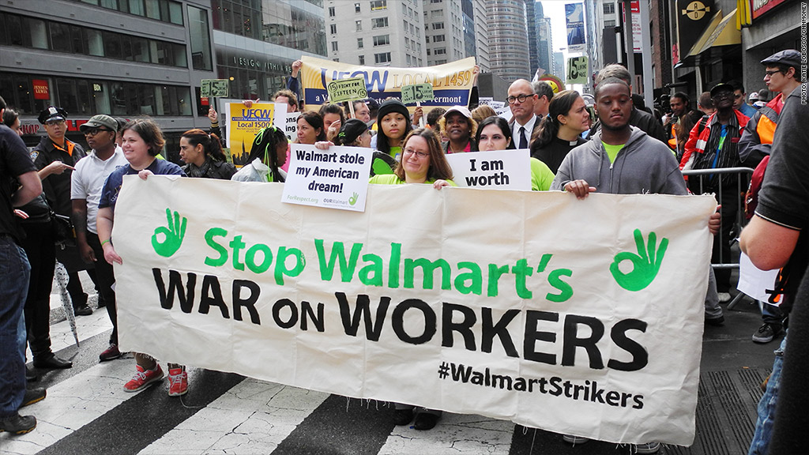

JOHNSON, STEPHON. “Walmart Protests Shine Light on Black Friday.” New York Amsterdam News, vol. 104, no. 49, 5 Dec. 2013, p. 10. EBSCOhost, citytech.ezproxy.cuny.edu:2048/login?url=http://search.ebscohost.com/login.aspx?direct=true&db=a9h&AN=103215427&site=ehost-live&scope=site.

If you were to stage a performative intervention related to this issue today in New York City where would you do it and why?
There are two places in New York City were we can do a performative intervention:
- Times Square because there you can see all the advertisement that corporations have spent millions to have their products advertise to the public.
- Wall Street because this is the financial hub for these large corporations and if you get their attentions from wall street you could make an impact and bring change.

