Learning Places Fall 2018
SITE REPORT #2A
name of site report

NAMING PROTOCOL. When saving and posting your site reports on OpenLab, please follow the following format: SiteReport#Letter.LastnameFirstname. Here’s an example: SiteReport2B.SwiftChristopher.

STUDENT NAME: Danielle Ali

Thinking Frame:
In the reading, audio, and video assignments for this week a number of spaces for voices of protest are discussed. The Guerilla Girls broadcast their messages across a wide variety of media and places: posters on walls and billboards, handouts on the sidewalk, t-shirts on bodies, projections on walls, installations in abandoned buildings and art galleries, magazines, zines, websites, etc. Next Epoch produces ecological art in neglected urban wastelands. Decolonize This Place conducts protests in museums, without prior permission for use of the spaces. As a group, these interventions could be described as unsanctioned or subversive events performed in spaces that were not designed or curated specifically for protest.
In response to these kinds of activities (and perhaps in recognition--aesthetically or culturally of their importance), there have been increased efforts by community leaders and cultural institutions to create spaces for critical or dissenting voices. Landers, et al, describes strategies to create sanctioned spaces for protest in libraries, plazas, and parks. Similarly, the Brooklyn Museum now seeks to create spaces for alternative, minority, and resistant cultures and voices through curation and architectural interventions.
The question remains whether resistant practices, alternative performances, and protest are more effective when sanctioned or unsanctioned. Where is Dread Scott’s Impossibility of Freedom in a Country Founded on Slavery and Genocide more effective, in the original 2014 performance on a street or represented in photographic form in a museum in 2018 as part of a curated exhibition?
As you go through the site report collecting images and documenting your ideas, keep these tensions in mind.

SITE OBSERVATIONS
Insert two images of Brooklyn Museum’s facades. The first of a more traditional architectural feature for a public civic space and the second an untraditional architectural feature.

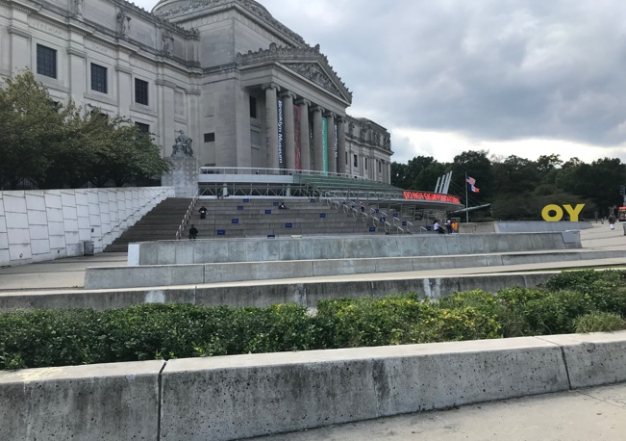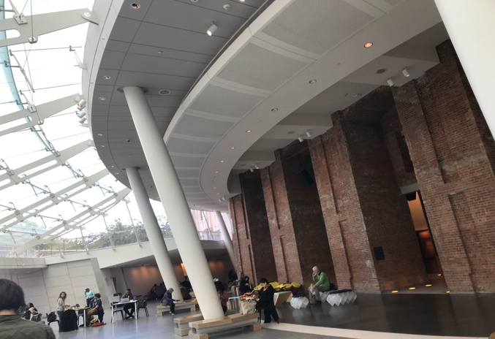
Image 1 Caption: Library of Art and Exhibitions Image 2 Caption: Modernization
Welcomed in Brooklyn Museum

Why did you choose these images? As you look at each, what do you expect to encounter once you enter the building? Explain.

Image 1 was chosen because it displays a traditional architectural feature of Roman columns and a large stair case. The traditional style of architecture of The Brooklyn Museum to me symbolizes that it is a public civic space where all can gather learn and communicate, due to its largeness and that the structure houses significant artifacts and material.

Image 2 was chosen because it has an untraditional architectural feature of exposed brick columns as well as the glass ceiling allowing plenty of natural light into the museum’s lobby.

Once I entered the buildings I expected to encounter large lines, metal detectors, an abundance of security, dim lights, no modern furniture, no public seating area or people lounging, eating, or babies being fed. I didn’t expect people to be using the museum lobby as an area to casually lounge/relax, because I have not ever seen it at any other museums I’ve visited in NYC.

The stated mission of the Brooklyn Museum is “to create inspiring encounters with art that expand the ways we see ourselves, the world and its possibilities.” Take a photo of one piece of artwork that expands the way you see yourself or the world. Give the photograph a caption and explain why it expands your vision of yourself or the world.
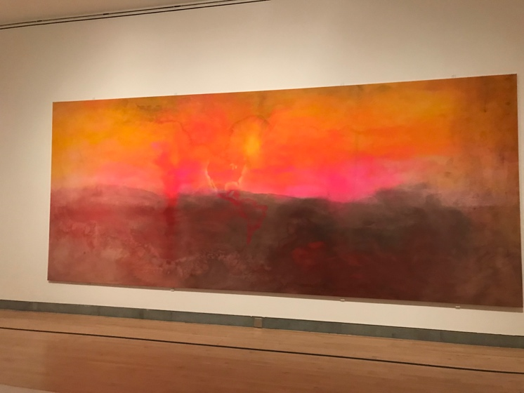
Image 3 Caption: Dying Sunset in the Americas

Image 3 expands my vision of the world because in the artwork it shows an outline of USA and South America. The artist paints the land of United States of America in vibrant, bright colors and South America in dark shades. My vison of the world in regards to this picture is that the collective opinion of many people is that the USA is always out-shinning other countries and other countries are forgotten about and abandoned. That including other races and ethnicities. Although USA is a melting pot and many people migrate here it is due to its vivacious appeal and ‘brighter’ dreams, I am sure other countries also have abundance of resources and space to fulfill dreams similarly to the ‘American Dream’.

The stated vision of the Brooklyn Museum is to create a place “where great art and courageous conversations are catalysts for a more connected, civic, and empathetic world.” Consider the curated areas of the museum. How is space arranged in order to create “courageous conversations”? Can you describe conversations between spaces?

The space is arranged in a way where each artwork/piece have common themes and stories. It does in fact create “courageous conversations” where there are bold, unexpected controversial expressions that are captured by the artists. Each piece is seeming to be arranged by similar time periods and locations. In both exhibits the artwork created messages that many people felt but never shared out loud or communicated to others. The artworks were arranged by common cultures, common messages to be directly expressed, also arranged by common audiences they may attract.

Insert an image of designed space (not art objects themselves) that suggest “connection.” How is the concept of “connection” articulated in the way art is arranged in space? (Consider the walls, walkways, display boards, pedestals, rooms, etc.)

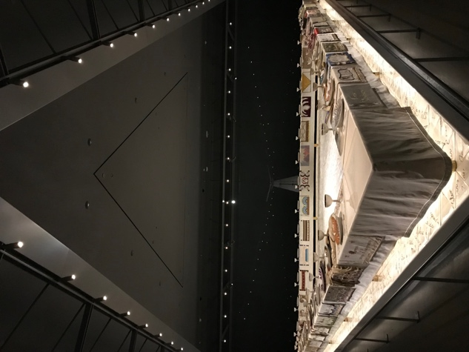

Image 4, The Dinner Party by Judy Chicago suggests the concept of connection in which the art is arranged in the space. The art pieces are in a secluded room, similar to a dining room. The room is dark but has bright spotlights shining down on the centerpiece triangular dinner table which seems to be gleaming against the porcelain plates and dinner ware (the art objects). In the walk ways the Brooklyn Museum website states that “the work is introduced by 6 hanging banners woven in the traditional French Aubusson tapestry technique. These banners and the work itself "express the belief and hope that once reverence for the feminine is reestablished on Earth, a balance will be restored to human existence and 'Everywhere will be Eden once again'." The concept of connection can be drawn from the shape of the table and triangular ceiling fixtures, the floor installation, the ceramic table legs, the draping table cloth all intertwine with each other to develop a message regarding feminism, history of women and the celebration of women as well as the richness to feminism. Each component of this art exhibit was intentionally used in the arrangement of this space because of its symbolism and how it correlates to the artist’s message.

Brooklyn Museum declares that “since we see ourselves as a conduit for open sharing and learning, we accept the controversies that may accompany courageous conversations.” Consider the way art objects are arranged in space for the Half the Picture exhibition in relation to viewers. How would you describe the arrangement of objects for viewers. Did the arrangements accept controversies? Did they encourage courageous conversations? If so, how? If not, why?

In Half the Picture Exhibition the arrangement of objects all had the common theme that addressed social and political issues. The arrangement included bold, controversial pieces and statements. The exhibit consisted of a wide range of art from a 100 years ago to present time. The exhibit featured women of different backgrounds and ethnicities. The art objects did encourage courageous conversations by conveying controversial messages that are/were a social problem. The objects were arranged in a fashion to make viewers think, react and respond to current politics and conversations about feminism. These topics can lead viewers to begin looking into these dilemmas to trying to draw conclusions to help create recognition on these social problems. By depicting the reality of these social problems and the obstacles it has created for many, also by having viewers become more aware and linking the challenges we are currently facing like the #MeToo Movement.

