Learning Places Fall 2018  
**SITE REPORT #1A**

Zuccotti Park

**STUDENT NAME**: **Gregona St Hill**

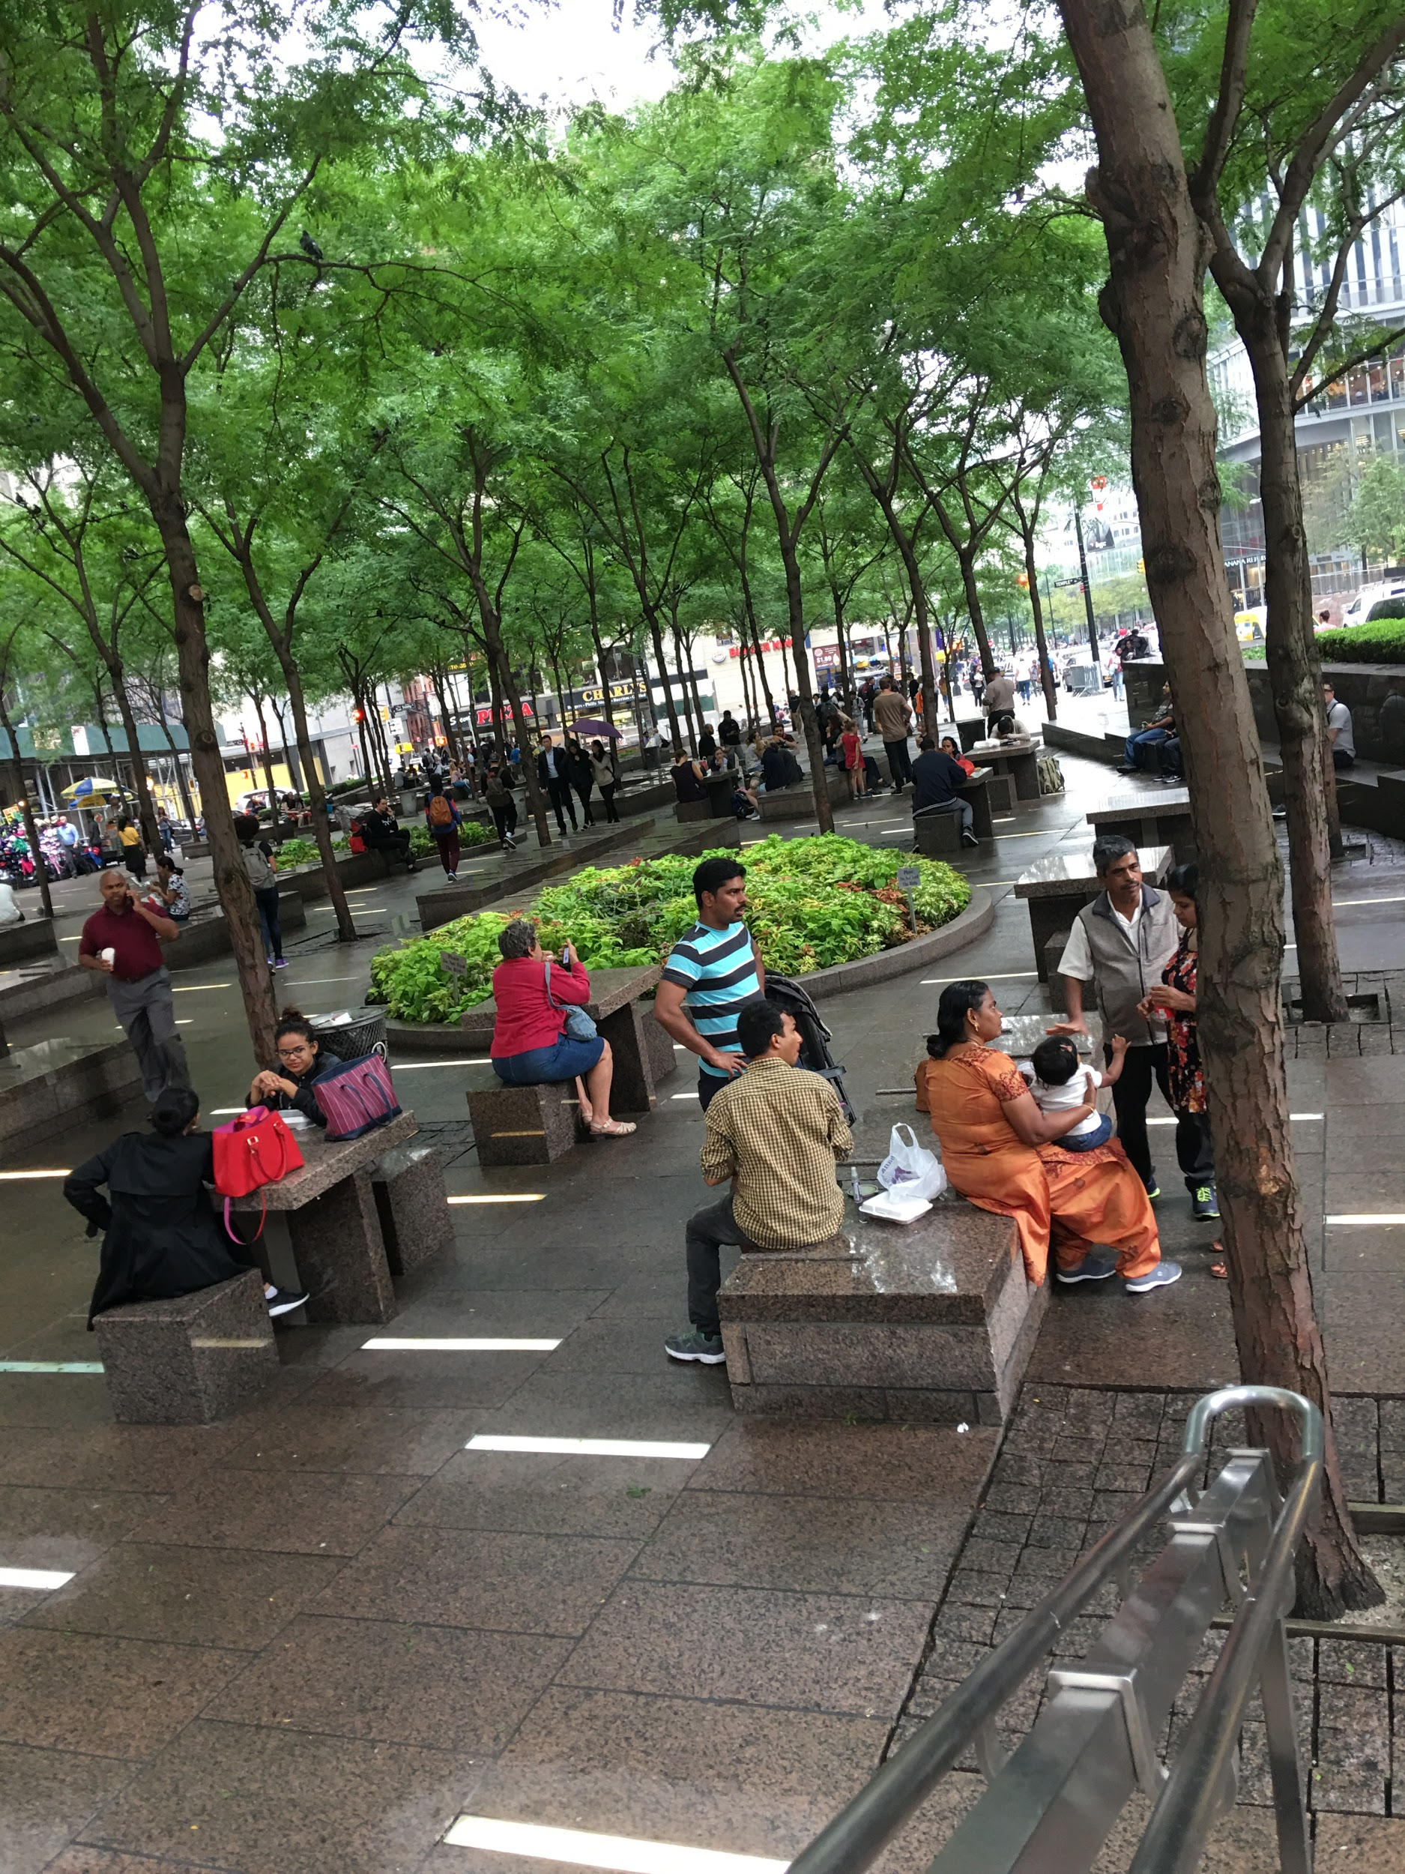 **Rainy Afternoon in Zuccotti Park**

# 

# INTRODUCTION

# My visit to Zuccotti Park was an exciting one. My expectations of the place was not met as I expected to see a bigger place or an actual park; a place with lots of grass and trees that was at least fenced in. I had never been to Zuccotti Park before but had heard about it on the news during the Occupy Wall Street period. I had never thought about visiting the location or researching it during or after the occupation. I was taken aback because I had been near the location several times but had no idea it was in the vicinity. Reading about the park and all that took place in there made me envision a place that was huge and able to support all the thousands of people that flooded the area to express their dissatisfaction during the protest. The site visit took me to a place that in my opinion could not accommodate more than a few hundred of people. I now understand the reason why there was such a huge police presence and noise complaints. In my mind’s eye I now see the chaos and congestion. One thing that stood out was how open the space was.

# SITE OBSERVATIONS.

I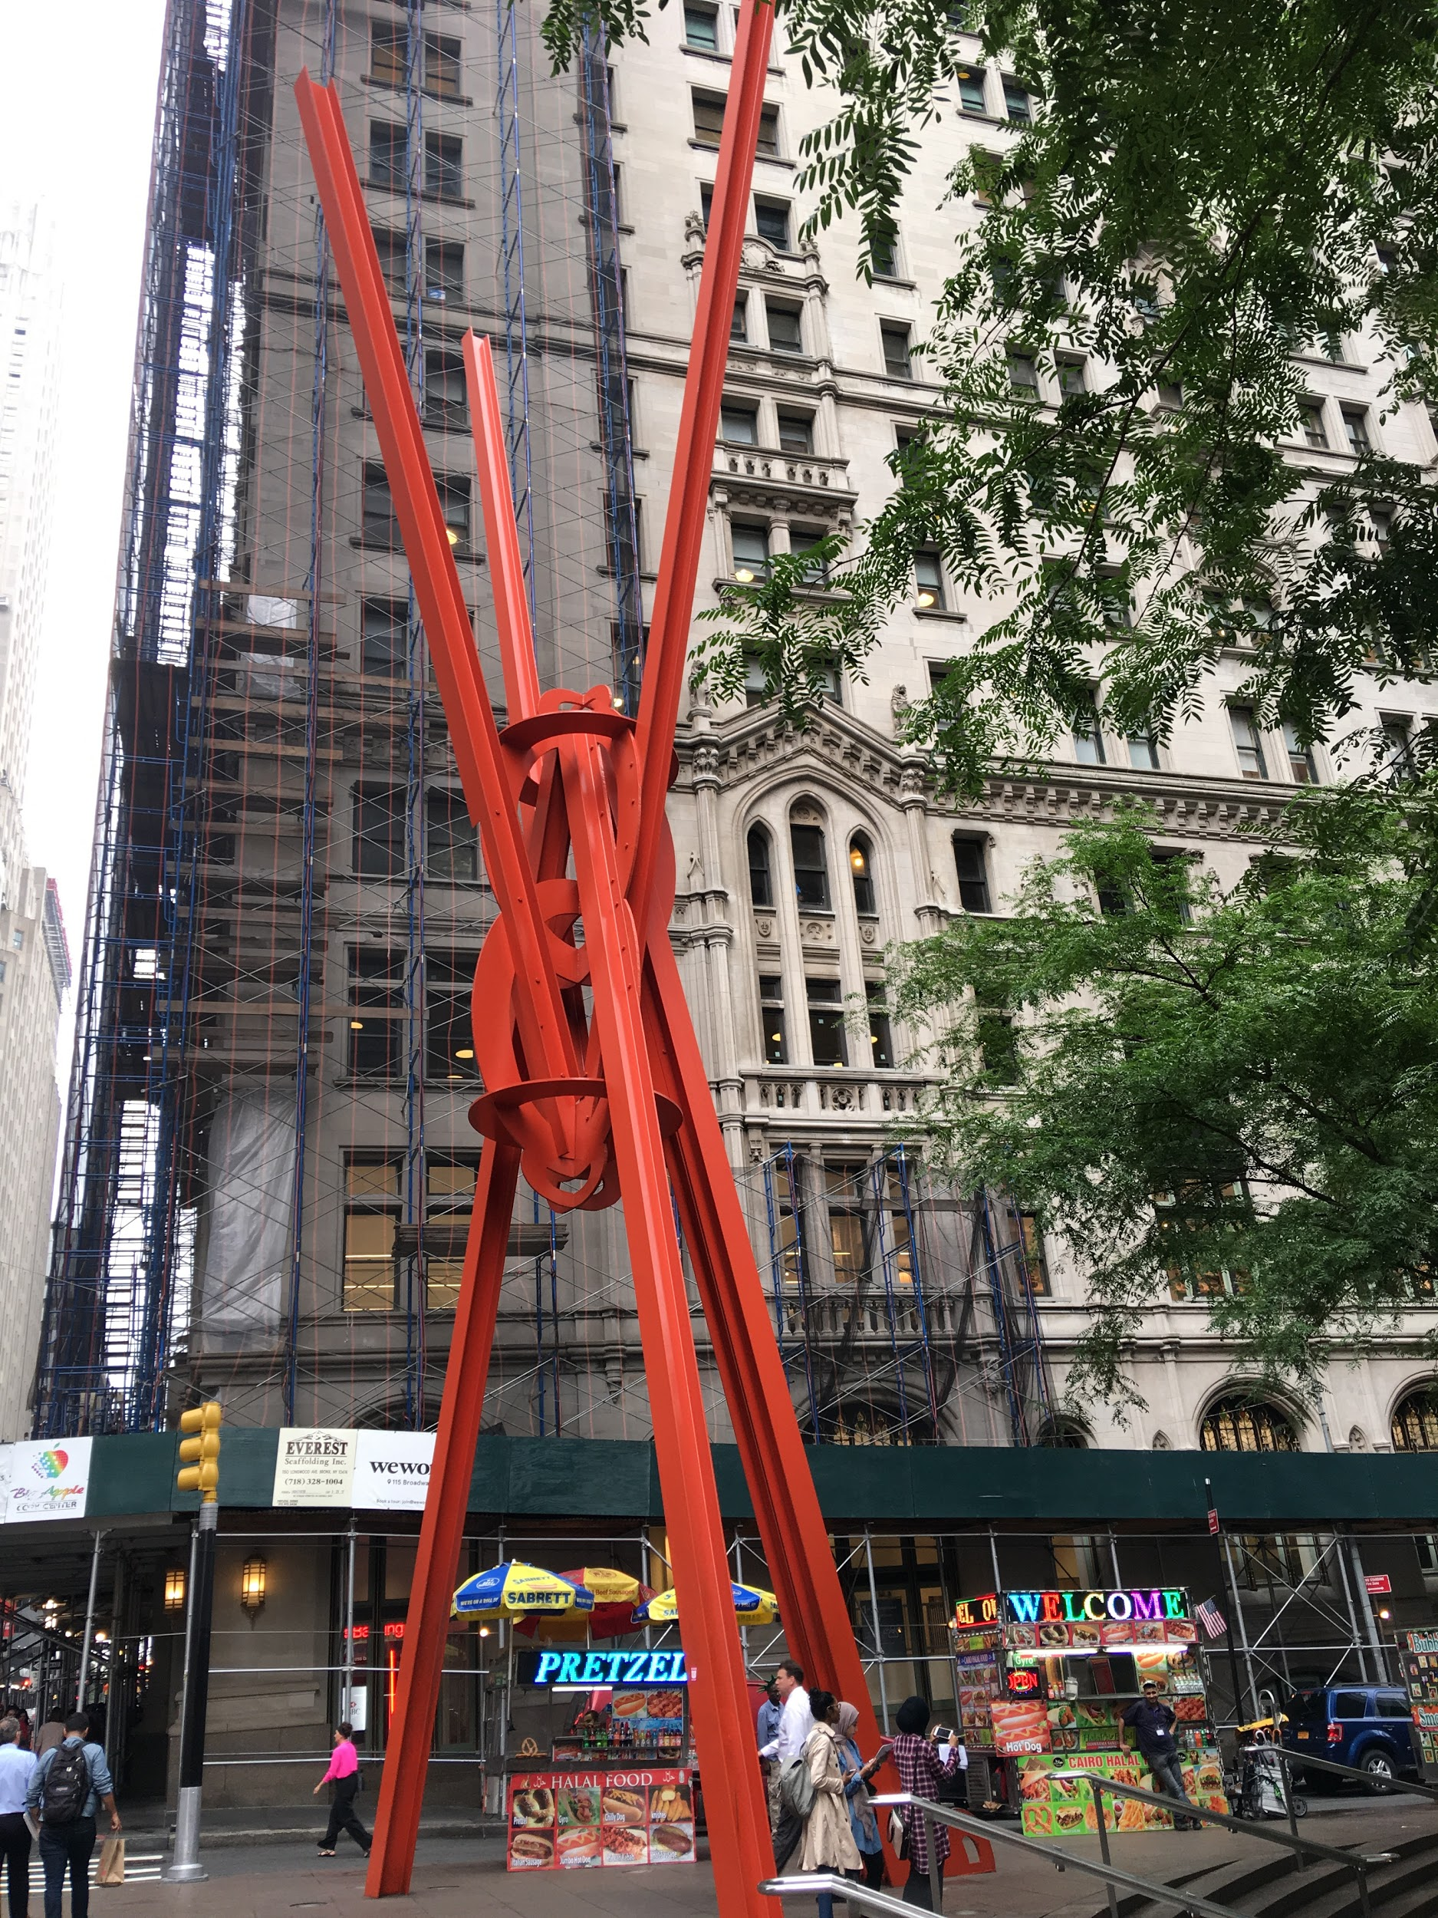 **Joy Of life**

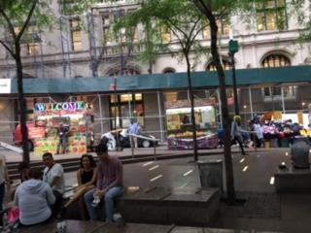

**Sharing is caring**

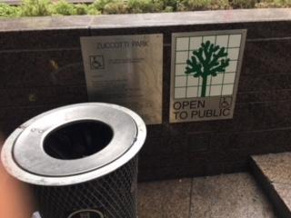

**No excuses**

I chose those images because to me they summarized the occupy Wall Street fiasco. The sculpture represents the “Joy of Life.” For me it confirms the fact that the protestors had a right to choose their parts in the occupation. They were free to choose their roles in making their voices be heard, in whatever form of contribution they chose. The second photo, “sharing is caring” fits its caption. People had to share space in a variety of ways for a cause. The third photo, “No excuses” was fitting as reports are that there was a sanitation department set up during the occupation. The fact that the garbage can was placed right under the sign shows the pride the designers took in keeping this place clean and inviting to the entire community.

Describe the sizes and shapes of buildings in this area. Is there general uniformity or heterogeneity among structures?

There isn’t uniformity or heterogeneity among structures. I believe that the many different structures and types of buildings especially makes the area unique. Walking to the park, there was no indication that there was a park coming up. In my opinion, it is more of a square or a place to just sit for a minute and reflect. It is a place where one can sit alone or with friends, eat lunch, have a quick discussion or just meditate for a second. The space can be used for whatever the patron chooses in the moment. It reminded me of a place to seek refuge for a period of time depending on the weather and just regroup.

Describe the patterns, textures, colors, and ornamental features of the surfaces of the buildings and structures in and around the place.

The structure of the place that stood out for me was the actual floor of the park. It was just so different. The floor seemed tiled, the earthy colors just made it so cool and peaceful. The orange sculpture seemed out of place until I searched its meaning and significance. The renovations going on around the park brought a reminded of gentrification. It was also interesting that there were so many choices where food was concerned. From the restaurants, pizza place to the food carts, it seemed that all palates were covered. I was surprised that there were all kinds of businesses in close proximity. There was a bank, shopping areas and housing facilities within reach. These things are not usually found around a park.

How is the natural world integrated into the built environment? Were trees, plants, lawns, and bodies of water established *around* existing architectures, or were the buildings and walkways built to observe preexisting “wild” areas? Describe patterns and methods of integration.

The park was built around the existing architecture in exchange for the privilege to expand on the height of a previous building in the area, in 1968. The way the park was integrated into the built environment include added granite sidewalks, in ground lights for illumination with built in seats and tables. Trees were planted in the park after it was renovated following the 9/11 attacks.

Other than buildings, what are the functions of the designed / built structures (walkways, seating, etc.)?

The seating is indeed built-in and has to be shared. It is unique and not something you usually find in a regular park. The granite on everything helps one realize that it’s indeed not a typical park but private yet open to the public. The walk ways are also detailed in that it too has granite but looks like it’s been tiled. The light has been built in the floor to illuminate the park. All of this helps in my opinion to emphasize the ambience. It gives it a homey feeling.

What public amenities are offered to users of the space (water fountains, wheelchair access and other supports for the disabled, public telephones, phone charging stations, Wi-Fi, subway and bus stations, etc.)?

The subway is within walking distance of the park. There is wheelchair accessible entrance. The many trees provided much needed shade for a space that is open. There are built-in tables and chair where visitors can sit and eat or relax.

How have the planners and architects communicated the purpose of the place, via signage or design elements?

The planners and architect communicated the purpose of the place when they installed built-in tables and benches. Most of the benches have dividers in them that make it uncomfortable for sleeping. Thought was given to comfort when trees were added that helps with providing shade in an open space during warm temperatures. The fact that the place is privately owned yet open to the public while having rules also signifies that the owners are still in charge. Therefore I believe that the planners and architectects used design to communicate the purpose of the place.

Are there any restrictions or rules (either explicit or implied) about how to use the space or interact with other people? Do you see anyone using the space in a manner that exceeds or violates the intentional design? Describe.

There are rules and restrictions that are either implied or explicit about the use of the space. The notice clearly states that the park is for the public’s enjoyment for passive recreation. It also lists all the behaviors that are prohibited.

How do people generally interact with the environment? Is this place crowded? Walkable? Easy to navigate? Comfortable?

The environment is easy to navigate, comfortable and walkable. During my visit, the place was not crowded. The people who were at the park were either eating or connecting with their particular groups. There were a few small groups that appeared to be from different walks of life. Some people were pushing strollers while others were just enjoying the environment. Some seemed to be taking a breather from work.

What is your personal experience of the place? Think about sound/smell/touch, your body’s movement, contact with the ground and physical comfort. How does the place make you feel?

My personal experience with the place was a peaceful one. It was a bit rainy but it smelled clean. I had pain while I was walking due to my bad knee but being in the environment was comforting. Although it wasn’t what I expected, I was able to appreciate the space. I tried to envision the occupation period by trying to figure out the layout of the space at that time. Therefore, for me it was trying to imagine the occupy Wall Street scene.

# ANALYSIS/DISCOVERIES

*Use this section to reflect on your observations. Remember to refer to your observations when drawing general conclusions.*

Thinking about the neighborhood in which the place is embedded, who is this space designed for and for what general purpose?

My observation of the place makes me think that the place is designed for anyone who wants to get a breath of fresh air and be in an open space at the same time. The place seemed designed for residents and tourists as well. Due to the location of the place and the proximity of the surrounding areas namely Wall Street, the shopping areas and the world trade center, the park is a welcomed distraction. It is a place for a little solace between activities.

More specifically, what kinds of social interactions does the place encourage or support? How do noise and light affect social interaction? What about the proximity of design elements (walkways, benches, etc.)? Mention specific design elements in your answer.

The kind of social interaction that the place encourages or support is casual friendship and togetherness. The design elements that give me this impression include the type of seating available, the openness of the park and the pride I think was put into the setting of the park. I do not believe noise affects the social interaction because at the time I visited it was peaceful and very inviting. The walkways are strategic and I believe a lot of thought was put into the design. The lightning I believe would be beautiful at nights and would encourage couples especially to use the space. It illuminates the park especially with the layout of the trees.

How might you use the space in a creative way that exceeds the intended use of the designers? Think about behavior, physical movement and organization, numbers of people, etc.

The way I can think of using the space in a creative way is to provide some form of entertainment for the people who patronize the park. Given the chance, I would organize small dance groups that put on 5-10 minutes dance sessions just for entertainment purposes at intervals during the summer. Maybe every 2 hours. I would also have 10 minutes of yoga sessions that people could participate in maybe twice a day. It would be my way of helping patrons relax and forget their problems for a minute.

# QUESTIONS for FURTHER RESEARCH. Write down questions that require further research to answer. These should follow directly from your analysis section and be complex and specific enough to serve as the basis of a research project; do not include questions you can answer with a quick google search.

1. Question? What future plans if any do the owners have for the use of this park?
2. Question? Will the present owners ever sell the park?
3. Question? Why did the owners decide to make a private park open to the public with no limitations to time of use?

**SITE REPORT #1B**

# FURTHER RESEARCH

Choose and revise one of your questions for further research from part 1A of this report.

Revised Research Question:

Is there a possibility that the present owners of the park will sell or donate the park to the city?

Find a book, government document, or newspaper article that could help you answer your question.

MLA Citation for Book, Government Document, or new article: There were no available articles that answered my question directly.

Why did you select this source? How does it address all or part of your research question?

Describe the process you used to find this source including any keywords and the search engine or tool you used to search.

I read book and newspaper articles on the internet for help with answers to this question but found none. My conclusion is that because of zoning laws allowing property owners concessions on their buildings, the parks have to remain private owned so that the said owners can continue to maintain them as per the agreements with the city.

What other sources or further information would you need to answer your question? Where would you look for them?

I think I would need to have an interview with the current owners and also I might have to visit city archives about private parks that are public to see the conditions or agreements made.