Learning Places Fall 2018
SITE REPORT #2A

STUDENT NAME: Gregona St Hill

Thinking Frame:
In the reading, audio, and video assignments for this week a number of spaces for voices of protest are discussed. The Guerilla Girls broadcast their messages across a wide variety of media and places: posters on walls and billboards, handouts on the sidewalk, t-shirts on bodies, projections on walls, installations in abandoned buildings and art galleries, magazines, zines, websites, etc. Next Epoch produces ecological art in neglected urban wastelands. Decolonize This Place conducts protests in museums, without prior permission for use of the spaces. As a group, these interventions could be described as unsanctioned or subversive events performed in spaces that were not designed or curated specifically for protest.
In response to these kinds of activities (and perhaps in recognition--aesthetically or culturally of their importance), there have been increased efforts by community leaders and cultural institutions to create spaces for critical or dissenting voices. Landers, et al, describes strategies to create sanctioned spaces for protest in libraries, plazas, and parks. Similarly, the Brooklyn Museum now seeks to create spaces for alternative, minority, and resistant cultures and voices through curation and architectural interventions.
The question remains whether resistant practices, alternative performances, and protest are more effective when sanctioned or unsanctioned. Where Dread Scott’s Impossibility of Freedom in a Country Founded on Slavery and Genocide more effective, in the original 2014 performance on a street or represented in photographic form in a museum in 2018 as part of a curated exhibition?
As you go through the site report collecting images and documenting your ideas, keep these tensions in mind.

SITE OBSERVATIONS
Insert two images of Brooklyn Museum’s facades. The first of a more traditional architectural feature for a public civic space and the second an untraditional architectural feature.
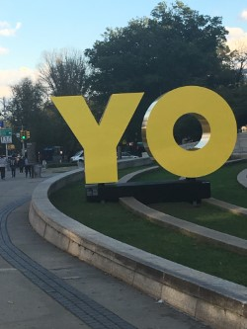
Image 1
spanish translation of I
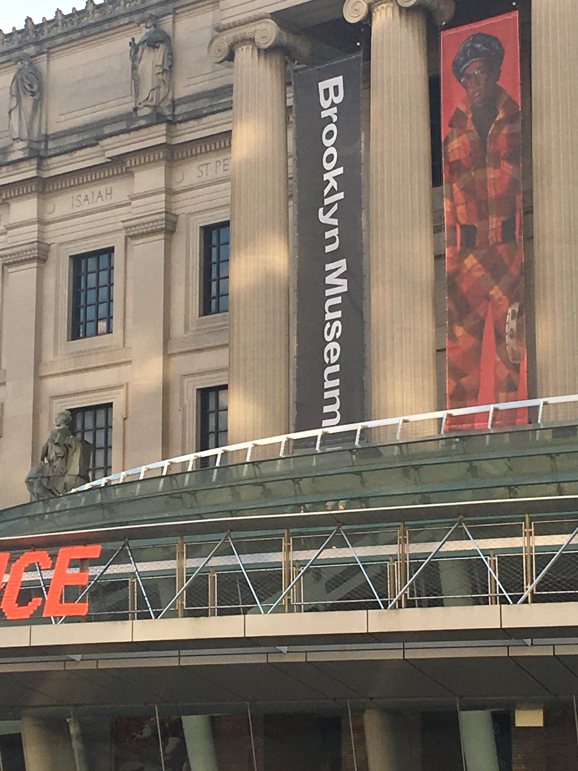
Image 2
Walk way open

Why did you choose these images? As you look at each, what do you expect to encounter once you enter the building? Explain.
I choose those two images as they stood out for me. The one of the sculpture is naturally what one would find at a museum I believe. The depiction I am not sure of the meaning but I prefer to look at it as a sculpture. The other photo I choose because to me it’s unusual for a museum. I witnessed people walking on it right before I took the photo. Though I have not been to many museums, I have not heard of any that has this feature. It makes it unique.

The stated mission of the Brooklyn Museum is “to create inspiring encounters with art that expand the ways we see ourselves, the world and its possibilities.” Take a photo of one piece of artwork that expands the way you see yourself or the world. Give the photograph a caption and explain why it expands your vision of yourself or the world.
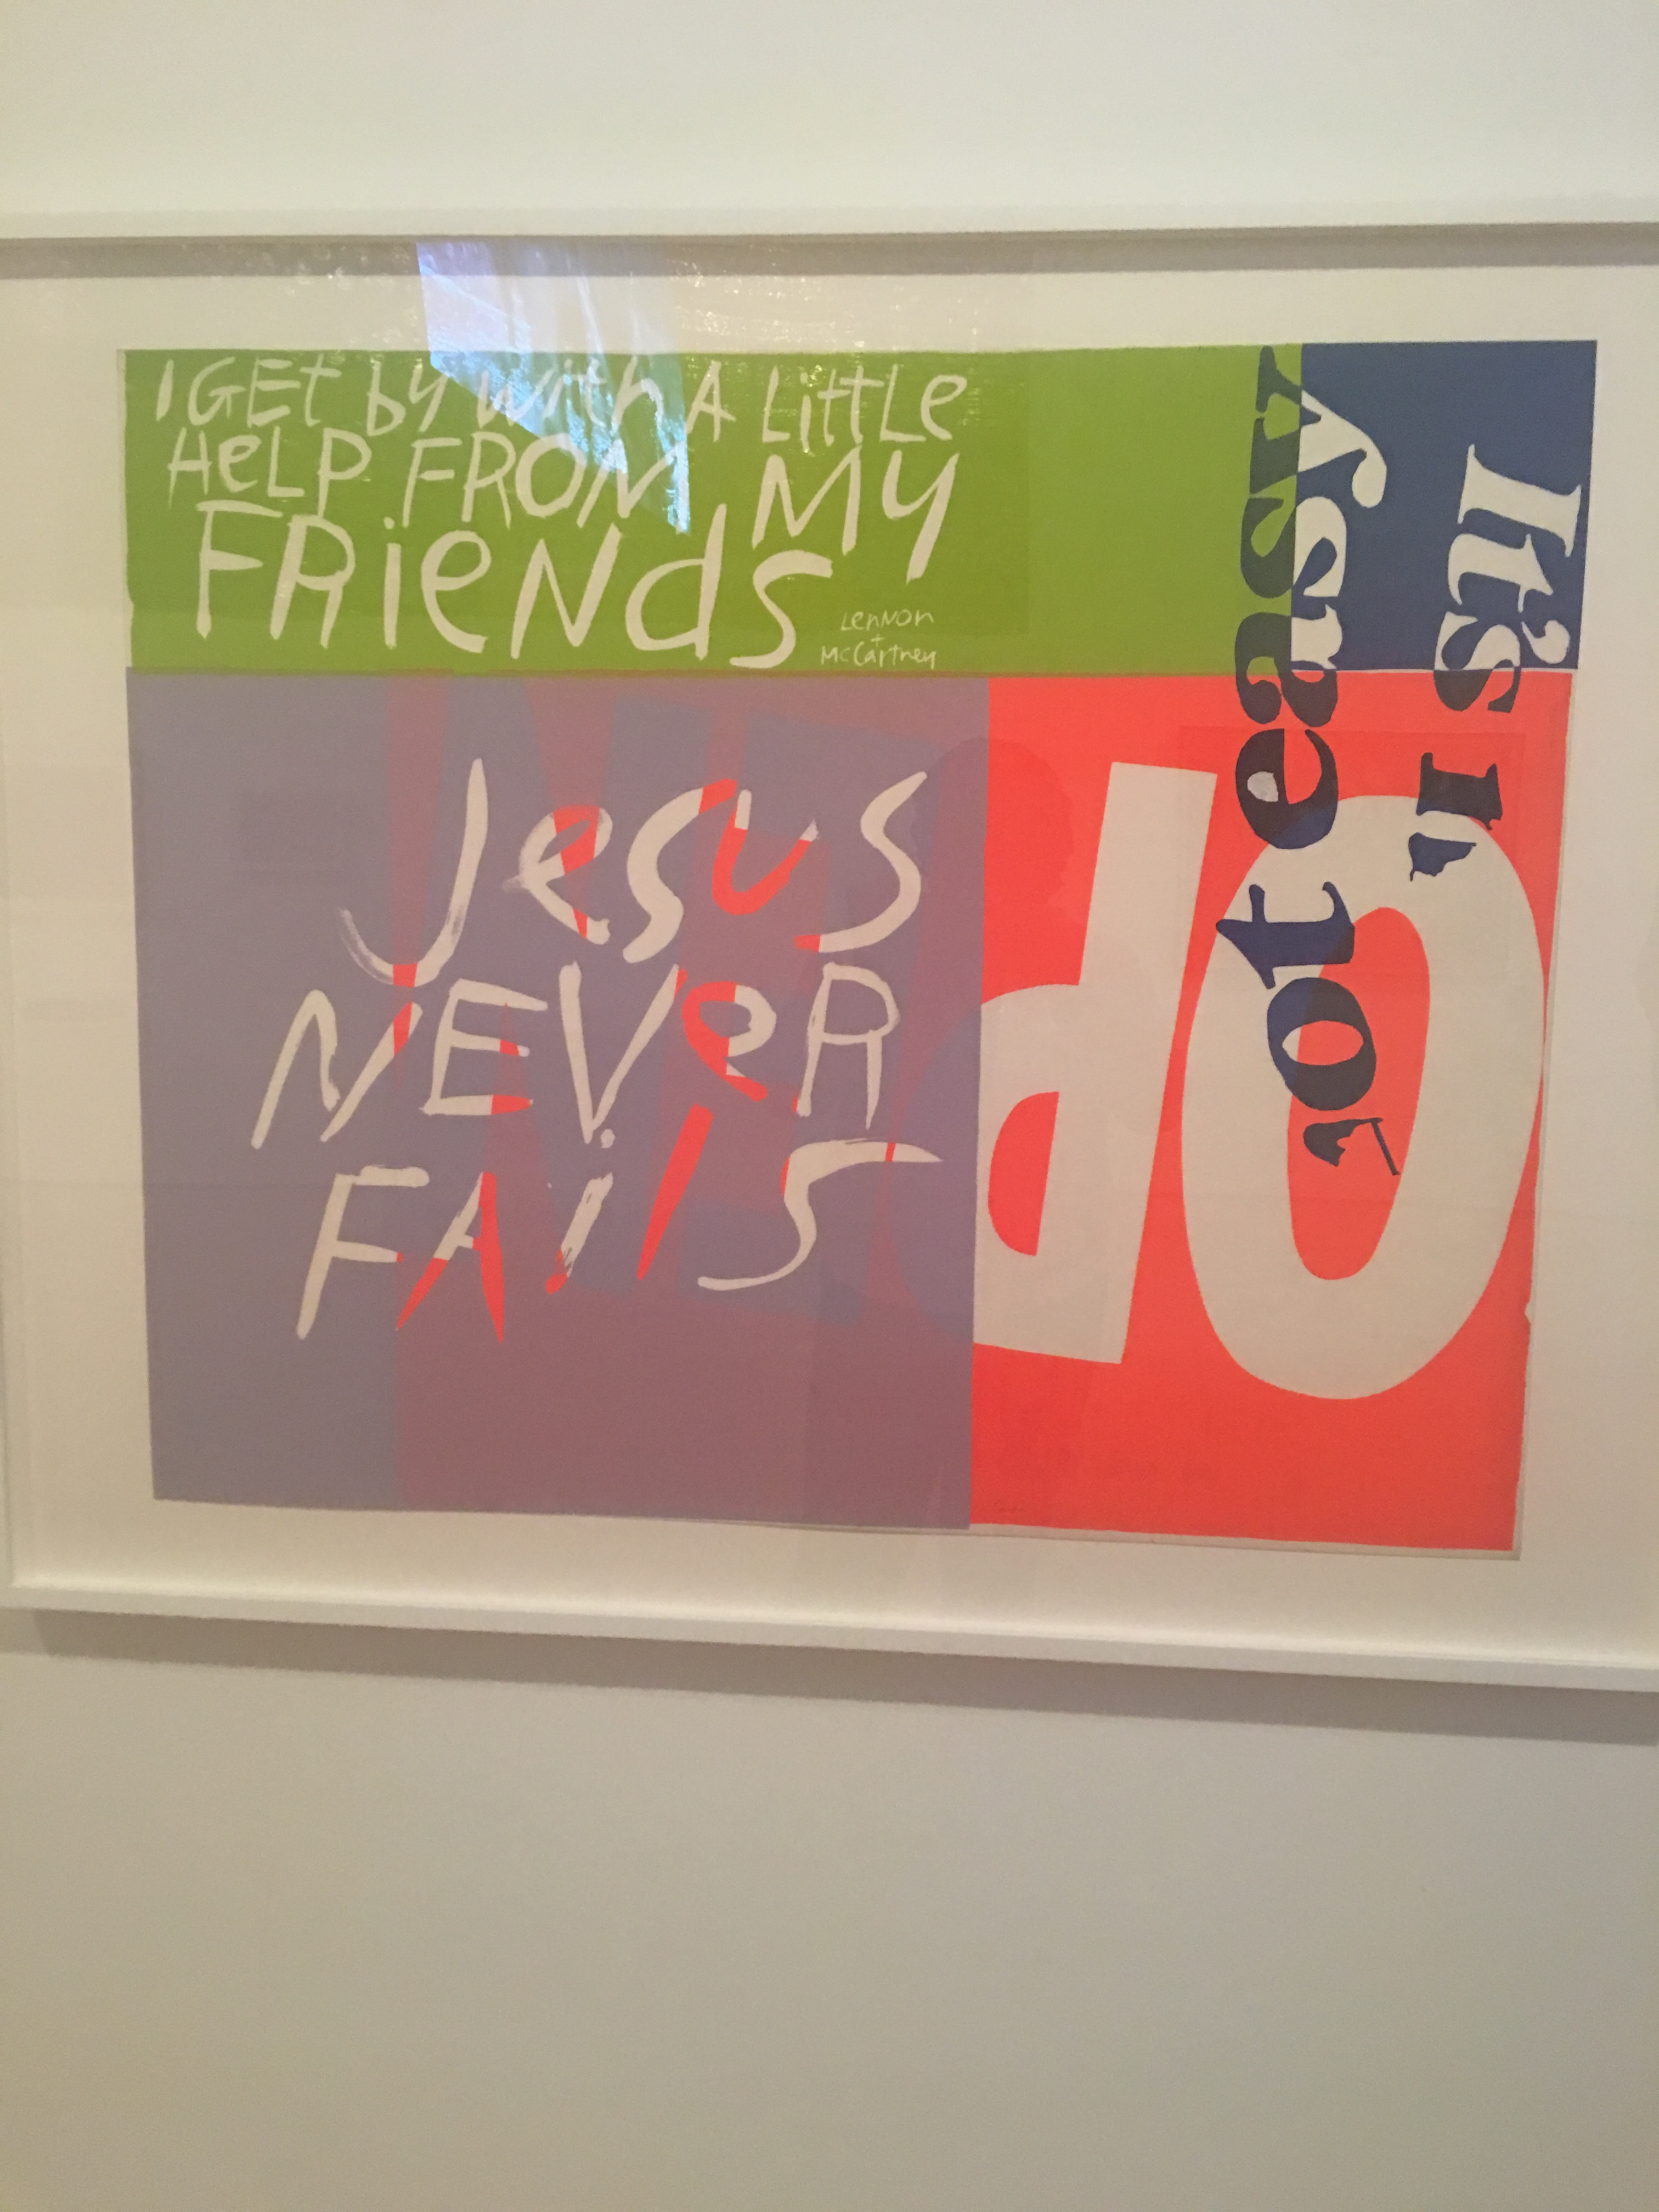

It is well
I choose this piece of artwork as a reminder. It stood out as a vision of myself and the world because with all that is happening right now, here’s a reminder that you can still go on. You can make it. There are people out there that will help if you just ask. It also reminds me of all that people in that period went through yet they were still happy, they persevered. They were positive. The phrase “Jesus never fails” reminds me that prayer works. No matter how tough the situation, there’s always a way out. This photo just brightens my day and is a reminder of the fact that everyone goes through stuff at times but your outlook on it is what counts.

The stated vision of the Brooklyn Museum is to create a place “where great art and courageous conversations are catalysts for a more connected, civic, and empathetic world.” Consider the curated areas of the museum. How is space arranged in order to create “courageous conversations”? Can you describe conversations between spaces?
The conversations between spaces made me think of the era and somehow gave me a visual of what was actually happening then. It was interesting to note some of the places where certain pieces were placed for example the mural of the era when “blacks or African Americans” turned to radio and music as a form of release and refuge. This particular display was secluded and made me wonder if it was a reminder that they could be persecuted if they were found or whether it was something they did not want to share. Maybe it was their world away from the reality of the time. A place where they felt free and reckless and forgot their plights for however long it lasted.

Insert an image of designed space (not art objects themselves) that suggest “connection.” How the concept of “connection” articulated in the way art is arranged in space? (Consider the walls, walkways, display boards, pedestals, rooms, etc.)
The image I choose for this question is the room where the mural was placed. The photo is said to represent the “Wall of Respect” which was painted in Chicago in 1968. It was a place where people gathered to socialize and started the movement of mural paintings in African American neighborhood across America. I found it interesting that it was placed in what I consider a hidden room. What stood out for me was the placement near what was an exit door, another door to some sort of room and there was a fire alarm lever in such close proximity. All of those details in the mural made me think that it was a definite strategy explaining “blacks” escaping their plight at the time. “I exit this situation and find relief in music, radio and any form of hidden comfort for a moment. Let’s forget what’s going on for a while. Let’s enjoy the one thing they can’t take from us since it’s hidden.” It’s the “connection” of blacks. An “us against the world” moment.
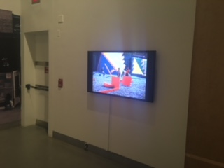

We will always remember

Brooklyn Museum declares that “since we see ourselves as a conduit for open sharing and learning, we accept the controversies that may accompany courageous conversations.” Consider the way art objects are arranged in space for the Half the Picture exhibition in relation to viewers. How would you describe the arrangement of objects for viewers? Did the arrangements accept controversies? Did they encourage courageous conversations? If so, how? If not, why?
I believe that the exhibit encourages courageous conversations. The half the picture exhibit showed one ethnicity fully clothed in their regalia and another half dressed. I found it controversial that the Indians were depicted well dressed with attention to details while the African American women were dressed from the bottom but their top was exposed. Although I see the beauty in the art as an African American, my issue is that they were both females placed at opposite sides of the display. Personally, I was not offended but I question why they did not share the same wall space? Someone else may appreciate that they were given their own section.

SITE REPORT #2B
Based on your observations at the Brooklyn Museum, develop a complex research question about the relationship between 1 piece of art that you viewed and a social or political issue.
Remember, your research question should be specific and researchable.
Research Question:

Find 2 sources. *For this report, one of your sources MUST be an academic journal article. Your other source can be a news article, internet source, or book.
1 source should have to do with the artwork, artist, artistic style, or some element of the work you chose. For example, if you were interested in learning more about realistic photography depicting women engaged in domestic activities, you might search for sources about “domestic imagery AND photography” or “realistic photography” rather than sources about the specific artist.
1 source should be about the social / political issue that is articulated in your research question. This source may or may not have to do with art.
Write an MLA citation for each source:
Source 1

Source 2

Describe the process you used to find these sources including any keywords and the specific search engine or tool you used to search.

In a sentence or 2, describe the main point of each source. Then consider: how do these sources address all or part of your research question?
Source 1

Source 2

Describe ways the two sources you chose are similar and different. Would it be difficult to integrate these two sources into a single writing assignment? Why or why not?

What other sources or further information would you need to answer your question? Where would you look for that information?

