Learning Places Fall 2018
SITE REPORT #1A
Zuccotti Park
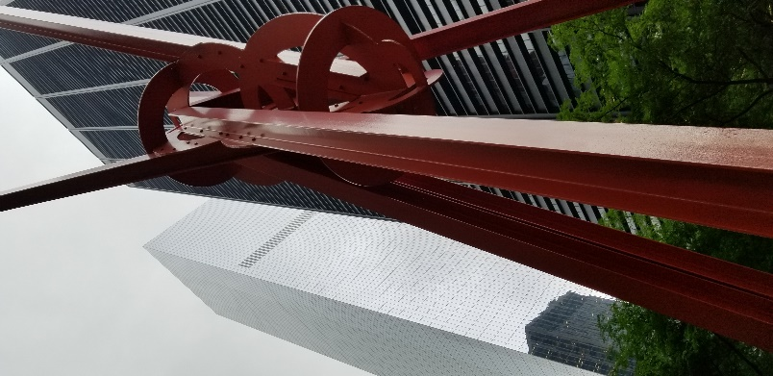
Select a meaningful image to that captures your perception of the site we visited and provide a caption explaining what the image is.
The image I have included for this site visit is the large sculpture in the park. I originally wanted to capture the man with the suit case, which was the original structure that survived when the Twin Towers collapsed. To me this sculpture is quite unique thus adding character to plain green space in the Downtown area. There isn’t a plaque to explain why this sculpture is in the park and I like how it is a curious piece of art in the middle of tall glass buildings within a small granite park. I like how it is different and seems like it does not belong. I feel that in a way that it represents a bit of New York of how we welcome so many different things into our city.

