Learning Places Spring 2016
SITE REPORT 4
The Brooklyn Bridge
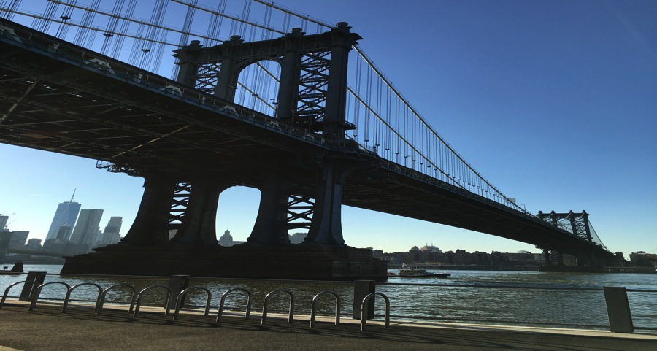

Frank A Smith
04.25.2016

INTRODUCTION
If you were to walk around Vinegar Hill, a person would notice above everything the monstrous Brooklyn bridge. The Brooklyn Bridge connects Brooklyn to Manhattan, which helps to bring not only aesthetic value, but helps add to the vitality of the Neighborhood.

PRE-VISIT REFLECTION
I was very excited to do a site report focused solely on the Brooklyn Bridge. I wanted to really dig into research and history of the Bridges manufacturing. My curiosity really was into how the bridge had affected traffic and rerouted streets.

SITE DOCUMENTATION (photos/sketches)

1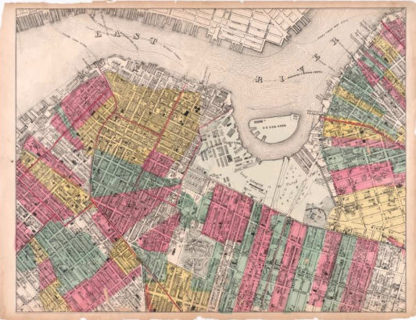

“1869 ‘map city of Brooklyn’ published M.Dripps 163 Fulton street New York by G.W Bromley & Co. Civil Engineers.”

This map is interesting because it shows what Brooklyn looked like before the Brooklyn Bridge was finished being built. The streets around the Downtown Brooklyn are still in a complete grid pattern.

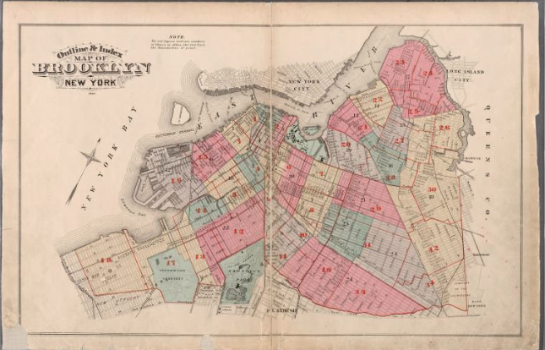

1880 “Brooklyn complete one volume by G.W Bromley & Co. Civil engineers published by Geo.W Bromley & E.Robinson 82 & 84 Nassau St.”

This map was made in 1880 which is a decade after the opening of the Brooklyn Bridge. A viewer can noticed many differences in this map and the one above it. The streets in the downtown Brooklyn area have now been molded to convene traffic towards the bridge. Fulton avenue has been made more into a highway towards Manhattan.

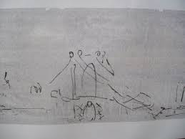

This is my very subpar sketch of the Brooklyn Bridge.

QUALITATIVE SITE OBSERVATIONS
- Neighborhood / Street Character
  - Vinegar Hill
  - Downtown Brooklyn
- Vitality of Neighborhood
  - The neighborhood is extremely vital with tens of thousands of people using the Brooklyn Bridge as transportation.

  - General Description
    - The Brooklyn Bridge was completed in 1880 this enabled tens of thousands pedestrians to commute to work into Manhattan everyday.
  - Pedestrian Activity
Pedestrian activity on the Bridge is extremely heavy people bike to Brooklyn or to Manhattan everyday.
  - Vehicular Traffic
    - There are tens of thousands of vehicles the commute back and forth on the Bridge everyday, mostly in the name of commuting to work.

- Building Details
  - Designer John Augustus Roebling
  - Opened 1880
  - Total Length 5,989ft Width 85 ft
- Relationship to the Waterfront
  - The Brooklyn Bridge is the only way for someone to drive to Manhattan from Downtown Brooklyn.
  - If a person was standing by the waterfront, you would notice the Bridge immediately
- Other Observations
  - The Brooklyn Bridge is of a suspension/cable hybrid
  - The Bridge crosses the East river
  - Six lanes of Roadway.

QUANTITATIVE DATA for Area of Study
Subject | Data
Street Names | Brooklyn Bridge
Street Width | 85ft
Street Pavement | Concrete
Building Heights | Clearance below 135 feet
Toll | Free both ways
Daily Traffic 123,731
Historic Monument
Designer : John Augustus Roebling
Other Data
Other Data
Other Data
Other Data

QUESTIONS to Research Further
QUESTIONS:
- What was John Augustus Roebling inspiration for the Bridge?
- What were some other designs for the Bridge before it was created?
- How much weight can the Bridge hold?
RESEARCH METHOD/SOURCE FOR EACH QUESTION ABOVE:
- Question 1
  - Check the library for a biography on John Augustus Roebling
  - Wikipedia search

- Question 2
  - Looking into Brooklyn Eagle archives
  - Maybe the NYPL has more information on the subject
  - Look into old blue prints on the subject
- Question 3
  - Use google to ask this question

SUMMARY / POST VISIT REFLECTION
I was really interested into researching the Brooklyn Bridge more, I’ve learned a lot more about this subject. The reason I felt it was important to look more into the Brooklyn Bridge is because of it’s affect on Vinegar Hill and Downtown Brooklyn. All of the vitality of the neighborhood I believe is caused by the Brooklyn Bridge in that it connects Manhattan and Downtown Brooklyn. The most interesting part of my research is looking at the old Sandborn maps showing how bridge was placed, and roads changed to ease the flow of traffic to the Brooklyn Bridge.

