Chris Raghubir

HMGT 1101

Prof. Akana

36 Hours in the caribbean island of Trinidad & Tobago

My visit to Trinidad and Tobago was during the carnival season. The [Trinidad and Tobago](https://en.wikipedia.org/wiki/Trinidad_and_Tobago) [Carnival](https://en.wikipedia.org/wiki/Carnival) is an annual event held on the Monday and Tuesday before [Ash Wednesday](https://en.wikipedia.org/wiki/Ash_Wednesday) in [Trinidad and Tobago](https://en.wikipedia.org/wiki/Trinidad_and_Tobago). The event is well known for participants' colorful costumes and exuberant celebrations. [Carnival](https://en.wikipedia.org/wiki/Carnival) is the most significant event on the islands' cultural and tourism calendar, with numerous cultural events such as "band launch fetes" running in the lead up to the street parade on Carnival Monday and Tuesday. It is said that if the islanders are not celebrating it, then they are preparing for it, while reminiscing about the past year's festival. I arrived on the island around 05:00 pm on a Friday.

05:00 pm – Landed at the Piarco International Airport, and was picked up by my brother-in-law and taken to their home. (Still have my mom and sister that still reside on the island)

06:00 pm – Arrived at my sister’s home and she had my favorite dish waiting for me. It was curry chicken and roti. After eating I needed a nap, because I know it’s going to be a busy weekend.



08:00 pm – Decided to visit one of the Band Launch and view their costumes. I decided I may partake in the festival.



12:00 am – Arrived at my home and called it a night.

07:00 am – My brother-in-law took me out to grab some doubles, which is a traditional roadside food and is loved by everyone. (yummy)



09:00 am – Decided to travel to one of the most popular beach, Maracas Bay. There you can find another favorite food of the citizen and visitors. It’s a bake and fry shark sandwich.

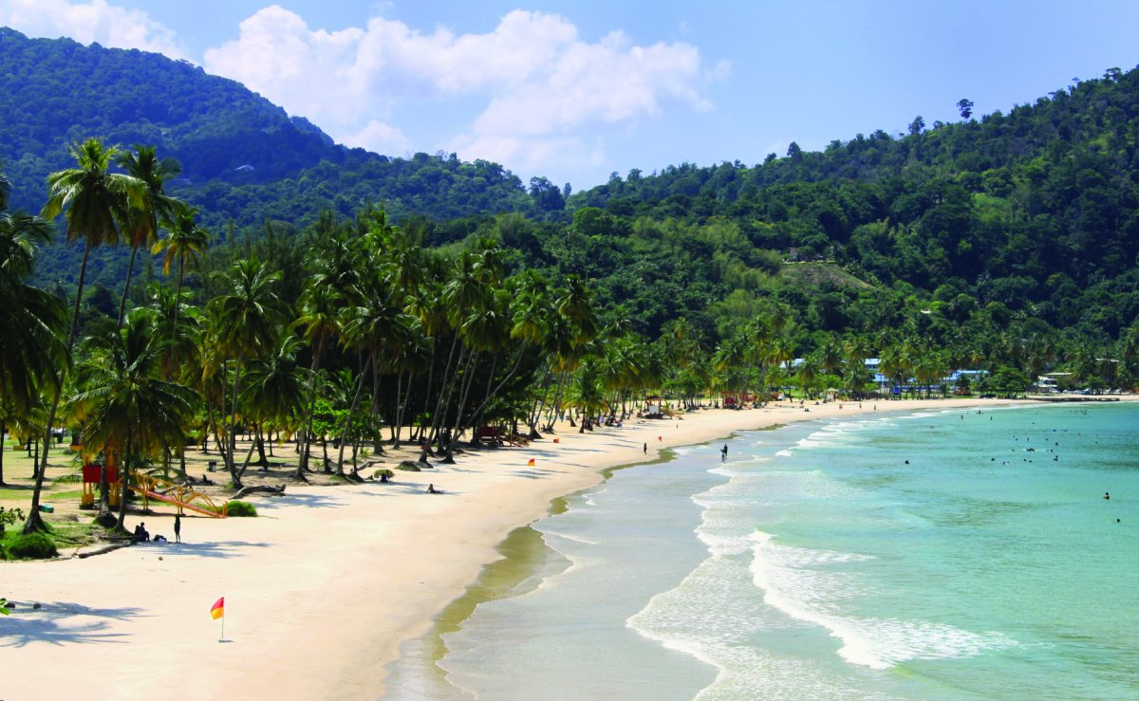



04:00 pm – Got back home and decided to take a nap for the night ahead.

07:00 pm – Head into the city to visit one the Pan Yard to listen to the sweet soca music played on steel drums.

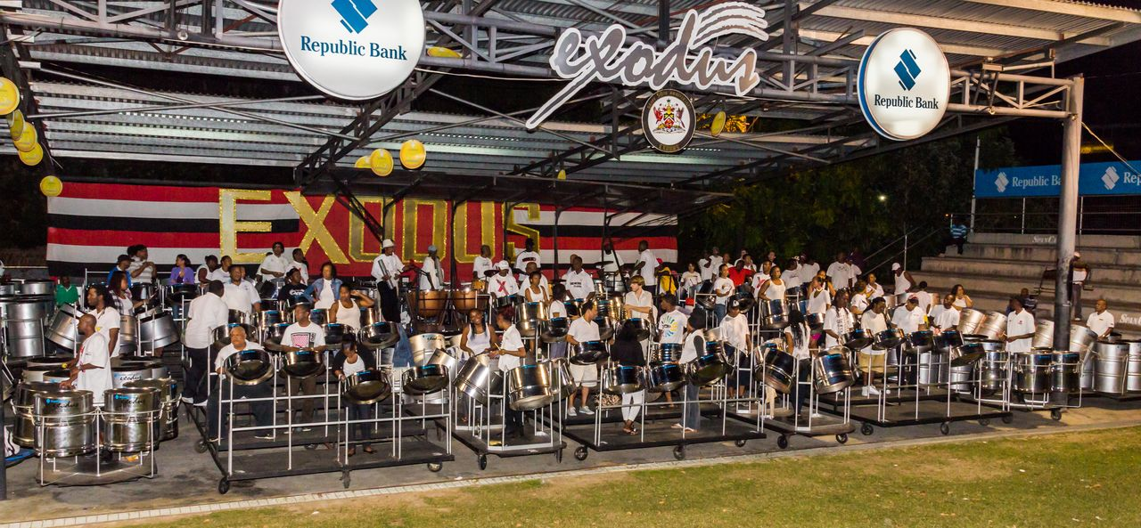

11:00 pm – Start of a great evening, decided to visit one of the favorite night club for some drinks and dance the night away.



06:00 am – arrived saftely home.

12:00 pm – Left to visit the great pitch lake, The Pitch Lake is the largest natural deposit of asphalt in the world, at La Brea in southwest Trinidad, within the Siparia Regional Corporation. The lake covers about 40 ha and is reported to be 75 m deep. Pitch Lake is a tourist attraction that attracts about 20,000 visitors annually.

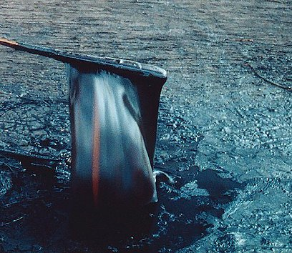

04:00 pm – Went to pick up my sister, who works at one of another tourist attraction. The Emperor Valley Zoo, the zoo was name aft er the Emperor butterfly.