Anthoneth Jeffrey
AFR 1311 E836(80386)
Professor Covert
12-19-13

THE RIVERSIDE CHURCH PRISON MINISTRY 40TH ANNIVERSAY CELEBRATION
ENDING PAROLE ABUSES –REUNITING FAMILIES

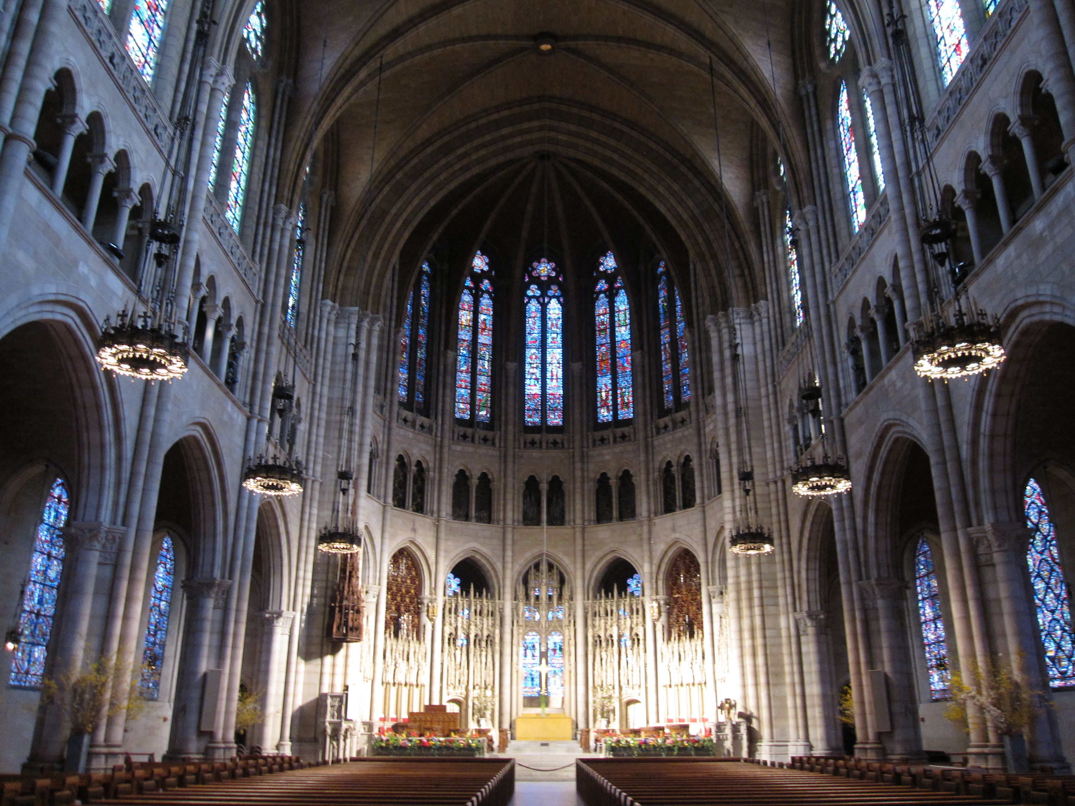

The Riverside Church Prison Ministry was founded by Robert L. Polk after the Attica uprising in 1971. This action was done to take a stand against cruel and unusual treatment towards prisoners, and a stand for human justice. The prison ministry believes in giving second chances and allowing people to redeem themselves, so in light of this they have launched a one year campaign to oppose the prison system for their vindictive, unfair and continuous denial of parole to countless men and women who have in no uncertain terms displayed their readiness to return to their homes and community to make positive contributions.
On Friday November 8th the Riverside church began a weekend celebration of their 40th year in existence. There were different vendors promoting their books and conducting book signing. Among them was Terrie Williams, author of “Black Pain”, a book about her experience and the experiences of otheres with depression. After the book signing there was a very interesting program which was schedule to beginning at 7:00pm.
There were several musical artists. The first performance was by a group called IMPACT Repertory Theatre Company. Their director/founder Jamal Joseph is an ex-prisoner who after being released from prison turned his life around and is now making a strong and positive impact in society. The senior interim Minister Rev. Stephen Phelps gave a short address followed by a message from the founder of the Prison Ministry Robert Polk. His message was very touching as he related his story of being in prison for 12yrs, solitary confinement 5 times; how he was denied parole a few times for no good reason, and how it affected his family. He is also now a well-respected man in his community. This is evidence that there are thousands of people held in the prison system unjustly, and the community needs to do something about it.
There were other speakers like Terrie Williams, who encouraged the audience to write a plan on what they think the family members should do when these individuals are release from prison, so they can have an easier transition. She also mentioned that we are nothing without mental and emotional health, so she encouraged the people to speak out about the things that bother them; pool together with a group of friends and most importantly seek professional help if needed for emotional and mental health issues.
Gloria Browne-Marshall, an Associate Professor of Constitutional Law at John Jay College of Criminal Justice addressed the audience about parole. She defined what parole is and gave some historical facts and statistics. An interesting thing she said was “the prison became an extension of slavery after it ended”. That’s something to think about. We were informed by a member of the prison ministry that there is a petition that we can sign to end parole abuses and reunite families. There were other musical entertainment from bands and soloist. The evening was very informative and entertaining at the same time, and I am sure people left with the prison system on their minds.

