NEW YORK CITY COLLEGE OF TECHNOLOGY



LAB 3

Anzamul Hyder

Prof. Islam

Date: 02/27/2015

Code:

**package** NumberStat;

**import** java.util.Scanner;

**import** lab3.NumberStats;

**public** **class** NumberStat {

**public** **static** **void** main(String[] args) {

Scanner input = **new** Scanner(System.***in***);

**int** value = 0; // This will do the job for us

**int** firstnumber = 0; // This will show the first number entered

**int** lastnumber = 0; // This will show the last number entered

**int** count = 0;// It will count

**int** minimum = 0; // This will show the minimum number entered

**int** maximum = 0; // It will show the maximum number entered

**int** totalsum = 0; // It will add the numbers entered

**double** average = 0 ; // It will show the average

**while** (**true**)

{

System.***out***.print("Input Number, type 0 to get result: ");

value = input.nextInt();

totalsum += value;

**if** (value >= maximum){

maximum = value;

}

**if**( value == 0 ) **break**;

**if** (value == minimum ){

minimum = value;

lastnumber = value;

}

count++;

**if**(count==1){

firstnumber=value;

minimum = value;

}

**if** (count>0){

lastnumber = value;

}

}

System.***out***.printf("First Number entered = %d\n", firstnumber);

System.***out***.printf("Last Number entered = %d\n", lastnumber);

System.***out***.printf("Count = %d\n", count);

System.***out***.printf("Maximum = %d\n", maximum);

System.***out***.printf("Minimum = %d\n", minimum);

System.***out***.printf("Average = %d\n", totalsum/count);

System.***out***.printf("Total Sum = %d\n", totalsum);

NumberStats mystats1 = **new** NumberStats();

NumberStats mystats2 = **new** NumberStats();

NumberStats mystats3 = **new** NumberStats();

NumberStats mystats4 = **new** NumberStats();

NumberStats mystats5 = **new** NumberStats();

NumberStats mystats6 = **new** NumberStats();

NumberStats mystats7 = **new** NumberStats();

NumberStats mystats8 = **new** NumberStats();

System.***out***.printf("%s\n" , mystats1.getmaximum());

System.***out***.printf("%s\n" , mystats2.getminimun());

System.***out***.printf("%s\n" , mystats3.getaverage());

System.***out***.printf("%s\n" , mystats4.getlastnumber());

System.***out***.printf("%s\n" , mystats5.getfirstnumber());

System.***out***.printf("%s\n" , mystats6.getvalue());

System.***out***.printf("%s\n" , mystats7.gettotalsum());

System.***out***.printf("%s\n" , mystats8.getcount());

}

}

**SnapShot:**

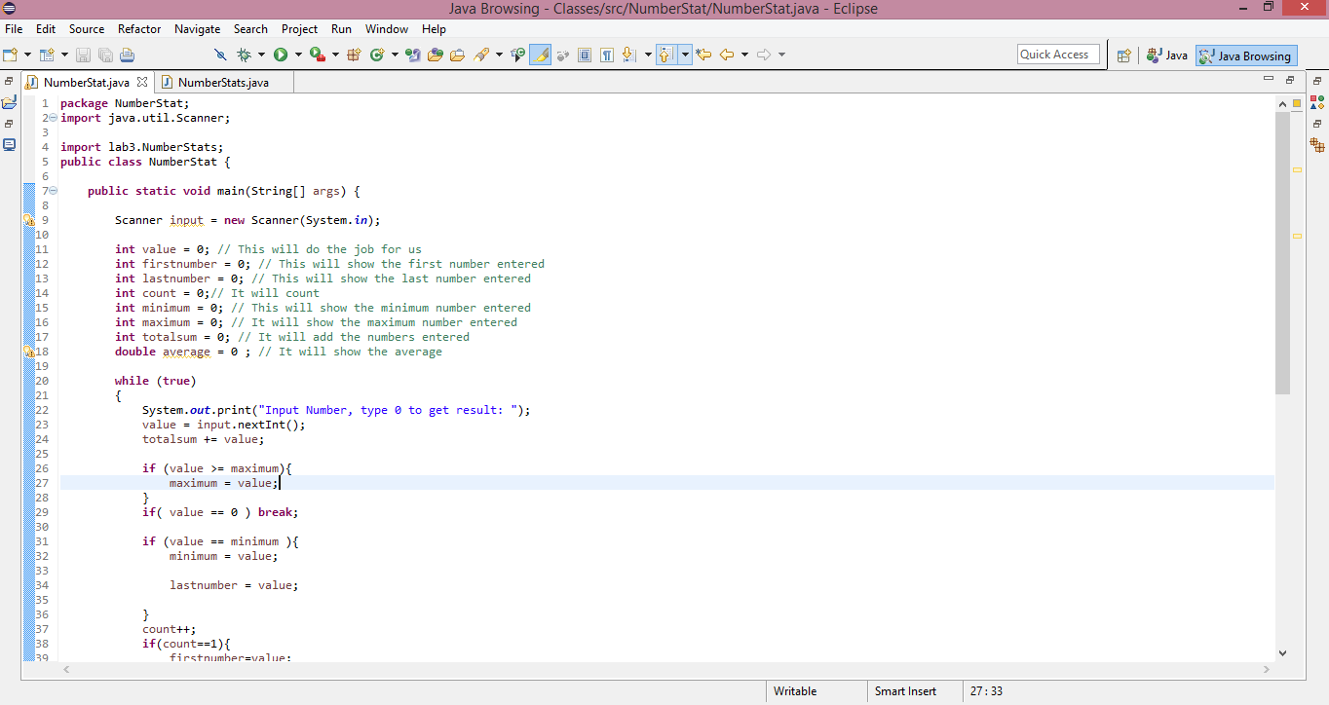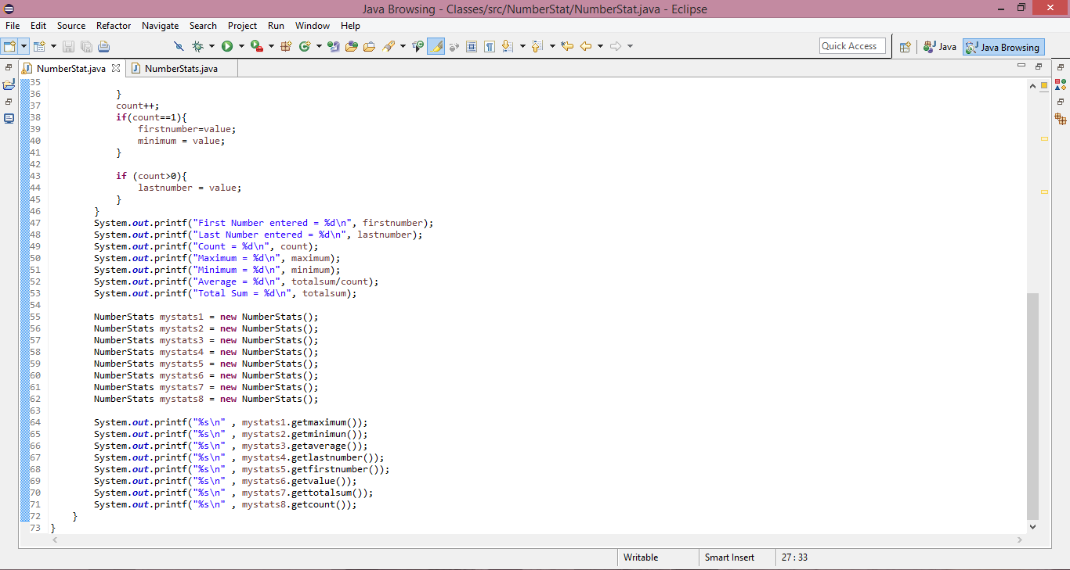

**Result:**

